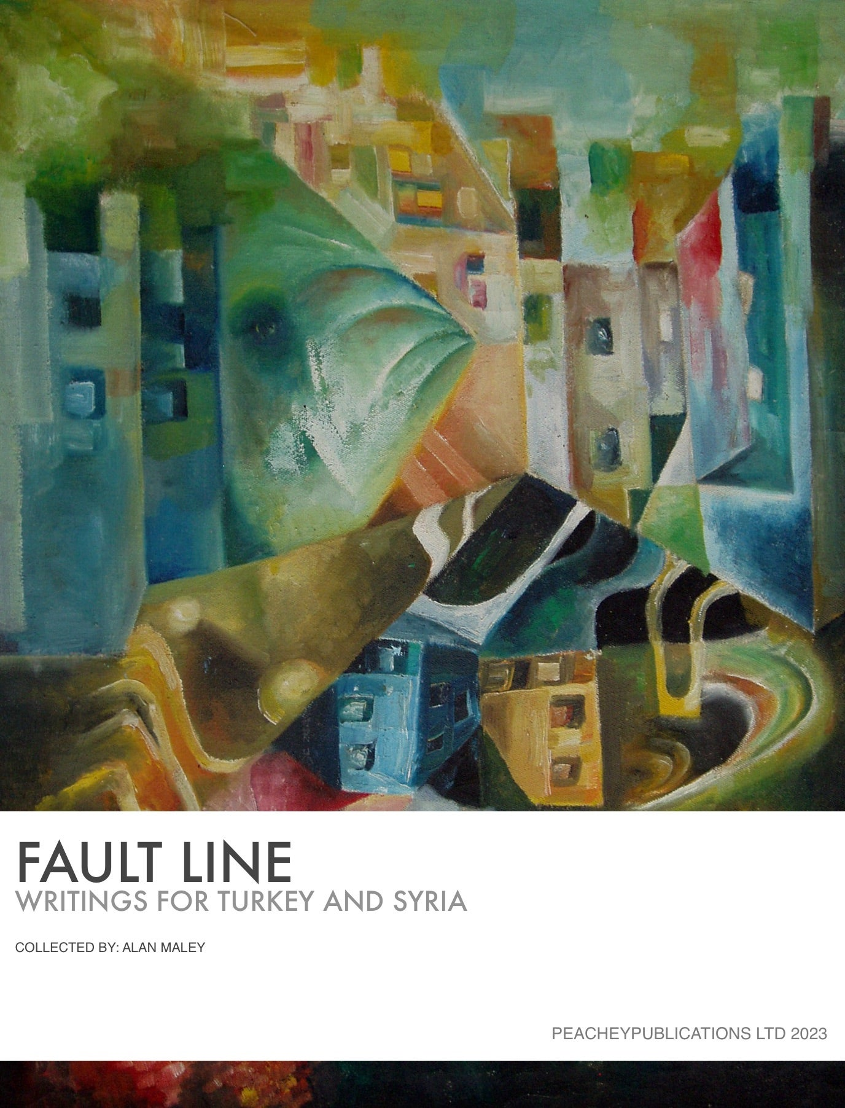

Dear All,

Our writing group, Worlds into Words, has produced an e-book of writings (mainly poems) in support of the earthquake victims in Turkey and Syria. All proceeds from the sales will go to the Disasters Emergency Committee (DEC), which brings together all the major charities involved.

Fault Line - Writings for Turkey and Syria at link
This book is a collection of poems from 34 poets around the world. The book has been created to raise money for victims and survivors of the earthquake which struck Turkey and Syria on February 6, 2023, at 4:17 a.m. Here are some sample poems:
The Cord
by Nishtha Chhabra

Under the rubble of cement and dust,
Among tiling shards and plain old rust,
A man stood upright, big and tall.
His arms nestling something frail and small.

The infant locked her liquid eyes
With her angel, in human guise.
He held the remnant of her umbilical cord
Snipped in two - mirroring nature’s discord.

The infant remained quiet, filled with fears.
She was cautious; no cries, no tears.
Better to stay silent in the midst of this trouble,
Fearing he’ll abandon her in the rubble.

A tale of the rescuer being rescued
From his own distress - an interlude.
The ruptured cord umbilical
Now forms a bond metaphysical.

Remembrances
by Gerard Hocmard

It's first the rumble that wakes you up.
The eerie noise from all around
That makes you wonder and fret.
Then comes the tremor, gentle at first,
A heavy lorry, passing in the street, perhaps?
But you fall from your bed, in gut-wrenching noise
As the world seems to crash - and run outside,
Barefoot, half-naked, to a crowd of zombies,
Haggard and silent, caught in their sleep,
Curlers and nighties, pyjamas, no shoes.
It seems to last and last, the world shaking,
Till daylight comes over the rubble, the tears and the cries,
The frenzy of the search, for victims or one's treasures,
The pain of survivors and the question: what now?

Earthquake – a haiku sequence
by Alan Maley

when the earth moves
our confidence collapses,
and with it, our homes …

the faintest whimper:
under this pile of rubble –
one child left alive …

the earth is hungry –
its belly rumbles and growls –
someone has to pay.

under the rubble
one child lives – another dies.
What’s fair about that?

this was a wardrobe –
we make do with what we have,
now it’s a coffin …

where once olives grew,
they are now planting bodies,
a sterile harvest…

deep under rubble,
from the still silence of death,
this small voice of hope …

I am sorry
by Jane Spiro

Sorry is not enough
- a ceiling has fallen
- a house has fallen
- a street has fallen
- a city has fallen
Words are not enough
-it was my home, it was my life,
my children born, grew up here, my mother
grew old here, all the best moments
I lived here
Money is not enough
My wife, she was my life, my everything
my boy, he was my eyes, he was my light
nothing can bring them back
Hope is not enough
-what now can I believe?
-who now can I trust?
-what now can I hope for?
Everything I had is lost.

If I could, I would bring you the world.
Words, if only
they were enough.

Half-truths and Realities
by Sharoon Sunny

We built our cities tall and proud,
On land Nature wouldn’t have allowed.
We paved our roads and cleared the trees,
And drained the rivers with such ease.

We dug deep into the earth for fuel,
And ignored warnings and all rules.
We tampered with the earth's foundation,
With no regard for its devastation.

And then the day arrived with force,
Nature's wrath taking its course.
The ground shook, the buildings fell,
Our choices had led us to this hell.

The tragedy so sudden and swift,
Leaves us feeling small and adrift.
Our pride and arrogance now laid bare,
As we mourn the lives lost in despair.

Yet though our choices led to this quake,
We can still make amends, for future’s sake.
And though it may take time to heal,
The human spirit will always prevail.

The book also includes a chapter on ways to include the poems into your classroom practice for any teachers who want to raise issues around this event with their students.
The illustrations for each chapter of the book were created using AI and a line or verse from each poem. The 34 images can be downloaded as a zip file along with the book.
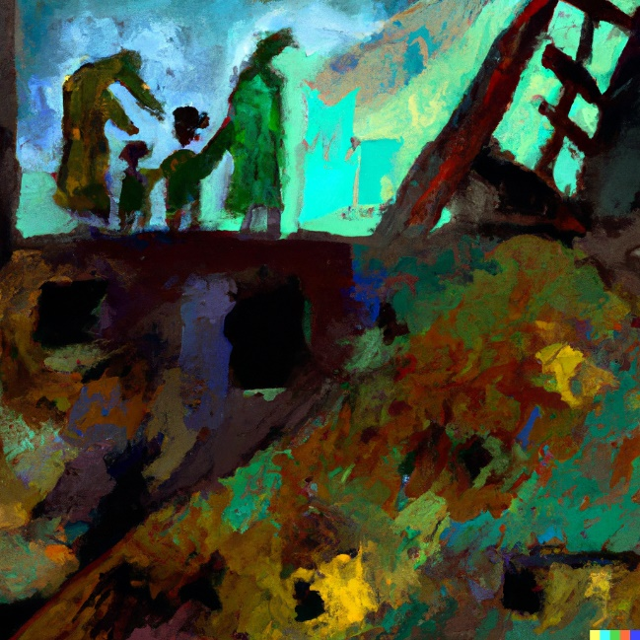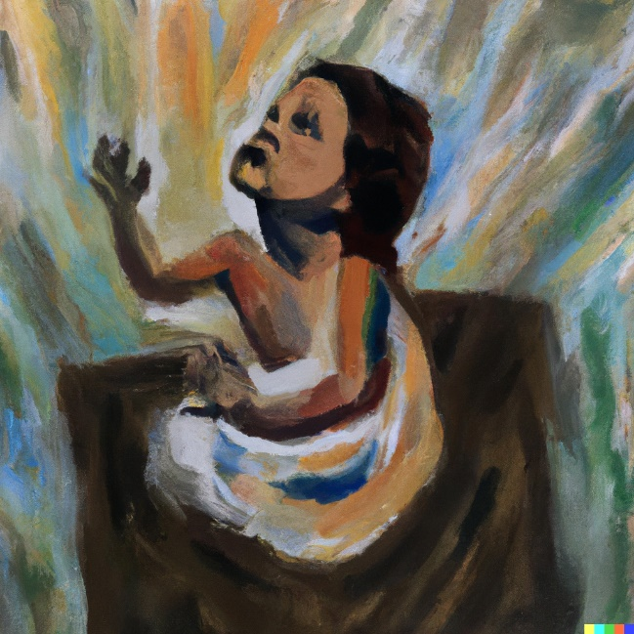
I hope you may be interested in buying a copy. The basic price is $5 - but you can pay more if you wish, simply by changing the amount in the link.
All proceeds from the sale of the book will go to Disaster Emergency Committee - Turkey-Syria Earthquake Appeal.
Please also pass on the link to your friends and contacts.

All good wishes,

Alan Maley, on behalf of Worlds into Words Group



