Part from Whole and Whole from Part – the Dynamics of Meaning in English Teaching

Norman Skillen, Ireland

Norman Skillen is a retired Waldorf high school teacher, who taught drama, literature, biology, geography and music. He has also been extensively involved in Waldorf teacher training in Witten, Cape Town and Stuttgart, largely working in the area of foreign language teaching. Since the early 1990’s he has also been active as a translator, translating many articles for the journal RoSE, as well as seven books, most of them by prominent Goethean scientists.
Email: normanskillen@gmail.com

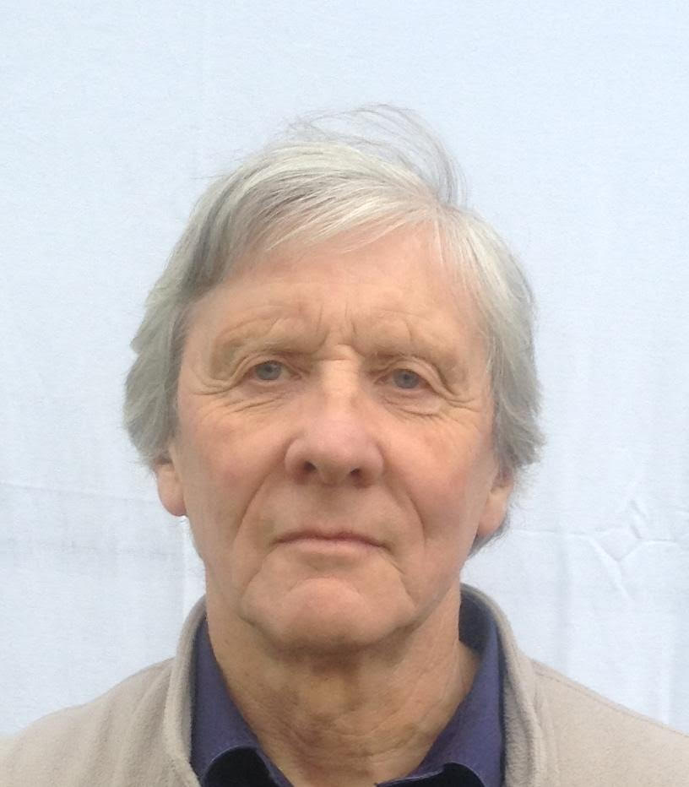

Abstract

Active imagination emerges in this article as the key to any act of understanding, for the dynamics of meaning are ruled not by simple logic, but by the polarity of part and whole. This means, on the one hand, that having a “feel” for sentences is inherently paradoxical and, on the other, that language is fundamentally holistic. Some exercises are also described that explore these part-whole relationships in practical terms. It is suggested also that imagination’s role in the process of understanding implies that language itself is inherently poetic.

Use the penumbra!

When I was part of the foreign language department at the Waldorf Institute in Witten, Germany, we regularly engaged the services of an experienced teacher from England, whose name as Rudolf Lissau. He had many good ideas for language teaching, and one that I vividly remember was his injunction to “use the penumbra”. By this he meant that every word implies a context (which may or may not be present to consciousness – hence the term “penumbra”) and within any class community there is a rich potential for expanding that context by using the collective memory and imagination of the children/students in it. Thus by starting anywhere you can use this penumbra of potential contexts to coax a story out of a group of children. It is clear that such a process will be a positive learning experience for a number of reasons:

- It produces an age appropriate story.
- It shows the class that they know more than they thought they knew.
- It strengthens their “feel” for the structure of sentences in the target language.
- It exercises and so helps develop their imaginations.

In addition to all this, such an exercise takes the class into territory which all four of the above-listed benefits already inhabit, for each in its own way depends for its effect on what could be called the dynamics of meaning.

Paradoxically, we understand

These dynamics are an expression of the part-whole relationships that subsist within the realm of language. We are all familiar with how, when listening to someone speaking, we are constantly anticipating what they are about to say, inwardly completing the sentences they are unfolding for us. This is because we have a feel for the dynamics of meaning as it lives in sentences, based on a deep intuitive knowledge that goes back to the time when we went through the process of acquiring our mother tongue. Throughout this extraordinarily mysterious phase of our lives we got used to putting ourselves into the paradoxical tension of the polarity involved in the experience of a sentence. Like a hovering hawk, mastering updraught and gravity, we grew skilful at holding in balance the opposing semantic currents of sentences. Stated as simply as possible, what I am referring to here is the fact that we understand the words in a sentence by understanding the sentence as a whole, and we understand a sentence by understanding the words in it. Thus it is by grasping the overall context of words that we understand them (and hence our ability to anticipate noted above), while it is by grasping the words that we understand the context. This immediately shows us two things about language. The first is that our feel for sentences is not based on normal logic, for it is immediately apparent that this tension between part and whole within a sentence is inherently paradoxical. It’s not a case of simple contradiction, but of mutually dependent opposition, in other words, a dynamic polarity. The second is that language is fundamentally holistic. This position was stated forcefully by Wilhelm von Humboldt, as follows: “For man to truly understand even a single word, not as a mere physical outburst, but as sound articulating a concept, language must already exist as a whole within him” (Humboldt, 1963).

If we take this seriously, it means that any kind of “building blocks” approach, whether to the origin of language or to what goes on in the language classroom, will be out of tune with reality. An isolated word is no more possible than an isolated leaf (or any other living organism one might care to name). The polarised penumbra, which gives us the dynamics of meaning, is poised to spring into action at the merest slip of the tongue. This testifies also to the innate playfulness of language, in that you can start anywhere, and the dynamic potential thus set in motion opens the door to an infinite field of possible combinations.

Whole from part

From the poet Paul Matthews I learnt an exercise for introducing words to each other, which illustrates this point very well. It works like this: one goes round the group pointing to each member in turn, and each person pointed to is to write down the word said to them. The words come in a sequence and they are: adjective, noun, verb, adjective, noun. So if I point to someone and say “adjective”, they write down the word “adjective”, and so on, until I have been round the group (in the same order!) several times, by which time everyone will have a list such as:

verb
adjective
noun
verb

Now the group are asked to write an example of each “type” of word beside their list, not showing them to anyone else. Now we are ready to introduce the words to each other, and probably to experience word combinations unprecedented in the whole history of the language! Before starting it is advisable to encourage the students not to take it personally if the sentences generated don’t work – people do get very attached to their words. So I go back to the person I started with and point to them. They say the first word on their list, and so on round the group until all the words are used up. By that time we will have generated quite a number of sentences, all with the same structure. Some of them might not make sense, but we might also get, say:

Blue cat flips lazy ant
Catastrophic paint covers lonely park

Some of them – like the second example here – sound like headlines in some bizarre newspaper, and this immediately opens up the possibility of trying to compose the articles that go with them – in other words, entering into the penumbra, into which such word combinations move the imagination. No matter what the sentences generated, however, one thing is certain – this exercise generates a lot of excitement. This arises spontaneously from the dynamic tension experienced as the sentences take shape. “Blue” – everyone is feeling “blue what?” – the possibilities at this point are vast. “Blue” … “cat” – hmm, oh well, there are some cats with fur that is described as blue, but it could also refer to the cat’s inner state, so it’s odd but not impossible; now “Blue” “cat” …. the tension here has increased, are we going to get something that fits into the penumbra of “blue cat”? “Flips” – wow, that’s great! Now what could a blue cat flip? Either something will come now that will foreclose the possible meanings or leave them wide open – “lazy” good! The doors are now wide open – lazy, lazy, lazy, lazy …. “ant” – this word rescues the whole sentence and the sentence augments the word. Everyone has a sense of satisfaction – dynamic balance has been upheld.

Part from whole

This exercise is one in which we begin with “parts” which when brought together mutually enhance one another (unless, of course, they are completely incompatible). We are not playing with passive blocks of language (there are no such things), but with dynamic elements. The following exercise also plays with this part-whole relationship, but in a different way, for here one word transforms the whole context, expanding it into the realms of before and after. I have used this on a number of occasions and it always produces striking results. The group are given a passage with one word missing and asked to fill in the blank by imagining what might fit, and then to write what came before and what came after, according to the word they have inserted. This is the passage:

“He got up trembling. He had less than half a mind to fetch the lamp, and more than half a mind to pretend to, and go and hide behind the beer-barrels in the cellar, and not come out again until all the ……………….. had gone away. Suddenly he found that the music and singing had stopped, and they were all looking at him with eyes shining in the dark.”

So far, no one has ever put in the “correct” word (“dwarves” – it’s a passage from “The Hobbit”), but it has never failed to produce highly creative results. It is a methodological principle in Waldorf practice that we work “from the whole to the parts”, and this exercise is a case in point, in that it uses a contextual whole to suggest a suitable “part”; but the relationship between part and whole here is no less dynamic than in any number of other contexts. The chosen word does receive its meaning from the wider context, but the latter’s whole meaning is transformed by the meaning it bestows upon the chosen word. Thus, the point is not to work “from the whole to the parts”, but rather to understand the dynamic relationship between part and whole. It is also possible to begin with a “part” and still be working holistically. I keep putting the word part in inverted commas, because strictly speaking in terms of this relationship there are no parts as such. Neither in language nor in life are there any fixed, isolated entities. As Henri Bortoft puts it, a “part” is “a place for the presencing of the whole” (Bortoft 1998, p. 284). At the same time, the whole is only manifest through the parts. As Humboldt argued, every word implies the whole of language, but “language” can never be manifest as a whole, even though language, as a whole, is the fundamental reality. A further implication of all this is that, in the absence of anything fixed, isolated or finally circumscribed, we are dealing with fluidity – organisms and ecosystems as flow-forms, parts of speech as fluid concepts. The fluidity of grammatical categories would warrant a whole article (or book!) to itself. While in the face of this we can and must, of course, distinguish (fish from frogs, participles from adjectives etc.), it is important never to mistake our distinctions for divisions.

As an example of beginning with a “part” and still working holistically, we could take our lead from Seamus Heaney. In his book “Preoccupations” he describes the genesis of his poem “Bogland” (1980, p. 54/5). Without going into details, we can say that by virtue of a combination of circumstances the phrase “We have no prairies” drifted into his mind (“we” being “we in Ireland”). Now he faced the task of “unpacking” this resonant sentence – what was the full context that it implied or contained? The poem “Bogland” was the result (see Appendix). And it, in turn, became an emblem, or template for a host of other poems he went on to write about the bogs of Ireland. The whole is expansive and never-ending.

The gift of imagination

In teaching poetry, therefore, it is worthwhile asking “what is the contextual penumbra of any ‘part’”? If, for instance, we wished to work on another Heaney poem, “The Forge”, we could begin by giving the class the first line: “All I know is a door into the dark”, and asking them to imagine what comes next. From the students’ thus launching themselves into the penumbra of this line we end up with a rich palette of potential contexts, each of which represents an aspect of the poem’s possible theme. This provides a matrix of meaning into which the actual poem, as Heaney wrote it, can eventually be integrated (see Appendix). Thus the groundwork for appreciating and possibly even enjoying the poem in its own right has been laid. The students’ concrete experience of the workings of imagination in laying this groundwork is highlighted in the case of this particular poem, for, as well as being a visceral, pithy description of the work of a blacksmith, it is also about the workings of imagination. One could imagine going on from here to “The Thought Fox” by Ted Hughes or “Adam’s Curse” by W. B. Yeats, both of which have the same theme.

No matter what the material chosen, however, one thing is certain and that is the central role of imagination in relation to the dynamics of meaning. We have seen that in the face of polarities – mutually-enhancing opposites - normal, rational logic breaks down. The only mental process that can cope with this paradoxical situation is imagination. Indeed, in chapter 3 of his book “What Coleridge Thought”, Owen Barfield declares: “…the apprehension of polarity is itself the basic act of imagination” (p. 36). If meaning is dynamic in this sense, and any approach to it requires an act of imagination, then this strongly implies that language itself is inherently poetic, and that the poem, the poetic “part”, is an expression of this inherently poetic whole. For a host of reasons, therefore, that extend far beyond the confines of the language classroom, providing concrete experience of the poetry inherent in language and of the imagination’s role in apprehending it is one of the greatest gifts a language teacher can give to his or her students.

References

Barfield, O. (1971). What Coleridge Thought. Wesleyan University Press.

Bortoft, H. (1998). Counterfeit and authentic wholes. In A. Zajonc and D. Seamon (Eds.). Goethe’s Way of Science. SUNY Press.

Heaney, S. (1980). Preoccupations. Faber and Faber.

Heaney, S. (1969). Door into the Dark. Faber and Faber.

Humboldt, W. v. (1963). Über das vergleichende Sprachstudium in Beziehung auf die verschiedenen Epochen der Sprachentwicklung. In A. Flitzer & K. Giel (Eds.). Werke in fünf Bänden, Bd 3: Schriften zur Sprachphilosophie (pp. 1-25). Wissenschaftliche Buchgesellschaft. (my translation)

Matthews, P. (1994). Sing Me the Creation. Hawthorn Press.

Appendix

1 The poem is the last one in Heaney’s second book “Door into the Dark” (1969, p. 55):

Bogland
We have no prairies
To slice a big sun at evening -
Everywhere the eye concedes to
Encroaching horizon,

Is wooed into the cyclops’ eye
Of a tarn. Our unfenced country
Is bog that keeps crusting
Between the sights of the sun.

They’ve taken the skeleton
Of the Great Irish Elk
Out of the peat, set it up
An astounding crate full of air.

Butter sunk under
More than a hundred years
Was recovered salty and white.
The ground itself is kind, black butter

Melting and opening underfoot,
Missing its last definition
By millions of years.
They’ll never dig coal here,

Only the waterlogged trunks
Of great firs, soft as pulp.
Our pioneers keep striking
Inwards and downwards,

Every layer they strip
Seems camped on before.
The bogholes might be Atlantic seepage.
The wet centre is bottomless.

2 Here is the text of the actual poem (Heaney, (1969), p. 19):

The Forge
All I know is a door into the dark.
Outside, old axles and iron hoops rusting;
Inside, the hammered anvil’s short-pitched ring,
The unpredictable fantail of sparks
Or hiss when a new shoe toughens in water.
The anvil must be somewhere in the centre,
Horned as a unicorn, at one end square,
Set there immovable: an altar
Where he expends himself in shape and music.
Sometimes, leather-aproned, hairs in his nose,
He leans out on the jamb, recalls a clatter
Of hoofs where traffic is flashing in rows;
Then grunts and goes in, with a slam and flick
To beat real iron out, to work the bellows.

