Dear HLT Readers,
Welcome to the April issue of HLT. First some Pilgrims News.

We are getting ready for our summer school. As many of you will already know, Pilgrims has been running Teacher Development courses in Ireland since 2022. Last year it was Limerick, this year it will be beautiful Galway, a vibrant, swinging town on the west coast of Ireland. Please take a look at the courses on offer:

https://www.pilgrims.co.uk/teacher-training-courses/2023-face-to-face-courses

If you are planning to attend IATEFL Conference Harrogate look out for Chaz Pugliese, Hania Kryszewska and other Pilgrims trainers. We will be very happy to chat to you. Another opportunity to meet will be at the MATSDA Conference in June.

Just before I hand over to the host editors of this issue, I would like to highlight Fault Line. Writings for Turkey and Syria which presents poems and texts collected by Alan Maley to raise money for the earthquake victims in Syria and Turkey.

The host editors of this April issue of HLT are teachers from Rudoph Steiner / Waldorf schools, mainly from Germany. I am very grateful to Alan Maley who had the idea to put me in touch with Peter Lutzker and Martyn Rawson. I am really impressed what a fantastic issue they have put together and I must say working together as a team with Peter, Martyn and Theresa was magic. A real dream team. Thank you so much. So without further ado I am handing over to the host editors.

Enjoy the April issue.

Hania Kryszewska
HLT Editor
Email: hania.kryszewska@pilgrimsteachertraining.eu

Zdjecie to co zawsze

Dear HLT Friends and Colleagues,

It is a great honour to be guest editors of a magazine that we have such respect and affection for, not least because those key figures who have been so deeply connected to HLT over the years, such as Mario Rinvolucri, Alan Maley and Chaz Pugliese have also contributed substantially to our work in Steiner/Waldorf circles. We refer here not only to the importance of their many publications, but also to the significant personal contributions they have all made at the English Week, now in its 24th Year. English Week as an institution has developed and promoted a performative and creative approach to language teaching, which can be experienced in a broad range of workshops led by teachers, actors, directors, storytellers, theatre clowns, poets, and singer-songwriters. In fact, most of the contributors to this issue are also regulars at English Week.

We have brought together a group of authors, all of whom are either practising Steiner/Waldorf teachers, or who work in teacher education (and some do both), who span a wide range of levels of experience - from some with 40 + years of teaching to others who are much younger. They are in a sense representative of both more traditional and new Waldorf approaches. Peter has outlined in his first article, the general principles of Waldorf language teaching (and Martyn also did this recently in the journal Scenario

The origins of Waldorf education go back to April, 1919 when the Stuttgart industrialist Emil Molt asked Rudolf Steiner to found a new type of school for the children of the workers at his Waldorf-Astoria cigarette factory. In September 1919 the first Waldorf school opened and within the first decade further Waldorf schools were founded in Germany, Switzerland, Holland, the United Kingdom, Norway and the United States. Today, there are more than 1,200 schools and over 1,900 Kindergartens worldwide. Some of the core principles of Waldorf education include a recognition of the fundamental importance of the pupil-teacher relationship, an artistic approach to the teaching of all subjects, the significance of emotional and embodied dimensions of learning, a phenomenological/experiential approach emphasising perceptual and observational capabilities, oral and written feedback and evaluation instead of grades as the foundation for assessment, and a curriculum based on supporting the age-appropriate holistic development of all pupils, in which the arts, handicrafts, and different forms of practical experience play a central role.

Language teaching is one of the areas of Waldorf education that was both highly innovative from its beginnings and has also significantly evolved since the first Waldorf School was founded. Among the many new pedagogical ideas which Rudolf Steiner introduced in the first Waldorf school in Stuttgart, Germany in 1919, one of the most striking is the crucial importance he placed on the learning of two modern foreign languages from first grade on. As WW1 had just ended, Steiner viewed modern language learning as essential for establishing peaceful relations and understanding between previously antagonistic cultures. Moreover, he was convinced that learning different foreign languages contributed to the development of universal human qualities, as each language is experienced and embodied differently and thus reveals, in its own ways, what it means to be human. In the first teachers’ courses, Steiner gave initial suggestions regarding a new methodology of L2 teaching which over the last hundred years have been widely developed and also extended to include a host of important developments in L2 teaching. The Steiner/Waldorf approach today has much in common with humanistic approaches that put the learner at the centre of all pedagogical considerations and draw extensively on the principles of natural language acquisition and immersion, as well as on embodiment and learning as an activity in a community of practice. We also share similar visions of forms of language teaching that take the broader developmental tasks and needs of the learners into account as part of an approach to self-formation in a social context. As teacher educators, we are very much committed to creating settings in which aspiring teachers can develop the dispositions and abilities needed to deliver this approach effectively across the age groups.
The articles in this issue offer a wide range of examples of best practice in Waldorf Schools from Grades 1-12. Some of the articles address the teacher education process that provides educators with the methods to meaningfully and effectively teach in a Waldorf language classroom. Though the examples are very different, there are underlying commonalities that characterise Waldorf language teaching.

In the opening article, Concepts and Practice of Steiner/Waldorf Foreign Language Teaching, Peter Lutzker describes the leading concepts upon which Steiner/Waldorf foreign language teaching are based, including Rudolf Steiner’s understanding of a specific ‘sense for language’.

Primary education

In his article Teaching Foreign Languages at Primary School Age, Christoph Jaffke describes some theoretical aspects of Waldorf foreign language teaching in the lower classes (ages 6/7 to 10/11) and illustrates a number of methodical ideas by giving concrete examples of verses and games that are used in the classroom. Kavita Desai’s article Poetry, Picnics and Plant Pots: A Waldorf Approach to Teaching English in the First School Years, gives the reader another taste of language learning in the first school years, with examples from lessons, as well as reflections on evolving teaching practice. In her article Why Nursery Rhymes? A Plea for the Use of Nursery Rhymes as an Integral Part of Lower School English Lessons, Alexandra Spencer lays out a case for prioritising nursery rhymes in the repertoire of the lower school. She argues that due to their historical and cultural relevance - even to this day - nursery rhymes give children much more than just linguistic skills and that children who are steeped in nursery rhymes at a young age will be given the chance to feel a unique and profound connection to the English language and culture. In her article Incorporating Foreign Languages into a Concept of Experience-Based Learning: A Short Report on a New Project, Miriam Watson-Kastell describes how experience-based learning in the early grades, which focuses on a practical hands-on approach to different subjects, can enrich the possibilities of foreign language lessons in the form of bilingual instruction in arithmetic, art, gardening and sports.

Middle school and high school

Peter Lutzker’s article The Teaching and Performance of Literature in a Foreign Language focuses on different ways of teaching literature in Steiner/Waldorf education. He describes an approach based on reading and discussing a literary work in the high school classroom, along with performative approaches to prose fiction and poetry. In his article Working with the Civil Rights Movement in the US in Grade 10 (16-year-olds), Mario Radisic outlines a unit of about 15 lessons on the Civil Rights Movement in class 10. The focus is on using a broad range of authentic and engaging material from the 1950s and 60s. Martyn Rawson’s article Working with Postcolonial Literature as a Learning Opportunity for the Development of the Young Person explores how teaching and learning English as a second language can contribute to the self-formation of young people, in particular when the texts and media they engage with help them to socialise in a multicultural world, enable them to learn the skills to analyse and understand literature from other cultures and when the subject matter offers them opportunities to step up, take a position and exercise their agency. In her article Learning in the foreign language about the world, the other and the self, Ulrike Sievers shows how learning in rather than about another language can widen the experiences of adolescent learners and hence contribute to their personal development as well as their language skills. By reading and talking about People who changed the world pupils in class 10 get to know about the power of ideals and in the context of the theme Growing up, pupils in class 12 are invited to reflect on their individual childhood experiences and gather some basic knowledge about child development and different pedagogical concepts.

In their contribution The Politics of Language Learning in New Zealand, Charlotte Goddard and Neil Boland consider the importance in schools of teaching and learning te reo Māori, the Indigenous language of Aotearoa New Zealand. They explore the vital role language plays in working to deconstruct colonial binaries of Māori–Pākehā in Aotearoa and their attendant, unequal power structures, allowing contemporary New Zealanders to explore spaces between these fixed identities and understand better different ways of viewing and experiencing the world.

Teacher education

In his article Part from Whole and Whole from Part – the Dynamics of Meaning in English Teaching, Norman Skillen discusses how important it is in practical terms to be aware of and understand the dynamic relationships between part and whole in the structure of sentences, poems, texts etc.. He explores the idea that to become aware in this sense exercises the imagination in both student and teacher alike. Tatjana Pavlov-West’s article Decolonizing the EAL-Curriculum: The Importance of Teaching Post-Colonial Literatures and Cultures from Various Perspectives emphasises the importance of decolonizing the German EAL [English as an Additional Language] curriculum with its tendency to focus on white authors from Britain and the US. She calls for a careful choice of teaching material that includes a variety of literary texts and performative artefacts created by indigenous writers and artists from the erstwhile colonies and the diaspora in order to engage students in critical discussions and to widen their perspectives on people’s history and cultures. Building on a previous HLT article (Clowning at the Heart of Teaching, 2005) in which she explored her personal relationship to clowning and how this practice enabled her to accept and live with the wide range of responsibilities of being a teacher, Catherine Bryden in Thinking with our Heart: The Art of Theatre Clowning, examines the long term influences of clowning through a series of interviews with regular participants who describe how this art form has served them to be more fully present to themselves, more deeply intuitive and receive their students along with the emerging unknown future.

Learning with and from the differently abled

In his article Present Continuous: Theater Clowning in Learning the Language of the Other, Robert McNeer explores the ways in which theatre clowning helps us engage with those whose cognitive paradigms are radically other. Theatre clowning offers a communicative field in which one becomes simultaneously learner and learned, co-creator of a new language in which distinctions of “ability” and “disability” become irrelevant, swept away in the energising flood of the “present continuous.”

Peter Lutzker
Freie Hochschule Stuttgart, Germany
Host Editor: HLT mag
Email: lutzker@freie-hochschule-stuttgart.de

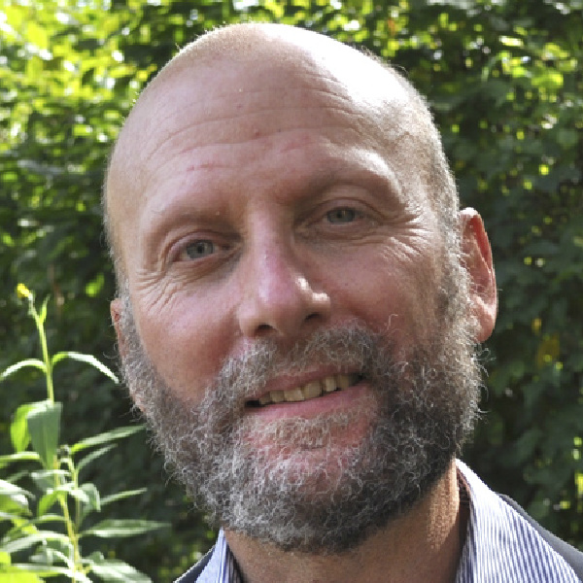

Martyn Rawson
Walorflehrerseminar Kiel, Germany
Host Editor: HLT mag
Email: martynrawson@icloud.com

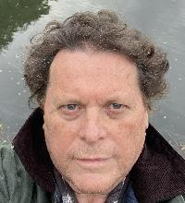

Theresa Hermanns
WABE International School &
Freelance Teacher, Germany
Host Editor: HLT mag
Email: hermannstheresa@gmail.com


