Letter 1
Dear all,

I may have forgotten to include this yesterday. Taken from Roy Cross' latest bulletin.

An intentionally alarmist piece by Liza Featherstone for The New Republic, The Scariest Part About Artificial Intelligence https://newrepublic.com/article/179538/environment-artificial-intelligence-water-energy
All the best,

Alan Maley

Letter 2

Hi Hanna

Get practical advice in an easy-to-use, bitesized format to help you:

- Expand your learners’ communications skills beyond speaking and writing.
- Encourage your learners to analyse, explore, and discuss the media around them.

Try it now!

Stay tuned for more!
Oxford University Press

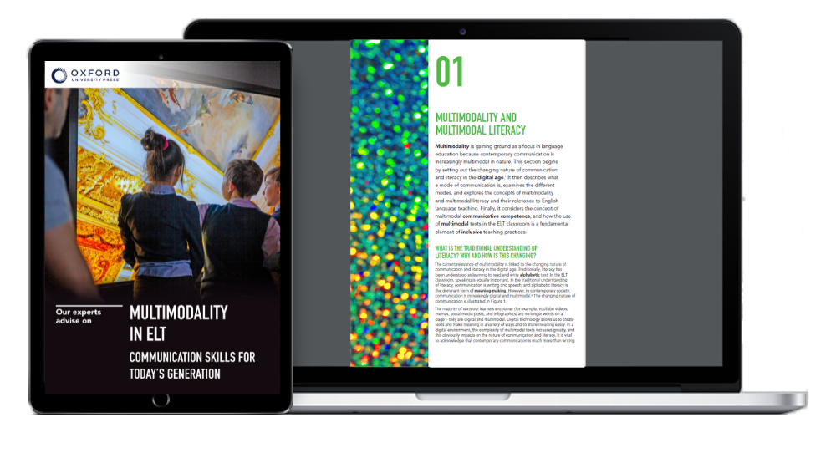

Letter 3

Hi
Just wanted to let my fellow teachers know that some of the ELT materials I've created can now be found on
https://amazy.uk/community
The content I create ranges from conversation-based lessons to materials incorporating a slightly less conventional approach to grammar and vocabulary practice.
So if you’re looking for interesting topics and stimulating activities, here are the links to my recent lessons. They are completely free and highly interactive. We all love freebies, right? 🙂
Error correction: native speakers’ mistakes edition (B1) - grammar and vocabulary
https://lnkd.in/djY73Fue
Chain messages: bad luck or a big scam? (B2) - speaking
https://lnkd.in/dWtwD39S
Informal contractions - AmE (B1) - pronunciation
https://lnkd.in/d6E4BFMN
And of course, there’s more to come so stay tuned!
Also if for some reason you still haven’t heard about Amazy be sure to check it out. A real game-changer for all language educators who teach online classes!
#elt #efl #englishteacher #eltresources #eltmaterials #onlineteaching #lessonplans #englishclasses #edtech

Julia OchocińskaJulia Ochocińska• 1st• 1stLanguage Educator | Published ELT Writer | Materials WriterLanguage Educator | Published ELT Writer | Materials Writer

Letter 4

Dear All,

We are pleased to inform you that the special issue in honour of Rebecca L. Oxford is now published online:

Language Teaching Research Quarterly (2024, 41)

We hope Rebecca accepts this volume as a token of our appreciation for all she has done.

Kindest Regards,
Carol and Hassan
The Guest-editors

PS.
(…)
A number of you have contributed to this special issue, and I hope you are happy with the result.

Could you all please consider doing us a big favour. Could you please open the link that Hassan has sent below and read at least one of the articles. Even better, quote at least one in your own next article. This all contributes to the journal's statistics and will assist the journal's promotion to ESCI status.

Best wishes
Carol Griffiths

Letter 5



