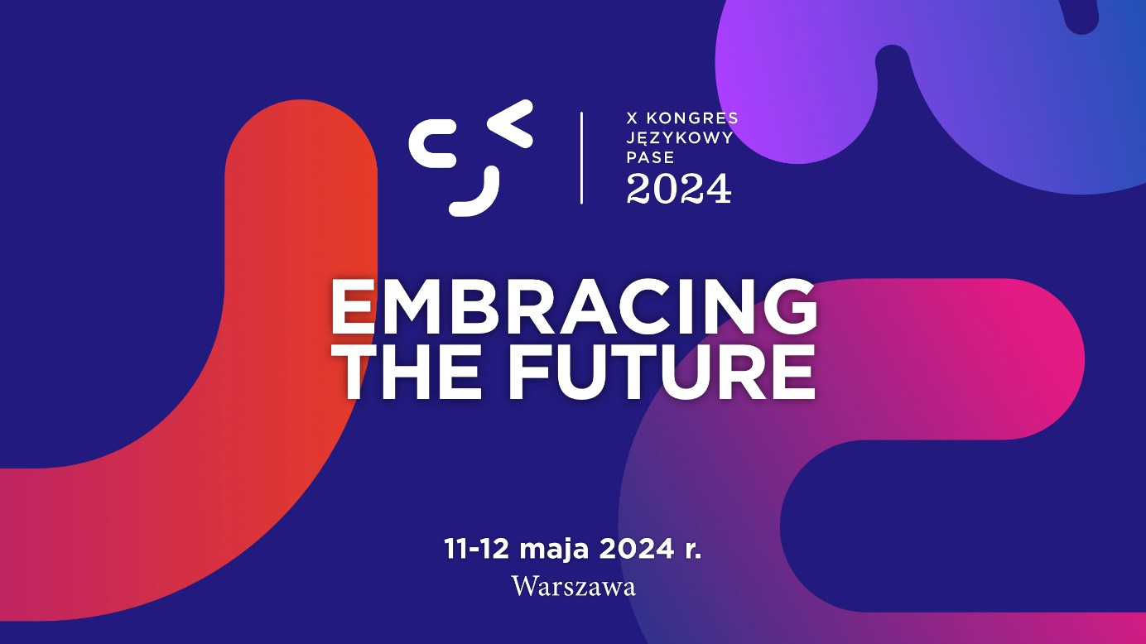

X PASE Language Congress 2024: Embracing the Future

May 11 - 12, 2024. Warsaw, Poland
We are delighted to invite you to the 10th PASE Language Congress 2024: Embracing the Future, which will take place on 11-12 May 2024 at the University of Warsaw. The event, organised by the Polish Association for Quality in Language Teaching PASE, brings together experts, teachers and education enthusiasts from all over Poland and abroad, to jointly explore new horizons in teaching foreign languages.
During the Congress, participants will have the opportunity to:

● participate in lectures and workshops led by experts from Poland and abroad, who will share their knowledge and experience in the latest educational methods, research and technologies,

● discover innovative teaching tools - learn about applications and platforms that facilitate language learning and teaching,

● networking - make new contacts with teachers, experts and other participants, which provides a unique opportunity to share experiences and best practices.

● inspiration for further personal and professional development – sessions and workshops are designed to provide practical skills and ideas that can be put into practice immediately.

Conference website: https://kongres.pase.pl/
FB event: https://www.facebook.com/events/1083116492907760
Memories from the Congress 2019

