Mario’s Last Project
Klaudia Bednárová, The Bridge

The first encounter
When I first met Mario Rinvolucri at a conference in 2009, I was completely fascinated by his teaching approach. It’s not about endless preparations, tools and technological gimmicks. It’s important to perceive the student and know how to give them what they need in the moment, as they need it, for them to be able to learn things. At that conference, Mario wrote a sentence on the board, said one more sentence, and we couldn’t stop for an hour, discussing and writing endlessly. It took me a while to understand that it’s not just about one sentence and that being able to work with a group like this is mastery.

The very first idea behind the project
In 2017, the late Jim Wright, Principal of Pilgrims, invited me to a course with Mike Shreeve, for which I will be forever grateful. At that time, I met Mario again. He invited Rakesh Bhanot, along with others, for lunch in his garden, and Rakesh brought me along. He told me about his notes and papers sorted out from his office because he didn’t want his sons to have to sort them when he’s no longer around, and I was curious about what was in the boxes. I suggested scanning them so they would be available for anyone interested in what “can be found in Mario´s office”.
The contents of the ‘boxes’
From today’s perspective, they ‘boxes’ are not treasures; they are papers from the office of a wise and widely educated person who, in my opinion, had a transformative impact on many teachers around the world, and consequently, on English language teaching. However, from a historical perspective, ‘what wouldn’t we give for boxes full of papers from, for example, J. A. Comenius’s office’? It would be great to preserve papers from various HLT practitioners. They would form a kaleidoscope of ELT development and help future generations of English teachers and trainers better understand the ELT world.
We talked a lot, and I was visiting Mario in the UK from autumn 2017 to February 2020. We met for 2-3 days each time and discussed (even argued) about various things. Gradually, our discussions led to a project, which we initially called an ‘archive’, then a ‘resource bank’, and finally, it became what now is known as HLT.digital.

The project is born
Over years of conferencing, I realised how many EFL people I didn’t know. I realized that there are many more great people, many of whom disappeared from the scene; their work remained forgotten in handwritten or printed papers dating back to the times before the internet. Jim Wright kept teasing us about talking about old papers and being stuck in the past, which led us to make videos the main focus of the website rather than scanned yellowed and dog-eared pages. He kept reminding us that we live in the 21st century. And rightly so.

We live in a time of lively discussions about the importance of an individual approach and seeing students as people. Conferences are full of such debates, yet few acknowledge those who dedicated decades to spreading these ideas, long before the internet. The problem, of course, is that many teachers who belong to the younger generation have little access to these findings, materials, wisdom and experience - unless they know where to look and who to look for. I believe that in order to move forward, it is essential to know what has already been written and build upon it, rather than reinventing the wheel.
All of this led us to the idea of a project in which we would try to capture and convey this information to teachers in the 21st century. Let them not reinvent the wheel; let them build on what our colleagues had discovered long ago. Let’s move forward and at the same time express respect and admiration for our older colleagues.
Implementing the project: Phase One
When we started implementing the project with Mario and created the first video recordings, with Simon Marshall, Rod Bolitho, James Dixey and Cynthia Beresford, the pandemic came. It interrupted our cooperation for two main reasons. I had to focus fully on transforming the school, and Mario was going through a very difficult period in his personal life.
However, the agreement was that I would continue the project and build a virtual space that would be a source of information about people working in n THE ELT field in the 60s, 70s, 80s, and 90s, basically before the age of the internet. Our goal was to make them and their knowledge and experience accessible to contemporary teachers and give them the opportunity to build on their work.

Implementing the project with Erasmus+: Phase Two
Then the stage of Erasmus+ came. In our Erasmus+ project we deviated from the original plan to focus only on the post-war generation, and expanded it to include Generation X. Our international team of project partners genuinely cared about the outcome. I think that together we laid the foundation to be worked on and built on by and for future generations of English teachers.

On the website we created you can find the following material about Mario:
Mario’s full biodata
A list of books Mario has written
Links to some articles
Links to video recordings, sessions and interviews
as well as information about many more ELT practitioners worth remembering.

All saved for posterity. I am sure Mario would be pleased about the outcome.

You can find more details about the Erasmus+ Project here and on Fb
.
Some photos from Faversham visits 2017 – 2020 during the early stages of hlt.digital

These pictures were taken during my visits to Mario in Faversham between 2017 and 2020, where we spent hours discussing and planning the project together. As always with Mario, the conversations were so engaging that taking photos was neither a priority nor something he particularly enjoyed. He wasn’t fond of being photographed—often making a funny rabbit face in protest—but occasionally, he would agree to a picture, though not without a bit of grumbling.
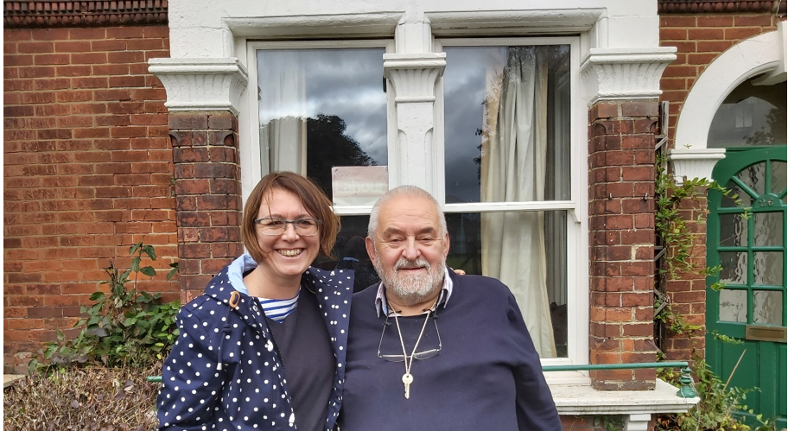
Fot. 1 Outside Mario’s house. Saying good-bye, September 2019

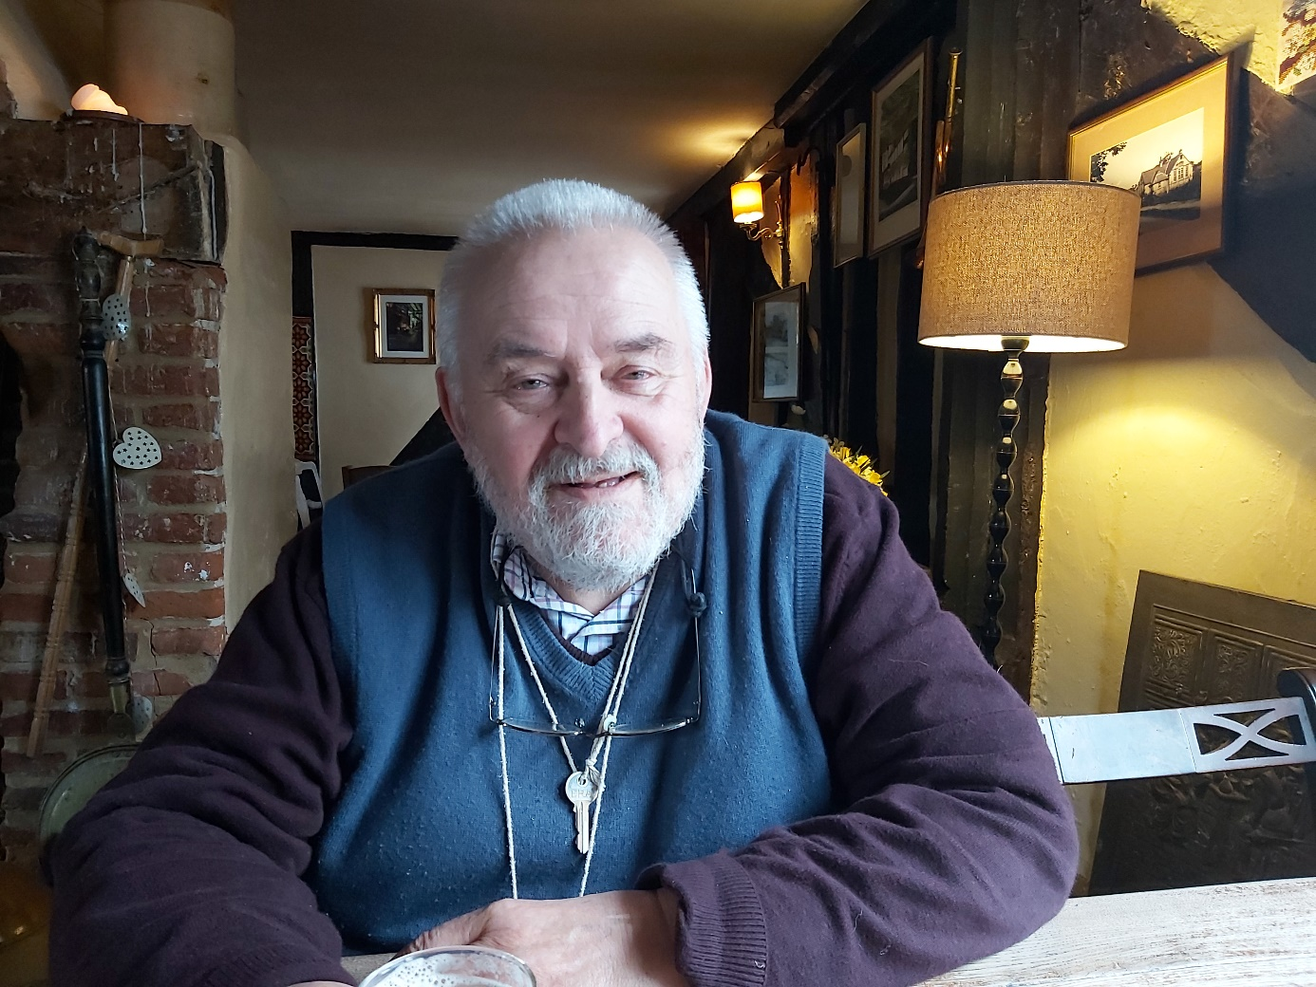
Fot. 2 A well deserved pint after a day spent planning, February 2020

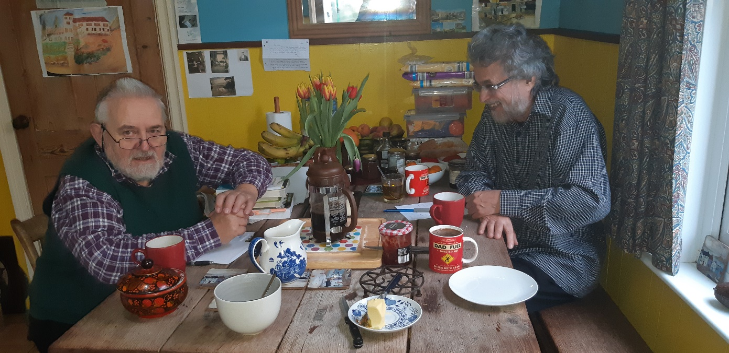
Fot 3. In Mario’s kitchen with Rakesh Bhanot, January 2019

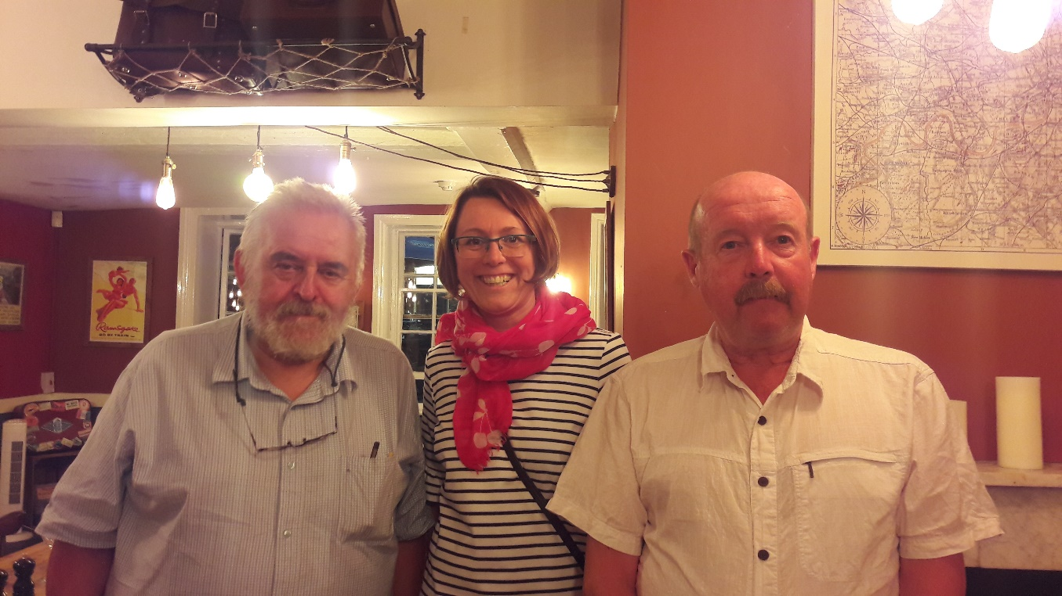
Fot. 4. With Simon Marshall and myself, Oktober 2018

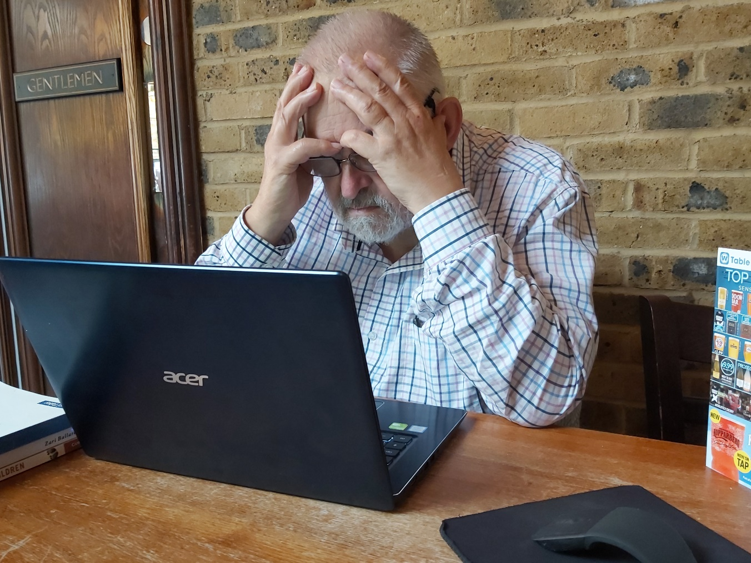
Fot. 5 Reading the first draft of our idea... if I remember right…, September 2019
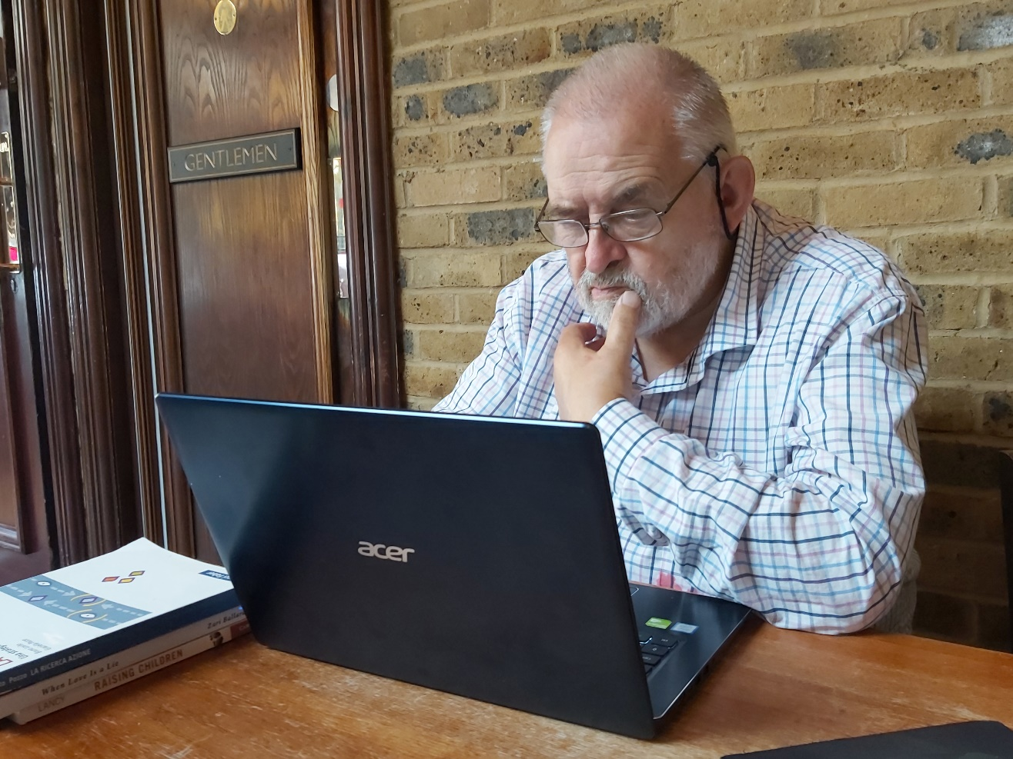

Fot. 6 Still reading the first draft of our idea... if I remember right…, September 2019

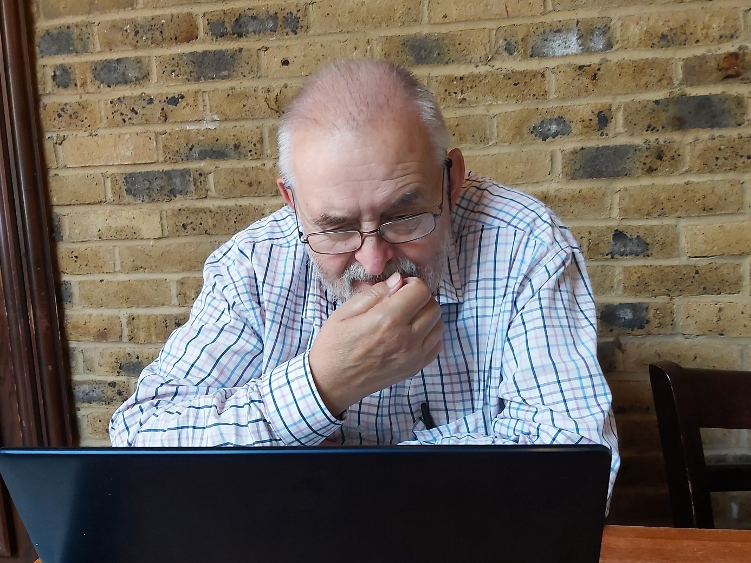

Fot. 7 Cannot stop reading the first draft of our idea... if I remember right… , September 2019

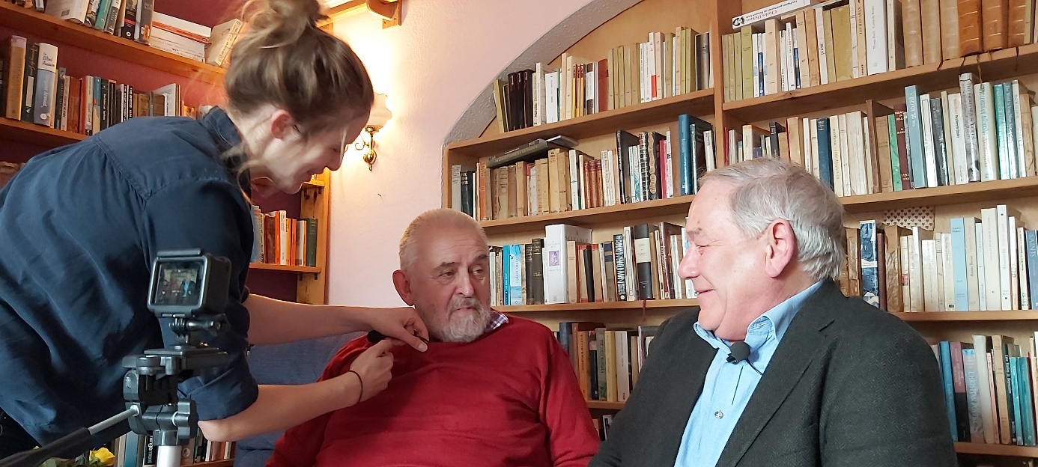
Fot. 8 Before filming with James Dixey, February 2020
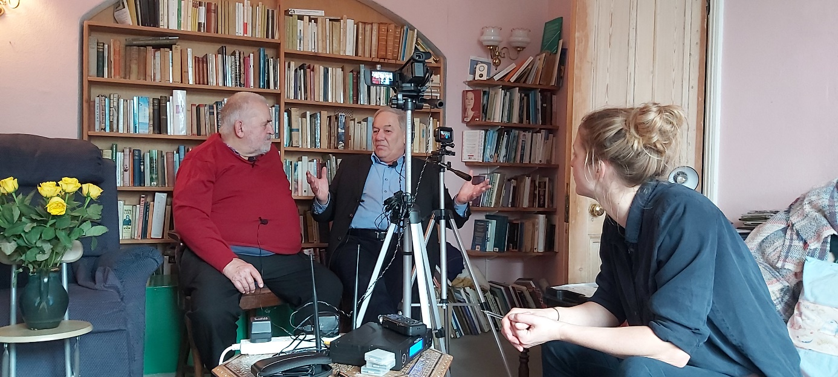
Fot. 9 After filming with James Dixey, February 2020

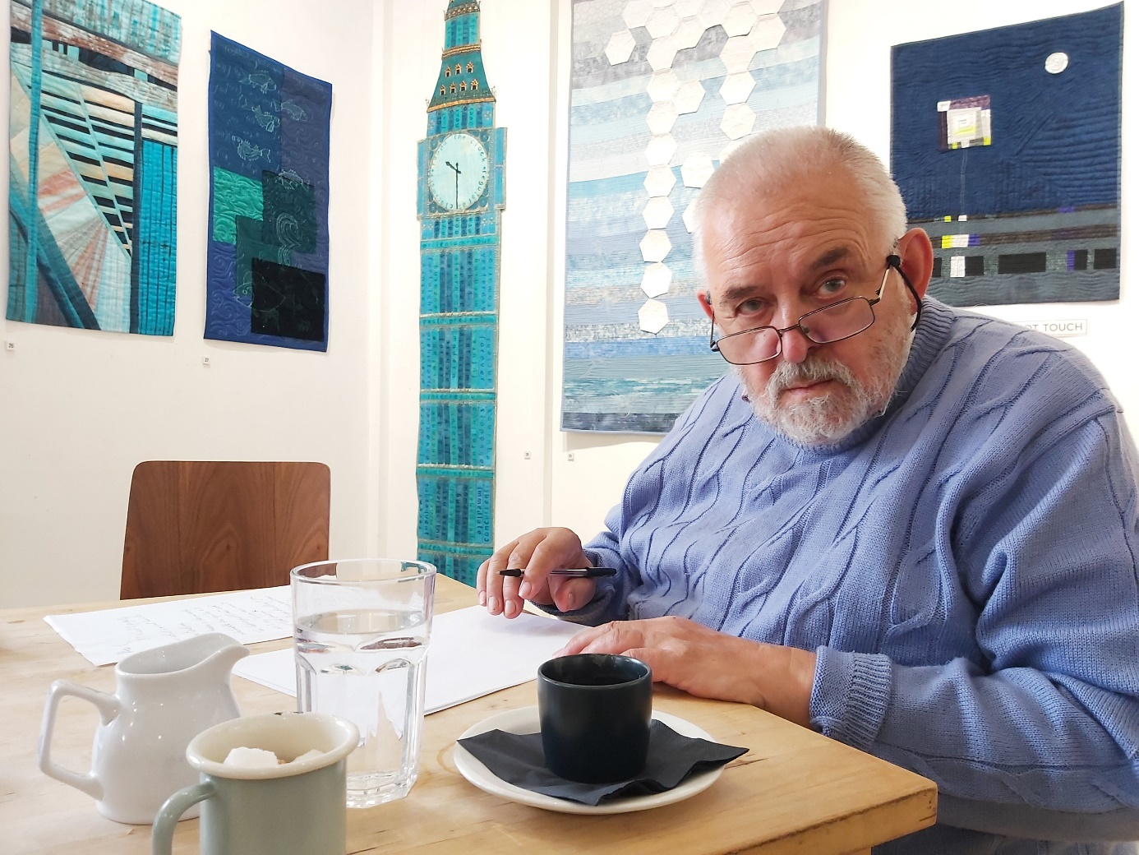
Fot. 10 Getting ready for the funny nose, September 2019

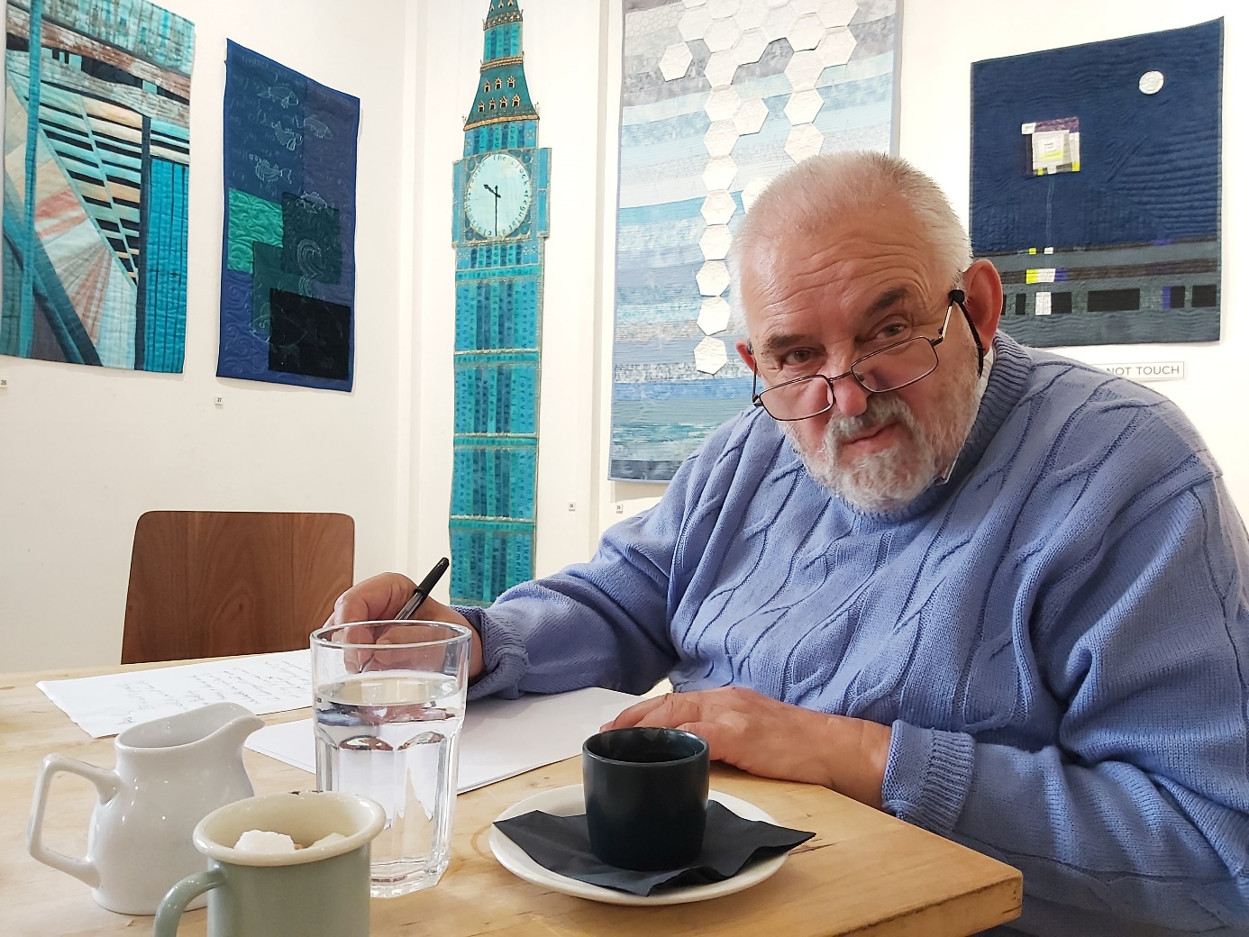
Fot. 11. The one with a funny nose ... He pretended to be a rabbit... It always made me smile. He didn´t like being photographed... Now I wish I had been more annoying and pushy with my camera..., September 2019

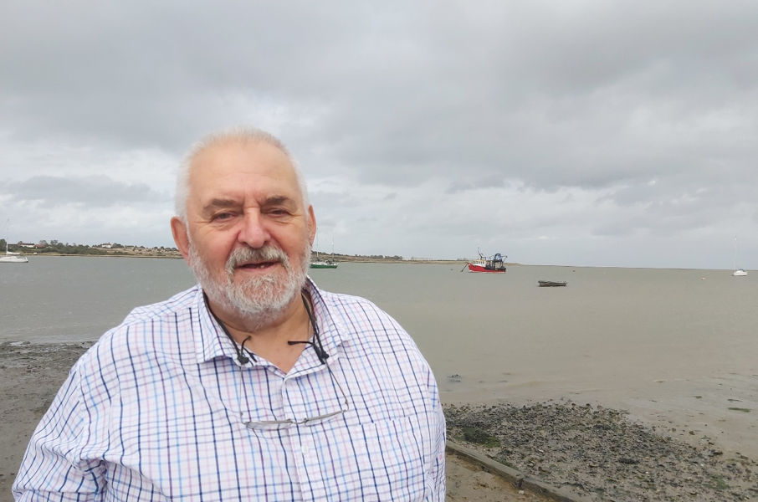
Fot. 12 The Old Man and the sea, September 2019

