  - Remembering Mario Rinvolucri: A Collection of Voices

joint tribute

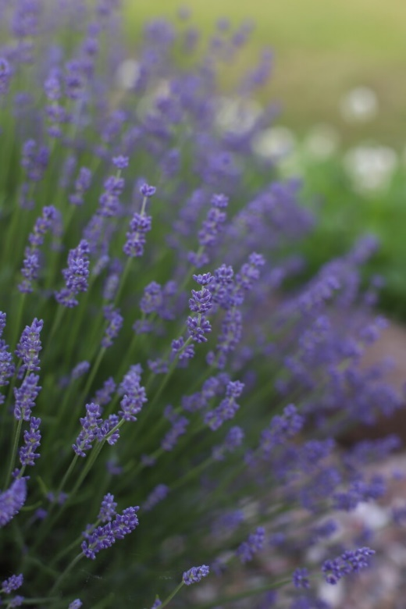

One of the Greats of English Language Teaching has passed on.
Mario died peacefully in Folkestone on February 19, 2025, with his family by his side.

Mario was hugely innovative in everything he did; and an inspiration to all who had
the privilege of working with him.

He always encouraged everybody to get involved in improving the way English was
taught and in making learning fun and personally meaningful.
Mario was never happier than when he was at the centre of things, infusing
everyone with the force of his presence and fuelling them with his boundless energy.

After training as a journalist with Reuters, he began teaching in Cambridge English
Language schools where he met James Dixey.

He then proceeded to encourage James to start Pilgrims English Language Courses
in Canterbury. He then rapidly led Pilgrims into Training Teachers of English from all
over the world.

He spent the summers running Pilgrims Teacher Training Courses on the campus at
The University of Kent, Canterbury. The winters he spent travelling the world running
inspirational workshops for literally thousands of Teachers of English.

No one who participated in his talks and workshops will ever forget his warmth and
his open-hearted wish to share his enthusiasms as widely as possible. And those
who benefitted from his advice and support over the years will be forever grateful for
what he gave them.

Mario was a prolific author of articles and books on teaching English as a Foreign
Language.
Some of the titles of his books tell you a lot about the man.

· Challenge to Think
· Once upon a Time
· Grammar Games
· Get Up and Do It
· Creative writing
· Culture in the Classroom

He always co-authored as it was part of his nature to encourage and lead others.
He gave others professional chances by encouraging them to author books, to start
The Teacher Trainer Journal, to establish the online Humanising Language Teaching
(HLT) mag and to edit the ground-breaking Pilgrims Longman Resource Book series.

A charismatic communicator. An inspiration. A true legend.
We shall all treasure our special memories.

James Dixey

***
When I was a new teacher, Mario’s influence on me through his books was powerful and changed my whole thinking about what teaching could be, opening up creativity (and democracy) that I hadn’t realised was possible. I remember Grammar Games, Once Upon a Time and Dictation as especially exciting and revolutionary. His writing encouraged me to take quite dangerous teaching risks. I remember the classes I taught where students were role-playing seagulls, balls of litter, wardrobes and other unlikely characters - with me shocked at how productive such an odd idea could be. I taught many lessons I could never have considered without his suggesting that they were possible.
In person he was charming and provocatively questioning. I recall one remarkable storytelling session he led, telling a ghost story that I have retold to my own students ever since. He once wrote me a lovely personal letter about the effect my own writing had on him which was so kind and generous.
He is a huge loss, but he has left his impact on so many of us.

Jim Scrivener
***
Thanks for letting me know about this sad news. I can’t claim a personal connection to Mario - I met him once or twice briefly at IATEFL conferences many years ago when I was still working for the British Council and was commissioning some articles from him. His books and his writing though had a huge impact on my early teaching and continue to influence the way I think about materials and task design. 'Challenge to Think' and 'Once Upon a Time’ still sit on my shelves in my office. I’ve nominated him a number of times to the BC for the lifetime achievement award.
As Adrian pointed out, the landscape of ELT has changed somewhat these days, but I still think there is a place for the kinds of original thinking and creativity he inspired.
Nick Peachy

***

Yeah I heard this sad news as well
I interacted with him at Pilgrims and SALT
He was inspiring !!
I loved his books
And chats over coffee breaks
He was enchanting
Paid so many compliments to our room set up at Pilgrims ... hahaha …he'd stop by to see what new surprises we had in store for our students that day....
Loved his books
My book shelf is filled with his work and his series (included Bonnie )... (ed. Longman Pilgrims Publications)
He will be missed I’m sure by oh sooooo many English teachers and trainers he touched with his work and creativity

Libyan Labiosa

***

Mario: Appreciation

A tapestry of innovative resource books, a myriad of thought-provoking articles, a blur of challenging conference presentations, a million letters, an array of enraptured students, a family of grateful colleagues and the very warmest of hearts – just some of the mighty legacy that Mario leaves.

Along with his friend James Dixey, Mario founded Pilgrims in the mid-1970s. Starting small, it developed into a world-renowned powerhouse of Humanistic Language Teaching and Teacher Training. Those of us fortunate enough to work there will always cherish the spirit of daring, endeavour and creativity which were its driving forces. Mario was never happier than when he was at the centre of things, infusing everyone with the force of his presence and fuelling them with his boundless energy.

He loved to go against the grain, lambasting course books, applied linguists and syllabuses in equal measures. Subtlety wasn’t a strong suit so a good few corns were indelicately trodden upon along the way!

Mario relished what he called “mismatching”, or as being as contrary as possible as others might put it. During my spell as Director of Training at Pilgrims I sometimes thought he would disagree with any and all of my decision making. He drove me absolutely nuts (and I wasn't the only one!). He attributed this proclivity to oppositional defiance to his early home schooling, principally overseen by his father. “There is a feral side to me, I know,” he used to say. He also once wrote to me that “There’s nothing as cleansing as an honest row – it's like having a good bath!”

Mario trained and worked as a journalist with Reuters and writing was always a major part of his life. He was able to compose an extraordinary amount of high-quality text within a very short time. His output over many years was nothing short of remarkable. I know he evinced great joy from collaborating with a number of colleagues, John Morgan, Christine Frank and Paul Davis, all being regular co-authors. How many teachers around the world have a copy of “Dictation”, “Grammar Games,” Challenge to Think” and “Once Upon a Time (to name only some) on their shelves? A whole legion, I should say.

It was not in our shared professional life that I am indebted to Mario. For five plus years I lodged with him and his wife Sophie in Faversham and was made to feel welcome at all times in a house filled with fascinating conversation and warm social gatherings.
I will also never forget their depth of humanity and care during times of severe personal ill health.

It is time, then, for me to say farewell, Mario, picturing you walking towards me with your trademark, slightly rolling gait. We are near the Gulbenkian Theatre, the University of Kent. You’re carrying a huge wadge of paper, some almost escaping your grasp. A biro is visible in your shirt pocket. Three course participants are following you, waiting eagerly with a host of questions to ask you. You are wearing that familiar look of keen interest.

“How did your evening session go, Simon?” he enquired.
“Well. Thanks.”
” Good. Excellent. I thought it would.”
“And your creative writing workshop, Mario?”
“Good feeling... A strong group. Some brilliant writers amongst them too. And I’m going to repeat it on Sunday afternoon. I’ll need three hours, not just ninety minutes.”
Mario.

Inextinguishable.

Simon Marshall

***

"One of the truly greats has left us. And in his private life he was as kind, generous and nurturing as he was in public. I lived with him and Sophie in Faversham for two summers running while teaching at Pilgrims’ and time spent in his presence was a blessed adventure of being engulfed in love and uplifted through the most exquisite vintage of inspiration. His essence will always be with me."

I could have written so much more, but the comments on Phil Dexter’s Facebook page announcing Mario’s death were so numerous that I didn’t expect anyone to read that far down the list. I’ll probably write more elsewhere.

My first meeting with Mario was a disastrous one, in a gent’s toilet somewhere in the west of Paris. He laced into me, telling me how my misplaced youthful energy was a source of great irritation to him. The second time we met - not in a gent’s toilet - he was far more affable and told me how much he appreciated my workshop. He then took me under his wing, we became friends, and I spent two summers at his home, probably happier than I’ve ever been staying at anyone else's place. Mario was a real Father to tens of thousands of English teachers throughout the world, urging them to experiment with new ideas and to publish their experiences and new practices to share these with the world around.

Anyhow, he was an important moulding influence on much of what I have done, and I will miss him.

Lonny Gold

***

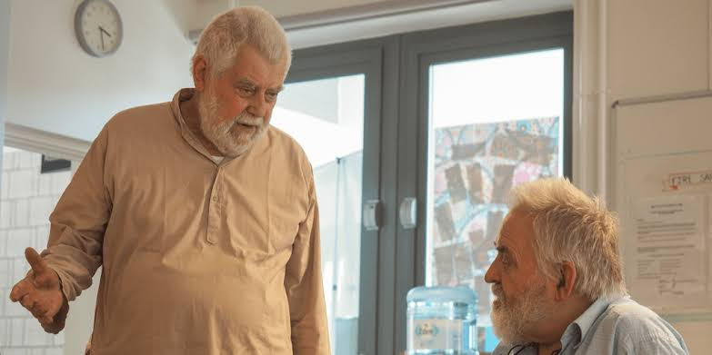

Memories of Mario.

The title of Gertrude Moskowitz’s book 'Caring and Sharing in the Language Classroom' could well serve as the hallmark for Mario's life. But his influence went well beyond the classroom, into teachers' and students' lives.

From very early on, he applied his keen intelligence and inquiring mind to communicating ideas to his fellow professionals. Whenever I met or communicated with Mario, he had new ideas to talk about. And he was constantly looking for ways of trying them out and making them a reality in classrooms.

He was a charismatic communicator, passionate about sharing his insights with all those he came into contact with. He was the presiding presence at the Pilgrims summer courses, which were for many teachers their lifeline, year after year. He genuinely cared about the teachers he worked with and would spend hours in deep discussion with them. He also had a vast correspondence with teachers by letter. Fortunately, many of these letters are now held in an archive by The Bridge in Bratislava as resource for teachers.

No one who participated in his talks and workshops will ever forget his warmth and his open-hearted wish to share his enthusiasms as widely as possible. And those who benefitted from his advice and support over the years will be forever grateful for what he gave them.

We stand on the shoulders of giants - and he was surely one of them.

Alan Maley

***

I first encountered Mario when he gave a seminar together with Janice Abbot in Paris some time in the mid-70s, during a series of meetings at the British Council organised by Alan Maley. At the time I was struggling to move away from my comfortable long-term stance as a bossy directive teacher, and to become more consultative, non-directive and so on, in the spirit of the times. That particular seminar came at exactly the right moment for me and helped a good to direct my attempts to become a better teacher and materials writer, if not a better person – that would have been asking too much of Mario. Half a century later, I still remember the seminar quite vividly, as one of the many inspirational moments that I was fortunate enough to experience during the remarkable educational ferment of that place at that time.
Our professional lives necessarily brought the two of us together from time to time, often on opposite sides of one fence or another. I liked and respected him – as who wouldn’t? – and perhaps learnt as much from our disagreements as from our moments of agreement. He was an important and influential figure in our profession, and will be sadly missed.

Michael Swan

***

MARIO RINVOLUCRI AT HIS BEST

If I have ever met a man larger than life, or larger than anything that constrains a free human spirit, then it was definitely Mario Rinvolucri. I was intrigued by his immense creativity that had no end on its own. I remember his classes: they were extremely loud, and one could tell that he wanted them that way: the louder, the merrier. But in fact, it was the teachers' buzzing, full of excitement, joy and pure pleasure at discovering some new avenues of teaching and learning that were so valuable and unique. On another occasion, his classes would be as quiet as it gets when the teachers were immersed in creative writing, or his dictation flavoured by some Greek words. One could tell and feel that he, in reality, loved people, keeping them and him company, he of all the people would be in awe and discovering new things each time, like the most innocent child in the appearance of a giant. He is not only one of the Pilgrims greats, but the legend in the English or any language teaching who happened to promote the humanistic pedagogy – or was such just because of it? In any case, we owe him to place him and his work where they really belong: in classrooms and in academia.

Nada Đukić

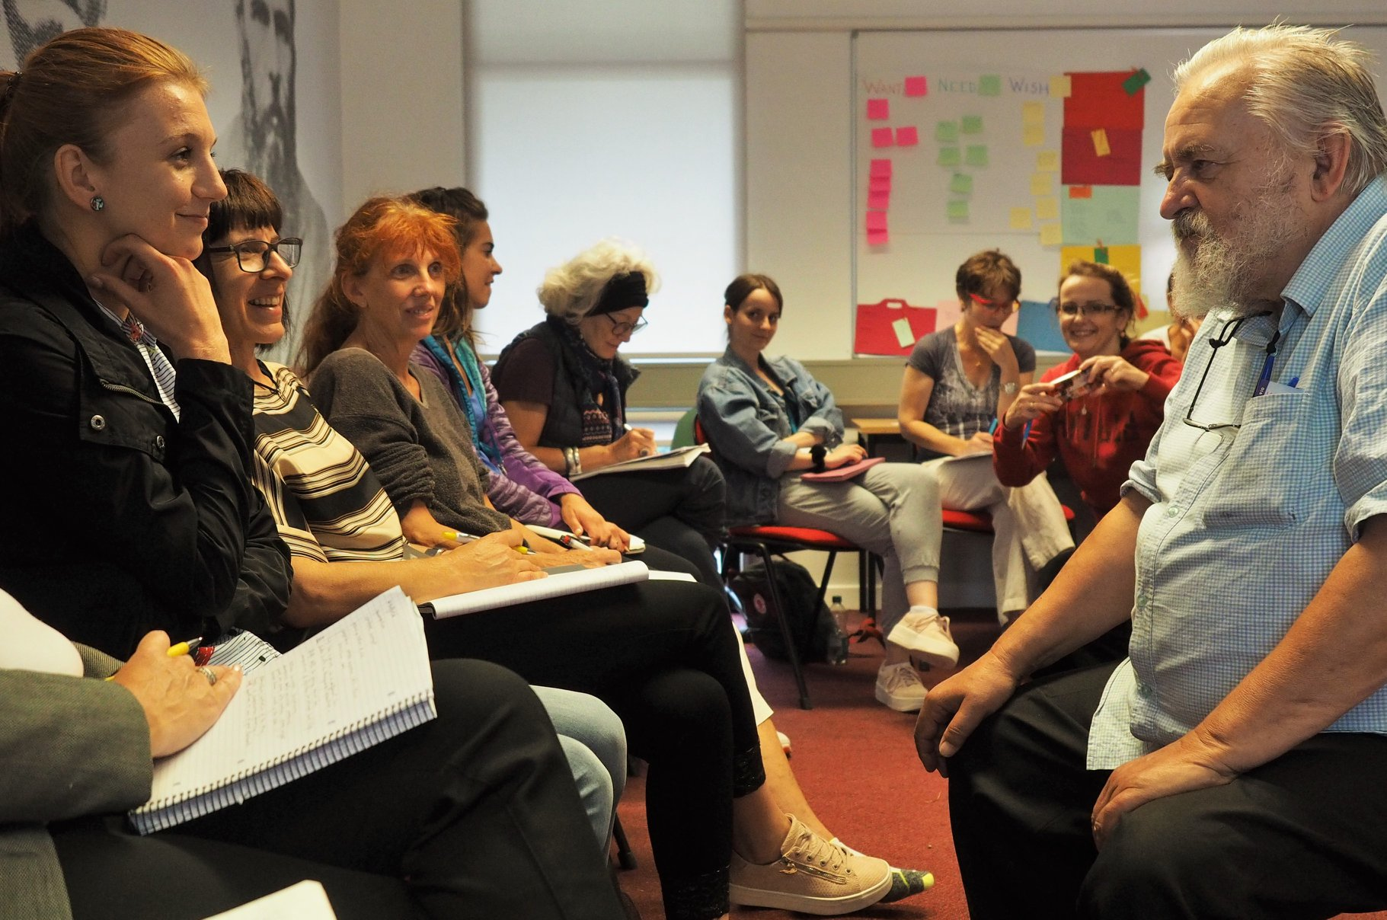

The photo was taken by Kev Byrne, alias Bink Venery, in August 2019 at Pilgrims in Canterbury (at the University of Kent's campus). Now featuring on HLT front page.

***

Mario

inspirational, generous

teaching, moulding, persuading

energy, intensity, vitality, enthusiasm

living, travelling, seeing

in our hearts and thoughts

Mario

Rosmarie Frick

***

Of course, like everybody else, I remember his inspirational articles, books and presentations and the calm, persuasive manner he used in response to doubters like the group of academics who resisted him at a MATSDA Conference in Singapore. But what I remember most of Mario is his friendship and companionship and the way you could meet him after a gap of many years and continue the conversation you were having before.

I think the best memory I have of Mario is the non-stop, fascinating conversation I had with him when I drove him back from Exeter to Cambridge. He made a very long journey seem short and I still wanted to continue our conversation when I dropped him off.

Brian Tomlinson



***

Mario kind of epitomises for me the extraordinary few decades of ELT as an extraordinary place to be, at least for some of us with wider connections, and others of us connected to local hubs of activity in whatever part of the world. There was so much happening, enough slack in the system, so many disciplines entering from outside ELT, and so much opportunity for many, not all, to invent and create …. until eventually the steel bars of corporate institutions, publishing, syllabuses and testing descended and monetised creativity, joy, learning and teaching…. and I think that was a bitter blow to many, not least of all to Mario.

And now it seems a different era with a different landscape of opportunity, and a fresh generation of transformational people…both starting afresh and building on the legacy of the likes of Mario.

Adrian Underhill

***
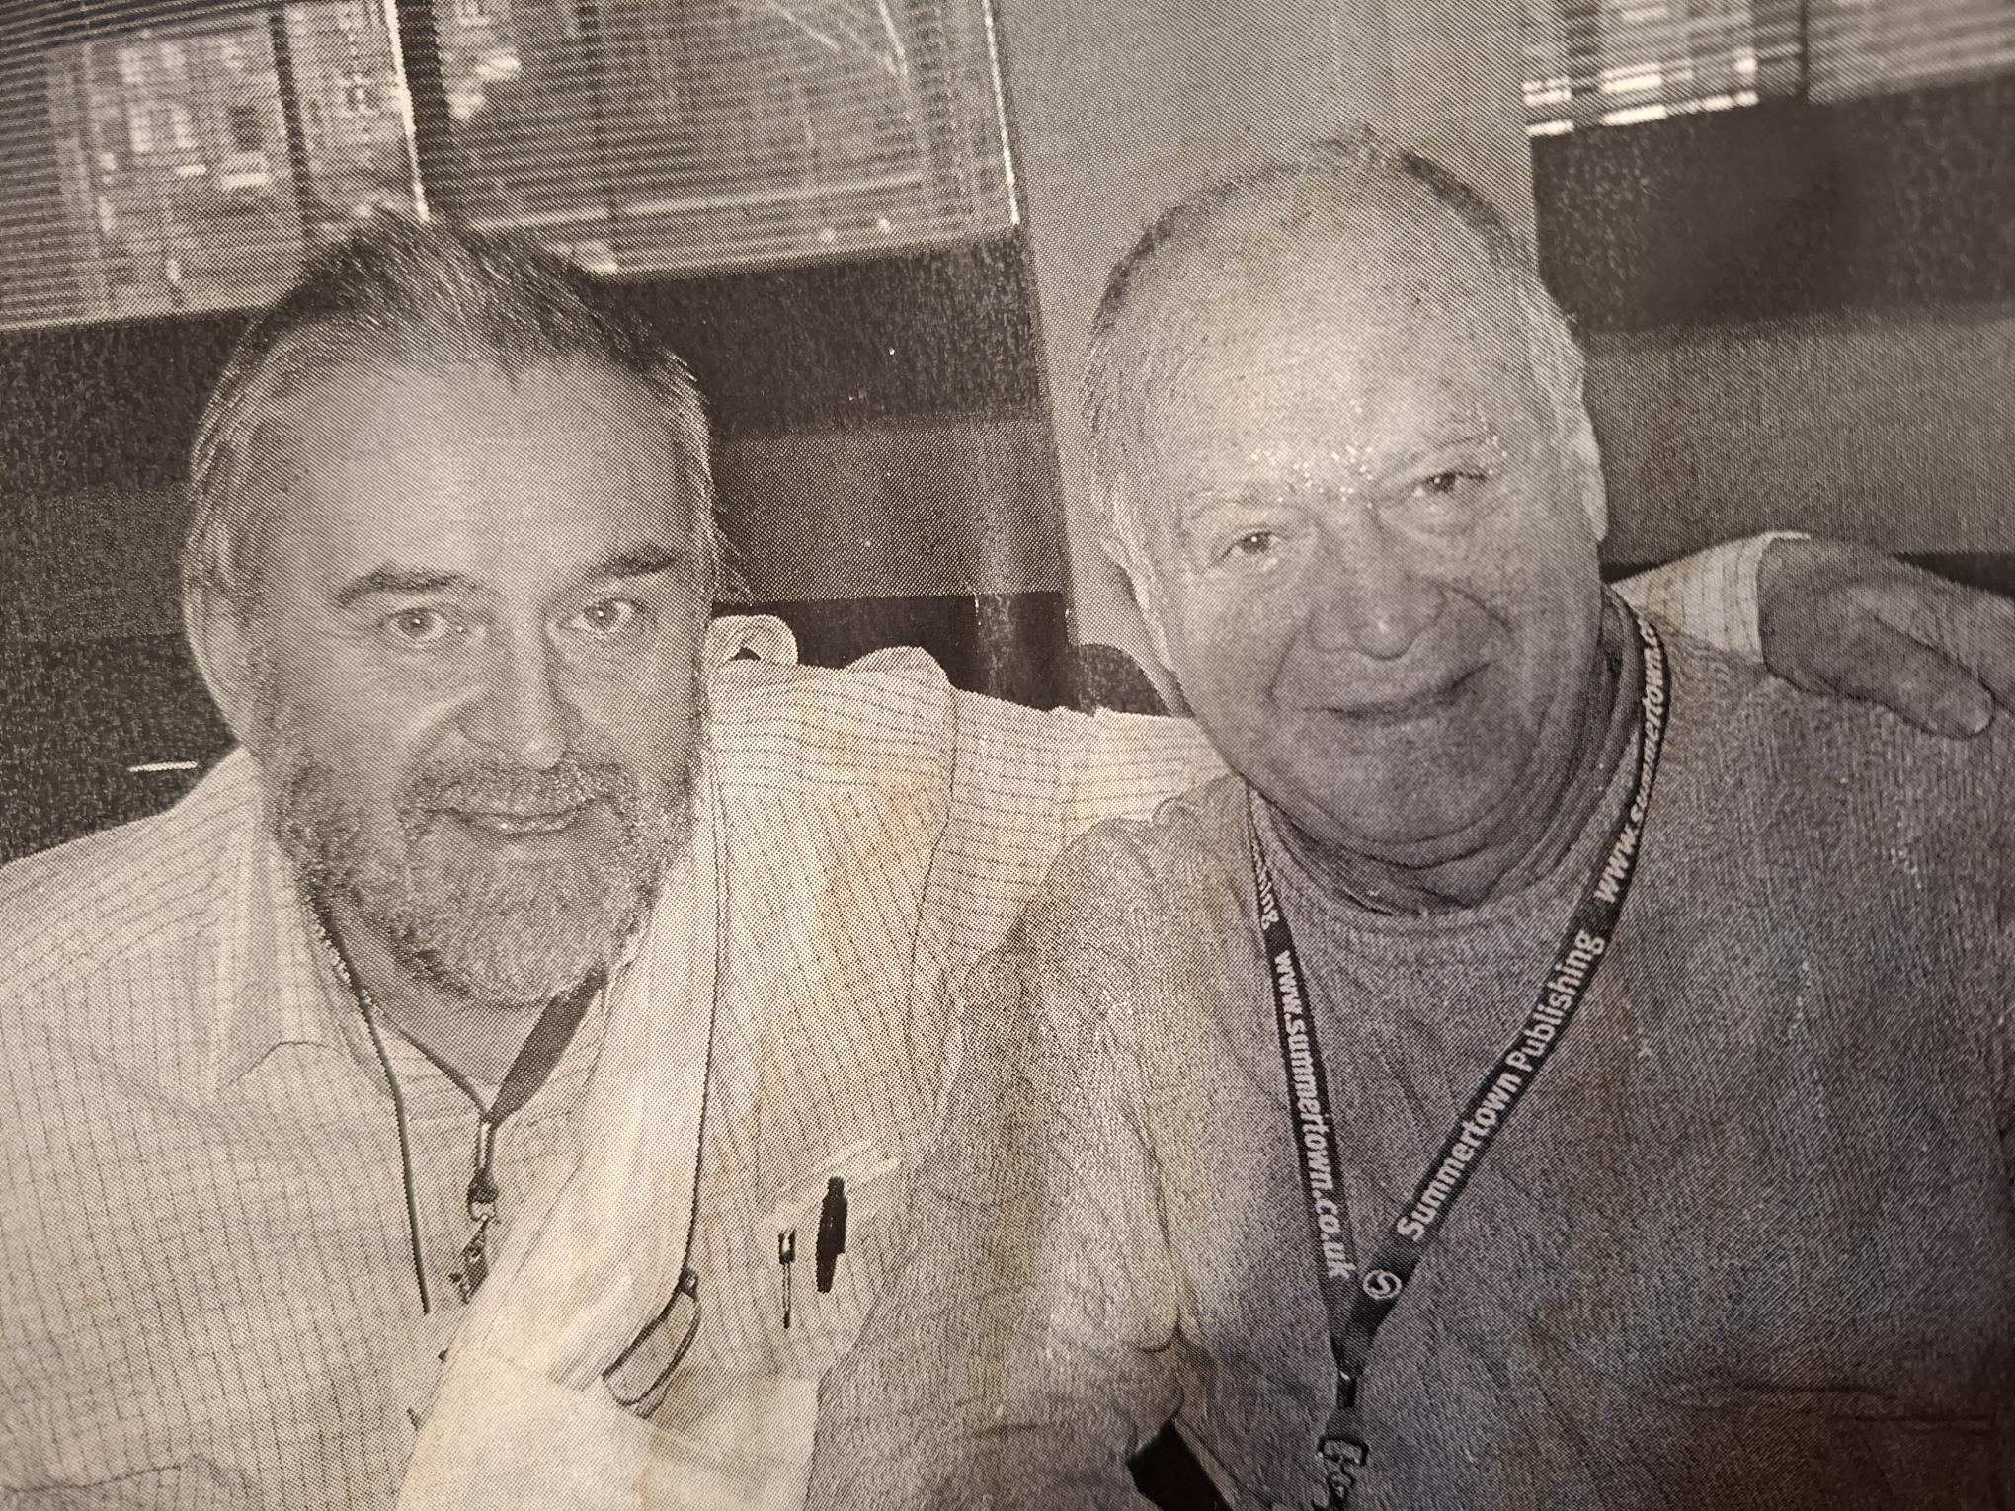

I am sure we all have our stories and our pictures about Mario. (on your left in my photo)
This photo is hanging with my puppets by my right elbow as I write two memories down.
Mario told me his father, an Italian, came to England before the Second World War and was then interned, in an internment camp, by the British, on the Isle of Man, during the war.

Mario told me that one of his earliest memories was throwing his teddy bear at a British soldier. Mario and his mother had gone to the camp to see his father and he had felt so angry with the British taking his father away from him that he threw his teddy bear at the guard at the gate of the camp.

I feel Mario has been a life friend, but I have not been able to see him for years and now, with this news, I realise he is far down that long corridor of time we are all in.

Andrew Wright

***

From the earnestly ignorant early days – to the stubbornness of the experimental mind
From Christine challenging his ways – to Dixey’s unborn dream yet unassigned
He was at the inception of that school
And he was there before us all

From the blissful trance of 1974 – to the frenzied years of the 90s
From familial insights he gained fourscore – to that inclusive hilltop breeze
He was never really alone
Always gifted to hone

From finding hope within the dregs – to laying foundations of a legacy
From the questions that questioning begs – to never bending the knee
He wasn’t always so gentle
But always annoyingly fundamental

From walking in prickly Woodwood – to getting phonemic foundations Underhill
From strolling in mythical Beresford – to the selflessness of the Wingate pill
He’s been twice round the block
And he was allowed to run amok

From the psychodramaturgy of Bernard and Marie – to the gentle calm of a Silent Way
From being Shreeved with NLP – to suggestopeadic child’s play
He adapted from the best
And so he ensured we were blessed

From the clarity of Maley’s voice – to the creative touch of Duff’s vision
From the game of pedagogical choice – to often making the wrong decision
He seemed to embrace that slippery slope
Forever surrounded by hope

From a hundred-thousand projects – to a million bizarre ideas
From simple things made complex – to championing learners for all these years
He was never far from the fight
He was an inspirational light

From the microclimate of Canter-Berry – to the hyper-focused awareness of now
From the banter with Jim so merry – to not being that unwanted sacred cow
He was never that far away
Forever the bubbling buffoon at play

From a husband, father, and our white dove – to opening doors to a pan-European team
From the choleric bull calmed by Sophie’s love – to being able to carry on Dixey’s dream
He proved he was essential
He showed us our potential

From the cackle of swinging moods – to the idiosyncratic wonder of being human
From the love of literary alludes – to the almost revolutionary humanistic lumen
He was inspiring without a doubt
Forever outstanding at standing out

From the dark relentlessness of depression – to the jittery candle that guides bright
From endless swathes of digression – to his twitchy bushy eyebrow delight
We shall keep his teachings alive
Forever indebted to his drive

From groundbreaking books and seminars – to countless courses all enchanted
From unfinished German memoirs – to not taking people for granted
He was the forever curve ball
Forever admired by us all

Bink Venery



***

Early on in my career as an English teacher and teacher of teachers – it must have been in the 1980s - I came to Pilgrim’s in Canterbury to work as a junior member of staff in a teacher training course and participated in some of Mario’s workshops. Like all the other participants, I was spellbound. It was not only his innovative humanistic approach, so different from the conventional teaching methodologies and approaches I was used to in classrooms I’d experienced previously as learner or teacher. It was also, and perhaps mainly, his warm and charismatic personality, combined with his original activities and discussions, that made his sessions unique.

Later, as an editor for Cambridge, I was privileged to work with him on one of his books - Ways of Doing, co-authored with John Morgan – and continued, at a distance, to benefit both from his general approach and from the wealth of practical teaching ideas that he made available through his writing.

Penny Ur

***

I echo what many have said about Mario here. He was a giant in the industry and for those of us starting out in ELT in the 1980’s he was, in so many ways, the pole star of innovative thinking as a teacher. I first saw Mario in action in the late 80’s when he delivered one of his ever-engaging workshops at Hilderstone College in Broadstairs, very near where he was to spend his last days it seems. I will also be eternally grateful to him for his kindness, help and support when I worked for the British Council helping to set up ELT programmes in the newly independent Bosnia just after the wars in the former Yugoslavia. He not only encouraged but filled me with enthusiasm at times when I wanted to walk away.

He was an enormous figure and in profession, and will be hugely missed.

Mike Solly

***

Turned away from a full British Council specialist course for teacher trainers in 1983, I wrote a pleading letter to a Mr. Rinvolucri. A place was then miraculously found for me. On the first day of that course, Mario gave participants a letter in which he invited us to write back to him. I wrote to him, ‘just in case nobody else did,’ and we corresponded daily for the next two weeks. That was the start of our friendship.

From then on, Mario gave me many chances. He invited me to teach on the hilltop, his name for the Pilgrims Language Courses summer institute at the University of Kent in Canterbury. He invited me to give a training workshop to colleagues, after which he encouraged me to write book. Once it was published by Pilgrims or ‘Pigs’ as he called the organisation, he pushed me to, ‘Go and talk to that man over there who works for Cambridge University Press.’

Mario also suggested that I start The Teacher Trainer Journal, and an IATEFL Special Interest Group (SIG) for people who trained teachers. He invited me to take over a teacher training workshop tour of Italy that he was too busy to undertake. So many chances.
And I know that others were also being offered all manner of ideas and suggestions and chances too, including the possibility of us getting to know each other well via Mario’s ‘copying in’ to messages, his collaborative way of working. And the mad ‘Technical evenings’ during the summer, where we laughed at the sight of each other in masks, or learned about the Theatre of Divorce or a hundred other wild and wonderful ideas.

In a whirlwind of late evening phone calls, letters written by Mario on some train somewhere, gorgeous Mario-home-cooked suppers, and good-humoured, combative conversations, my admiration grew at his ability with languages, his personal knowledge of geography because he had been just about everywhere, his warmth and energy, his unusual take on just about anything and everything, and the way that all topics eventually led back to his central concern, his work in English language teaching and training. At that time, in the 1980s, 90s, 2000s, Mario was like a warm wind tornado of activity, encouragement and connection to scores of people.

In later years, well after the family had moved to Faversham, a 45-minute drive from us, Mario was more of a friend and neighbour than a colleague, though his giving a workshop at the college where I worked FOR FREE was typical of his generosity with his own energy and ideas. ‘Oh, just buy me a book,’ he said, when I asked him about his fee. ‘A book will be fine.’

Through his illnesses and resurgences, through the gradual dilapidation of house and garden, through long periods of quietness, and his gradual slide into increased gentleness, I never once doubted that Mario was warmly holding us all in his heart.

Tessa Woodward

***

I’m so very sad to hear about Mario going. I have always been a great fan of his, and learnt so much from him. Many of my memories are now beginning to fade, but I have not forgotten just how exceptional teacher and teacher trainer, he was and one of those people who make an unusual impact. I stayed with him in his house at one point, can’t remember where it was, but I can see still Mario standing there in his open sandals, waving his arms around and passionately going on about some point of language teaching.

I think he came to do a class at one of our RSA sessions at ESIEE, it would have been at rue Falguière.

A little anecdote, I worked several summers on the Pilgrims Course at Canterbury. One year at the end of my course, I was given a huge bouquet of flowers by the students. I was very touched by the gesture -but not sure what to do with the flowers as I was leaving for France the next day. Mario was around and I offered the flowers to him and his family. He looked shocked and aghast: No Janice, he proclaimed, you NEVER give away to another person a present hat has been given to you. I’m not sure what I did with the flowers, but I know I felt abashed, and strangely have never forgotten the admonition -and have never since passed off a present - welcome or unwelcome - to another.

So goodbye Mario, I’m so glad to have known you.

Janice Abbot Burlurut

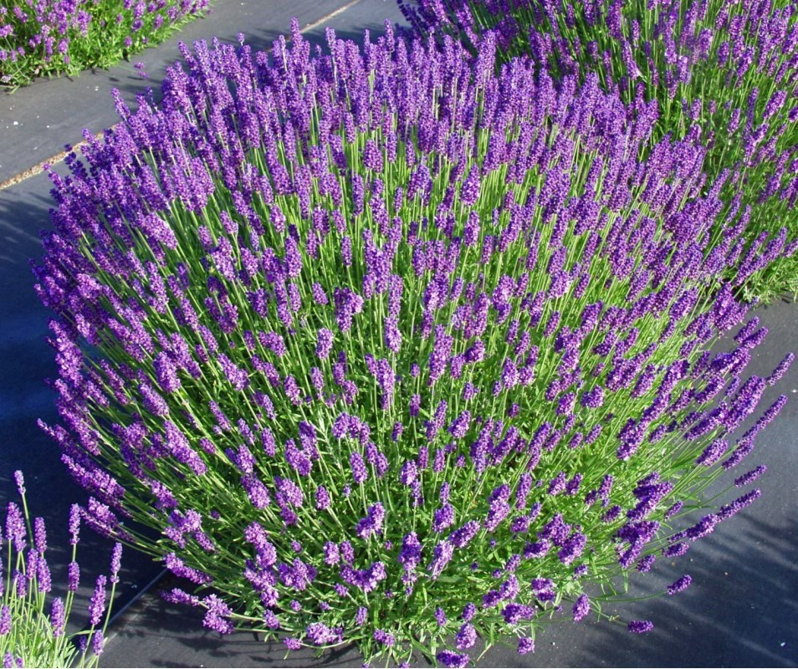

***

Mario came to us shining his
multiple facets
and continues
to Challenge us
To Think, and be.

He is a Dictation of Once Upon a Time.
Imagine That!

Mario was a major key to Culture, Confidence and Creativity.

This brave, Renaissance polymath wrapped in integrity

continues in
and with us.
~~~~~~
with deep gratitude for seeing the me
in US and the
WE in me.

Noreen Caplen-Spence

***

Firstly, I’d like to thank Hania, without whose prompting I wouldn’t have written anything about Mario and now it’s done, I’m so grateful to have had the chance to articulate something of what I feel about him. My first thoughts were “How do I even start to write about Mario? How do I find the words to encapsulate this amazing human being?” Then I thought maybe I’d start by saying how we met. Like many of us, I’d ‘met’ Mario through his books and his brilliant lesson ideas. The thought that I might work with him one day had never occurred to me.

I came to train at Pilgrims in the summer of 1994, a relatively newly qualified CELTA trainer. terrified that I’d make a fool of myself. I felt like I’d got a gig at Glastonbury with all the international rock stars and turned up with a broken ukelele and some pretty rubbish song lyrics!

We all lived in the University of Canterbury halls of residence and meals were taken in the refectory. I think on the first day I decided that I’d go for breakfast with my Walkman on and put in my earphones so I wouldn’t have to talk to anyone until I felt a bit more confident. The first five minutes or so were fine, until I realised that someone was talking to me, very animatedly. I took out my earphones and spoke to him probably more curtly than I’d intended, which elicited a gale of laughter from this man who, as it turned out, was Mario Rinvolucri; the person I had been most afraid to meet! Those of you who knew him well will remember how relentlessly curious he was and of course by the time we’d finished breakfast Mario had winkled out so much more information about me than I’d normally have divulged to anyone I didn’t know well, but he was just so disarmingly warm and charming and though his questions came thick and fast, it was the easiest thing in the world to answer them. He really wanted to know. I was later to discover his genius for forming deep connections with his students, his colleagues and just about anyone he met who interested him.

Over the next 25 years or so, we worked together as part of the ‘Hilltop’ team, we even wrote together, we talked often and sat in on each other’s workshops. I found his observations invaluable. I never knew what he was going to say but I always knew it’d be something I hadn’t thought of. He definitely had a different ‘viewing lens’ and while we didn’t always agree, our conversations had a huge impact on my practice as a teacher and trainer. I will be forever grateful for that.

Mario was a great collector of articles; both journalistic and academic and my colleagues and I would often find a stack of these in our pigeonholes at Pilgrims or they’d come through the post in a large envelope (particularly frequently when we were writing together) and I’d wonder what thought had provoked this particular delivery. Sometimes the articles he sent were incredibly useful, some truly thought-provoking, particularly when they were annotated, some were just, well, ‘odd’ but usually worth the read. I now see these articles as an invitation into his world; a real gift (even if I didn’t always appreciate it at the time)

For his unshakeable belief in me (I would never have had the courage to write a book, but Mario cajoled, wheedled, persuaded until even I had to believe I could do it!) for his boundless generosity, his creativity, his wickedly amusing observations, his great big belly laugh, his legendary hospitality, for his walking behind a couple of moorhens outside the Keynes building when Bonnie and I noticed (and were reduced to a giggling mess) that Mario’s and the moorhens’ walking gaits had a lot in common… for his inimitable way of ending phone calls ( If you know, you know!) for his brilliant (and sometimes crazy) ideas, for the intellectually (and sometimes exhaustingly) challenging conversations, for his wonderful ‘soul food’ meals, for the way he shared his home, his kitchen and his heart with us all… for this and so much more, Mario has his own special ‘Mario-shaped’ space in my heart.

Of course, he was a rebel and a giant of ELT whose legacy will live on in classrooms the world over. In the Pilgrims family, Mario was a beacon; a father figure, both a disruptor and a community creator, fascinating and fascinated, deeply invested in what the Pilgrims community of trainers were trying to achieve, a one-off…I could go on and on, but more importantly he was my friend and like so many of us all over the world, I mourn his passing.

Gill Johnson
***

Remembering Mario

A bundle of humanity
And fun called Mario.
You affected the teaching lives
Of so many.
We met in 1995
My first summer at Pilgrims.
I attended all your workshops
Of which there were many.
We stayed in contact
We called it “The Italian Connection”.
Sharing reminiscences of the lakes, and teaching,
Of which there were also many.
Life on the Hilltop
In the summer months
Your insights and reflections
Which influenced so many.
Later in Scotland, where
You came to give workshops
To PG students from near and far
And motivated many.
Mario, your enthusiasm, positivity
And especially creativity
Your kindness and interest in others
Will be missed by many.
But you,
And your legacy,
Will always be remembered
By so many.
Thank you.

Sandra Piai

***

Mario
I decided to write my personal tribute to Mario in a letter to him. I think he would
have liked that!

Dear Mario,
Since we last corresponded and met in Faversham in 2020, I have missed you
and your pithy email messages. I know that the last few years were tough for
you and it was again difficult for you to reach out. But I will keep close to my
heart the memory of you meeting me at Faversham station and welcoming me to
your home, where we sat round the kitchen table together (others were there:
Simon, Phil, Klaudia and James) and talked about what we all saw as your ELT
heritage. You and Sophie made us all feel relaxed and at home, and plied us with
delicious food and good wine. Because of what followed, it seemed like a very
special occasion.

But let me talk to you for a moment about how we first got together in
Cambridge in 1977. I was fresh back from 3 years in Germany and the people at
Bell pitched me head first into the role of Director of the RSA Dip TEFL
programme, run on behalf of the recognised language schools in the city. You
offered to teach a couple of slots on the course and I was advised to agree to
your offer but also warned that you could rub people up the wrong way. The
first session you led was on Gattegno’s Silent Way and it was a very intense
experience for everyone present, myself included. When I talked to you about
it, you said the intensity was deliberate as you wanted people to concentrate
and to remember the session. You taught a couple more sessions after that and
they also made a very big impression on me. Coming from a university
background in Germany, I had never experienced this type of whole-person
involvement in training, and it really appealed to me.

We stayed in touch after that when I moved to Devon and you ran memorable
sessions for our local association and continued to write inspiring activity books,
usually with a Pilgrims co-author, which were unlike any other resource books on
the market. My colleagues at South Devon College lapped them up eagerly.
Whenever we met, you would berate me for not writing enough, either
coursebooks or resource books for teachers, and it did take me a long time to
respond to your challenge though I was grateful for it. You came at everything
in our field from your own deeply held convictions, for example about the
hegemony of university applied linguistics departments in ELT, about the

importance of valuing learners and of involving them actively in their own
learning. The one thing we disagreed about was your refusal to discuss any
principles underlying your activities. Your view was that participants in your
workshops should be free to take or leave whatever they experienced and to
make their own sense of it.

I learned more from you, Mario, than from any other professional in our field
and I will always be grateful to you for that, but also for your warmth and
friendship. The steps that were taken by Klaudia Bednarova and her HLT
Digital Project to preserve your legacy were welcome and entirely appropriate,
especially for newer generations in ELT who have never had the good fortune to
meet you..

You will always be present in my thoughts and feelings.
My thanks and warmest wishes
Rod

Rod Bolitho



***

Mario’s unnoticed flair for business...

I’d like to present an aspect of Mario which was well hidden: buried within his
bohemian style was a paradoxically shrewd businessperson!
I might have to qualify this assertion by adding the adjective “traditional” (in front of “businessperson"), given that many Business Schools teach their students to forget the concept of integrity, which formed a large part of Mario’s DNA.

So, what were the signs of Mario’s talented business mind? First and foremost, clarity of purpose: he knew precisely what added value he wanted to provide the Pilgrims trainees with, and he never wavered from this mission. By defining his teaching and that of his followers as free spirited, he (as Pilgrims) expanded methodology to encompass meta-methodology: not just the philosophy of teaching but ultimately equipping teachers with the intellectual bandwidth to create a transformational learning climate! A rare USP (Unique Selling Point) saturates the conversation of many, if not most, Boardrooms around the world; Mario knew instinctively how to nurture it and never to dilute it: a clear feature of an astute entrepreneurial brain.

Another sign of his sagacity was his amazing ability to network (to use a modern term): he saw in everyone he ever met an opportunity to engage and create a bond with Pilgrims. I am not only referring to his relentless capacity to travel around the world to deliver presentations, often plenary sessions given his reputation, but his humble willingness to grasp the opportunity of distributing Pilgrims leaflets: the signs of a thorough marketing professional!
Another great asset was his gift for selecting the right collaborators: over the 45 years as head of Pilgrims Teacher Training programmes, he rarely made a mistake in his recruitment of trainers: all proved, and still do, as enthusiastic and dedicated as Mario to creative teaching approaches which provide the trainees with a renewed sense of teaching satisfaction.

Finally, Mario understood instinctively how to delegate business activities which were not in his skill set, thus always managing to concentrate his efforts on the areas he enjoyed most and was best at. In other words, he never fell into the trap of meddling and undermining the work of his colleagues: another sign of the wise business professional!

In a world where English language teaching has gradually become commodified, Mario stood as the ultimate barrier to Teacher Training following suit: throughout his career, he made sure that Pilgrims thrived on differentiating itself by always focusing on innovative training approaches that could withstand the pressure towards homogeneity. By delivering the
teacher training in a most unconventional style (he likened the zeitgeist of the Pilgrims community to Ste Marie de la Mer!), he made it virtually impossible to imitate, thus crystallising the uniqueness of Pilgrims for future generations.

Mario’s legacy is considerable: by inspiring so many great Pilgrims trainers who have proved capable of getting close to filling his shoes, his work continues unabated and, as more younger trainers get inspired by Mario’s “children”, his life achievements will endure the test of time. We should celebrate his achievements and show gratitude for his phenomenal legacy.

Till Gins

***

Thoughts on Master Teacher Mario Rinvolucri

Mario opened the door to teaching English for me. Then he showed me how to open the windows and let in the light. He loved nothing more than a noisy classroom humming with conversation. He was one of a kind.

I first met Mario in 1981 as a trainee on the famous Pilgrims Learn to teach EFL in a week course when my trainer, Marjorie Baudains, sent me to observe his class to get some experience of seeing a real teacher at work. It turned out to be a storytelling session where we exchanged and created stories with the students. I won't go into the details which I have shared in a post called We All Know Stories, but it was a transformational experience. His publications were then only available as pilot editions sold directly by Pilgrims and I went home with a book called Awareness Activities – which would ultimately be published as Grammar in Action - which basically fed all my classes at some point for years. I just assumed that what I had experienced on my high-speed training course was the way English was taught to adults everywhere.

This initial illusion was comforted by the fact that at my first job interview in Toulouse, the person whom I met picked up on the fact that the only thing vaguely EFL in my very thin CV was the mention of Pilgrims. She looked up at me and smiled: “OK, so you know Mario”. Fortunately, I had seen him at work. The interviewer's name was Bonnie Tsai, and she would be my first Director of Studies. Mario was the connection between us from that very first moment. Bonnie and I got to know each other well over the next 15 years – both in Toulouse where we lived and when we worked for Pilgrims Summer School on the hilltop in Canterbury where she stayed long after I had moved on to secondary teaching in France. It was Mario who encouraged Bonnie and I to write together. He introduced us to Sheila Borges at Practical English Teaching magazine and closely monitored our preparatory conversations which ultimately gave the Teacher Development series called Teachers Speak Out which ran for 30 issues from December 1987 and June 1994 when the magazine changed owners, and they sent us back the planned September article.

Amazingly, Mario kept in touch over the years, mainly by letter, and occasionally by phone. He was exceptional in that you could write him a letter at any time, about anything related to anything to do with teaching or learning, and he would always find the time to answer. And make a suggestion as to where he could see that idea or experience leading next.

His legacy is enormous. I can say that now he's no longer here to disapprove. Not only because he helped create Pilgrims Teacher Training and HLT Mag which live on, and not just in terms of his prolific and immensely varied writing, but also because he reached so many people individually through his teaching, travelling and correspondence. He was a giant in the field of teaching English as a foreign language. We often talk about standing on the shoulders of giants so we can see further. Mario Rinvolucri was the sort of person who said : "I'd like to see what you're looking at. Can I look over your shoulder? ... Hey, this is new territory!" He was like that. He always saw genius in other people and helped us share what we didn't always know we had.

When working with storytelling in class, as I have constantly since that first experience of seeing it at work in his teaching back when I started as a trainee, I have often thought as I watch the room buzzing with student narratives that I wished Mario were there to see it. But of course, he always was there, every time.

Gerald Kenny
***

Mario Rinvolucri was a huge influence on my teaching and writing, not least because he was also an influence on my mother’s work as an English teacher in Canada. When I became a teacher in my twenties, she lent me two of his books: Grammar Games and Dictation. They were my life raft for creative and interesting activities during my first years especially , but so many of them still hold up today some thirty years later. (I collected six of my favourite ‘Mario’ activities here. Since then, I made a point of collecting almost everything Mario wrote, and I consider it to be one of the high points in my career to have met and then worked with Mario both at Pilgrims and on the Delta Teacher Development Series of books. He was truly a monumental figure in the field and although he will be greatly missed I believe his influence on classroom activities will echo through the ages.

Lindsay Clandfield



***

My memory of Mario

Bliss leaves when friends depart.
Their footprint cannot be repeated.
I cannot walk that way again.
I will always walk that way again (note 1)

My friend Lucy’s mum died recently eschewing a formal funeral because she didn’t want a eulogy. Her reason was that no one person can know or describe another’s life. It is like the Hindu story of the blind men surrounding different parts of an elephant and only perceiving the part as a separate object (like the trunk as a snake and the tail as rope and the tusks as a spear).This is like my memory of Mario; it only represents a small part of the whole life. (note 2 and 3) It is not a eulogy but my personal memory of a great person and teacher.

It didn’t start well. I was on the same Master Practitioner NLP course as Judy Baker in 1993. She invited me to lead the Pilgrims first NLP course for Teachers in Canterbury. She mentioned that a” colleague” would attend the first week and help me apply the principles to language teaching in the second week. She couldn’t run it because she had other duties as Director of Studies (even though she was marvellously adept at NLP). I later realised she was terribly in awe of her colleague and was s*** scared of teaching him.

No prizes for guessing who the colleague was- the one and same Mario Rinvolucri. I was blissfully unaware that he was a well-known teacher, and my ignorance was a blessing otherwise I would have been more nervous and uncertain than I already was. The first two days Mario listened with the attention of a bloodhound and asked questions I couldn’t answer. The net effect of the questions and occasional strong opinion sapped my confidence to snapping point. I asked him to stop, what I took as browbeating me (but later I realised was his excitable curiosity in a completely new area) in every break and lunchtime as I was struggling to teach my technical skills and turn these into practical exercises. It was as if a light came on, Maria opened like a flower and asked with true humility and surprise “am I being too challenging?” He was so apologetic.

The next day he quietly supported me, asks questions that clarified and was totally different. He had been prepared to surrender his learning style to support me as a teacher and a human being. He then applied my garbled teaching in such a creative way that I learnt more about teaching that week than I had learnt at Teacher Training or in my career up to then.

The crowning glory of that first course was the Monday morning of the second week. I was walking into the university when a lorry pulls up and out pops Mario. He had hitch-hiked from Canterbury to his home in Cambridge and back that weekend (Note 4). This really won me over as it was such an illustration of how adventurous and different he was,

After that start he fostered and supported me, using his network, introducing me to many teachers, it was like an MBA of learning and teaching, He was a true mentor as he was with so many Pilgrims teachers. So many methods the Silent Way, Suggestopedia, Psycho Drama, Drama, Multiple Intelligences, Creative teaching. So many new ideas. He accelerated my development far beyond anything I could reach on my own. He cajoled challenged and poked at my complacency. He helped me understand my writer’s block. Most of all he inspired and dazzled me and sometimes annoyed me. Behind all this was the humanistic method which wasn’t a theory but a reality of the way Mario lived. He explained it to me so simply. Classic language teachers were like laboratory technicians in their white coats prodding their rats and making them suffer language (often nonsensical not relating to their lives). The humanistic way accepted that they were people and needed to be honoured, respected, and allowed free expression. Everyone had an individual map of the world (to use the NLP expression), and this had to be explored.

He drew me into his enthusiasms such his discovery of “supervision,” We spent a delightful summer in 2006 supervising each other’s lessons. With anyone else it could have been like pulling teeth, with Mario it was an adventure and creative dance of joy. His mind and knowledge were awesome, but his wonderful love and acceptance was beyond this. You were always welcome at his house, however busy he always had time to listen, he made you feel part of an immense. diverse (and sometimes dysfunctional) Pilgrims’ family.

And although from time to time we would argue, he never withdrew friendship and was always the bigger person, although I was shy and secretive I felt I could trust him with anything. As time progressed his teaching became even better, simpler artistic and warm. He was at times a roller coaster emotionally and had periods of intense introspection, depression and once lost his confidence. This is the greatest teacher I had known who was truly vulnerable and fragile as any human can be.

His life had many challenges, he had passionate pedagogical and political opinions, he was alive and always looking to learn, when I last saw him, he was off to a German class. I don’t think he would like the present political situation, but he would offer a way of viewing that would be inspiring.

I don’t think there will be such a Polymath of teaching again. I recently have read the book “Hard Times” (note 5). In this book Dickens exposes the non- humanistic way of the Victorian education system and the lack of value of human life. The greed and pollution could be modern North American and British State education. Mario realised that the alternative way was not soft soaping and liberalism, but a courageous act of unselfishness mediated by the teacher.

This extract from an article Mario wrote for HLT magazine (note 6) in 2003 illustrates this. Earlier on he cites how John Morgan got his Chinese students to tell stories about their scars, as they worked on the land with sharp implements, they all had a story to tell,

The point that John Morgan's Fuzhou students make for me is that person-centred 'humanistic' techniques are not a 1970's Californian fashion useful for titivating the palates of language students from the Latin American and European bourgeoisies. In the Fuzhou situation John was working with mostly first-generation intellectuals from a rural background. The 'scars' trigger works as well with them as with the sons and daughters of Zurich bankers in private language schools in the UK. Some things are universal.

In some way a person continues to live even when their body dies. They live in the memories of us all, in their books and in the waves that ripple from their being. The Tibetan Buddhist would believe that the soul survives 48 days before change and reincarnation. In this period, we can send messages to the departed one. My message to Mario is thank you and I send him a favourite quote from Carl Rogers.

“People are just as wonderful as sunsets if I can let them be. When I look at a sunset, I don't find myself saying, "Soften the orange a little on the right-hand corner, and put a bit more purple along the base, and use a little pinker in the cloud colour." I don't do that. I don’t try to control a sunset. I watch it with awe as it unfolds. “ (note 7)

Humanistic approaches are even more needed in this time of A1, science worship and greed. Let’s hope that we all can continue to carry the torch that Mario held for future generations. I will do my best in the time I have left. Most of all I miss his laugh.

Mike Shreeve

References
- The lines of the poem are extracted from a poem I wrote on the early death of my lovely university friend Angela Quinn.
- Mario was an expert storyteller and loved exploring different perspectives. I remember a session he did in Bratislava around 2019 looking at the same facts from a wife’s, husband, and child’s perspective.
- By devoting his body to medicine, he has made a posthumous humanistic gift and escaped eulogies!
- Mario authored a lovely book called Hitchhiking. (Published 1974 Cambridge and still available on Kindle. We shared mutual stories of hitchhiking adventures,
- Dickens, Charles. Hard Times: For These Times: Unabridged. Kindle Edition
- The article about the scars is a wonderful taut and transformative writing. The full article can be found in the rich resource of http://old.hltmag.co.uk/nov05/mart03.htm
- Carl Rogers A Way of Being, Houghton Mifflin, 1980: 22

***

I first met Mario in 2009 at a conference in Český Těšín. That workshop is forever burned into my memory. Mario was sitting in the corner of the classroom while we were writing and working like crazy. If someone had observed the lesson, it might have seemed like the trainer did very little to set up the activity—I remember Mario simply writing a sentence on the board: "She loved him." Then, he asked us to add different words at the beginning or end of the sentence to create as many variations as possible.

Fast forward to the summer of 2018 in Canterbury—another creative writing workshop with Mario. This time, in a group, we were pretending that a wilted bouquet of flowers was a family, and once again, we were writing like crazy.

I’m not a fan of creative writing at all. Don’t get me wrong, but I avoid it whenever I can. The first time, I had no idea what I was getting into, and the second time, I had no choice but to participate. The deal was that I would take part and then analyze it.
It was magic. Mario knew exactly which buttons to push to make us / his students play his tune.

The next day, our group, guided by trainer Mike Shreeve, spent over an hour analyzing the workshop and Mario’s approach. At first glance, it might have seemed like he hadn’t done much in either case, but the opposite was true. It was like a brushstroke of Picasso—just a simple circle, nothing special. But try to recreate it yourself… Behind that one stroke was a lifetime of experience and genius.

I reconnected with Mario eight years after we first met, on a summer day in 2017. Together with Rakesh Bhanot and other trainers from hilltop, we were invited to Mario’s garden for lunch. I was super excited to see him again. Little did I know that it wouldn’t be just a lunch, but the beginning of three years of visits and long discussions. He teased me, calling me FME or Tory, and I got my revenge by calling him maestro—a title he liked very little. Happy times.

I am deeply grateful for the privilege of working with him. We spent hours talking and debating what first started as an idea for an archive, then a repository, and finally, a website. Together, we shaped the vision of HLT.digital - my dream of creating a repository of key figures in ELT, primarily those active before the internet era, about whom little can be found online. This was combined with his foresight in bringing CPD online long before the world recognized its necessity.

The last time we met in person was in February 2020. He had been going on and on about the pandemic since December… while I thought he read too much news, once again, he was right about the unprecedented consequences. He was daring, visionary, and both tough and deeply compassionate at the same time.

Mario’s presence is irreplaceable, but his legacy will live on in the countless lives he shaped, the ideas he sparked, and the projects that will continue to grow in his memory.
I will forever miss our discussions, his sharp wit, and our laughter over my here-there-and-everywhere nature and my non-British attitude.

Thank you, Mario.

Klaudia Bednárová

***

Thank you for coming to Poland in the 80ies… and bringing along John Morgan.
Thank you for those bunches of lavender you gave me.
Thank you for changing and shaping my ideas about teaching.
Thank you for inviting me to Pilgrims to learn and train.
Thank you for sending me and Paul to Bulgaria.
Thank you for giving me Paul.
Thank you for wining and dining me.
Thank you for your taxi service Canterbury/Parkwood -Faversham-Canterbury/Parkwood.
Thank you for bleaching only some of my trousers, when you disinfected Pace’s pee.
Thank you for believing in me.
Thank you for entrusting HLT to me. Your ‘soul sister’ you said. Honestly?
Thank you for your regular calls checking up on me.
Thank you for putting a 30-minute time limit on our phone calls.
Thank you for understanding when I took Paul’s side.
Thank you for coming to the last Pilgrims old style do at Parkwood, late summer 2019.
Thank you for all these memories and your impact on my life.

Hania Kryszewska

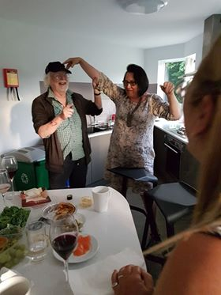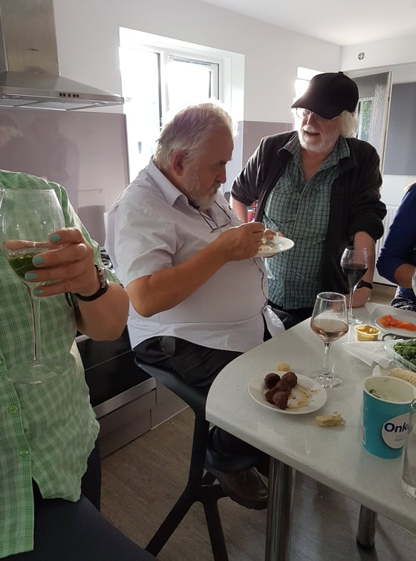

The trainers’ kitchen: Last ever Pilgrims trainers’ do in Parkwood accommodation.

***
Some Random Memories of Mario Rinvolucri

When I first met/came across Mario in December 1977, he was sitting cross-legged on the floor of a seminar room in (what used to be) The Institute of Education (now part of UCL). I was a student on the PGCE course for TEFL, and Mario had been invited by a fellow student to address (sic.) the EFL Society. However, Mario was not actually ‘addressing’ the audience; he was demonstrating The Silent Way to a handful of students while the rest of us watched. Sitting cross-legged on the floor, Mario reminded me of an Indian guru, and, indeed, there was something spiritual (not religious!) about this encounter. It is interesting that some colleagues have used the word ‘guru’ to describe Mario in recent tributes posted on Facebook.
Our paths didn’t cross for a while, but my next memory of Mario is visiting his (and Sophie’s) house in Cambridge with my friend Margit Tetz. After wining and dining us, Mario insisted that we stay the night rather than drive back to London. Then he took out a bag with a tent and began to put it up in his garden. I offered to help but he told me to go upstairs and to help Sophie who was busy (re)making the bed in their boudoir for us. Mario and Sophie slept in the tent and gave us their bed!

In the summer of 1981, I visited Mario in Canterbury. He asked what I was planning to do during the coming year. When I replied that I would be doing the MA course in TEFL with Brumfit, Widdowson et al, he was rather cynical and said something to the effect that I would be wasting my time in terms of being/becoming a better teacher. He went on to say, “you might as well go and sit on the beach for a year”! Perhaps, in some ways, he was right? His rationale was that if you “don’t play a musical instrument for a year (i.e. not teach) you become less skilled in your art”.

During the 80s and 90s, I did a lot of work for Pilgrims, and Mario sent me to Russia and (what was East) Germany to run Teacher Training courses. I mention this because on two occasions my luggage went missing at the airport, and I had to improvise (without my materials) but was able to manage based on activities I had learnt while working with Mario.
In 1987, after running a workshop on Race, Sex and Class, and causing some ‘wokish’ drama at the IATEFL AGM in Belgium, I stopped attending these conferences. Twenty years later, Mario persuaded me to reconsider by saying something like: “look, things have changed in IATEFL. They have even had a female President and the in-coming President is a non-native speaker of English”! Following this, I began to attend IATEFL conferences on a regular basis. Needless to say, Mario and his ideas have had a very positive influence on my professional (and personal) life. I am sure numerous ELT colleagues can and will echo this sentiment.

One of the (many) things I want to thank him for is the concept of what I call “teaching below the neck”; the idea that we should teach the whole person and not just address the cognitive faculties in the head. He insisted that this was not a term he ever used, but he did inspire it!
I often went to stay with Mario and Sophie in Faversham and during one of my visits we discussed the possibility of co-writing a book. After several days of intensive discussions mostly about my life and not ‘the book’, Mario closed his notebook and put down his pen saying, “sorry, I don’t want to continue with this project”. After the initial shock had subsided, I asked him to explain. “You are wasting your time trying to write a book for teachers of English which only a few colleagues may read. You would be better off writing your life story which is much more interesting than a book with a few novel ideas about language learning and teaching”. Although we had known each other for over 40 years, Mario had spent our (almost a week) time together quizzing me about my ‘life story’ rather than focussing on ‘the proposed book’. I have not yet taken up Mario’s advice about writing my autobiography.

How does one thank such an inspiring friend and teacher? Perhaps this gratitude has somehow happened almost accidentally. When another friend and colleague, Klaudia Bednarova, came to see me in London some years ago, we decided to go and visit Mario. Some magic happened during this meeting, and the rest, as they say, is history. Thank you, Mario, and thank you Klaudia for creating hlt.digital.

Rakesh Bhanot

***
Simply Mario

It might have been a force of nature, a touch of stardust, or something one is puzzled to formulate, but what Mario Rinvolucri was, and what he was able to do (and the number who might be declining rapidly in our internet age), was to open a window easily by listening to someone—really listening—and genuinely wanting to know about that person and the stories they carried within them. He was a vast vessel, brimming with stories of his own, yet what mattered to him when he spoke with you was your vessel—and how it could contribute not only to him, but also to others in our lives and in our field.

Yes, he wrote many books and contributed countless workshops to our field and to humanity in general. But he also contributed to your life with vegetables he grew in his garden, which I remember him sharing with other Pilgrims trainers living on the University of Kent campus in Canterbury, where the teacher training courses were held. Over so many summers, so many of us trainers were lucky enough to be touched by his—like everyone else's—all-too-brief presence on earth. Eighty-four years—he concluded an era in our field, now more "online" than ever, a development many of us find convenient but which lacks the essential humanness where we can best refine our ideas about teaching through conversations we have during class breaks.

Between sessions, Mario seamlessly continued his interaction with teachers—not taking the meaning of "breaks" literally, but seeing them as further opportunities to get to know what moves you, what motivates you, as a teacher and as a human being. Our dear Mario Rinvolucri’s passing leaves a huge void in the hearts of many. Like so many others, I considered him my friend and mentor, one of the few who believed that anyone, regardless of nationality, could become a great teacher trainer in the field of English Language Teaching. I only met Mario once, at a conference, yet the very next day, he emailed me, having read my article on teaching at a monastery in Tibet. And the rest, as they say, is history. His invitation to become a teacher trainer at Pilgrims Teacher Training Centre in the UK opened doors for me that I could never have imagined.

Thereafter, I met him in the UK many summers, stayed at his home with his dear wife, Sophie, and had the privilege of absorbing his abundant love, wisdom and knowledge. I am so grateful that he graced us with his presence. His humanity and brilliance contributed immeasurably to our field. I am deeply saddened by his loss. He was a truly remarkable man. And his wisdom, like when he always said to me, "less is more - in whatever you do," continues to guide me.

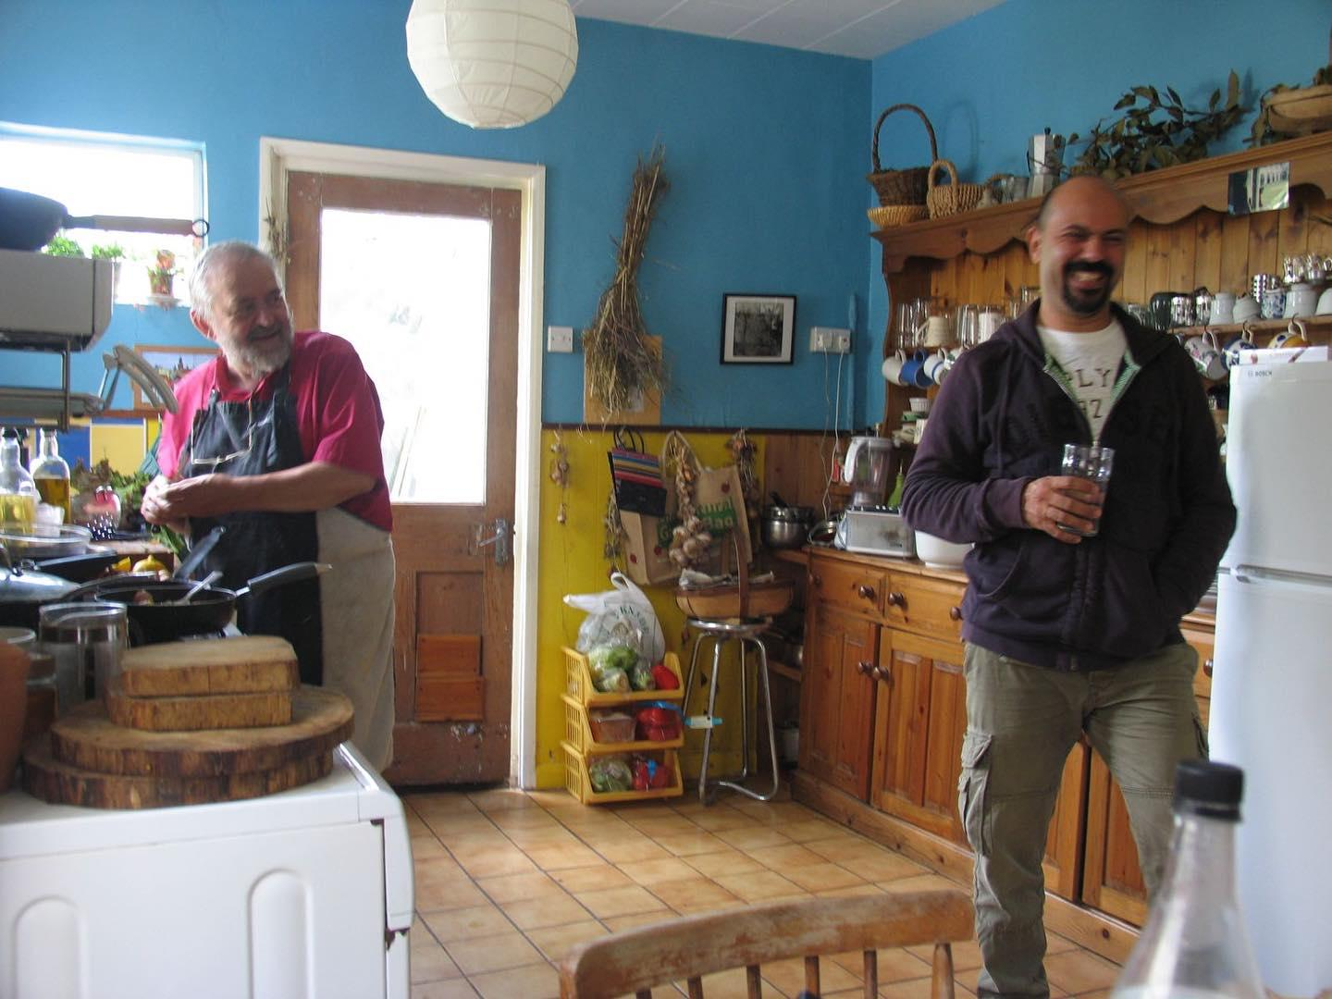
In the photo, Mario and my husband cooking for us at his home in Faversham, Kent, UK.

Sezgi Yalın

***

I have just returned from TESOL conferences in Athens and Burgos. In both conferences,
almost every presenter began their sessions by describing the role Mario Rinvoluccri had
played in their lives. They shared the personal loss they felt, and how saddened they were by
Mario’s passing.

A dominant theme running through both conferences, was the formative role played by
Mario in moulding the lives of everyone he touched. While there was great joy at both
conferences as old friends, delighted to see each other, fell into each other’s arms, an
important connection binding us together this year was our shared mourning of someone who
was a mentor, a father, a guide and a beacon of light to us.

Mario had a unique gift for making you feel that you were the most important person – and
in same cases the ONLY person – in the world when he was interacting with you. Mario
could look into you, see what was special in you and reveal to you what your particular gift
was. He was like an impish sunshine who would take delight in surprising you with what he
could uncover and expose. He gave so much to so many but each one of his gifts was custom
tailored to each individual person he was nurturing. His travel schedule was a punishing one,
and when he was no longer in front of a group he was breathing life into, he could have
moments of exhaustion where he needed be on his own to reconstitute himself. At those
moments he could become restless and dissatisfied. But Mario’s default position was one of
joy and gentle provocation. He was deeply respectful of people, their processes and what they
were struggling with.

Mario encouraged younger teachers to experiment with new ideas in a playful spirit and to
have fun. He also pressured neophytes to publish their ideas and promising experiments for
the benefit of the entire teaching community.

Like thousands of others, I felt I had a special relationship with him. I spent parts of two
summers living with him and Sophie, in Faversham, while working at Pilgrims in Canterbury.
He was like an ideas production machine that never stopped, and he had the rare gift of
making you feel intelligent as you swam around inside his ideas. Mario was excited about
Life and he infected everyone else with that passion. He could be head over heels because
new ideas for activities were taking shape in his mind, he could get ecstatic because the
Corpus had come up with new research that bore out – or negated – concepts he held dear. He
could radiate happiness because he had figured out how to help a student or trainee who was
in a rut and was suffering.

Mario was inventive through and through – and this wasn’t confined to English language
teaching. During one of my stays with him in Faversham, I was trying to lose weight and had
eliminated carbs from my diet. He found this an exhilarating situation. “I’ve never had to do
any cooking with that particular constraint before,” he exclaimed. And he immediately began
emptying his fridge, sorting which ingredients he could work with, and went about
concocting some of the most original and delicious dishes I’ve ever enjoyed.

Above all else, Mario was very clear about who he was. Having had an Italian father whom
the British government had deemed an alien enemy and incarcerated when Britain went to
war with Italy in the early 1940’s, Mario had an excruciating appreciation of deep pain and
alienation. Mario’s entire life was devoted to helping others avert what he had gone through.

The EFL world has lost one of its most inspiring figures and a real giant amongst us.

Lonny Gold

***

I didn’t know Mario all that well, but I lived in Canterbury for years when Pilgrims was based there. Mario would occasionally invite me to talk to one of his classes. I’m not a language teacher but a corpus linguist and lexicographer, and I’ve worked on dictionaries aimed at learners of English. I suspect that neither dictionaries nor corpora nor language technology featured highly in Mario’s thinking, but one of his great assets was that he was always open to any methodology that might get us closer to understanding how language works. He asked me to write a regular column for HLT, on corpora and what we can learn from them, and I did this for a couple of years. Mario had, as I soon discovered, a rare talent for the unexpected, left-field insight, spotting things in the data that I hadn’t noticed — which made it a pleasure and a privilege to collaborate with him. Anyone lucky enough to watch Mario in action could see that he was a true original and very much one of a kind.

Michael Rundell

***

Memories of Mario

I owe Mario such a lot - I was so fortunate to meet him and his wonderful teacher resource materials early on in my career, and was able to take his ideas into my classes in many different countries and contexts for the next four decades. So many colleagues benefitted from his approach, and I can't begin to calculate how many fortunate learners he helped, and is still helping, as a result. Here are a few brief glimpses of how he came into my life.

My first encounter was at London University in the Institute of Education, during the long grey winter of 1979-80. I was in the middle of my MA EFL in the company of twenty or so classmates from many different countries, mostly enjoying the course, while struggling with its intellectual challenges. One afternoon, a dark-bearded stranger appeared in our classroom. Passionate, fiery, he questioned everything we were doing, apparently angry at the orthodoxies we were being made to swallow on our MA course. I could hardly understand a word he was saying, just wondering why he seemed so angry. Had he sat in on just one of our lectures and seminars, I felt he would have changed his mind, but he was quite obviously on a mission of his own and wouldn't be contradicted. Shortly afterwards, at a book exhibition (IATEFL 1980, held at Goldsmith's College) I picked up some of the early Pilgrims teacher resource pamphlets and recognised his name... the activities were really interesting, and certainly different from the mainstream. I was intrigued... hooked would be a better word.

The second time I bumped into Mario was at Trinity College Dublin, 1990, at IATEFL. Jill and I were there to help launch our new book WRITING GAMES. We were amazed that Mario seemed to know who we were, that we were working in Madagascar, and he asked in great detail about our work there. I told him how valuable his books DICTATION (with Paul Davis, 1988) and ONCE UPON A TIME (with John Morgan, 1983) were for our work in Madagascar, and had been in China in the mid 1980s... he was very happy to hear we liked DICTATION, saying that we were among the very few people who actually mentioned it favourably, it was not selling well... perhaps the title put them off? He was just as fiery and passionate as ten years before: I was struck by his great interest in new ideas, his ability to listen and consider, his openness, his honesty and belief in change.

A few years later, we invited him down to Torquay, to the old South Devon College, to run a session for our local teachers' association, the wonderfully named SWELTA - a veritable hotbed of revolutionary educational thought experimentation. Well, maybe, at times! Mario certainly put the cat among the pigeons that evening in the early 1990s. His 'thing' at the time was 'writing letters to learners', generating correspondence between teachers and learners. "Rather time consuming!" muttered one or two of my colleagues, "don't think my students would want me writing to them like this..." But for those of us who took him up on his ideas, it was a wonderful new approach to teaching and learning, which I have practised many times since in different contexts.

After the workshop, we invited Mario and colleague back to our house for a continuation of the discussion over food and drinks ... ah, those were the days... Jill and I really should arrange to put a blue plaque up on our house: "Mario slept here". Trouble was, he didn't really get much sleep at all that night, as the conversation continued till dawn.

Postscript from Jill

I share many of Charlie’s memories of Mario – his passion, his inspiration, his creativity…. A real star in our profession! Here is a short postscript, a memory of my own:

I went to a workshop at a conference (IATEFL?) where Mario did an activity that involved people changing socks. I cannot think of anyone else with the enthusiasm and charisma that could persuade a roomful of strangers to exchange socks!

(The activity survives in a different format in Grammar Games)

RIP Mario! Thank you for everything you gave us. You changed our way of teaching in so many many ways, and so many learners have benefitted over the years from your work.

Charlie and Jill Hadfield

***
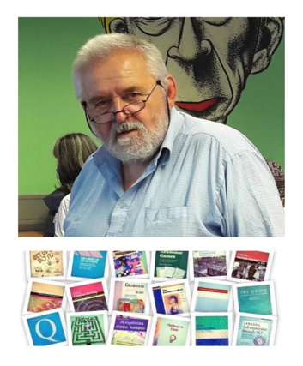

Celebrating Mario

Where to begin! What to say! So much and so many different stories. Let me keep to just a few…

As a fairly novice teacher in Bulgaria, I like so many others had been influenced by books such as the Q book, Grammar Games, the Confidence Book – a significant one – and wrote to Mario saying how much my ideas on teaching and learning were ‘very Pilgrims’. Mario wrote back as he always did – “When you are next in the UK come and stay” This was in his Cambridge days and I did with my wife Helen and we had a lovely meal with Mario, Sophie and the very young Bruno talking about ELT, Pilgrims and so much else. I remember going to the park with Bruno.

Soon after that I was involved in organising the first Bulgaria IATEFL conference in 1992. This was a major event in the era that Bulgaria called ‘The Changes’ after the fall of the Todor Zhivkov regime in 1989. I was working for the British Council in the heady days of funding for Central and Easter Europe and we held the conference in the splendour of the National Palace of Culture and we invited so many of the ‘leading lights’ of the ELT world. Mario of course among them. Mario actually stayed with us or Helen’s mother, Christine, who was also my colleague at the English language school in Sofia – but that’s another story!!!!

The Palace of Culture was a brilliant venue with some really interesting rooms. I had a session in a kind of mini amphitheatre – I think I was doing something on music, drawing and storytelling. Not sure where I got the idea from – no doubt one of the Pilgrims Longman books – or perhaps the OUP ones. The thing is given the layout of the room I was in the centre with those attending all around me in a circle, so I had to constantly spin round the room. Mario thought this was hilarious and said so. I aske him for feedback though in very Mario ways he just said it was my session and who was he to give feedback. He said what did I learn from it – that’s for me to process! This then led to the beginning of my relationship with Pilgrims working from 1997 to the present day as a trainer on the Hilltop at the University of Kent and sometime DoS. The story doesn’t quite end there as probably every summer Mario commented on this session in Bulgaria long after I had rather forgotten it. This is another aspect of Mario with his amazing memory and for detail – especially on these incidents that so strongly impacted on him.

Another memory I’d like to share would have been one summer on the hilltop probably around 2007 or thereabouts. As was Mario’s kindness he invited trainers to dinner. One evening Mario picked me up from our ‘wonderful Parkwood residence’ to take me to Faversham. On the way I started talking about an idea from one of the books – possibly Once Upon a Time or Dictation Many Ways or could have been another one. I was explaining I got the idea from the book and how I had taken it in a different direction involving drawing leading to what I described as a ‘learning independence activity’. I explained in detail what I was doing though Mario looked puzzled and had no idea what activity I was talking about. I had obviously taken the idea to be mine and well away from what was in his mind! There is another aspect to this story as on our route to Faversham Mario need to fill up his car with petrol. We stopped at the garage and Mario filled up though I think still puzzled in his mind about what I was saying about the activity. After filling up the tank we drove off and I realised Mario hadn’t paid for the petrol! I thought to myself that’s strange – does Mario have an account with garage or something similar. Bit unlikely but never mind. About five minutes later Mario realised he hadn’t paid and did some kind of emergency stop screeching the car to a stop as realised he hadn’t paid. Back we went to the garage. The strange thing is the garage hadn’t realised he hadn’t paid either. No idea how! Anyway, with services paid for off we went to Faversham – I didn’t bother continuing to explain the activity. Just seems to me to be another very Mario story.

I will also never forget his kindness in driving me to and from the hospital in Ashford where Helen was after her stroke in her nearing end of life days. We were living in Faversham at this time. This was at the beginning of Covid time where we were not recommended to be travelling. Mario’s act of kindness was he knew I had difficulties getting to the hospital and it had to be done. If we left the windows open we’d all be fine – as we were. So, Mario again!
Thanks for everything – and more! Rest in Power Mario!

Phil Dexter

***

M - entor
A - cute
R - esourceful
I - nnovative
O - utstanding

This was Mario Rinvolucri.

Mario had a profound impact on my life, both professionally and personally. He inspired and
motivated me throughout my career as a teacher and teacher trainer. His honesty, though
sometimes harsh, was always rooted in kindness and a desire to see me grow. I can proudly say I’m a “child of Mario Rinvolucri” .

Coming from similar Italian roots, we shared a deep connection that went beyond our work. This bond, built on shared origins and mutual respect, was a foundation for everything he taught me. He had an incredible way of inspiring and motivating those around him, and I will forever carry his insights with me, guiding me through my journey as a member of the Pilgrim’s team.

He was always there for me, at every step along the way, from my first time as a Pilgrim’s trainer decades ago. There is so much, much more I could say, for now, it’s “GRAZIE, Mario, with all my respect and gratitude from Stefania, from Table Mountain, ciao”.

Stefania Ballotto

***

Dear Mario,
Thank you for your last letter with a poem attached, and my apologies for taking so long to answer it. I know that I won’t be able to see you… for some time … . Apparently, you are now exploring the kingdom of Chronos and Aion, so my words or intentions may need a different medium of communication. Still, I’d like to take up this tiny particle of your unlimited time to express my Kairos feelings and share the images they bring.

When I close my eyes and think of you, I can see an Old Master and an Eternal Pilgrim. The former is giving a Master Class course, but rather than showing his apprentices how to paint, he invites them to experiment with different techniques and subjects and then reflect on what they have learned in the process. The latter, a distinctive and tireless figure, is always on the road in search of personal growth, sharing the path with other pilgrims.

I was so lucky to have been both a modest apprentice and a fellow pilgrim in your quest to humanise language teaching. And what a fascinating journey it was !. You showed me the riches and vast realms of storytelling, helped me discover that working with vocabulary was like going through a treasure chest, invited to have fun in the playground of grammar games, gave me a map and asked to explore the territory, brought new, exciting flavours to traditional techniques like dictation and moved writing from an austere, intellect-driven, highly structured environment to a rich, creative, personalised space. You taught me that the soul of teaching lies in the art of observation and self-reflection. You opened so many windows in stuffy language classrooms and staffrooms inviting both teachers and learners to value the vital, human element in their journey of learning.

On my continuous pilgrimage I keep your books in my backpack. Mario Rinvolucri - Books. But books and activities aside, there was yet another dimension to this journey. It was your abundance and generosity in sharing, selflessness in supporting and positive interest as well as your belief in other people. With time, we remember less of What we were taught but vividly remember How it was done. Your integrity in practising what you taught and preached, walking the roughly charted road of humanism, was the key lesson to learn. So here and now, I want to thank you, with all my heart, for the journey and the joy of professional fulfilment.

It is my hope that gratitude - the new medium of our communication - can transcend and reach you wherever you are. Then, you could change the ending of the poem you sent me :
“(…) At the moment no one is reachable…

For example, my dream-maker
My marvellous Night-cinema master,
Impossible to get to know him,
At this number there is no answer.

At the moment no-one is reachable
At this number there is no answer”.
( MR)
With grateful and loving thoughts,

Małgosia

Małgosia Szwaj

***

Even though I think Mario deserves an absolutely monumental eulogy as he very humbly played a monumental part in my professional life, I know I will never be able to attempt such a daunting task and even if I tried, he would just laugh at me. Mario knew that writing was not exactly my favourite medium of expression.
We first met back in 1987, when Mario and John Morgan ran a TT course for University Language Centres in a small seaside town in Poland. I was a rookie teacher, having graduated just one year before and absolutely gobsmacked by the training delivered by the two ELT giants. It made me realise that teaching and training can be an exciting and extremely creative journey taken with your students, colleagues, and mentors. Almost 38 years on, I still find it fascinating.
That is who Mario was to me: a mentor and a friend always ready to offer support, thought provoking ideas, a challenge or constructive criticism. Over the years, as I started working for Pilgrims Teacher Training, I knew I could count on his expertise and experience in case of any trepidation related to my courses or ideas I wanted to try. One of the most important things that I have learnt from Mario is probably focusing on another human being both in my professional and private life.
In 2019, during the last summer at Pilgrims in Canterbury, before the world changed, Mario offered mentoring sessions to all interested trainers. Brilliant as ever, curious and attentive. Now it seems as if he was saying goodbye to each of us…
There are several images that I have of Mario imprinted in my memory:
sitting on the floor in my flat listening with such genuine interest to my daughter rambling on (at the age of 8) about the picture she made for him
Mario in his apron, walking barefoot around the kitchen, cooking effortlessly a scrumptious meal while discussing psychodrama
Mario, sitting in my classroom, observing with furrowed brow, focused and analytical with tons of helpful hints to offer afterwards
Picking Mario up at the airport, in his famous one-hundred pocket jacket which was heavier than registered luggage on Ryanair
Mario zooming on his moped on his way to class...
And so many, many more… as I am sure many of us have.
He inspired generations of educators, and I will always consider him my mentor, from my formative years till now.
Thank you, Mario, for everything. Till we meet again.
Magda Zamorska and family

***
A tribute to Mario
I first met Mario at a seminar organized by the British Council in Manchester in the 1980s. He was a guest speaker and arrived the afternoon before his workshop to observe the final session. The next morning he surprised everyone by knowing all our names—more than 25 of us. My name is not easy for English speakers to pronounce, yet Mario had no trouble with it. I was a young teacher then, fresh from university, eager to absorb everything I could. His ability to remember my name instantly endeared him to me, and later, I adopted the same practice with my students—with much the same effect.
Mario’s Grammar Games had a profound influence on my teaching. I still use many of them today, but it was running dictation that truly set my teaching apart. At the time, I was working at a language school for adults in Ljubljana—my first job. When I introduced the idea to my colleagues, they warned me that middle-aged businessmen would never run around the classroom gathering information from small slips of paper. How wrong they were! My students, all older than me at the time, absolutely loved the activity—just as they did many of Mario’s other ideas.
In the mid-2000s, I began working for Pilgrims. To strengthen the connection and promote their teacher training courses, Pilgrims sent Mario to Ljubljana to lead workshops. I vividly remember him stepping off the plane wearing a multi-pocket vest that looked rather heavy. Only later did I learn that each pocket was stuffed with books, which he later sold at a reduced price to workshop participants. He refused to bring a separate case for them on the plane because he didn’t want Pilgrims to incur unnecessary expenses. At that time—and for many years—Pilgrims and Mario were inseparable; he was its very essence.
When I started teacher training at Pilgrims, Mario suggested we had supervision sessions. Every lunchtime we met for half an hour to exchange impressions of our groups and our teaching. Some colleagues thought he should let me rest between lessons, but Mario knew that these conversations benefited us both—though I’m certain I gained more. During our supervision he shared his thoughts as a teacher, his philosophy, and the reasoning behind his classroom techniques. To say this was an eye-opener for me would be an understatement.
My time at Pilgrims wasn’t just about training in-service teachers; I was growing professionally as well. When I wasn’t teaching, I attended my colleagues’ workshops—especially Mario’s. His endless (and sometimes crazy) ideas always worked in class. Later, when my colleagues at the university back home mentioned an activity from his books, I often recognized it—not from reading, but from experiencing it firsthand with Mario. What a privilege that was.
During those Pilgrims summers, Mario often invited colleagues to his home. He loved cooking and entertaining, and one of my fondest memories is of him in his kitchen, apron on, discussing some intricate teaching or language point while cooking at the same time. His knowledge was vast, and just talking to him expanded my horizons. Sometimes, it was simply his unique perspective that made all the difference. He spoke so many languages and understood so many cultures that he could easily draw fascinating parallels between them.
I remember one lazy Sunday afternoon in his garden, where a few of us trainers sat around the table discussing which word for potato best captured its essence. After considering many options, we finally agreed that the Slovenian word krompir was the most fitting.
Another memorable conversation was about language acquisition. Mario asked me whether children, as native speakers of synthetic languages like Slovenian (which has six noun declensions), first learn the nominative case and then acquire the others, or whether they use all cases from the start. I shared an example from my daughter, when she was not yet two. We went for a walk, and she raised her hand and said, “Oko!” By this, she meant, “Daj mi roko!”—Give me your hand—already using the accusative form correctly.
When I became an IATEFL trustee, I often travelled to Faversham, where IATEFL head office is located, and I would often meet up with Mario, who also lived in Faversham. Each time I left with a new topic to reflect on and a list of books to read.
Mario, I will miss you. I will miss your boundless creativity, your vast knowledge, your extreme energy, and your deep love for languages and people. The world feels a little poorer without you.
Mojca Belak



