Letter 1
Hania
Mein neuester Titel ist online!

https://www.youtube.com/watch?v=5mNuOZbHZpE

LG Walter

Attachments area
Preview YouTube video Walter Pichler

Walter Pichler

Letter 2

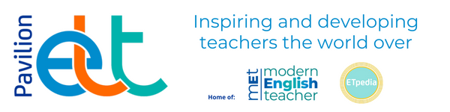

We've added more Pavilion ELT eBooks!

Save 20% on the full print price if you purchase your eBook directly through Pavilion

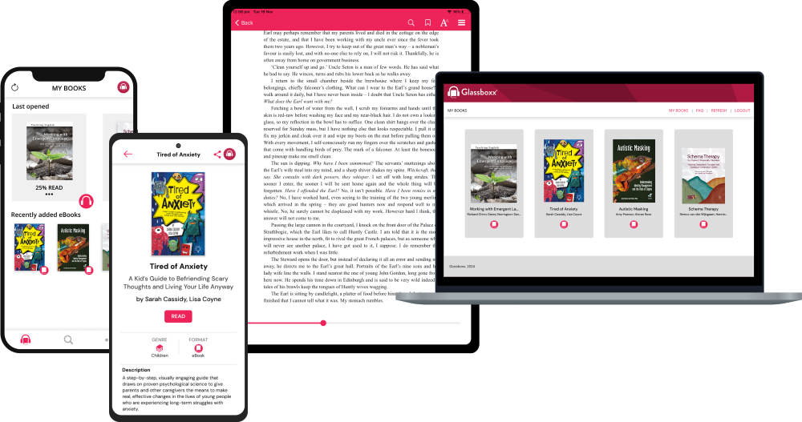

We are delighted that we now have 15 Pavilion ELT eBooks available to purchase directly from Pavilion! This includes a fantastic range of titles from the Teaching English series, as well as Successful International Communication.

Plus, our eBooks are available for 20% less than the standard RRP. Our eBooks can be purchased directly through Pavilion, in partnership with Glassboxx. These can be read through the Glassboxx app on your mobile, tablet or computer, or through the Glassboxx browser. Find out more about Pavilion eBooks and Glassboxx here.

Prefer reading on Kindle? Our book are also available on your Kindle store!

Letter 3


New Professional Development feature for teachers

Our Professional Development website allows you to access a variety of resources to support your interests, goals and needs. Whether you want to improve your everyday teaching or advance your career, our tools will help you learn what you need, put it into practice, and see results.

We have recently added a new Resource Finder questionnaire that allows you to customize your search depending on preferred mode of learning and topics of interest, and receive relevant results.

Find the right PD tool

If you have any questions, please send us a message at info.western-europe@oup.com. We look forward to hearing from you.

With best wishes,
Oxford University Press

Letter 4

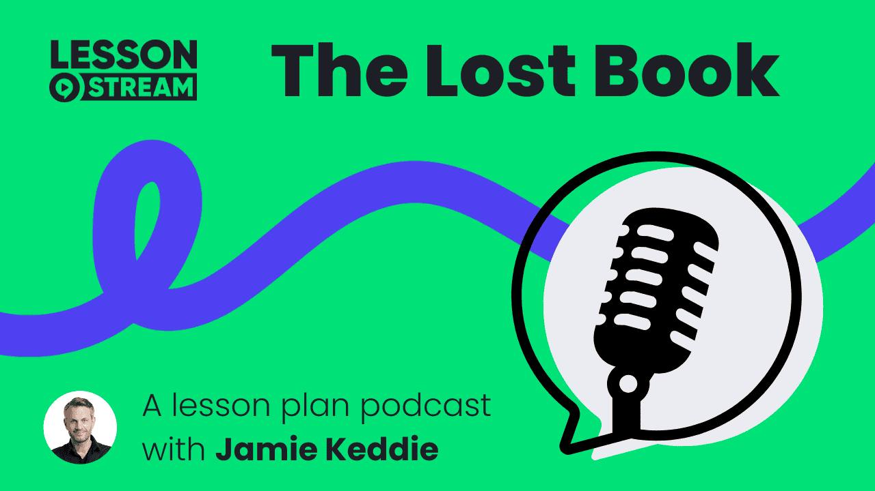

Hello teachers,
I don't know about you, but I am a huge fan of podcasts.
Over the last couple of years, it has occurred to me how valuable they could be in providing support for teachers.
In January, I launched the brand-new LessonStream Video Course, which offers an exclusive podcast for participants.
More recently, I have been creating podcasts to accompany LessonStream lesson plans.
Would you like to hear one?

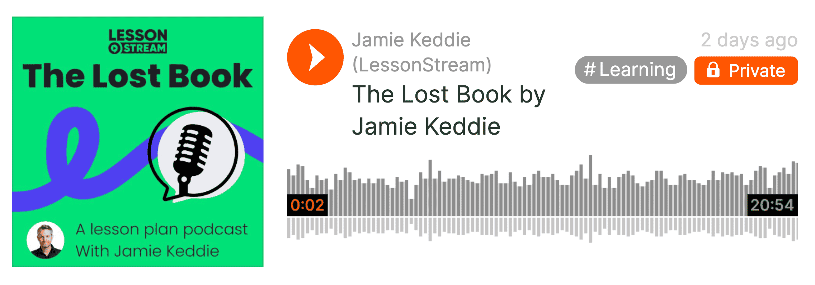

Fly Fishing by JR. Hartley
If you were in the UK in the 1980s, you might remember this book.
It featured in an incredibly successful advert that has left a cultural legacy.
In the podcast, I tell the story, walk you through the activity and offer tips and guidance along the way.

Listen to the podcast on SoundCloud

The Lost Book is the very first lesson plan in the brand-new LessonStream library and is available right now.
It includes the following:
- Detailed teaching notes and a step-by-step guide
- A handout for your students
- A slideshow to support your teaching
- Community access to ask questions, share insights and connect with other teachers

Buy the lesson plan

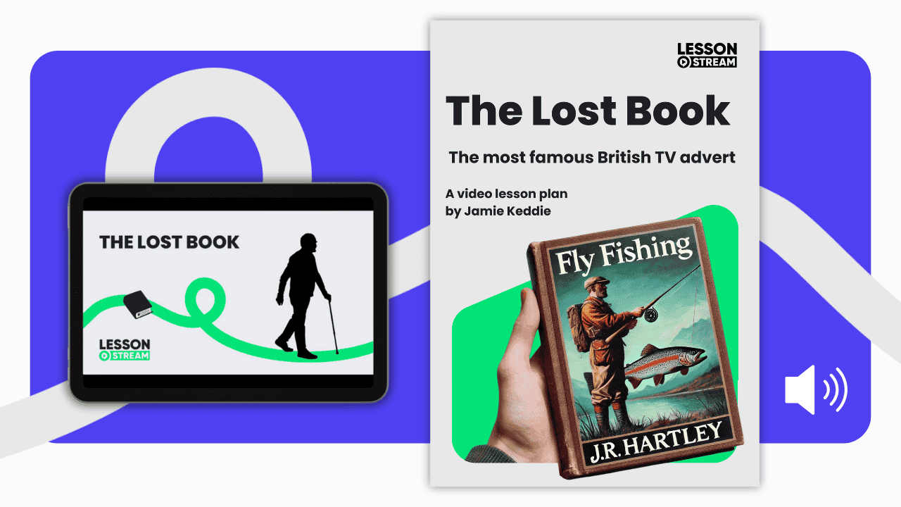

This is the first of many lesson plans and podcasts will feature in most of them.
I'll keep you posted.
Thank you for reading 🤗
Jamie Keddie

Letter 5


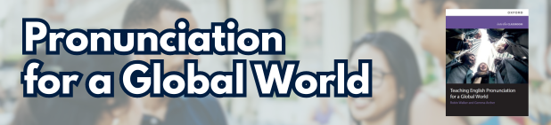

Research shows that up to 60% of communication breakdowns between non-native speakers come from poor pronunciation!

Discover the key to effective communication in today’s international world with our latest book, Teaching English Pronunciation for a Global World!

Read a Sample!

Buy the Book!

Watch and interview with the authors here.

Letter 6




Hi Hania,

The world needs more writers. More thinkers. More people who have something to say, sharing their insights. Does that sound like someone you know?
For just $50 a year, you can give the writer (or reader) in your life full access to a thriving global writing community, full of tips and inspiration, with an annual Medium membership. Plus, they'll be able to use all our Member-only features, like starting their own publication and joining our Partner Program to earn money for their writing. Your gift will also help support the great writers they read over the course of the year.

Over 100 million people come to Medium to read and share wisdom every month. Developers, amateur novelists, product designers, scientists, CEOs, poets—anyone burning with a story they need to get out into the world. They write about what they’re working on, what’s keeping them up at night, what they’ve lived through, and what they’ve learned that the rest of us might want to know, too.
If that sounds like someone you know, why not give them the gift of Medium? Include a personal note, and schedule delivery for any date you wish—what are you waiting for?
Make the writer in your life happy. Give the gift of Medium.
– The team at Medium

Letter 7
Dear all,

A couple of things to keep you awake at night...

Alan Maley

AI is chillingly starting to make decisions on its own. #AI #scary #gbt #captcha #robot #technology

‘Godfather of AI’ on AI “exceeding human intelligence” and it “trying to take over”

Preview YouTube video ‘Godfather of AI’ on AI “exceeding human intelligence” and it “trying to take over”

‘Godfather of AI’ on AI “exceeding human intelligence” and it “trying to take over”

Please check the Pilgrims in Segovia Teacher Training courses 2025 at Pilgrims website.

Please check the Pilgrims f2f courses at Pilgrims website.

