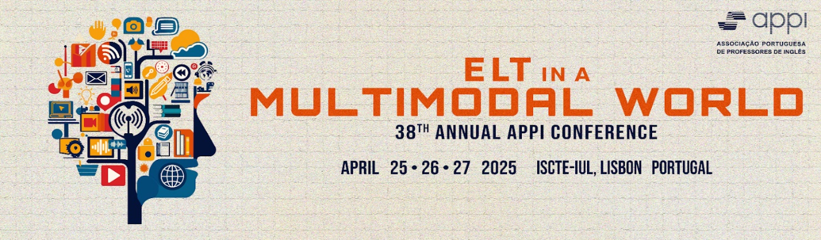
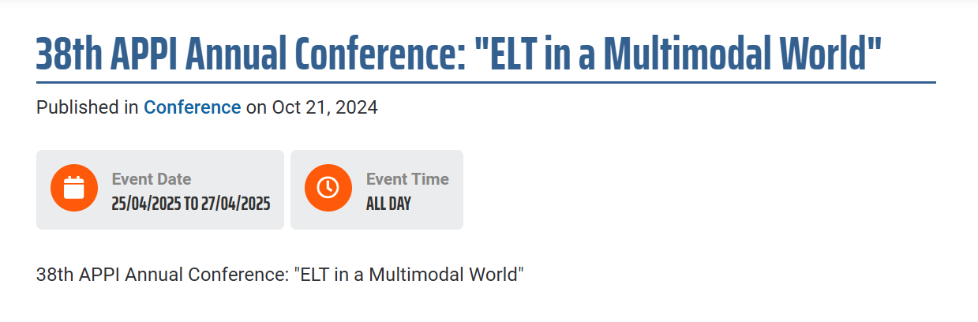
The APPI Executive Board is delighted to inform that the 38th Annual APPI Conference “ELT in a Multimodal World” will take place at ISCTE, in Lisbon. Once again, ISCTE - University Institute of Lisbon will host our largest Annual gathering on April 25th, 26th and 27th, 2025.
This year, we aim to further develop the Conference topic “ELT in a Multimodal World”, by inviting speakers and experts in this field to share ideas and approaches on how to develop Multimodal literacy with students, reinforcing the importance of communication skills in this digital era. We also encourage discussions on activities that raise awareness of real world issues, such as the UN’s Sustainable Development Goals (SDGs).
Confirmed Plenary Speakers: Gabriel Diaz Maggioli, George Kokolas, Nayr Ibrahim, Nik Peachey, Rose Aylett, Sandie Mourão

Contact:
Sónia Ferreirinha, APPI President
Tel.: +351 969570805
Email: appiconf@gmail.com
https://www.appi.pt/event/38th-appi-annual-conference-elt-multimodal-world
www.appi.pt



