Mario and HLT
Hanna (Hania) Kryszewska, HLT Editor

1
Mario will be remembered for the books he wrote, for the work he did with teachers, for how he shaped people, how he instilled thoughts and ideas in us, for how he wined and dined us, for the notes and messages he wrote to us, and last not least, and he will also be remembered for starting Humanising Language Teaching Magazine.
It all began in 1999. Mario had conceived of the idea on a train and asked a befriended IT expert to run the site. Little did he know what the bill at the end of the year would be, and it almost gave Jim a heart attack, and almost killed the whole project. Fortunately, Jim found ways of keeping the cost down and the project was saved. HLT stayed afloat.
The first issue of HLT looks modest and small compared to current issues, and yet it is so powerful and has impact. I still quote the ideas presented in the Fishbowl; Mario had Michael Rundell run the Corpora Ideas section. Then the contributing authors were John Morgan, Jane Arnold, Seth Lindstromberg, Robert Feather, Clem Laroy, Paloma Valera, Michael Rundell, Lou Spaventa and many other.

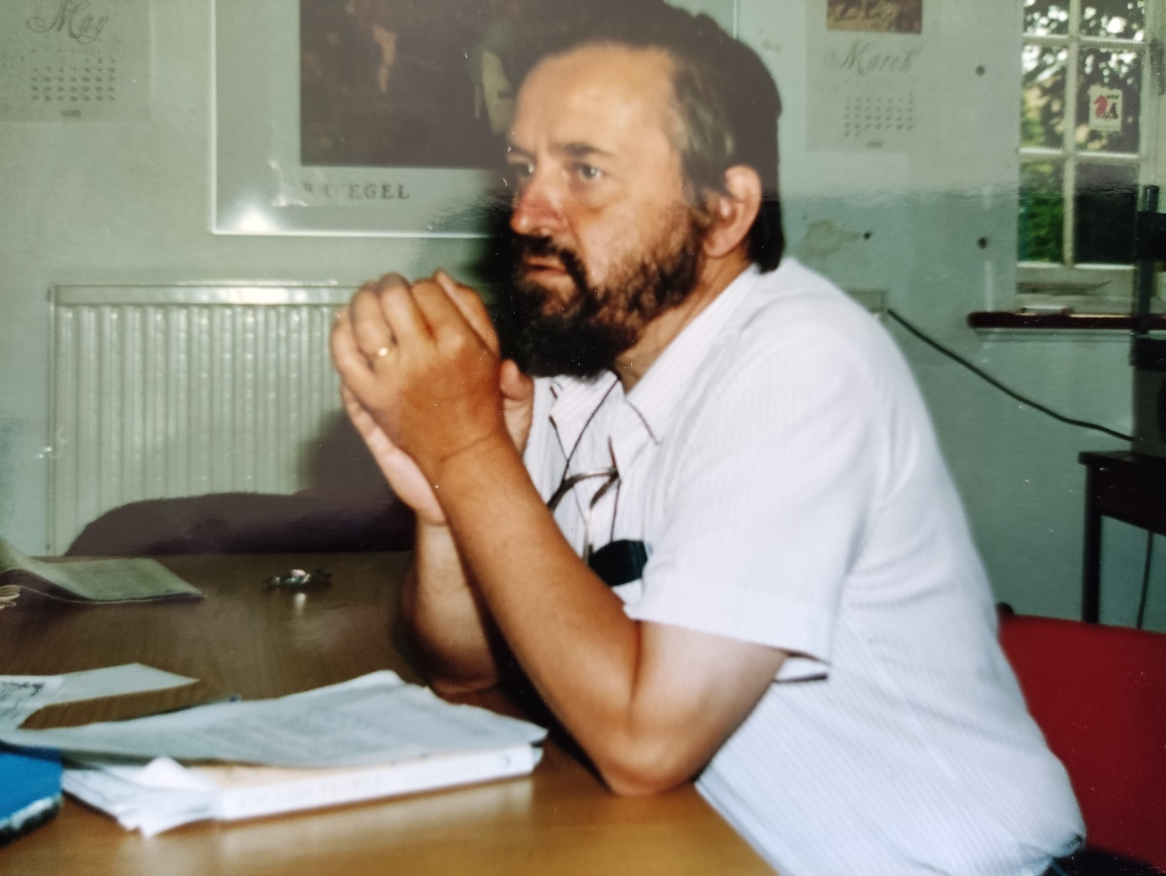

2
Mario was like fireworks… Unpredictable, unique, original, passionate, erratic, special …
And so, he was unpredictable, unique, original, passionate, erratic, special as the editor.
So…
Sometimes Mario was short of an article for a given column, so he would write it himself under a pen name.
Sometimes Mario got carried away, and HLT became Mario online.
Sometimes he was so busy travelling, that two issues appeared one after another, instead of appearing every two months.
Sometimes he would push and push the prospective author, until he got the article he wanted.
Sometimes he would help people grow beyond what they had thought they could do.
Sometimes he would mercilessly criticize.
Sometimes….

But he would never miss an opportunity to harvest an article.
But he was always a careful and sharp-eyed editor.
But he would give fair feedback.
But he made things happen.

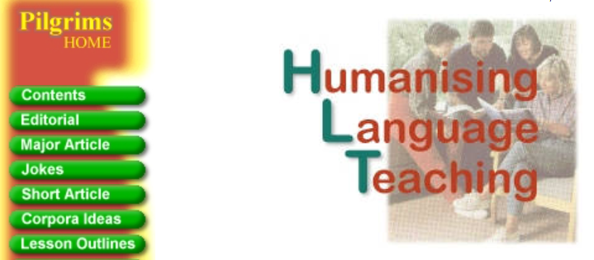

3
He wrote 54 books, at least this is how many you can find in the list here.
But he also made over 123 contributions (or more) to HLT. Sometimes they were short but sometimes like the ones here Klett 1 , Klett 2 and Klett 3 contained around 20 activities each, all on how to jazz up your coursebook. This could count as another book that he wrote.
His contributions to HLT include (listed starting from the most recent):
https://www.hltmag.co.uk/dec2019/putting-the-human-centre-stage
https://www.hltmag.co.uk/oct19/thank-you-japan
https://www.hltmag.co.uk/aug19/review-of-harmer-and-puchta
https://www.hltmag.co.uk/aug19/questions-to-brazilian-experts
https://www.hltmag.co.uk/aug19/pilgrims-bridges-efl-conference
https://www.hltmag.co.uk/june19/literature-lessons
https://www.hltmag.co.uk/feb19/50-creative-activities
https://www.hltmag.co.uk/feb19/using-questions
https://www.hltmag.co.uk/feb19/literaturelessons
https://www.hltmag.co.uk/feb19/editorial
Bill Lee Speaks to us from the 1970’s
“Doubling” as a Language Learning Technique
Spotlight on the Teacher
Talking to Yourself in English
One-liners from Edinburgh Festival, 2017
Some Old Exercises
What Chinese Students Expect
Why Teach Music Well and Language Badly in China?
Puzzle Story Leading to a Values Clarification
Smile or Die - How Positive Thinking Fooled America and the World
When E for B is Wrong for a Business Learner: A Case-study
Two Five Year Old Voices
The New Courses We Offer You in 2010
The Alternative Way: Green Line 1 Klett Ernst Klett Verlag GmbH
The Pilgrims Business English Centre: A Laboratory for Change
The Alternative Way: Green Line 3
'The Art of Foreign Language Teaching: Improvisation and Drama in Teacher Development' by Peter Lutz
When Teachers Fail
A Blonde Joke
Movement in EFL
Teacher-training in the Dark: Ignorant Westerner Works with Top Quality EFL Teachers from China
Teaching is Life is a Game by Visnja Anic
The Optional Afternoon and Evening Programme: Pilgrims Summer TT Courses
Creativity through Strict Timing in Story-telling
How Relevant is Humanistic Language Teaching Methodology in India?
What Pilgrims People Write
Course Outline Summer 2008
Creative Writing: Flowers
Doubling - a Psychodrama Technique that has been successfully Transposed to Language Teaching
Exercises from Companion to Cambridge Grammar of English - Listening Section
Our Three New Courses in 2008
A Coursebook Writer's Limerick
'Four Voice Dictation' after Herbert Puchta
Emotions
Trainer Development by Tony Wright and Rod Bolitho
The Alternative Way: Greenline 2 Klett
Who and What is Worst
An Old Exercise: From SMALL TALK, Carolyn Graham, OUP 1986
Parallel Poems
We come to you: Pilgrims Overseas Workshops
Headstrong: A book of Thinking Frames for Mental Exercise
Imagine That! Mental Imagery in the EFL Classroom
Pilgrims Course Outline: Our April courses for Teachers
Maze: His Family
Exercises that help to build up confidence during exam time
Jazz Chants, at secondary level - but whose?
Any difference between cemetery and graveyard?
Letters out from the class - 12 Exercises taken from Letters
21 creative writing techniques - Letters across the classroom
Learning from colleagues - Focus on Simon Marshall
Advanced and Beyond
Funny things Sports Commentators say
Intensive Question Practice
Mindgame (CDrom)
Personalising Dictionary Searches
What's in the May 2003 issue?
Thoughts about this Issue of HLT
A Definition of a humanistic Teacher's Attitude
Review of Using the Mother Tongue
What do our Teacher Training Courses achieve?
Are Teachers of persecuted Languages the World's top Language teachers?
Humanistic thinking 1910-40, Brilliant Adriatci conference
Summer 2003 Teacher Training Courses
Writer Nationality Spread in HLT
A look at Teacher Training through Bateson Eyes
A September 11th Comparison- Passives
Are Exams Child Abuse?
The Weakest Link
What's in this issue
6 exercises from Multiple Intelligences in EFL
From Declarative to Interrogative to Negative
Humanising your Coursebook
Why Pilgrims Teacher Training Courses are better
Editorial - Jan 2002
Interview with Maria Eugenia Guimerans about her article
Using the Mother Tongue
Editorial - Sep 2001
Making 'Round Tables' less boring
What is an EFL teacher?
Definitions Dictation
Editorial - Jul 2001
Stealing phrases from the Idiolects of Others
Editorial - May 2001
Editorial - Mar 2001
From Declarative to Interrogative to Negative
Humanising your Coursebook: Add words to a Dictation
Humanising your Coursebook: Cloze Dictation
Humanising your Coursebook: Dictating Mistakes
Humanising your Coursebook: First and last letter dictation
Humanising your Coursebook: Four Voice Dictation
Humanising your Coursebook: Overwriting
Humanising your Coursebook: Stuttering Dictation
Why Pilgrims Teacher Trainer Courses are better.
Editorial - Jan 2001
Editorial - Nov 2000
Making exercises out of Corpus Discoveries
Editorial - Sept 2000
Editorial - July 2000
Courtesy to Students
Editorial - May 2000
Editorial - Mar 2000
Editorial - Jan 2000
Editorial - Dec 1999
Editorial - Nov 1999
Corpora Ideas - Oct 1999
Editorial - Oct 1999
Editorial - Aug 1999
Editorial - Jun 1999
Looking down from on high
Editorial - May 1999
Editorial - Apr 1999
Editorial - Feb 1999
The Fishbowl

These HLT contributions fall into 5 periods:
- first when Mario was the editor till November 2005,
- second 2006-2012 when he kept writing for HLT and supporting me in my role as the editor in many ways,
- third when he stopped publishing in HLT and withdrew from EFL suffering from what he called ‘falling out of love with EFL”,
- fourth 2017-2019 when he made a comeback and was very active not only in HLT,
- fifth after summer 2019 when again he gradually stopped engaging in HLT and also EFL for personal and health reasons.
You know the rest…

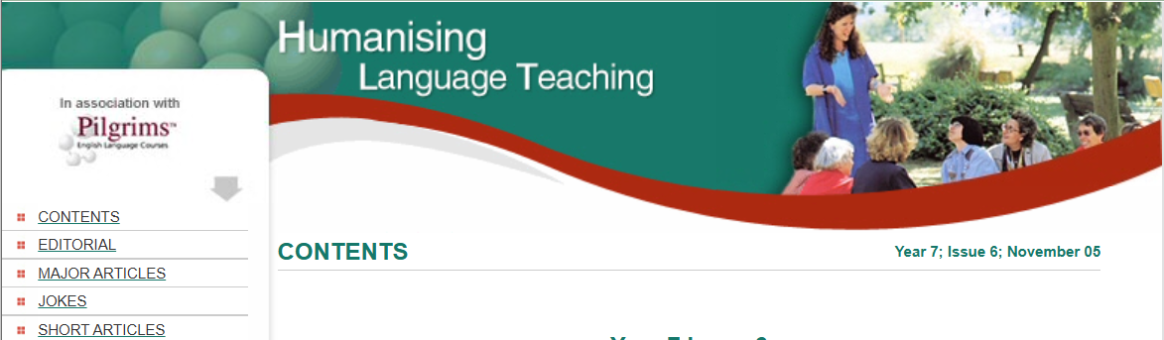

4
Mario always believed in non-native teachers as well as native teachers. He treated us all in the same way, often believing that non-native teachers can bring freshness and innovation to EFL. He supported the idea of, for example, Hungarian, Polish or Czech trainers working for Pilgrims as trainers, and he believed in inviting host editors to edit an issue of HLT. I think the first ‘foreign’ edition was edited by Małgosia Szwaj from English Unlimited, Poland. It was the December 1999 edition, so in the first year of HLT’s existence. I continued the tradition with issues from South America, Iran, Malaysia, South Korea, Czechia, Turkey, Indonesia and many other.

5
Mario’s idea of HLT was democratic - free for all and not peer reviewed. The idea has been to make sure the articles were humanistic and brought some fresh ideas and innovation, at the same time keeping the learners wellbeing in the centre, long before the word ‘wellbeing’ became a buzzword in ELT and not only.

It was not easy to follow in Mario’s footsteps, also because he had much larger shoes size than me. I was honoured he thought I was his soul sister and that he chose me. In fact, as I am writing these words I have been editing HLT for 20 years.

Mario, you have been a great HLT role model for me to follow and a very inspiring and encouraging editor helping the contributing authors to grow.

Your books you have written are one of the monuments of your great mind and heritage you have left for the next generations of ELT, the magazine, its archive and the community of like-minded teachers, is another monument.
We are all grateful to you for every idea you have shared with us.



