An Interview with Mario Rinvolucri
Mario Rinvolucri, Pilgrims Trainer, and Bink Venery, UK/Italy

Acknowledgement
The interview was originally published online in August 3, 2018 issue of
https://pilgrimsteachertraining.wordpress.com/2018/08/03/an-interview-with-mario-rinvolucri/


From the interviewer
I managed to have lunch with Mario this summer and we then ‘conversed’ via email to produce this short but informative interview. Thanks for your time, Mario!
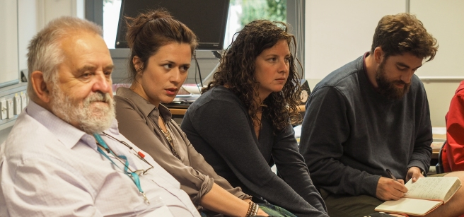

KB: Mario, you have been at Pilgrims since its inception in the summer of 1974. That must have been an exciting time.
MR: In summer 1974 the teaching staff were four people: James Dixey founder and original owner of Pilgrims. Christine Frank, me and a lady whose name has now flown out of the window. We were in our late twenties to early thirties, we were earnestly ignorant… We truly felt that Robert O’Neil’s course book, KERNELS INTERMEDIATE, was wow, state of the art.
KB: “Earnestly ignorant”, love that. So it wasn’t quite “Pilgrims” yet, in terms of ethos, right? I mean, course books aren’t what you’d normally associate with Pilgrims nowadays; even if we have 2 participants to 26 on a course, we are, as you of course know, more centred on the learner(s) than anything else.
MR: That summer we taught the whole of 108 language students!!! I think that for those weeks we focused amazingly on our very own students who seemed like a kind of miracle.
KB: Ha, incredible.
MR: Dixey had hitch-hiked round Europe in the Spring, staying in youth hostels, impressing opinion formers across the continent with the wonders of a new kind of school that only at that point existed in his own head. He had kilos of self-confidence and gave of that feeling of entitlement associated with boarding schools. He was, at one stage, Richard Branson’s fag in the teenage hierarchy of their archaic school. Come September 1974 we were in a sort of blissful trance.
KB: Some sort of magic was undoubtedly happening back then. There were no Pilgrims Young Learners courses back then, were there? I mean, that’s how I discovered Pilgrims.
MR: Well, let us move on to, say, 1994. Twenty years on. Pilgrims was now vast in comparison with 1974. We were running a lot of children’s courses in a selection of boarding schools around Kent and beyond.
KB: Ah, right. Places like Manwood’s, Cranbrook, and Kent College Pembury, stunning schools.
MR: Yes, these new courses were created by Jim Wingate on his own model which was based on dynamism, drama skills, a hate of the normal classroom ethos and the ability to sleep Mrs Thatcher hours (4.5 per night). Jim was able to work selflessly and very fast. He drove his teams of young teachers, let us say, vigorously.
KB: Hahaha! I can assure you that hasn’t changed much on the PYL courses.
MR: We ran large language courses for adults and plenty of 1-2-1 for executive types as well. We had fun experimenting with classes in which you had two teachers and one student.
Inputs from The Experiment for International Living in Brattleboro, Vermont, from Gattegno’s Silent Way, from Charles Curran’s Community Language Learning, from Tessa Woodward’s THE TEACHER TRAINER (kicked off in 1988 or thereabouts), from Willy Urbain and Bernard Dufeu’s Language Psychodramaturgy, from Lozanov’s Suggestopaedia, all of these now informed a company of some 30 teacher trainers on the UKC Canterbury Hilltop.
KB: Impressive stuff.
MR: In the summer of 1994 we worked with around 850 TT participants and felt the thrill of many of them going back to their autumn classes with a massive spring in their step. Those people we managed to train adequately left Canterbury: with massively improved awareness of their own power and creativity, with loads learnt from their co-participants with a bulging bag of useful teaching attitudes, ways and sequences and with their command of English refreshed.
KB: Which is exactly the same way participants feel after doing current courses. Would you say Pilgrims still retains its original ethos as a company then?
MR: Well, about change of ethos over those twenty years, Kev, between 1974 and 1994 the following things certainly changed:
In 1974 we tended to be around 30 years old and were just starting to have kids. By 1994 the staff’s kids were in secondary schools. We were maybe still half-baked but much more knowledgeable and deeply aware of people than in the mid-seventies. Parenthood certainly helped me in this area.
KB: Agreed: becoming a parent is a full-time learning experience that I would argue never really stops, or, perhaps, shouldn’t.
MR: We had also moved on in our reading: by 1994 very few of us were still waiting round with bated breath for Chomsky’s next book. We had learnt where not to look for enlightenment. For some of us the term “Applied Linguist”, within our field, described a person who did not have much to do with teaching. We were aware of the thrilling discoveries being made, though, by corpus linguists especially the ones in Birmingham Uni as well as Carter and McCarthy, working with the Cambridge University Press on oral language corpora.
KB: Well, there was definitely change there, or rather: a development of an ethos more than a change of one?
MR: Perhaps most important of all, many of us had really come to appreciate each other and formed lifetime friendships despite normal grumps and jealousies that had to be worked through.
Some of us were working together and writing teaching idea books that seemed to be well received in many countries. In 1974 we were all native speakers of English. By 1994 we were more like a 50/50 mix of native speakers and second language speakers of the language. We had become a pan-European team with a smattering of North Americans.
KB: So, much more of a reflection of the current teaching climate in TEFL And what of 2018? How do you see it? How does it feel to you nowadays?
Advertisement
Privacy Settings
MR: With 200 or so participants this summer we in Pilgrims Teacher Training are a quarter of the size we were back in 1994. This makes the feeling of the courses calmer and more relaxed so maybe people are working more reasonably and less hectically. I feel very happy to be around in this atmosphere.
KB: A lot easier to manage those numbers, I’m sure.
MR: Maybe a downside is a lack of the thrill and variety of a big crowd of participants. A compensation for this loss is the fact that there are a healthy number of bespoke TT groups across the other nine months of the year.
KB: Yeah, as well as quite a few Pilgrims courses being run abroad too.
MR: Another downside is that many of our colleagues from previous years find there are no jobs for them. I move around my familiar places on campus thinking “where have all the ghosts gone?” Suddenly I bump into Mike Shreeve, who taught me NLP, and realise that the “ghosts” are in indeed “revenants” as they say in French, or “comers –back”! (Sorry Mike!)
KB: Thanks, Mario! Yes, a five-minute conversation with Mike leaves you with a wealth of thought-provoking ideas. And What about where Pilgrims is heading? In ten years’ time, where do you see Pilgrims being?
MR: 2028? By then the British Isles, having brexited, will have been towed across the North Atlantic and anchored next to Newfoundland. Our main work will be in French Canada helping Québécois to speak English using entirely French phonology, and grotesquely French grammar so as to rile English-speaking Canadians as much as possible.
Since we cannot see into the future it must clearly be behind us.
KB: Hahahaa, brilliant So the Greeks had it right!

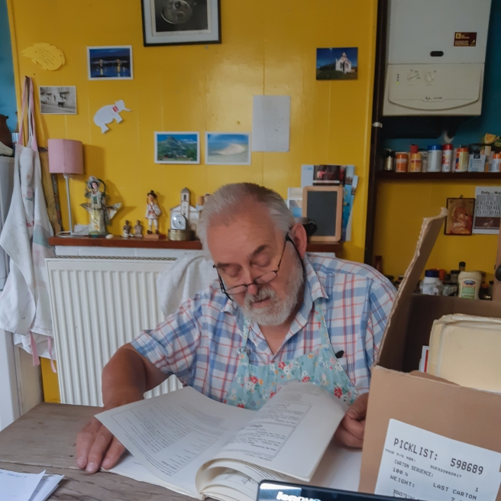Mario looking through his vast archive in Faversham (soon to be shipped over to Bratislava to be converted into an accessible digital archive!)

