Addressing the Crime of Human Trafficking and Modern Slavery in ELT Education - How and Why

Judy Boyle, Greece

Judy Boyle is the founder of The NO Project, an award-winning, arts-based, global educational campaign against modern slavery and human trafficking. She has been involved in anti-slavery educational actions for over 23 years. Judy is a teacher, trainer, researcher and author. Her background also includes professional theatre and filmmaking. In 2022, Judy directed and produced It’s Just Business, an award-winning, surreal short film against modern slavery based on a spoken-word poem by a 16-year-old high school student.
Eamail: judy@thenoproject.org

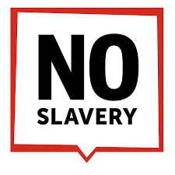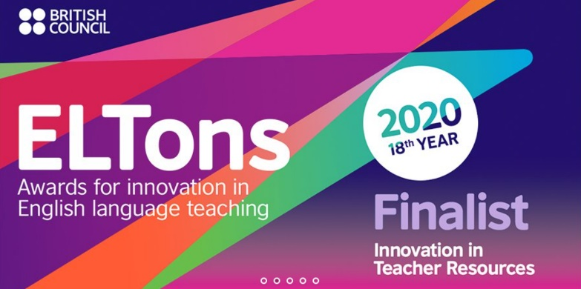
Introduction

Human trafficking and modern slavery exist on every continent. According to the Global Estimates of Modern Slavery Report 2022, over 50 million people are enslaved today, and it is youth and young adults who are at risk. Traffickers can ‘sniff’ vulnerability, and sadly, the belief, ‘This could never happen to me,’ is unrealistic. Yet mainstream education, including ELT, rarely addresses this issue or more accurately, this crime. While teachers may wish to deal with such topics, they are often hesitant to do so, often feeling unsure of how to approach such sensitive themes in a formal learning context. Furthermore, educators may feel that their own knowledge of the crime is insufficient or possible inaccurate, which is a very fair point. The NO Project educational material is specifically designed to support teachers so that the class becomes a shared learning space in which the

What is The NO Project?

The NO Project is an award-winning, arts-based, global, educational campaign that specifically targets awareness of modern slavery and human trafficking through film, music, art, theatre, dance, journalism, creative writing and social media. The governing values of The NO Project are inclusivity, sustainability, dignity, respect.

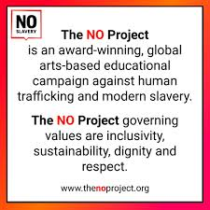

Why focus on youth?

First, young people are often ‘easy targets’ to recruit. Traffickers know that teens and young adults are likely to be more vulnerable and more willing to take a risk, especially when the risk is presented as an exciting romantic adventure or a wonderful way to make good money – and fast. With smiling eyes, false promises and lies traffickers will do what it takes during the grooming or recruitment process.

Second, young people today have consumer buying power for the next 50-60 years, and slavery is in the supply chain of our daily products. Youth today are the consumers, clients, managers, suppliers, managers, business owners, CEOs, lawyers, policy makers and leaders of the future. Their knowledge base will impact decisions they make – decisions which can have a long term, sustainable impact. The crime of human trafficking and modern slavery is not present in mainstream education. Yet, it impacts our daily lives. Our goal is to create a well-informed, pro-active youth population who understand the scale and immediacy of modern slavery and human trafficking. Knowledge is power that leads to change.

The NO Project values the power and skills of young people to influence attitudes and change behaviour. Their ability and willingness to confront those who sustain the demand for human trafficking and modern slavery lies at the heart of this campaign. To reach and inform the next generation we rely on the support of educators who have the courage, integrity and willingness to address this crime in their lessons.

Student-driven actions reflect The NO Project values – with intentional avoidance of clichéd, inaccurate, exploitative narratives often associated with trafficking and slavery. Only through well-informed, pro-active, non-sensationalist understanding of this crime will the next generation be able to confront slavery – be it through governmental policy, corporate legislation, supply chain transparency or ethical consumer behaviour.

The NO Project award-winning lesson plans

The NO Project has created free, downloadable teaching resources on human trafficking and modern slavery. Each lesson is based on a true narrative and is approached with dignity, sensitivity and respect. Designed for upper secondary, young adult and adult learners, The NO Project lessons are ideal for both on-line teaching and in the classroom. Each unit includes slides, artwork, authentic interviews, videos, lexical input, original listening material, and a gentle step-by-step teacher’s guide. Also provided are student autonomous learning resources with suggestions for project-based actions beyond the class.

The NO Project lesson plans have been designed based on the following pedagogical principles and values.

- Reconceiving the classroom as a community of change. The impact of these plans goes beyond linguistic practice or passive awareness. Together, ELT teachers and students are creating remarkable events in the public domain, which have subsequently become part of new lessons, inspiring others to do the same.

- Teacher education beyond ‘training’. The gentle, step-by-step Teacher’s Guide goes beyond being a roadmap of pedagogical suggestions. The Guide provides concise, well-researched knowledge of trafficking and slavery, so that with confidence and accuracy, the teacher becomes an agent of change along with their students.

- Respect for learners and time for personal reflection. Each lesson includes space and time for the learners (and teacher!) to express their personal reactions, thoughts and emotions. The plan allows necessary time for individuals to gradually come to terms with the overwhelming scale and immediacy of slavery.

- Multi-modality of content. In addition to the written narratives, each lesson includes art, images, films or music videos to accommodate the needs of students with diverse learning styles or differences.

- Beyond the class/Personal Projects: development of transversal skills. Globally, ELT students and their teachers are taking action beyond the classroom setting, thus developing skills such as leadership, effective communication, collaboration, problem solving, and project management.

The NO Project free downloadable Teaching Resources were nominated as a global finalist for the British Council ELTons Award 2020, for Innovation in Teacher Resources. In addition to this honour, The NO Project received the British Council ELTons Judges Commendation for Equality, Diversity and Inclusivity. The teaching material was created in partnership with The Rights Lab, Nottingham University, UK.

The NO Project teaching resources have also been featured in the Master’s in Education Program at Havard Graduate School of Education and are now being used by thousands of educators worldwide.

The NO Project educational multi-media seminar

The educational multi-media seminar is the heartbeat of The NO Project work. The presentation includes award-winning short films, world-class animation, music, art, sport, dance, theatre, poetry and creative writing – all reflecting the purposeful, pro-active stance that youth, artists and educators are taking to confront the crime of modern slavery. The seminar content is respectful, non-sensationalist, sensitive. and specifically designed to inform and engage an older teen/young adult audience. Seminars are also designed for adult audiences, specifically lawyers, business people, educators and parents.

A primary goal of The NO Project multi-media seminar is that participants will gain knowledge of and be able to respond to the crime of modern slavery and human trafficking with accuracy, confidence, clarity and purpose.

The NO Project multi-media can be presented in person or online. Please contact us for further information. We would love to hear from you. judy@thenoproject.org

It’s Just Business: a surreal short film with global reach

It’s Just Business is a short film against the crime of human trafficking and modern slavery. The film is surreal, dreamlike, non-linear. and based on the spoken-word poem of the same title. The point of view is unexpected, disturbing, real. As film unfolds, we realise who is speaking - and why. It’s Just Business is based on the remarkable spoken-word poem of the same title. The poet at the time was a 16-year-old high school student who, the previous week, had attended The NO Project multi-media seminar in their school.

The film has been featured in over 35 International film festivals and is now being used in anti-trafficking prevention workshops with vulnerable youth in a major conflict zone. This global outreach was profoundly impacted by the young poet’s English teacher whose insight, compassion and proactive behaviour prompted her to send the poem to us at The NO Project. With the consent and engagement of the poet, educational resources based on the film are currently being piloted in various countries ready to soon go global.
We would love to hear from teachers who would like to pilot the material. Please do contact us: judy@thenoproject.org

‘You may choose to look the other way, but you can no longer say you do not know.’
William Wilberforce, Abolitionist (1759 –1833)

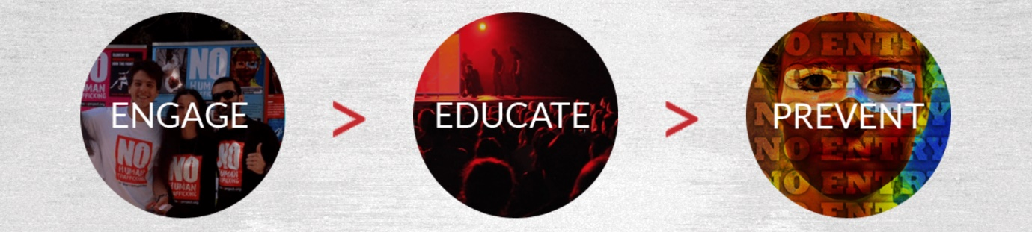

Please check the Pilgrims in Segovia Teacher Training courses 2025 at Pilgrims website.

Please check the Pilgrims f2f courses at Pilgrims website.

