Using Wisdom Stories in Language Teacher Education: How ancient wisdom, anecdotes and aphorisms can enhance teacher training and development by Alan Maley

from Pavilion ELT



Out now!

Using Wisdom Stories in Language Teacher Education
by Alan Maley

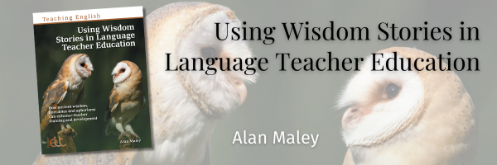

Wisdom Stories offer absurd, creative, and often nonsensical narratives which work on many levels, are open to interpretation, and easily spark discussion and debate. They may come from traditional sources including Zen stories, Sufi stories, Prankster stories such as Anansi stories of West Africa or the Xieng Mieng stories of Laos, fables, Folk stories and, more recently, Urban Myths. They also come from personal anecdotes, poetry, certain categories of jokes, flash fiction and more.

In this new title in the Teaching English series, Alan Maley shares a wide variety of Wisdom Stories and explores how they can be deployed in teacher training and development. This includes traditional Wisdom Stories alongside stories from published accounts on teaching and stories from ELT colleagues. These Wisdom Stories and the accompanying framework and ideas aim to provoke discussion and exploration and challenge teachers and trainee teachers to think about their own teaching practice.

Description
The value of using stories in in language education is well-documented, but in Using Wisdom Stories in Language Teacher Education Alan Maley explores how one particular kind of story can be a useful resource for teacher training and teacher development.
Wisdom Stories present narratives which, on the surface level at least, often appear absurd, paradoxical, illogical and nonsensical. They are open to multiple interpretations and are often allegorical, which makes them extremely valuable for sparking discussion and debate. These Wisdom Stories often come from a number of traditional sources from cultures and countries across the world. This includes Zen stories, Sufi stories, Prankster stories such as Anansi stories of West Africa or the Xieng Mieng stories of Laos, fables, Folk stories and, more recently, Urban Myths. They also come from personal anecdotes, poetry, certain categories of jokes, flash fiction and more.
These stories often provoke discussion and debate on issues which touch on life in general. However, they can also illuminate pedagogical and other classroom issues. In this book, Alan Maley shares a wide variety of Wisdom Stories and explores how they can be deployed in teacher training and development. This includes traditional Wisdom Stories alongside stories from published accounts on teaching and stories from ELT colleagues. These Wisdom Stories and the accompanying framework and ideas aim to provoke discussion and exploration and challenge teachers and trainee teachers to think about their own teaching practice.
Using Wisdom Stories in Language Teacher Education is part of the Teaching English series.
source

About the Author
Alan Maley began working in ELT with The British Council in 1962. Across 26 years he worked in Yugoslavia, Ghana, Italy, France, China and India. He then became Director-General of the Bell Educational Trust in Cambridge, before taking up the post of Senior Fellow in the Department of English, National University of Singapore. His last full-time post was as Dean and Professor of the Institute for English Language Education, Assumption University, Bangkok, where he set up new MA programmes. Since then, he has occupied a number of visiting professorial posts at Leeds Metropolitan, Nottingham, Durham, Malaysia (UKM), Vietnam (OU-HCMC) and Germany (Universitat Augsburg). He has published extensively and was series editor for the Oxford Resource Books for Teachers for over 20 years. He was a co-founder of The Extensive Reading Foundation, and of The C group: Creativity for Change in Language Education. He is a past-President of IATEFL, and was given the ELTons Lifetime Achievement Award in 2012.
source

Please check the Pilgrims in Segovia Teacher Training courses 2025 at Pilgrims website.

Please check the Pilgrims f2f courses at Pilgrims website.

