Enhancing Speaking Skills Integrating Mind-Mapping During Blended Learning
Lazizakhon Abdullaeva, Uzbekistan
Abdullaeva Lazizakhon is an ESL/EFL lecturer at Yeoju Technical Institute in Tashkent. Has written a number of articles about motivation and ways of enhancing productive skills for L2 learners. E-mail:laziza.abdullaeva@gmail.com
Abstract
The following paper describes a study process of mind-mapping to amplify speaking skills and fluency during distance learning. The study investigates the role of mind-mapping to make learners start speaking and utilizing context vocabulary in oral discourse. Needs analysis showed learner`s demand for improving speaking skills as it has always been an obstacle in expressing themselves in everyday life. The method included integration of traditional teaching and utilizing tech-tools for blended learning or commonly named as `hybrid mode` learning during the first semester at University. The activities included different topics based on their major subject and general topics. The results are revealed and discussed in the article
Introduction
Speaking plays a crucial role in language learning. As a productive skill, speaking is desired by many L2 learners. Thornbury (2005) distinguishes between grammar of spoken language and grammar of written language and states that grammar should be practiced and expanded independently of grammar syllabus. Based on the results of a study, considerable numbers of L2 learners have satisfactory grammar knowledge as most books and curricula are designed to prepare them for entrance exams for universities. Nonetheless, most of learners have high affective filter and face hesitation when it comes to perform their ideas in oral discourse. Another issue that aggravates the situation is that the world faced pandemic and educational system had to readjust the system of traditional classroom teaching to blended learning or online learning and teaching. This brought to a slight impairment of students` performance in oral discourse. There are a plethora of ways to improving speaking including listening, reading, or recording your voice, and speaking itself. A good input, practice followed by the performance can meet the requirements of a good speaking performance. As the world faced pandemics the need for diverse teaching strategies increased. Mind-mapping was utilized as an additional tool as the instructor started designing activities beyond “chalk and talk” (Becker and Watts, 1996). The role of Digital-literacy should also be mentioned here. As educational system started changing rapidly, the ability to use tech tools and other devices came into the priority as well and digital literacy has become an essential skill. As a justification for mapping tools it is worth mentioning that most learners are visual learners and they find utilizing pictures, diagrams, and videos effortless to comprehend. Vekiri (2002) and Winn (1991) also stated that visual displays enhance learning and comprehension. This can serve as an empirical support for utilizing mind-mapping in improving skills.
The following article describes a process of enhancing speaking skills through mind-mapping utilizing task-based approach and technology during blended learning. The term “mind map”was first mentioned by Tony Buzan in 1960s.It is manipulated as an effective tool of note-taking, exchanging visual thinking, and problem solving. As speaking comprises vocabulary and grammar the task for this case was to implement mind-mapping and enhance speaking through a set of topics and vocabulary related to them. The procedure comprised 4 stages that were sequenced and task-based approach was utilized. As the classes were conducted in ‘hybrid mode’ a wide range of tech tools were utilized during the lessons comprising ZOOM platform, PadLet panel for discussion, Coggle.it for making mind maps, and other appliances as videos, projectors and other messengers.
Needs analysis and Data Collection
For this research a Needs Analysis was designed (further NA).The purpose of this NA was to identify an issue that occurred during students` performance and to recognize methods that could assist them to overcome a barrier during interlocution. As the lessons were conducted in ‘hybrid’ mode, the questionnaires were shared via Zoom platform chat boxes and Telegram channels. A triangular approach was utilized to collect the data.(Richards,2017).Students (27 females,23males) were given a questionnaire; a set of speaking tests were done; an observation was made during one semester online. The results showed that learners with high affective filter outnumbered those who did not feel anxiety while making conversations and working on dialogues. It was also detected that L2 learners had a wide range vocabulary and knowledge of grammar but were not able to perform feeling an ‘obstacle’ during oral discourse. In order to overcome this ‘obstacle’ a set of stages were designed.
Method and implementation in the class
Stage 1
The initial stage of the process included integration of vocabulary, grammar and speaking .As it was preferable to follow the university curriculum, the topics that were given in the core book remained in the lesson plans and were designed for intermediate level. The covered topics were the following: Family, Education, Advertisement, Work etc. According to Commonwealth European Framework of Reference (CEFR) Intermediate level students should be able to produce simple speeches on familiar topics or of personal interest such as hobby, friends and others.(Kovrova & Avetisyan,2022).The first topic was Family. Based on a task-based approach the learners were given a Pre-task with a video of an interview where speakers talked about their families that were demonstrated online on the screen of an online platform. Students guessed the topic first. A handout with a set of questions followed the video(Figure 1)
1.Do you have a family?
2.How many people are there in your family?
3.Do you spend a lot of time together?
4.Who is your closest person in your family?
Figure 1.Pre-stage activity for the main topic
When the learners finished with the first task they were asked to write down all the words related to family. The link for a digital tool PadLet was provided. The requirement of the task included adding any words to the discussion panel and sharing the new vocabulary. The new vocabulary and collocations were given to be looked through as a home assignment. Figure 2 shows the results of students` work.
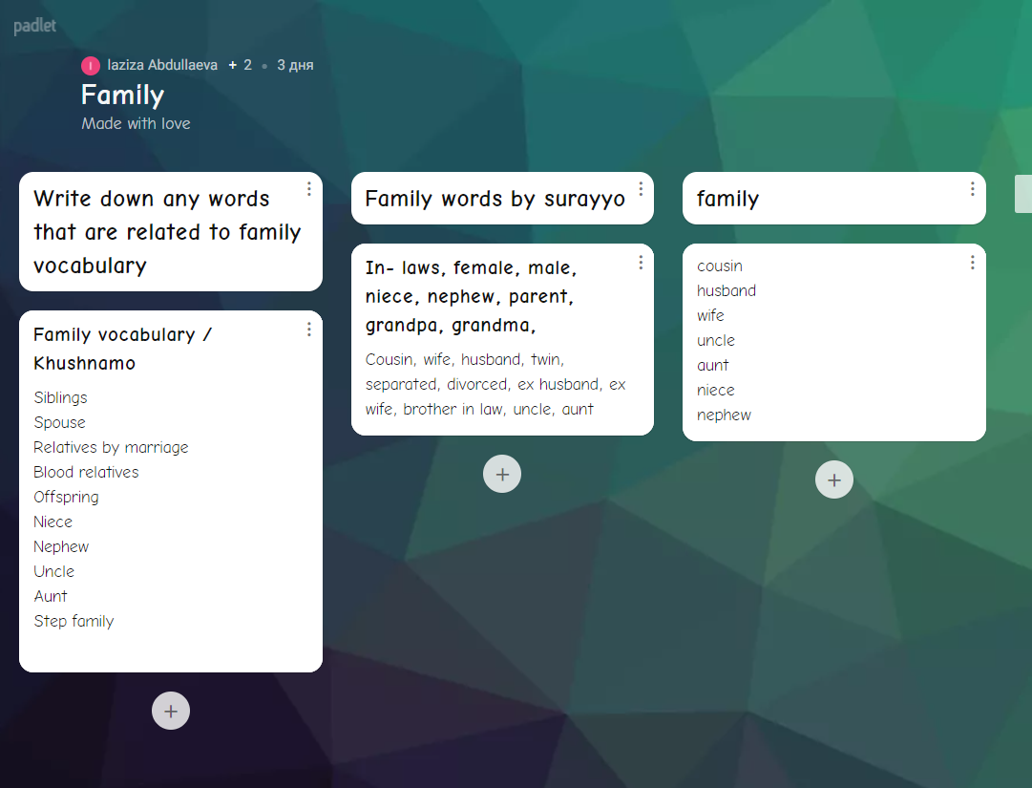
Figure 2.Students` responses on an online discussion panel
Stage 2
This part of the process included the consolidation of the new vocabulary and utilizing mind-mapping online. Traditionally, mind maps are association maps involving an image in the center and colors, pictures and diagrams to ‘draw’ a general picture of the topic. While designing the following mind maps a number of recommendations that were stated by Buzan (2000) were followed. First, an image with topic was placed in the middle with lines coming from the center. Then, students were asked to choose subtopics and write them in as well.Logically,the questions from Pre-task were written there(Figure1). Finally, the key notes were added answering the questions. It should also be mentioned that Mind Map should have been clear by utilizing radial hierarchy (http:www.minmapexample.com/samples.php,Buzan and Buzan,2000).
Stage 3
The following step required looking through the answers on subtopics. The task was to add at least two comments to each answer provided under the question subtopics.(Figure3).Figure 3 shows how learners added comments for each answer making up more sentences and providing others with new ideas. As mind mapping tool is linked to the google account, it was unchallenging to make changes and adding any new information. As a differentiated activity, for some whose level was beyond Intermediate, it was permissible to work in pairs with students who performed better in English.
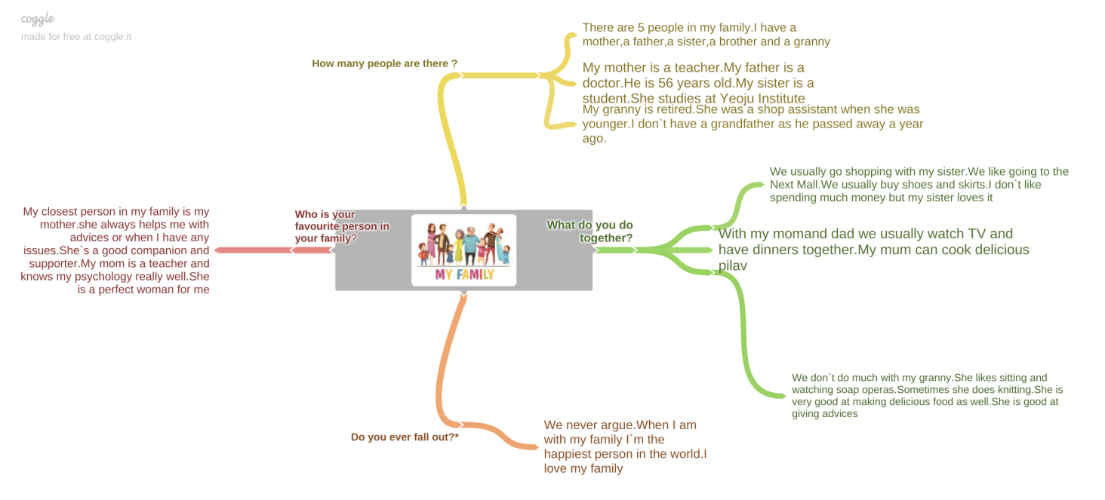
Figure 3.A mind map with students` responses
Stage 4
As a terminating part, the following step comprises a full performance of learners. The learners were asked to take write short essays based on their mind-mapping information.After being observed and having their mistakes verified, the learners try to use the mind maps and perform in front of the class. The ones who still felt hesitation and had high affective filter had an opportunity to make a short recording or record a video while talking about their family. The next topics that were given prior in the syllabus were also made up utilizing this approach.
Results
The outcomes of this approach expose the effect of utilizing mind mapping in enhancing speaking and vocabulary. An estimated 45 learners out of 50 claimed to have lower affective filter, mentioned higher self-esteem during oral performance, and improvement in vocabulary. Post-survey and later observations showed the students` eagerness to participate in speaking activities and as the rest set of topics were taught by utilizing the same method, they felt less anxious while performing. By the end of the semester more than a half of participants started attending speaking clubs at their educational setting and took their chance in public speaking contest.
Conclusion
Mind-mapping advocates itself as ‘free-form’ writing where there are no limits with strict format. It can be utilized for ‘brainstorming’ and it can be used both for successful students hand in hand with those who acquire lower level in English. The work described above aimed to expose an approach that was utilized during blended learning in multi-level class to enhance speaking skills using mind-mapping. The outcomes proved usability, meaningful learning (Hay et al, 2008),scaffolding in learning and motivated the learners to start speaking. Post survey and observation showed low affective filter as the learners felt themselves comfortable and sheltered, were eager to perform. The primary concern of the study was to make learners to start speaking, lowering their high affective filter, improving their vocabulary and speaking skills which was met by the end of the semester. Mind-mapping can be utilized effectively during online sessions or classes that are conducted in ‘hybrid mode’ as they are editable online tools that are easy to comprehend and utilize. For further implications this tool can be used for group-working or pair work where learners work and edit the maps in distance from home. As mind-mapping tools are still developing, instructors and learners are being provided with new teaching and learning tools enriching new directions and ways in education in the near future.
References
Becker,W.E.,and M.Watts.1995.Teaching tools: Teaching methods in undergraduate economics.
Economic Enquiry 33 (October):692-700

Buzan,T.,& Buzan,B.(2000).The mind map book. London: BBC Books.

Hay,D.,Kinchin,I,.& Lygo-Baker,S.(2008).Making learning visible: The role of concept mapping
in higher education. Studies in Higher Education,33(3),295-311

Kovrova, M., Avetisyan, V.,. (2022). Tips on Teaching Intermediate students. Retrieved 24 April
2022, from https://skyteach.ru/2019/10/15/tips-on-teaching-intermediate-students/

Richards, J. (2017). Curriculum development in language teaching. Cambridge: Cambridge
University Press.

Thornby, S. (2005). How to teach speaking. Harlow: Longman. (2022). Retrieved 24 April 2022, from https://youtu.be/Jp7Tu_Ns6Io

Family.(2022). Retriev April 2022, from https://padlet.com/lazizaabdullaeva/abs7pie1ionxvbya

Vekiri, I. (2002). What is the value of graphical displays in learning? Educational Psychology Review,
14(3), 261–312

Winn, W. (1991). Learning from maps and diagrams. Educational Psychology Review, 3(3), 211–247.

Please check the Pilgrims f2f courses at Pilgrims website.

Please check the Pilgrims online courses at Pilgrims website.

