An Activity from More Grammar Games by Mario Rinvolucri and Paul Davis
Hanna Kryszewska, Poland

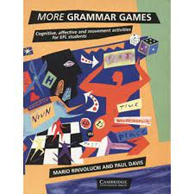

More Grammar Games were published on 4 May 1995, and they book made ripples. So, it deserves to be called a Golden Classic not only because of its age as well as of the impact it has had. It was probably the first resource book that looked at practicing grammar and making grammar clear and understandable to learners in such a way. Also, the activities in the resource book are very humanistic as they came form key trainers at Pilgrims, the hotbed of humanism in English Language Teaching.
Personally, I know the book was very important to Paul even though he never said it. Until he died in 2020 the first page of the galley proofs with the cover of the book, which was faded and dog eared, was still pinned to the cork notice board over the kitchen table. Other bits came and went but the cover was a the never changed feature of the display.
The very first activity in the book “Betting on Grammar Horses” (see below) is a very good example of how Mario and Paul thought about language, how they observed language and how they got inspired. It is noticeable that they wanted learning and practising grammar to be fun, meaningful, natural, and communicative. And… they were inspired by an Italian quiz show! In other words they not only imported the activity to the UK but they also imported it to ELT. It was so typical Mario in Paul to find inspiration everywhere…
I am sure we can do the same. Use or adapt the currently popular quiz shows suitable for language learners or dust some other golden classics like:
- Whose Line is in Anyway with its short-form improvisation games, creating funny scenes for given situation,s performing a scene to different television and film styles or using props creatively,
- Taboo for vocabulary work to elicit the key word using other related words.
- Charades which is a very physical guessing game in which we use body language and facial expressions to elicit a word, a phrase or a title
- and many other. (If you have any more ideas describe them and share them with HLT readers in an article).

Please check the Pilgrims f2f courses at Pilgrims website.

Please check the Pilgrims online courses at Pilgrims website.

