upporting your professional development

View in browser



Out now in the Teaching English series!

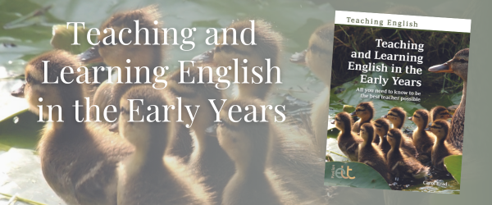

Teaching and Learning English in the Early Years provides a lively, varied, ‘must have’ A–Z compendium of how to teach English to very young children between the ages of 3–6. It offers teachers an extensive repertoire of easy-to-implement creative ideas and techniques to work with in the classroom. The A–Z format provides a memorable and easily-referenced manual for teachers, with a large variety of low-preparation, practical teaching ideas. Each one links clearly to a language point with easy-to-follow teaching notes. Each also links to a section providing further reflection and teacher development.

Carol Read is a teacher, teacher trainer and materials writer with over 30 years’ experience in English language teaching. She has taught students of all ages and levels, from very young children to adults. Her interest in early years and primary education grew after having her own children. She became fascinated by child development, bilingualism, and foreign language teaching and learning in mainstream education – all areas which continue to be central to her work today.

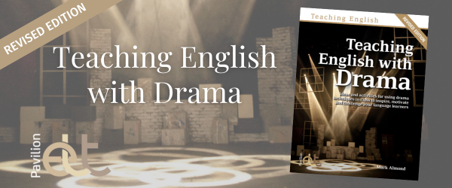

Teaching English with Drama shows teachers how to teach language learners using drama, plays and theatre techniques. This revised edition provides explanations on how the techniques can be incorporated into standard English lessons whilst encouraging teachers to go beyond the norm. The book’s activities are designed to motivate learners and get them talking in English in innovative and creative ways, in order to increase their confidence in speaking and help ensure they will develop the skill set to operate more effectively in English in real life.

Mark Almond is a Senior Lecturer at the School of Language Studies and Applied Linguistics at Canterbury Christ Church University. He has over 20 years’ experience of teaching and teacher training in the field of ELT. Mark is a regular speaker at conferences on the use of drama and theatre techniques in the classroom, and frequently provides training of this kind on invitation and as part of the teaching he does at Christ Church.

