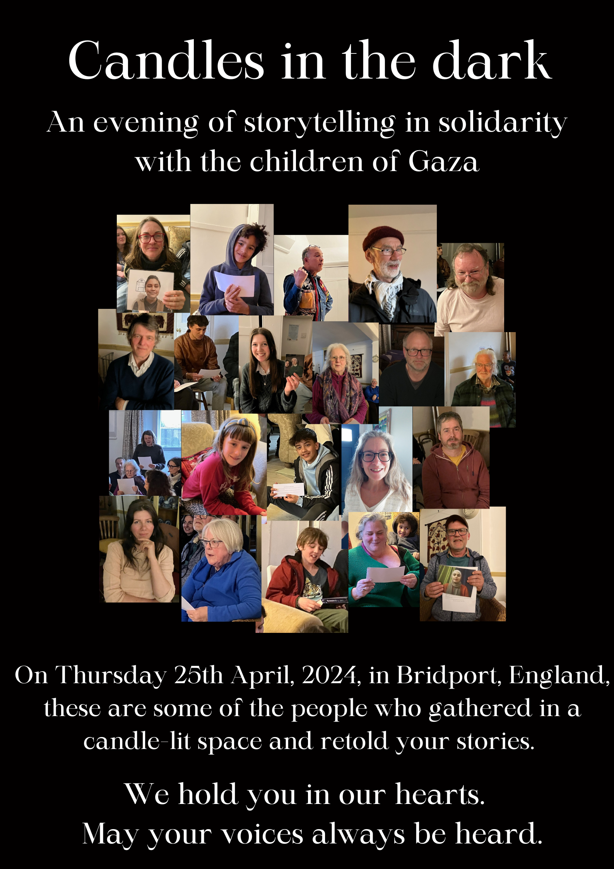

Candles in the Dark

Lu Orza and Raja Jarrah, UK

Raja Jarrah is a storyteller, craftsperson and environmentalist from Bridport, Dorset. Email: rajajarrah@hotmail.co.uk

Lu Orza is a storyteller, writer and facilitator from Bridport, Dorset. Lu Orza Storytelling (google.com). Email: luisa.orza@gmail.com

Foreword. The story behind the project

When Haneen Jadallah from Gaza and I spontaneously launched Tell a Child in Gaza’s Tale (see our article from February 2024 https://www.hltmag.co.uk/feb24/tell-a-child-in-gazas-tale)

in response to the ongoing catastrophe, we could not foresee how the project would be received and where it would lead.

Below is an account by Lu Orza and Raja Jarrah who read the article and found in the project an opportunity for local people in the town of Bridport, Dorset, UK to celebrate the culture and creativity of young learners of English in Gaza and show solidarity in this time of extreme suffering. This is a fantastic example showing the impact that young learners of English such as these children in Gaza can have when they share their stories with the world.

All of the video recordings of children in Gaza telling stories that we have shared so far have now been retold, recorded and shared by storytellers, teachers of English and their students all around the world, some of them several times – see the YouTube playlist. We continue to encourage more people to join in, especially English language teaching professionals who are in a unique position to invite learners to respond to the deeply meaningful and relevant learning these stories offer.

David Heathfield
Storyteller and Teacher Trainer,
Exeter, UK

Meet Lu and Raja

We are two storytellers from Bridport, Dorset. At the start of 2024, we held a storytelling event around the time of year that celebrates the returning of the light as the days begin to lengthen again after the darkness of the winter. Towards the end of January, the first flowers of spring can be seen here, and the days are noticeably longer again.

Raja asked, ‘how can we celebrate the returning of the light when things are still so dark for the people of Gaza?’ That evening he told two Palestinian stories, asking those present to bring the light of hope to the people of Gaza.

The very next week - as if by magic! - Lu, who is a member of the UK Society for Storytellers, came across an article by David Heathfield about the “Tell a Child in Gaza’s Tale” project he runs with Palestinian English teacher Haneen Jadallah.

Importantly, the project included an explicit invitation to retell the stories of young storytellers from Gaza and lift the spirits of the children and their teachers that their stories were being retold by others from across the world. Lu shared the article with Raja, and together they said: ‘Let’s do this!’

And so, borrowing a line from the poem ‘Think of Others’ by Palestinian poet Mahmoud Darwish, the idea for Candles in the Dark was born, a storytelling event in solidarity with the children of Gaza. We wanted their voices to continue to be heard, celebrating their storytelling, with our heartfelt support and solidarity. We hoped we could shine some light for these children and their families at this very dark time.

We wanted to retell stories, fables and folktales that have been told at the online World Storytelling Cafe by children from Gaza. Lu and Raja spent days listening to the stories on the Tell a Child in Gaza’s Tale platform and transcribing them so that we could print them off, and invite people to read them at the event in Bridport on 25th April 2024.

We were thrilled that the people of Bridport responded to this invitation and came along to the event excited at the idea of being able to show their solidarity, support and love in their own small way through the reading of stories. To promote the evening we had used a photo montage of the storytellers from Gaza who had told their stories on the World Storytelling Cafe, and after the event we created a similar compilation of people from Bridport retelling the stories. Here you can see Lu and Raja, Michele, Andrew, Theo, Harriet, Clare, Samir, Kamsi, Jules, Jo, Joe, Jessie, John, Conrad, Ioana, Martin, Tom, Horatio and Hazel – and a couple of others whose names we don’t know! – who all read or told stories on the night.

The stories we heard that night…

They included:

The Island of Feelings - Told by Raghad from Gaza, and retold by Ioana from Bridport
Lolaja, Yusefi and the Ghoul – told by Areej from Gaza, and retold by Jules from Bridport
The Fool and the Donkey - Told by Mesk from Gaza, and retold by Michele from Bridport
Sally goes to the petting zoo - told by Mariam from Gaza, and retold by Kamsi from Bridport
The Blind Girl – told by Hala from Gaza, and retold by Lu from Bridport
The Apple Tree (or the Selfish Boy) – told by Sheraz from Gaza, and retold by Martin from Bridport
Pete the cat - told by Zena from Gaza, and retold Jo from Bridport
The Neighbour is before the House – told by Maram from Gaza, and retold by Clare from Bridport
The Most Beautiful Bird – told by Raghad from Gaza, and retold by Theo from Bridport
Joha and the Cat – told by Nima from Gaza, and retold by Samir from Bridport

We were also lucky that David and his wife, Tammy, joined us from Exeter. David told the wonderful story of Lolaja, Yusefi and the Ghoul https://youtu.be/BPWC061VnwM?si=7yJZ5i7rYPvbOlRX

And here are some of the children in Gaza whose stories we are retelling…

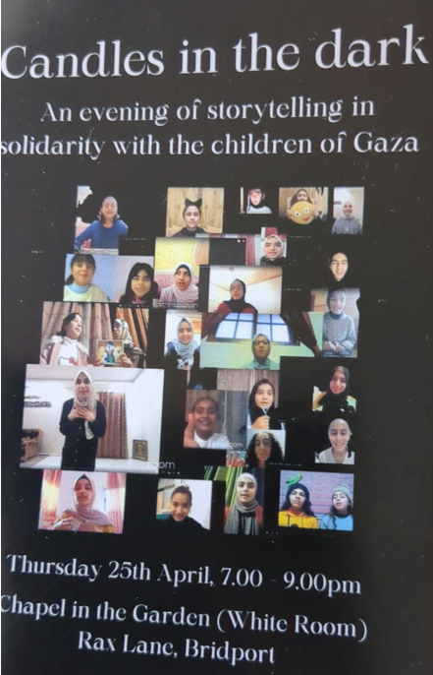

Follow-up

Following the event, we wanted to make sure that as news of the war is eclipsed by other world events, that people would remember what is going on. The devastation that has taken place in Gaza will take years to rebuild, and for those families who have lost loved ones, there will be no recovery. We can only hold them in our hearts and support them in any way we can.

The poem, our motto

So, as we organise other storytelling evenings and events, we continue to retell the children’s stories and remind people of the words of the poem:

Think of Others
As you prepare your breakfast, think of others
(do not forget the pigeon's food).
As you conduct your wars, think of others
(do not forget those who seek peace).
As you pay your water bill, think of others
(those who are nursed by clouds).
As you return home, to your home, think of others
(do not forget the people of the camps).
As you sleep and count the stars, think of others
(those who have nowhere to sleep).
As you liberate yourself in metaphor, think of others
(those who have lost the right to speak).
As you think of others far away, think of yourself
(say: 'if only I were a candle in the dark').

Mahmoud Darwish (1941-2008)

The sharing of stories is a deeply human act of connection. The stories retold at the event, in the words of the children from Gaza, were a strong message of love that we send back to them, and to all of you reading this today.

Please check the Pilgrims f2f courses at Pilgrims website.

Please check the Pilgrims online courses at Pilgrims website.

