Teaching ESL in Rural Hungary
Joe Macpherson, UK
Joe Macpherson is a teacher at Várday Kata Református Általános Iskola in Hungary. He has taught ESL for 9 years, predominantly in China. He enjoys working with teenage students, and is always reading about and learning new methodologies to improve his classes. He will transition to a new role at an International School in Myanmar

Editorial note
The text was originally published on LinkedIn at https://www.linkedin.com/pulse/teaching-esl-rural-eastern-hungary-joe-macpherson-opv7f/

Teaching in Hungary can be a challenging but rewarding experience, and it is quite different to what I expected before I started my role. So, I decided to write down some of my thoughts and observations for those interested to know what it is like here. Before I start, please note this is my own experience and it may differ from yours.
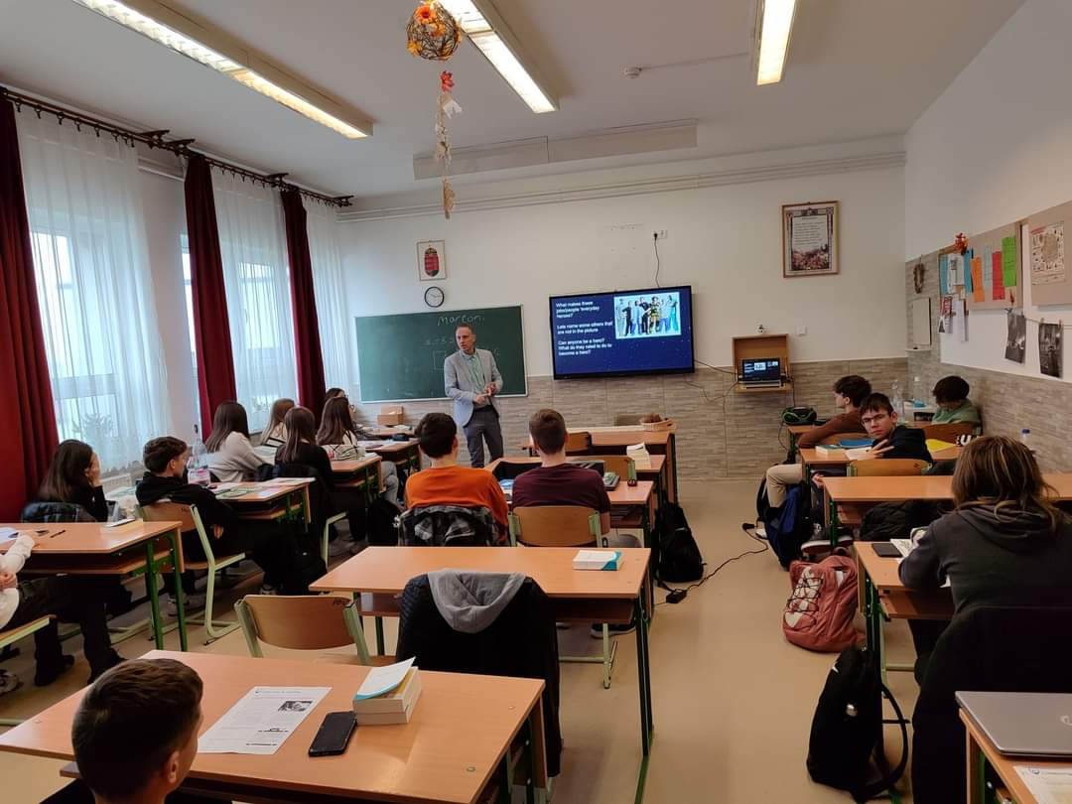

Some background. I work in a reformed church grammar school in Kisvarda, which is a small town in North Eastern Hungary. It is split up in different buildings from grades 1-12, and I teach grades 5-12. Most of my classes are grades 9-12 with a few classes a week for the lower grades. My typical schedule is 23 classes a week, and this is just about a manageable load. I would like less lessons of course, but my workload is the same as my Hungarian colleagues so I just get on with it.
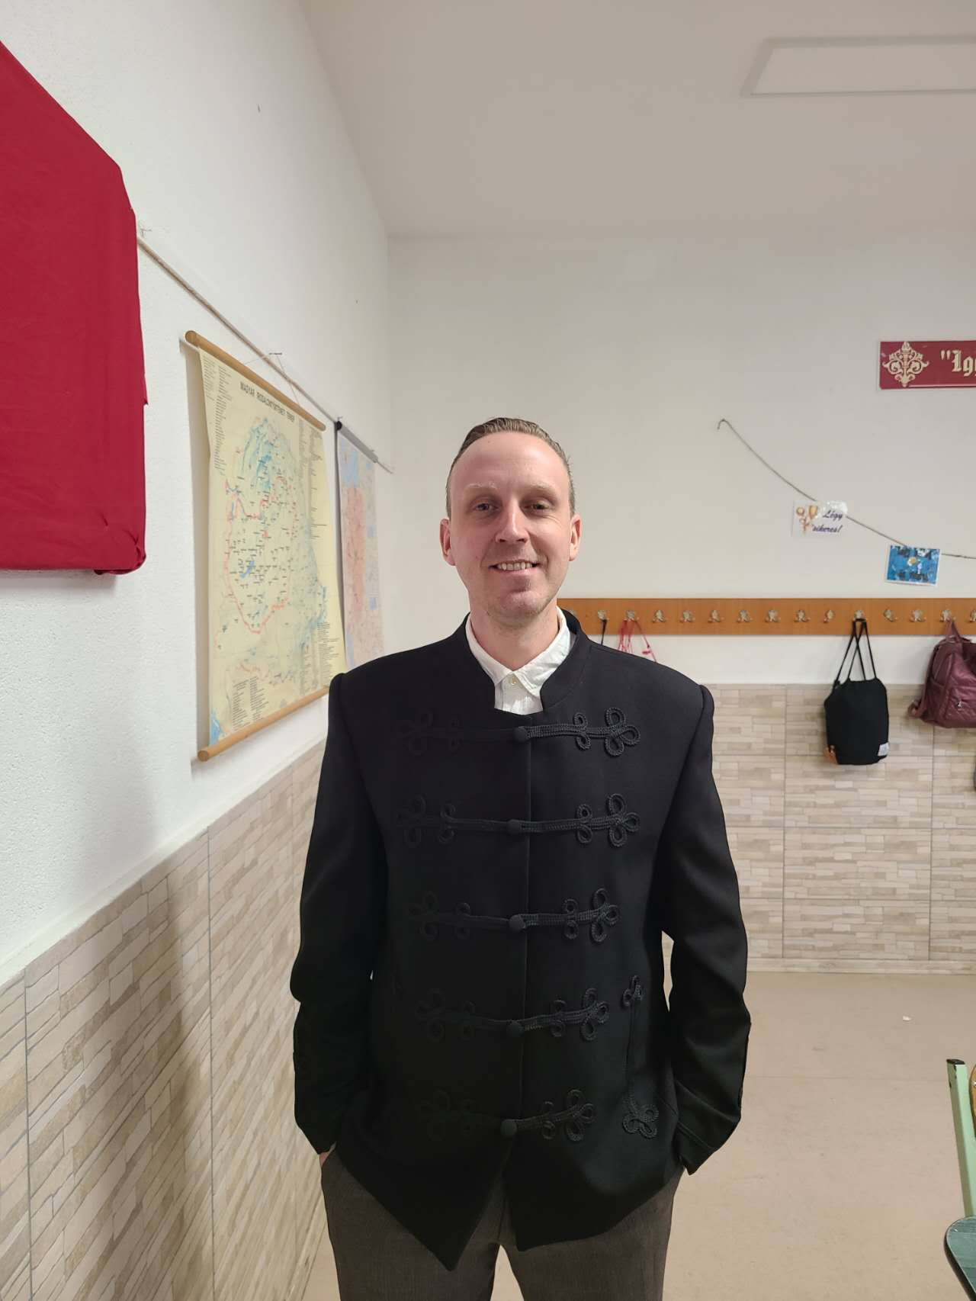

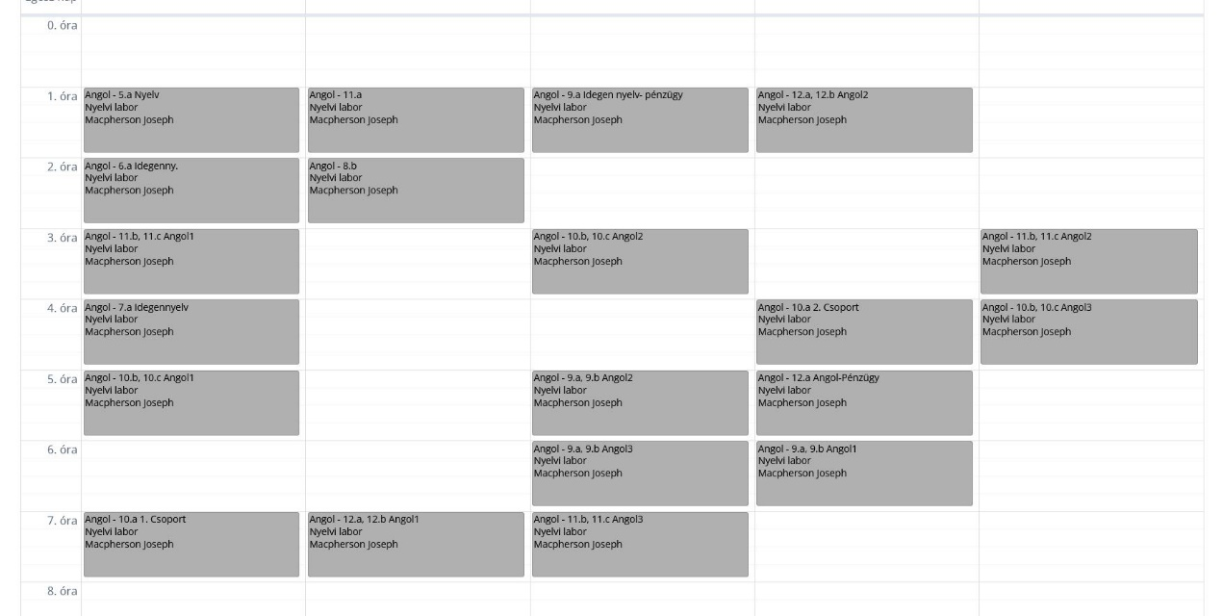
I have my own classroom; it is known as ‘the language lab’ and it was assigned to the ESL teacher at the request of my predecessor. It is designed for listening sections of language exams and has audio capability both from speakers and headphones. It did not have much personality so I did what I would with what I would find. I would prefer a classroom with a computer, but again I choose not to rock the boat. If I really need to use one, I can sometimes swap with another teacher.
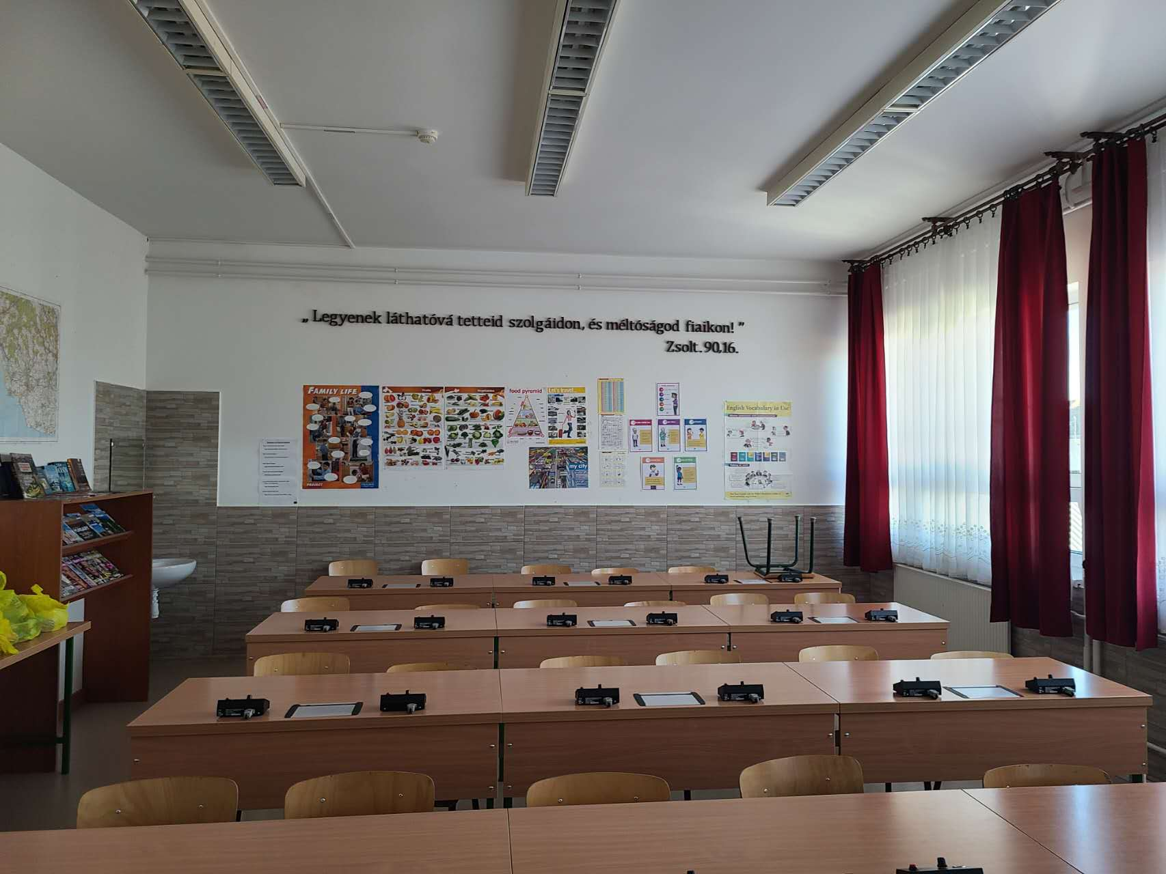
Now back to my schedule. The English classes here are split up in quite an interesting way, and it took me a few weeks to become acclimatized to just how different each class is. There are specialized classes, and these are the ‘higher’ level language students and have 6/7 English classes a week. They will likely take language exams, enter competitions and it is a much more of an academic style class with tangible aims at the end of each year. Additionally, there are ‘mixed’ groups. These are the students who have compulsory language classes, and as such are not so interested in the subject. The ability level can vary greatly in these classes, from A1 to C1 (they are grouped together). Usually, my aim in these classes is to make English as fun & interesting as possible, whilst of course following a teaching/lesson aim.
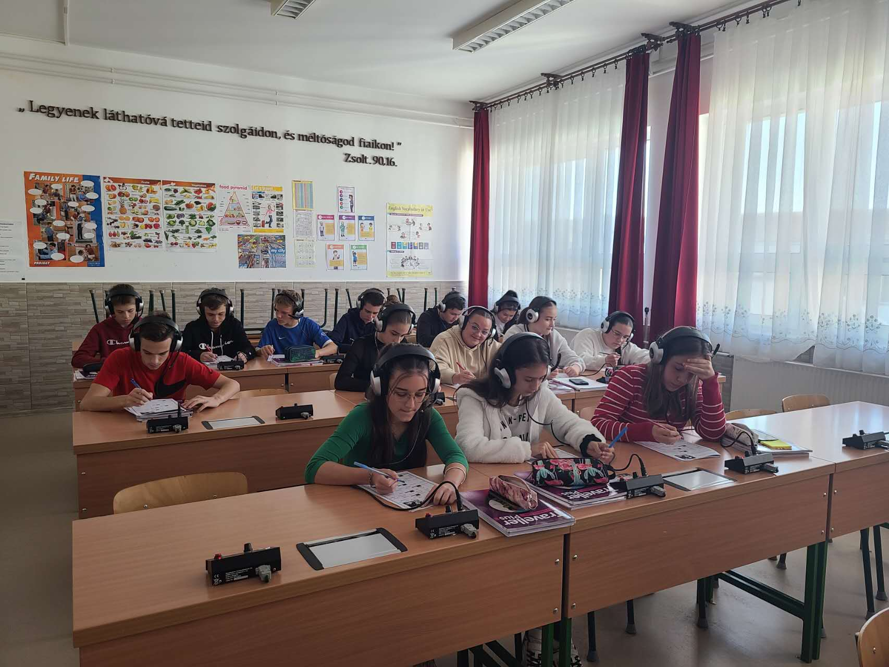
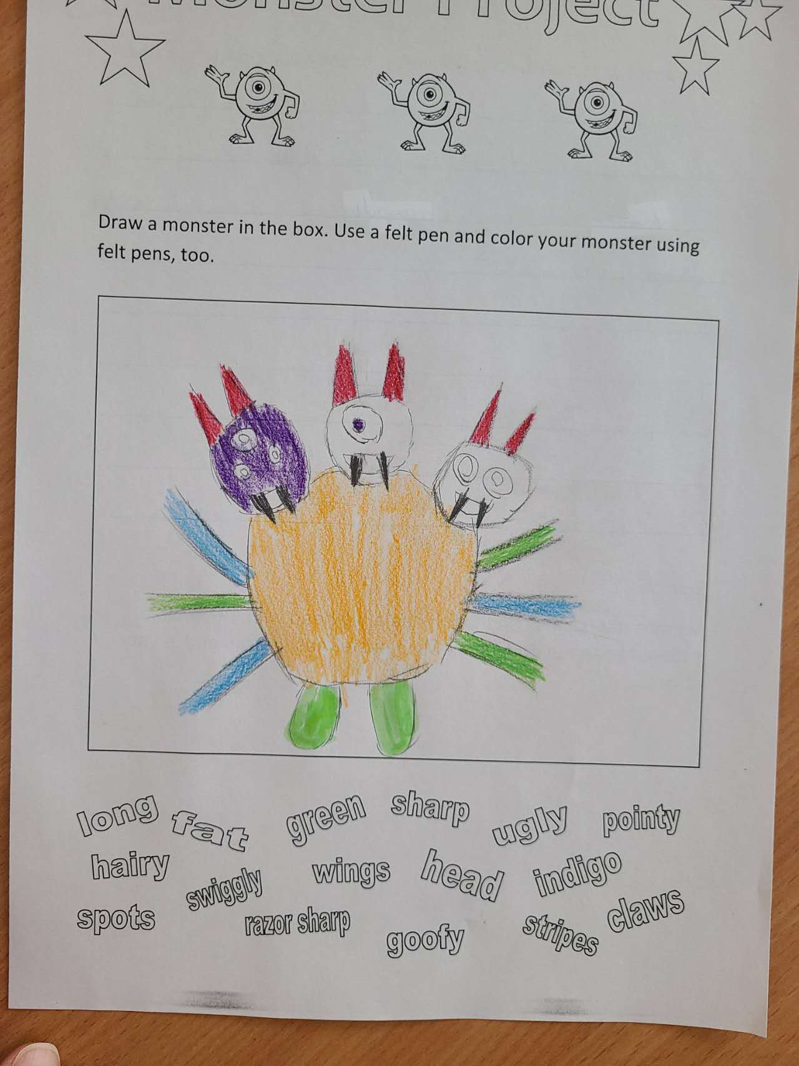
The biggest issue with this kind of schedule is that you can go from a mixed A1 level class, to a specialised C1 level class, to an after school B1 level class and so on. And this does keep the job interesting, and it is common for most teachers, so I am not alone in that regard, but it can be disorientating. One minutes I am teaching basic time or likes/dislikes then next we are doing a group presentation or debating some interesting topics. Each class and day are quite different, and it keeps me on my toes.
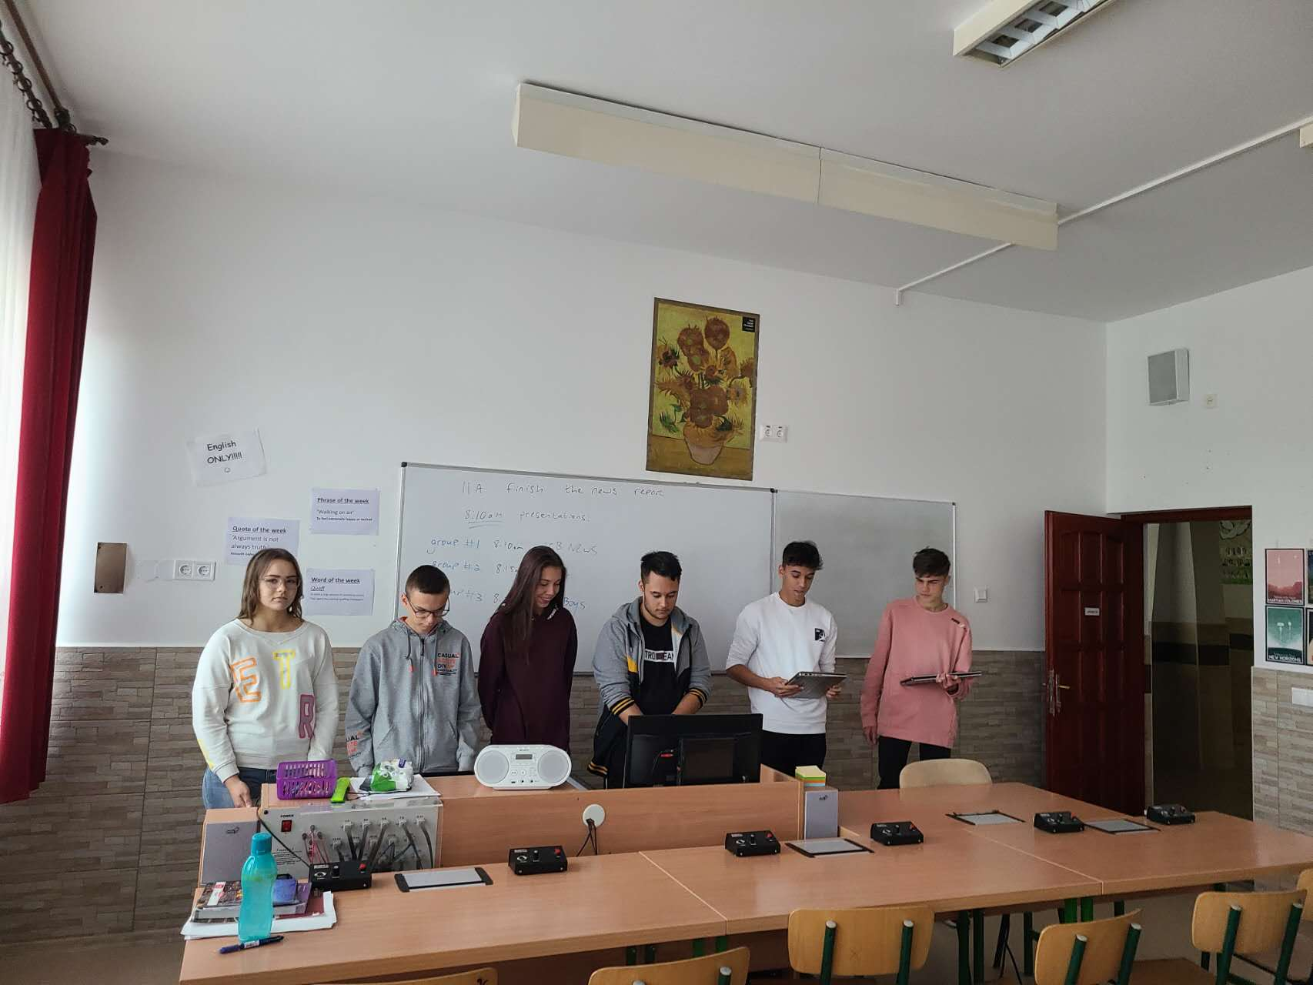

The school itself is nice. I do not know how it compares to other public schools in Hungary as I have not seen any. But I think it has everything the students need. There are of course standard classrooms. A language lab as stated above), IT room, Gymnasium for gymnastics and indoor sprots, outdoor gym and sports field, dining hall, lockers, science classrooms and a ‘buffet’ or ‘snack store.’ I am probably missing some things but you get the gist. The school has a successful gymnastics team and swimming team, thanks to talented students and PE teachers.
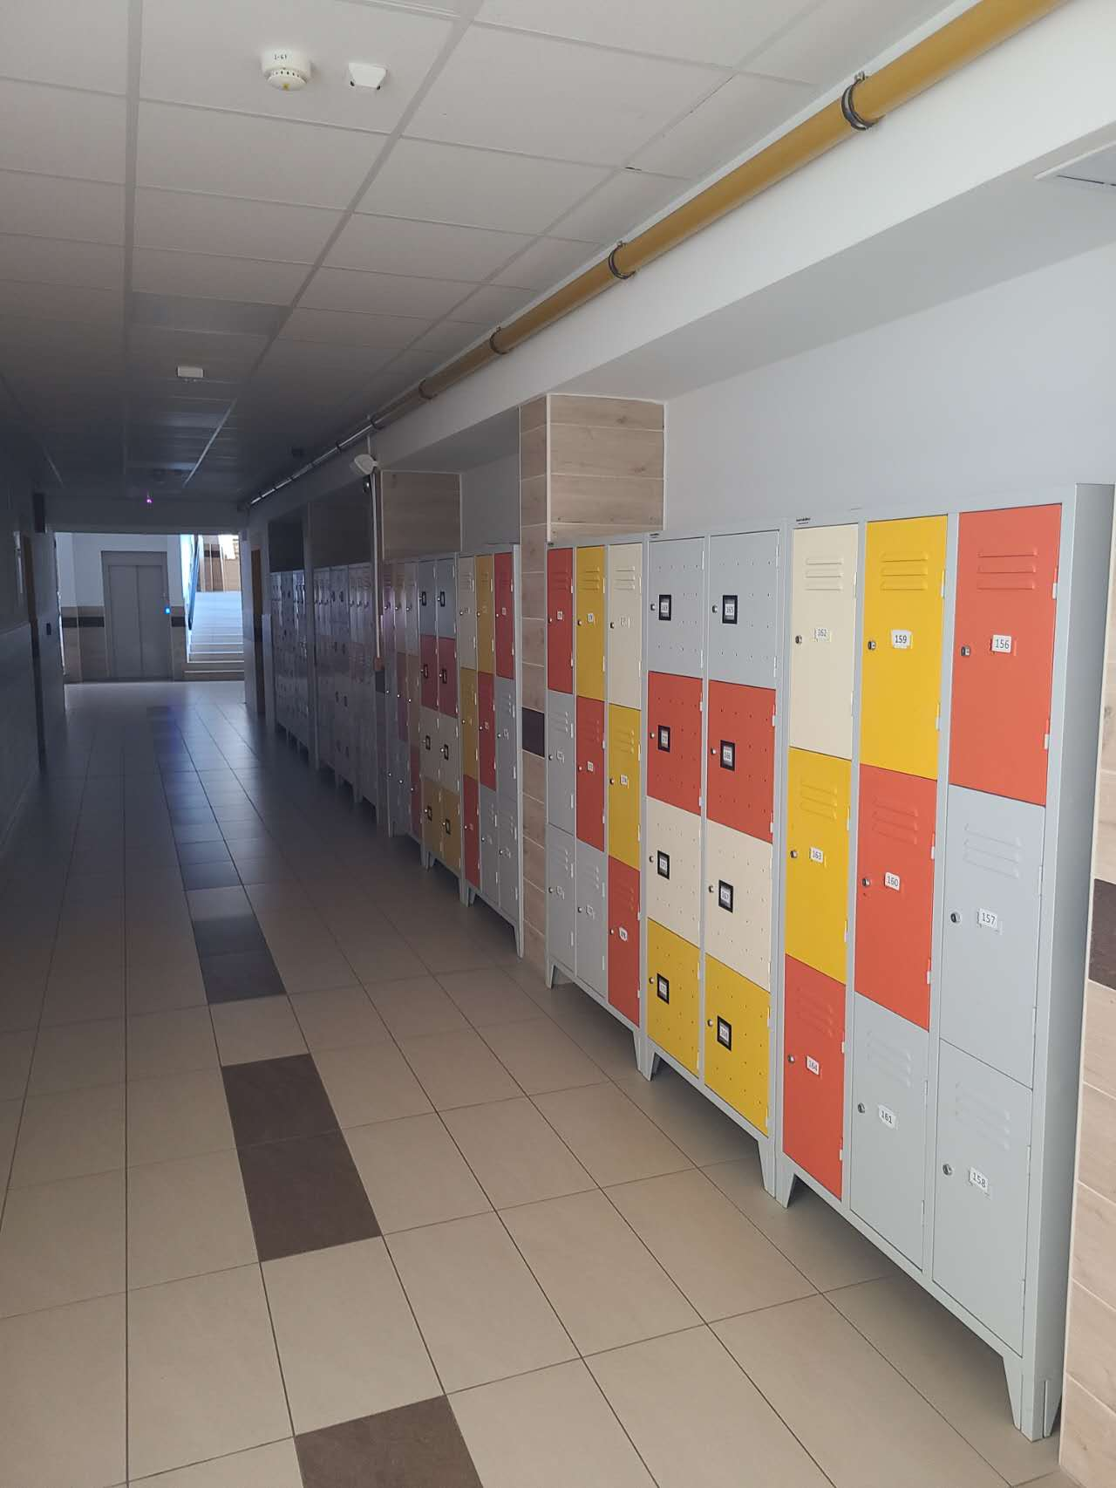
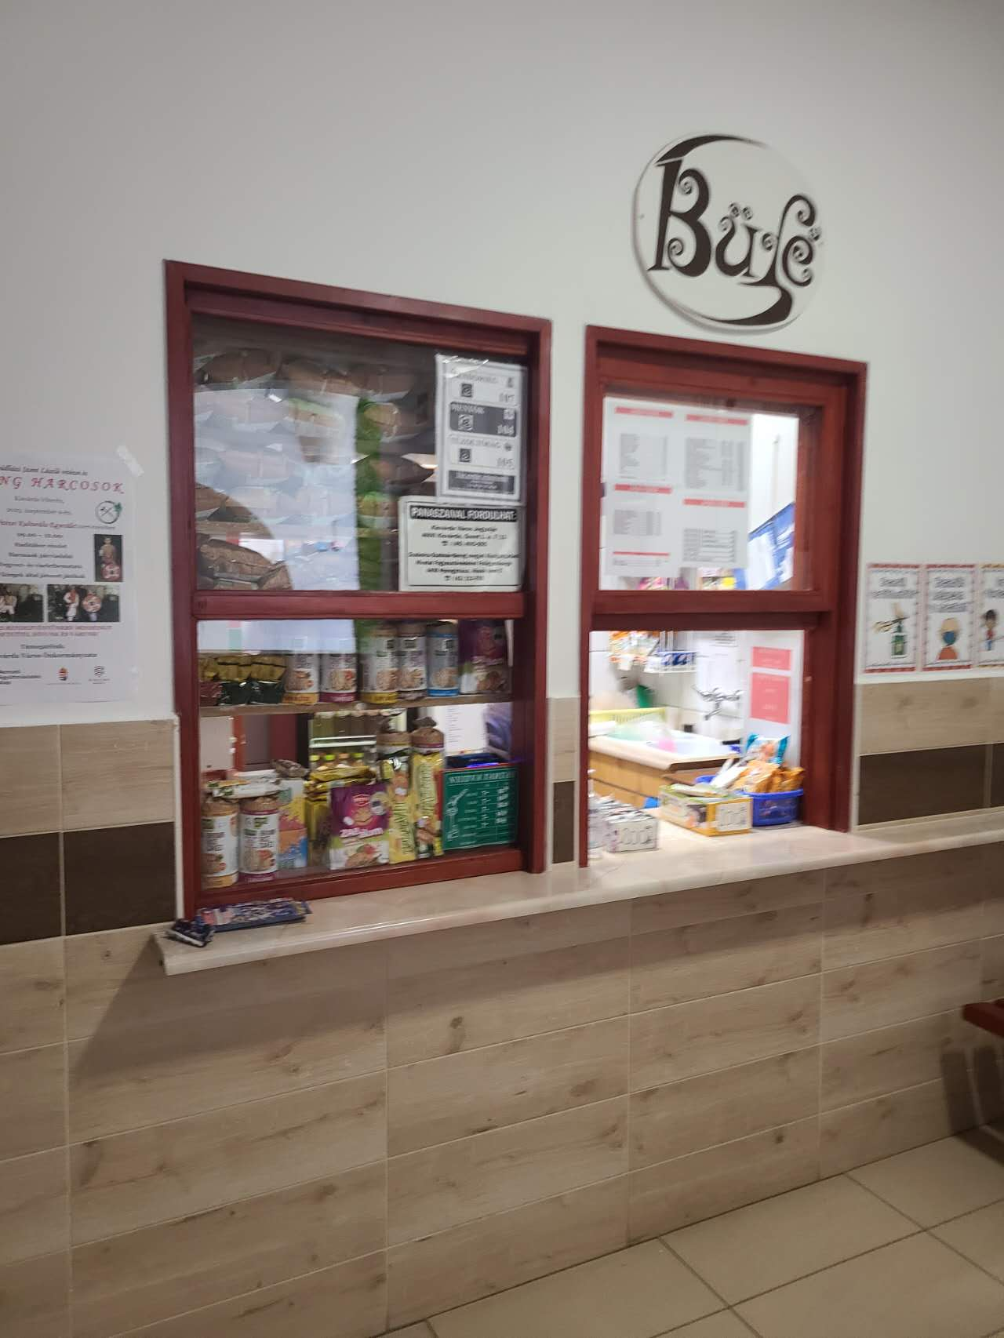

The teacher’s office is what you would expect, a room of desks and computers, with a kitchen, sofa, and a coffee machine. It is a nice place to chill between classes or to do work prep.
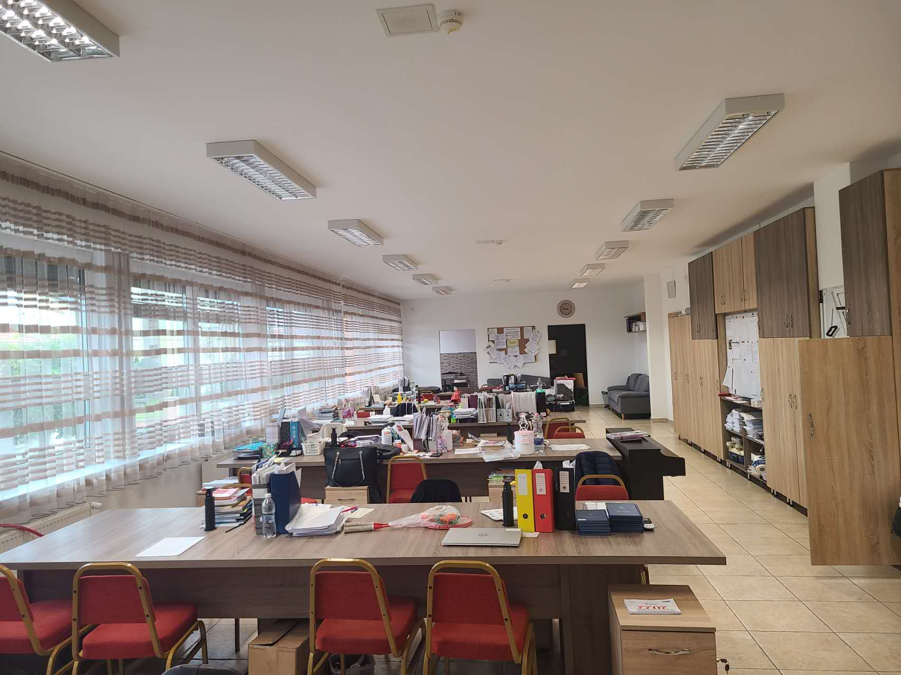
Lunch (usually my favourite part of the day) is also a mixed bag. While the price is excellent (approx. 2 euros) sometimes the dishes are not to my taste. You get the stables like soup, spaghetti, and so on. But truthfully it is a bit bland and boring.
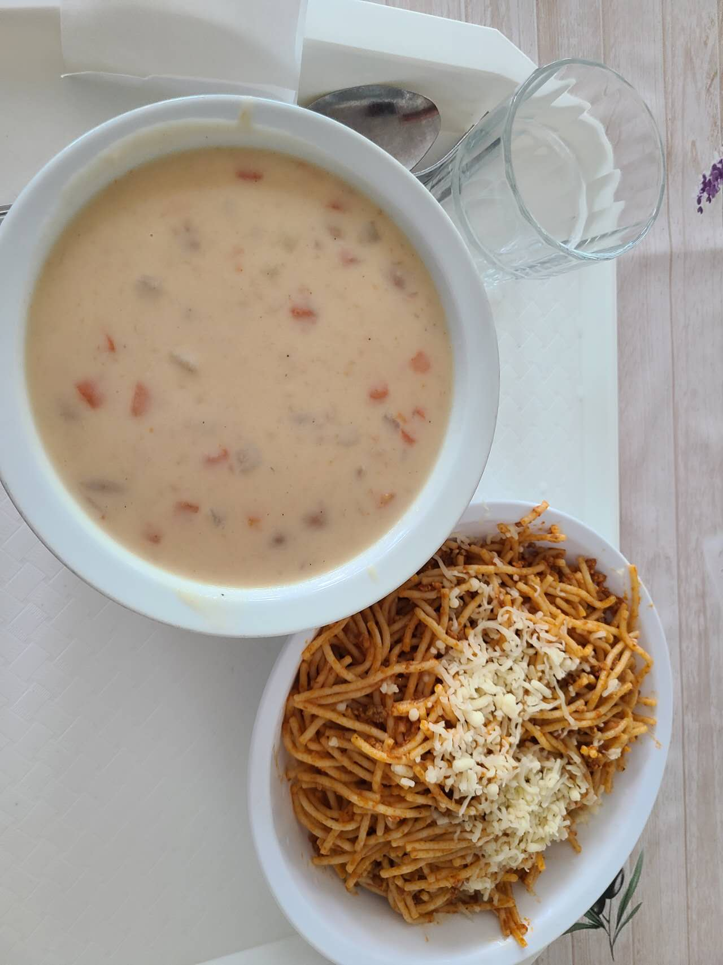

In our school we use online software called ‘KRETA’ for our daily administration. On here you record absences, give grades or homework, read, or send inter-department messages, check your schedule, or see any changes to your schedule and more. For my personal role I use it for recording grades and absences only as I am not a department head or have any serious administrative duties, above those of standard teacher. It’s all in Hungarian so I’ve memorised the functions, even though I can read the text.

One of the most enjoyable parts of my job are the cultural events and experiences that I have. For example, when there are ceremonies or special days during the school year such as ‘National Day’ or ‘Revolution Day’ the students will do skits, dramas, or concerts. These are interesting to watch. I also am lucky enough to join school trips, parties, and other auxiliary things.
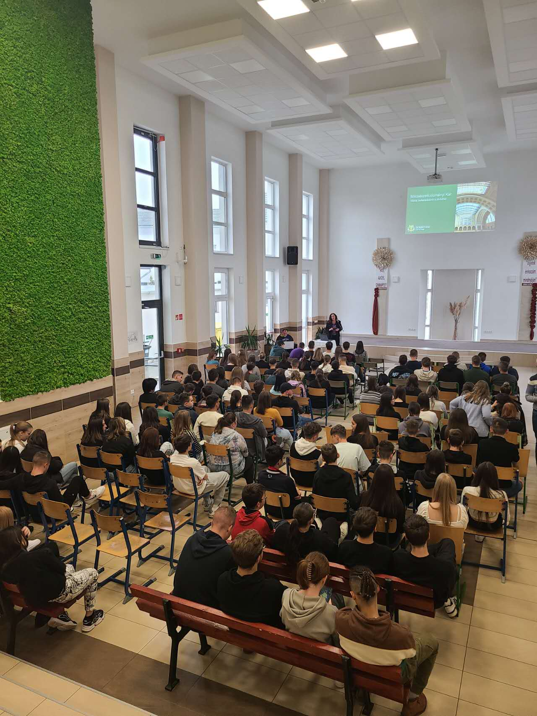
The most memorable of all was the G12 graduation ceremony, which involved flags, marching, chanting and more. I will never forget it.
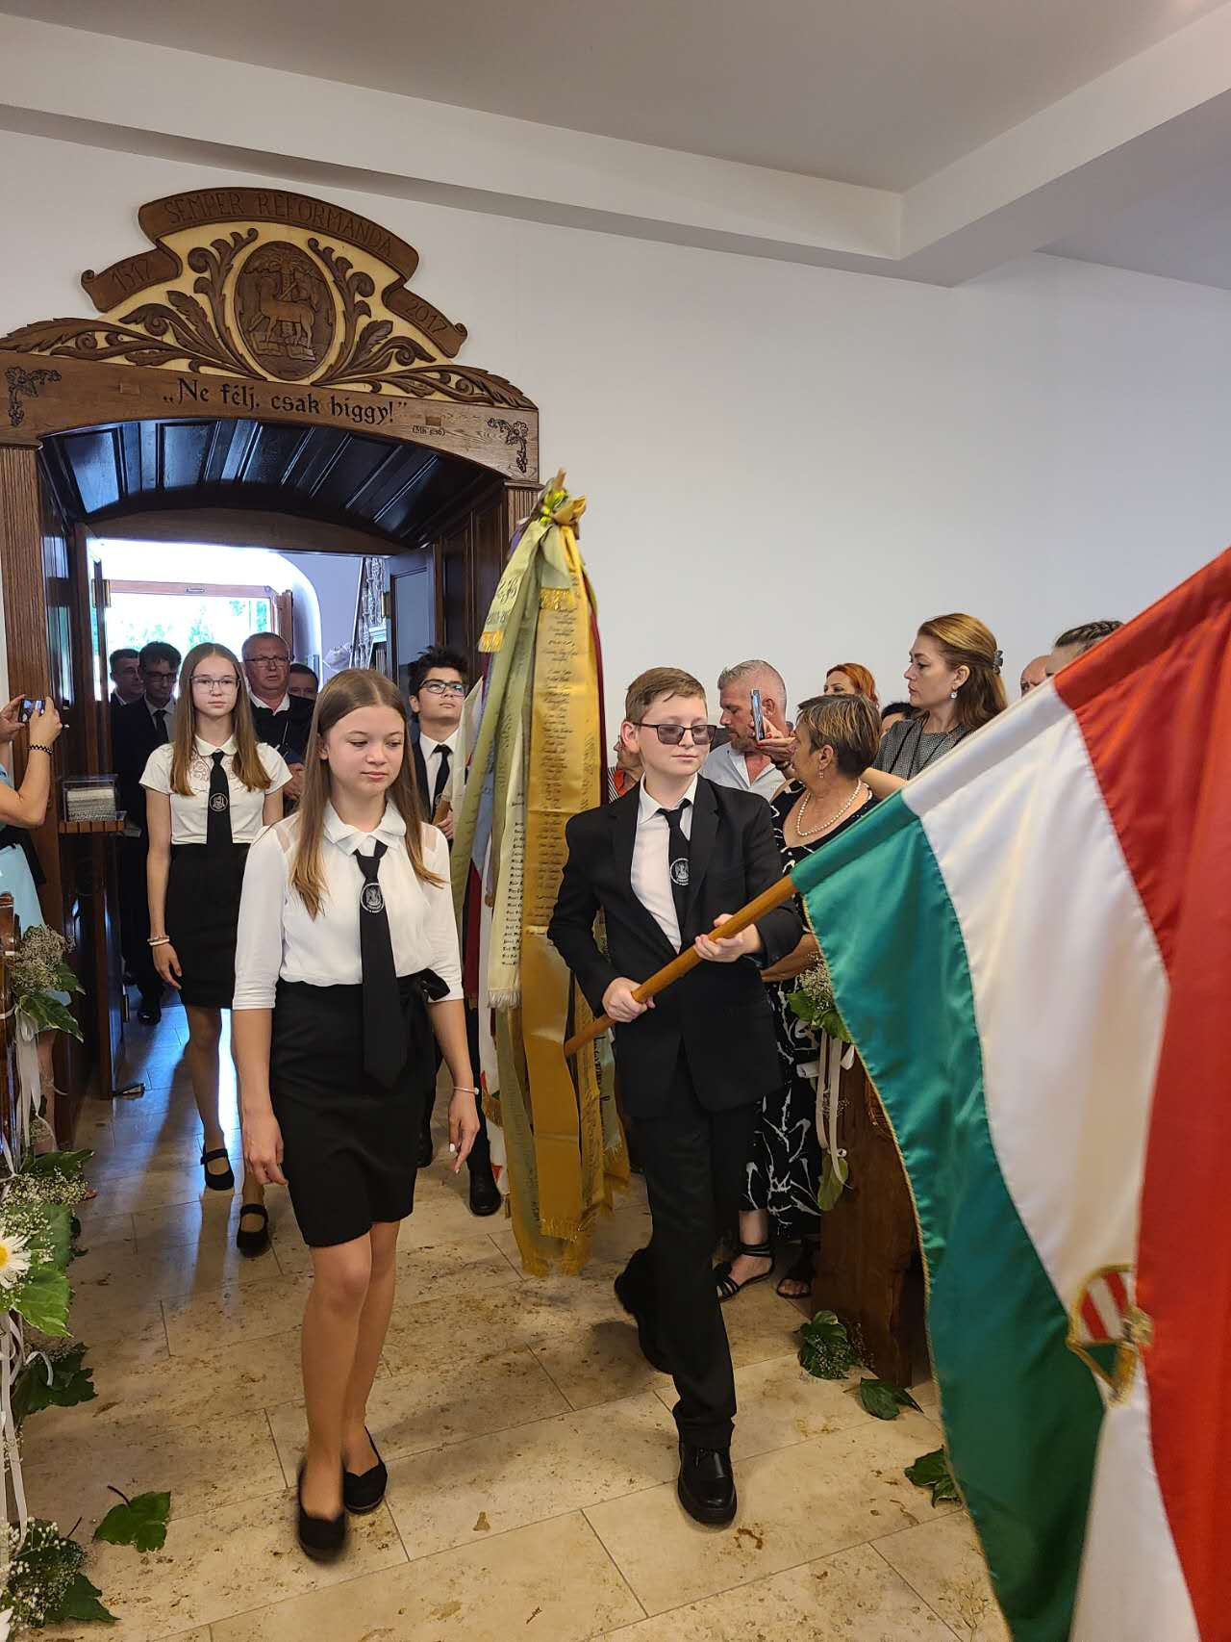
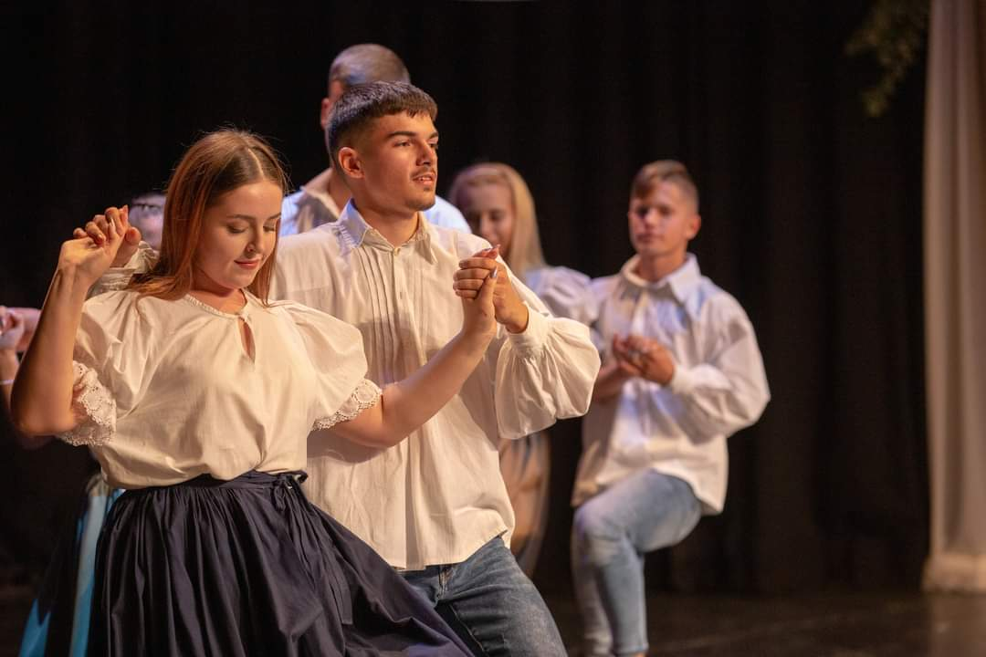
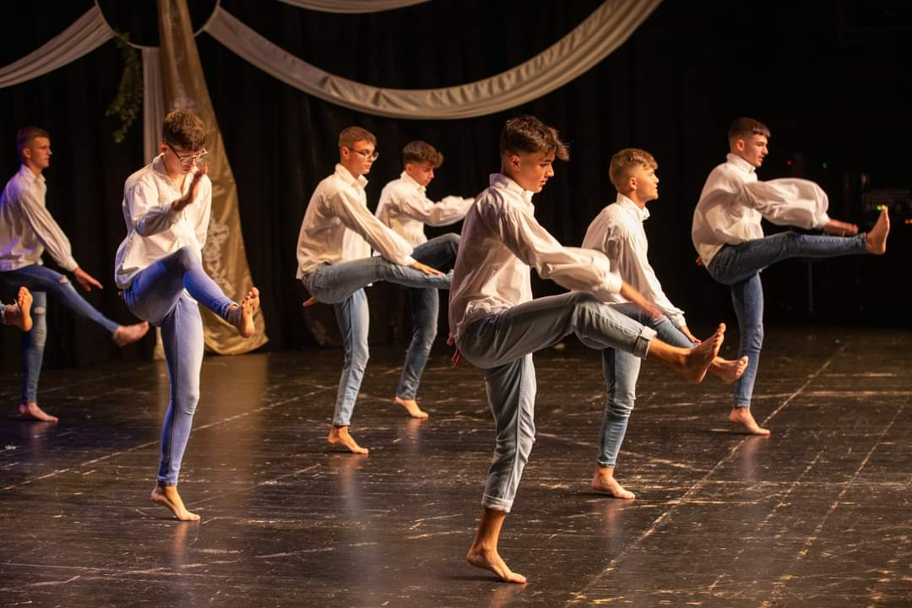
Overall, my teaching life here is a nice experience and I really enjoy it. I am not sure what’s next for me in the future, but for now I’m content. Thanks for reading and I will be writing more about life as an ESL teacher in rural Hungary
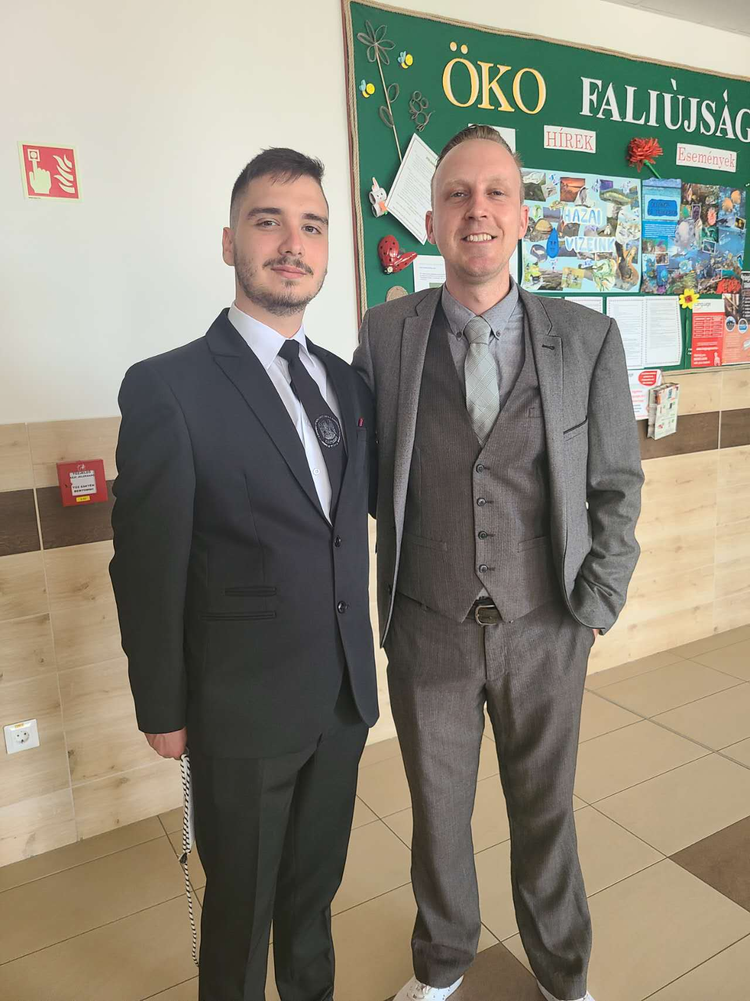

Please check the Pilgrims f2f courses at Pilgrims website.

Please check the Pilgrims online courses at Pilgrims website.

