  - Pilgrims Teacher Training in Segovia, Spain, 2024, Phil Dexter, DOS, Pilgrims

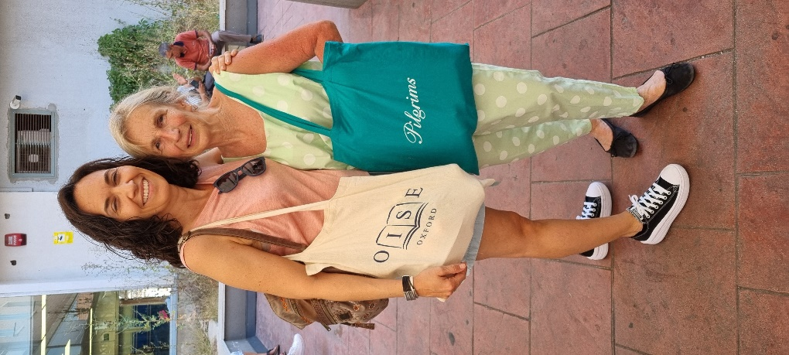

As we celebrate the 50th anniversary of Pilgrims teacher training and 25 years of Humanising Language Teaching – all wonderfully expressed in the April and June 2024 issues of HLT – Pilgrims summer teacher training is now beginning a new era continuing the excellence of what was our summer magic at the University of Canterbury for almost 50 years though in new ways. I’m sure most readers of HLT will know the quote below – from NLP and other sources – though my little twist below I hope expresses what has been most successful now perhaps needs to be reframed in different ways.
"If we always do what we've always done we'll always get what we've always got". We continue with our excellence though " If we only do what we've always done - we won't now get what we've always got".
Our nostalgia and memories of these almost 50 years of great summers in Canterbury and across the world expressing in so many ways the Pilgrims approach to humanising teacher training will remain with us and embedded in our Pilgrims DNA.
We all know that the reality of ELT today has changed – not in what we do but how we do it - and we need to respond in continuing our magic is some different ways. What is working well we will continue to do and do better and do more of. Other things just need to be different…
This summer our great Pilgrims difference and innovation has been running three weeks of teacher training in the beautiful historic city of Segovia in Spain. And thanks to Till Gins our Pilgrims lead officer for his inspiration and support for making this happen. This year the themes can be found in this link https://www.pilgrims.co.uk/teacher-training-courses/pilgrims-in-segovia
I have had the privilege to plan and oversee the training as Director of Studies’ working with the wonderful Pilgrims trainers Stefy Ballotto and Linda Yael delivering the courses with teachers from Germany, Italy, Netherlands, Slovenia and Spain.
We all know how teachers from all over the world have enjoyed the experience of Canterbury, the UK and spending time in a first language English speaking country. Segovia, though, offers something different in this UNESCO heritage city with all its historic beauty and of course exceptional summer weather. Our training courses are at the highest level of experience as always. Though Pilgrims has always been about a total engagement experience and through the most meticulously planned social programme in our OISE host school and by the wonderful centre manager Raquel Lucia we have engaged with a total cultural experience – which Pilgrims is uniquely about and such an important aspect of humanism.

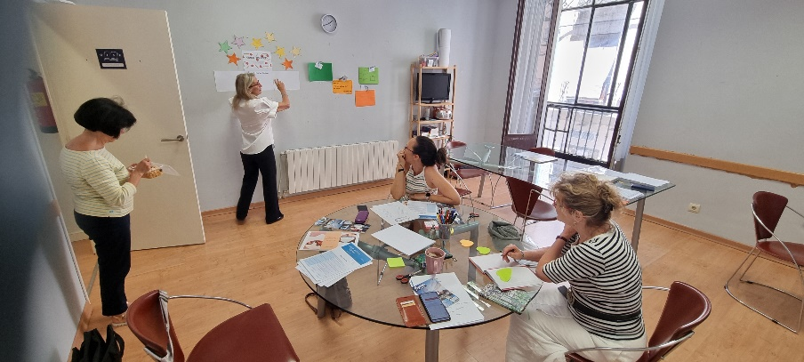

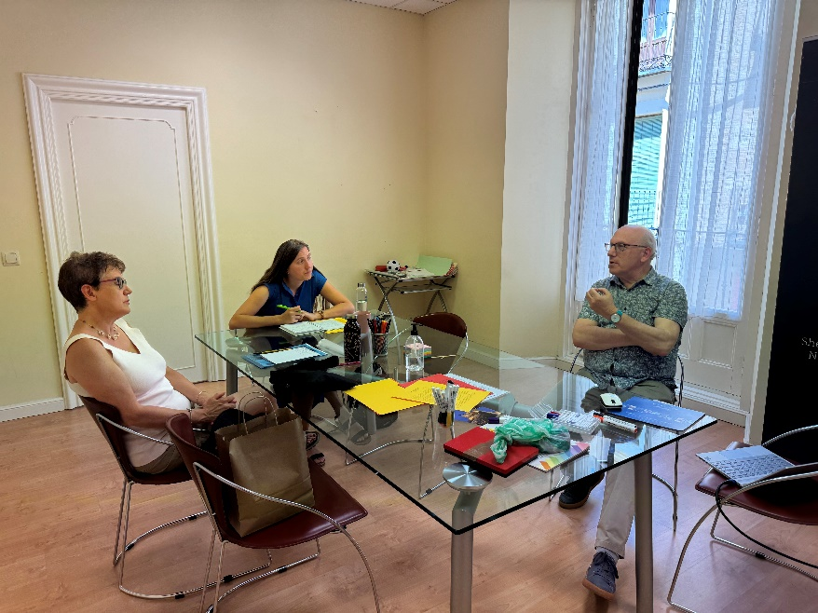

Such events as a city and castle tour, Segovia Cathedral with the 192 steps to glorious views over the city, the visit to the amazing royal palace of La Granja with its ‘wonder of the world fountains’, tapas and wine tasting, the calming flower arranging session and so much more. Madrid is a short journey away as are so many other ‘must see’ Spanish cities. This intercultural experience has enriched everyone and defines what Pilgrims is all about and will continue to be. As one participant said to me “This time in Segovia is a journey of the soul as we explore picture postcard Segovia in 3D!”

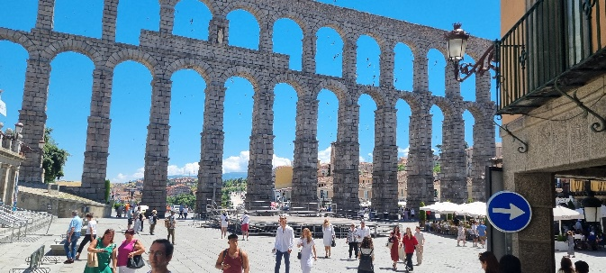

The future for Pilgrims teacher training is exciting as we plan and promote our offer for 2025 and beyond. Teacher Training in Segovia in summer 2005 will be an essential aspect of our planning with a greater enriching programme. Though we plan much more besides – as always we can come to you, we will be present at many teacher conferences and develop more partnerships. Of course, we will be proactively present in the virtual world with webinars and other events. And our high reputation and unique magazines – Humanising Language Teaching and the Teacher Trainer Journal will continue to promote all we do giving a voice to the ELT world promoting humanistic approaches. Watch this space…

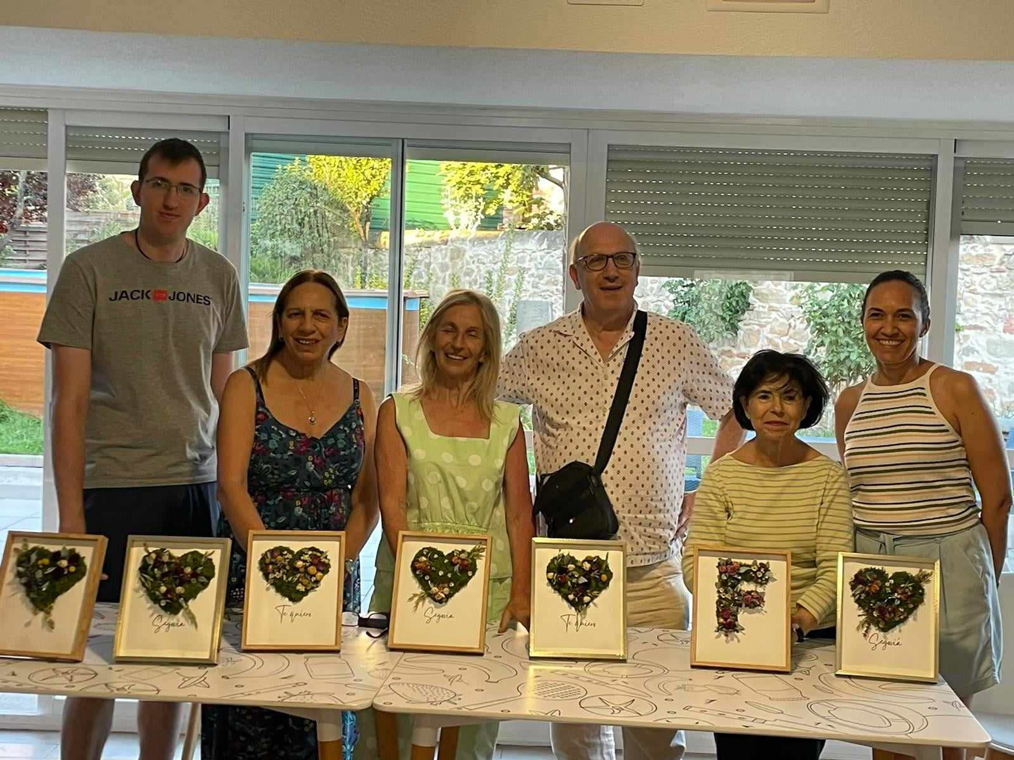

Phil Dexter
Director of Studies, Pilgrims Teacher Training in Segovia 2024.
Editor of The Teacher Trainer Journal
https://pilgrimsttj.com
Please check the Pilgrims f2f courses at Pilgrims website.

Please check the Pilgrims online courses at Pilgrims website.

