Humanizing a Language Assessment Course

Vahid Nimehchisalem, Malaysia

Vahid Nimehchisalem started teaching in 1994. Ever since, he has been involved in the area as a lecturer, teacher trainer, test designer, material developer, researcher, editor, and writer. He is currently Associate Professor at the Faculty of Modern Languages and Communication, Universiti Putra Malaysia. He’s chief editor of the International Journal of Education and Literacy Studies and managing editor of the Journal of Language and Communication. His main area of teaching and research interest is learning-oriented language assessment.
vahid@upm.edu.my; nimechie@gmail.com
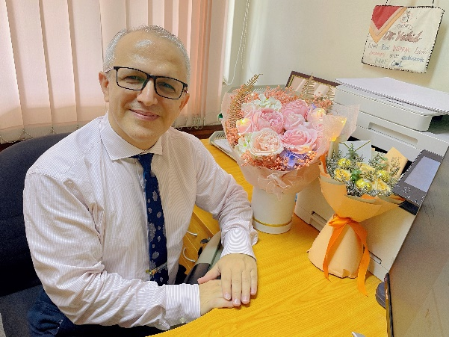
Introduction

This article relates the story of a creative writing project that began as an assignment in partial fulfilment of a postgraduate course, namely, Language Evaluation and Accountability about ten years ago. The assignment prompted the students to draft a short story of around 1,000 words, related to language assessment (Appendix). The course lecturer also did this assignment and contributed his own story. Before starting to write, we read some short stories related to assessing writing, such as, The Teacher, by Catherine Lim (1978). Then, we drafted a short story related to our personal assessment experiences. When the first draft was ready, we self-assessed and further revised our stories. After this, we received feedback from peers and gave them feedback for their stories. The session in our final week was called the Tests & Us Academy Awards. We read our stories, listened to other stories, voted for the top ten stories whose writers received certificates. We selected the best stories for further review and publication.

Evolution of a creative writing project

We compiled the stories from a number of classes and published the first volume of Tests & Us (Nimehchisalem & Babaee, 2017). In the following years, we collected more stories from a couple of other classes. These were published in the second volume (Nimehchisalem & Geng, 2023). The students enjoyed writing short stories and found our Academy Awards extremely engaging; however, the part they enjoyed most was when they saw their stories published in a book.

After a while, another lecturer started offering the assessment course, but this would not stop us. Thanks to my students, who were no longer my students, we kept writing more stories. We also opened this project for other colleagues that we thought would be interested to share their stories of assessment. We started a Facebook group called ‘Tests and Us’. Stories started pouring from everywhere and everyone, including school students. Some stories had to be rejected for not being related to assessment or for not having an acceptable quality. We also published these short stories in the third volume of Tests & Us (Nimehchisalem & Geng, 2024). The figure shows the cover of this book.
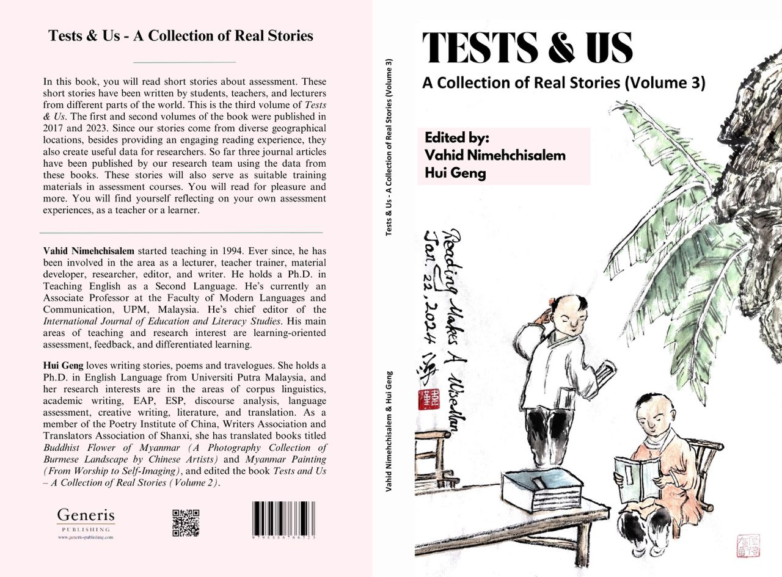
The Cover of Tests & Us - A Collection of Real Stories (Vol 3)

We are planning to do the next volume in a slightly different way. We have already started calling for short stories related to assessment, but this time we will raise the bar a bit. Once we have compiled a number of stories, the contributors are going to participate in creative writing workshops where we will learn to improve the quality of our narratives. We will also make sure our stories go through more stringent self-assessment and peer review processes. We expect in this way the outcome will be more engaging and impactful.

Reflection and conclusion

To my observation, Tests & Us has been an amazing professional development activity. As we all know, assessment workshops can be extremely dry, and therefore, the least popular among language teachers. You may have observed frequently in conferences that most of the seats are empty during assessment sessions. This is usually because of the technical and cold concepts related to assessment. However, this assignment is proof that talking about assessment matters does not have to be boring. During our courses, the students found the assignment meaningful and therefore, engaging. The assignment created an opportunity for them to link the technical concepts in language assessment to their personal experiences of assessment as language teachers, students, and/or parents. On the other hand, this was also a professional development opportunity for the course lecturer himself and his teaching assistants who had a hands-on experience of how to teach a technical course in a different and engaging way.

During the course, the students found it inspiring when they saw their lecturer join them in doing the assignment. It’s very unusual for teachers and lecturers to do the assignment. Students will expect them to stand by, provide feedback, answer questions, and mark. My students felt more confident as they observed their lecturer, who was not a professional writer, write his own short story. This also helped me better empathize with them.

The students also liked the idea that the assignment was given to them right at the beginning of the semester. This gave them sufficient time to read similar stories before drafting their own stories, self-assess, peer-review, revise recursively, provide feedback for their lecturer’s and peers’ stories, proofread their own stories, read their stories aloud to their peers during the final session, listen to others’ stories, and vote for the best stories. They experienced the different stages that their stories went through before being selected for publication. All this could never have been accomplished if they had received the assignment towards the end of the semester.

Later when the assignment evolved as a creative writing project, several students, who had already graduated continued to contribute short stories even though they would not receive any marks for it! The assignment had turned into a life-long learning activity for us, including my former students as well as those contributors who had never been my students; indeed, several contributors in our third volume are professional writers.

The stories also provided data for our research teams. In a study, we analyzed the themes emerging from the short stories published in the first volume, and we found that some of the most frequently recurring themes included “cheating,” “test anxiety,” and “motivation tool”; on the other hand, “fair assessment,” “promoting learner collaboration,” “teaching to the test,” and “biased assessment” were some of the least frequent themes, each occurring only once (Nimehchisalem & Nur Izyan Syamimi, 2018). Furthermore, in another study, we analyzed the conceptual metaphors that emerged from the stories published in the second volume (Geng & Nimehchisalem, 2023). More research is on-going now.

Acknowledgement

I would like to acknowledge Alan Maley for his professional support of our project. I also appreciate Tests & Us contributors. Especial thanks to Hui Geng for her ceaseless support. The project would not have continued without her.

References

Lim, C. (1978). Little Ironies: Stories of Singapore. Heinemann.
Geng, H., & Nimehchisalem, V. (2023). Can ChatGPT Analyse Textual Data? The Sub-Themes Reflected by Typical Conceptual Metaphors in Short Stories of Language Assessment. ASEAN Journal of Applied Languages, 2, 16-31.
Nimehchisalem, V. & Babaee, R. (Eds.). (2017). Tests & Us - A collection of real stories (Vol 1). Australian International Academic Centre PTY. LTD.
Nimehchisalem, V., Geng, H. (Eds.). (2023). Tests & Us - A Collection of Real Stories (Vol 2). Generis Publishing. https://www.generis-publishing.com/book.php?title=tests-amp-us-a-collection-of-real-stories-1270 (ISBN: 9798886766707)
Nimehchisalem, V., Geng, H. (Eds.). (2024). Tests & Us - A Collection of Real Stories (Vol 3). Generis Publishing. https://www.generis-publishing.com/book.php?title=tests-amp-us-a-collection-of-real-stories-volume-3-2017 (ISBN: 9798892482851)
Nimehchisalem, V., Kai, E. F. S., & Nowrouzi, S. (2019). English as a Second Language Learners and Teachers' Conceptions of Language Assessment. Journal of Asia TEFL, 16(4), 1348. http://dx.doi.org/10.18823/asiatefl.2019.16.4.18.1348
Nimehchisalem, V. & Nur Izyan Syamimi B. M. H. (2018). Postgraduate students' conception of language assessment, Language Testing in Asia, 8(11), 1-14. https://doi.org/10.1186/s40468-018-0066-3

Appendix: The Assignment

Note: This assignment encourages the learner to self-assess and peer-assess in the process of writing a short story about their language assessment experience.
Language Evaluation and Accountability (BBI5216)
Tests & Us
Assignment 1 Mark: 10% Deadline: Week 12

Aim: The objective of this assignment is to help students reflect on issues learners or teachers face in language evaluation.
Instructions: Write a short story of no more than 1000 words on the theme of ‘language assessment’. The story should address an issue in the area of language evaluation.
Follow the steps below to write your story:
Plot (Week 5) > Draft 1 > Self-assessment (Week 6) > Draft 2> Peer-feedback (Week 7) > Draft 3 (Week 9) > Teacher conferencing (Weeks 10-11) > Final Draft Submission (Week 12) > Marking, Academy Awards, & Selection for publication
After they have been marked, based on the marking scheme below, ten top stories will be selected for publication in a book. The most popular story (to be selected by all) will win the Grand Prize.
Marking Scheme: The short stories will be scored based on their:
- Task fulfillment (meeting the deadline, writing a short story within the word limit, and covering an issue in language evaluation) 3%
- Engagement (Does the story attract and engage the audience?) 3%
- Clarity (Is the story able to present the issue in a simple and comprehensible way?) 2%
- Accuracy (Is the language accurate?) 2%

Here is an example, The Teacher by Catherine Lim:
https://www.scribd.com/document/459485492/The-Teacher-by-Catherine-Lim?utm_medium=cpc&utm_source=google_search&utm_campaign=Scribd_Google_DSA_NB_RoW_UGC&utm_adgroup=Documents&utm_term=&utm_matchtype=&utm_device=c&utm_network=g&gad_source=1&gclid=CjwKCAjw57exBhAsEiwAaIxaZhKMycRDZjR9L9PEoAUEoNo0g_V9KiP4-TrK6C9sP0GDh3HVKZH4JBoCdRgQAvD_BwE

Please check the Pilgrims f2f courses at Pilgrims website.

Please check the Pilgrims online courses at Pilgrims website.

