Rhymed Reflections: Review of Francisco Gomes de Matos’s Book

Dat Bao, Australia

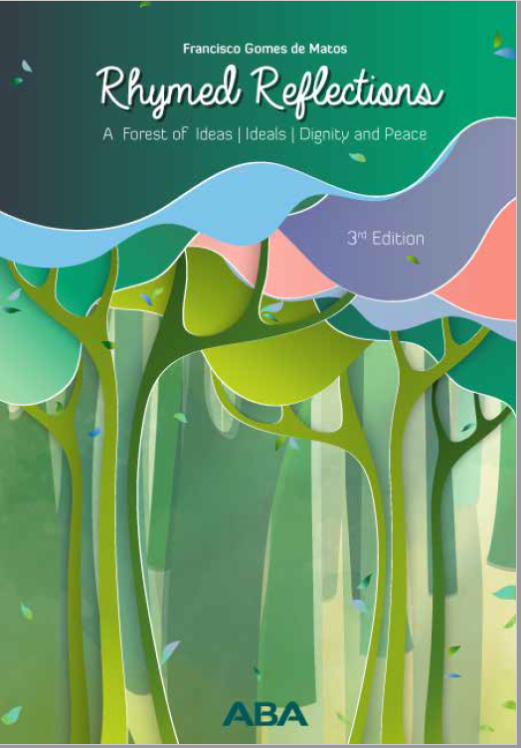
Rhymed Reflections
A Forest of Ideas, Ideals, Dignity and Peace
3rd Edition, Aba Book (2023) – 108 pages

This book challenges some of the undesirable aspects of human nature. Inherently, not only are we born into a world of chaos but our brains are also programmed to struggle with consistency. Sometimes, we say one thing while meaning another. We believe in every worthy ideal but end up acting against it. We care about fellow citizens but end up hurting them. We claim to support the unfortunate yet spend most of the time attending to our own interests.

The book begins with a recognition of such instability in our moral outlook. While our mouths sing global peace, our actions condemn harmony. While our conscience favours human rights, our performance moves away from them. We are living in a world filled with paradoxes saturated in our veins. To point out such a dilemma is already a helpful thing to do; to delve into such issues in a book represents a profound act.

Jiddi Krisnamurti in his public talk in Switzerland in 1985 commented: ‘Though we biologically have changed from a million years ago till now, but psychologically, inwardly, subjectively we are more or less what we were a million years ago - barbarous, cruel, violent, competitive, self-centred, egocentric.’ Although everyone, one generation after another, keeps dreaming about a better future, we are going backwards intellectually and morally. de Matos’s book raises this awareness by getting us all to rethink our roles in co-constructing a better future.

To do so, in de Matos’s view, one needs to start from healthy thoughts and helpful understandings as the foundation for positive words and good deeds. Throughout the book, the message is that to bring about such an impact one needs to learn to welcome differences and embrace inclusivity. These contents are beautifully packaged in poetry as a powerful means of making the abstract concrete, reader-friendly and experiential. Readers are helped not only to understand positive meanings and values but also to feel them and live them.

I am overwhelmed and touched when reading all the poems and posters (whose words never stop dancing through the pages). I see peace and dignity in the poem ‘Attention!’ through the voice, of a peace linguist, that wakes up a part of me that seems to be sleeping.

The ideal of a non-killing movement pervades the work. It reminds me so much of Mahatma Gandhi’s views on non-violence as a choice to move the world forward, unlike the world’s dictators, who built the illusion of peace by wading through a sea of blood and ended up ruining all human dignity.

This book is for everyone: instructors who are hungry for new pedagogical ideas, some politicians who may need more education about peace awareness, global citizens who wish to nurture intercultural understandings and relationships, activists who need eloquent words to talk about human rights, linguists who find ways to be more self-expressive, musicians who yearn for new lyrics to compose their songs (when reading ‘the day weapons refuse to kill,’ I hear a melody in my head), children who seek playgrounds that meet their curiosity, human beings who want to be more human, and soldiers who must think twice before mercilessly gunning down the innocents.

Another bonus of the book is the input on creativity, spirituality, education, and beyond. A unique feature of this work is that it is not something being written from beginning to end for the purpose of producing an orderly publication. Instead, the volume is the author’s cultivation of creative materials gathered through a dozen years of passionate pursuit of good human qualities and of social movements for a better world. Such materials come in the form of posters, poetry, and teaching. Readers are invited to rethink their stance and action towards events in our world.

Despite the author’s critical stance, the tone of the book is far from a gloomy, disturbed or furious one. It is a pleasant voice filled with compassion and empathy, often cheerful and encouraging. As someone who is learning to be a teacher, poet, musician and artist, this work feeds my thoughts and inspiration. It is clear that the book was produced by someone with high responsibility and commitment towards the virtues of humankind. Visual attractiveness and rich design are additional bonuses of this publication. After reading it, I am tempted to go ahead and write a similar book myself. And I would, if the need for individual creativity did not stop me from doing so.

You can read find out more about the book and read the poems here.

Please check the Pilgrims f2f courses at Pilgrims website.

Please check the Pilgrims online courses at Pilgrims website.

