ECO: Funny or Unfunny

Hanna (Hania) Kryszewska, Poland

Hanna (Hania) Kryszewska is a teacher, teacher trainer, trainer of trainers. She is a senior lecturer at the University of Gdańsk, Poland. She is co-author of resource books: Learner Based Teaching, OUP, Towards Teaching, Heinemann, The Standby Book, CUP, Language Activities for Teenagers, CUP, The Company Words Keep, DELTA Publishing, and a course book series for secondary schools: ForMat, Macmillan. She is also co-author of a video-based teacher training course: Observing English Lessons, and online course for Orient Black Swan on 21st Century Skills and Teaching the whole person: Humanising language teaching. Hania is a Pilgrims trainer, OTA trainer and editor of HLT Magazine. E-mail: hania.kryszewska@pilgrimsteachertrainig.eu
Background

In my teaching I like to use cartoons; to introduce the topic of the lesson or module, as a break or at the end of the class. In HLTmag you will find a number of my contributions along these lines. So, I went on the net, and I collected the following six cartoons to do with Eco Issues, which I thought were the best. Here they are.
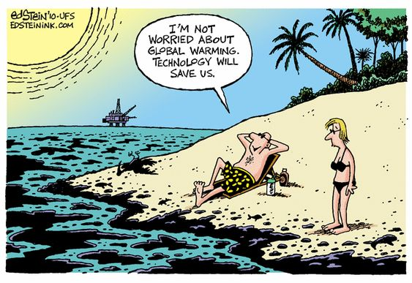

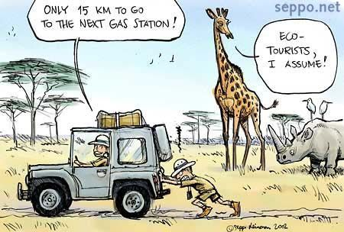



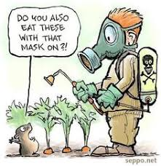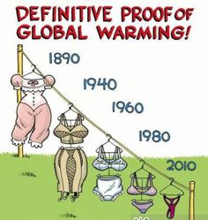
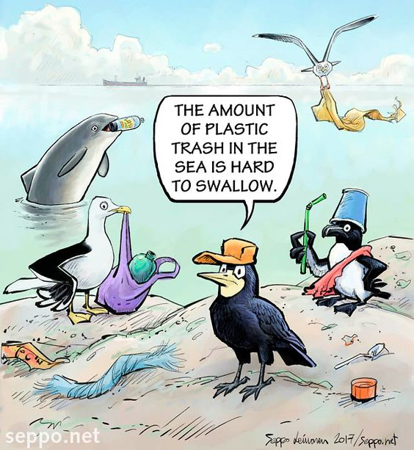
But to be honest they are not really funny to me. I looked at them and I was sad. I came to the conclusion that perhaps Eco Issues could belong to the taboo topics we do not like laughing at.
And hence this lesson idea.
Funny or unfunny

1 Brainstorm with the class taboos we normally don’t joke about.
2 Give them time to discuss if it is the same with stand-up comedians and comedy shows.
3 The students read the following authentic blog entries and discuss if they agree or disagree with the points they make.

I am of the opinion that Jewish jokes should only be told by Jews - such as myself.
Veronica Zundel, London United Kingdom
Strange to hear from an Aussie, but yes. Death. And rape.
Fiona, Brisbane Australia
Death of particular individuals maybe, but not death in general, surely? What about those conversations at the pearly gates type jokes?
Jonathan Rhoades, Reading
I have done stand-up comedy for several years and the question prompted a quick poll among myself and colleagues. The following is the top five of taboo subjects: 1) September 11 2) Child molestation 3) The Holocaust 4) Rape 5) The Queen Mother (RIP)
Robert del Valle, Detroit USA

https://www.theguardian.com/notesandqueries/query/0,5753,-23095,00.html
24hourcinderella

If you can't laugh about taboo topics then you have a weak sense of humor
I think the greatest thing you need in terms of comedy is a thick skin. I feel like anybody should be able to turn dark things in life into jokes. I don't like being told I can't joke about certain things like 9/11, the holocaust, abortion, etc. (…) Racism much like all these other controversial topics are very real and hard to tackle. It's just nice to joke about these topics rather than taking them so serious all the time.

Speedy_Cheese

Humour, like art, is subjective. There are various genres and not everyone likes dark/shock humour.
Nobody is "weak" for not sharing your sense of humour any more than someone is "weak" for liking classical or hip hop music instead of rock. People have different tastes and that's fine.
Nobody likes being genre policed with music and the same applies with humour.
If the people you associate with don't appreciate your sense of humour and it means that much to you then find a group of people who do. My friends and I love dark humour but it's not the kind of thing I bust out at Thanksgiving dinner.
https://www.reddit.com/r/unpopularopinion/comments/gmlbly/if_you_cant_laugh_about_taboo_topics_then_you/

4 Pool the reactions.
5 Give out the headlines and ask the students to predict what the texts are about.

https://www.thebarkumd.com/voices/2019/4/18/using-humor-as-an-outlet-for-discussing-serious-topics

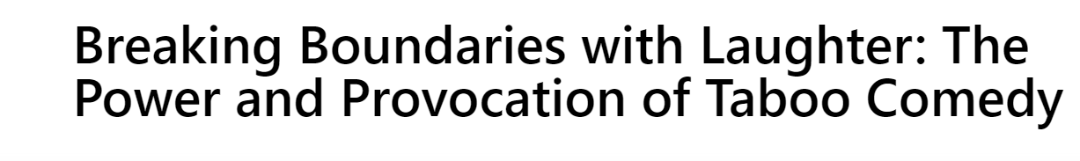
https://thebrokenspine.co.uk/2024/01/03/breaking-boundaries-with-laughter-the-power-and-provocation-of-taboo-comedy/

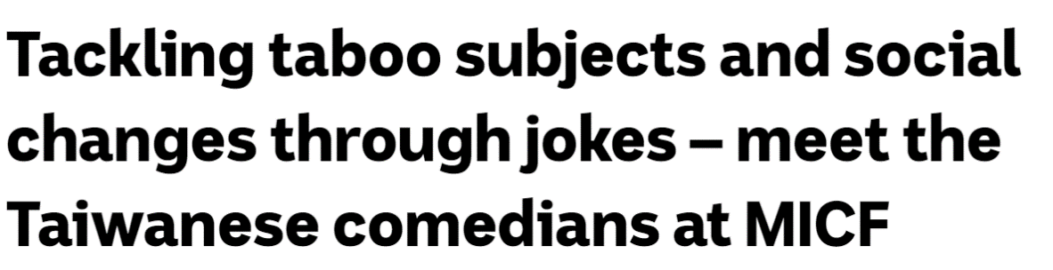
https://www.abc.net.au/asia/meet-the-taiwanese-comedians-at-micf/103746126

6 Homework: Students skim through the texts and write 50-word summaries.
7 Students compare their summaries in class in group of 3-4.
8 Show the Eco Issues cartoons you have selected. Explain your reactions and emotions.
9 The students look for 3 cartoons on the subject of Eco Issues.
10 They reflect on the emotions the cartoon evokes; You may want to brainstorm useful words e.g.:
amusement
embarrassment
irritation
anger
frustration
sadness
surprise
disbelief
etc.

11 They present their cartoons focusing on their reactions and emotions.
12 Discuss with the whole class whether Eco Issues are now among taboo issues we feel uneasy to joke about.

Please check the Pilgrims f2f courses at Pilgrims website.

Please check the Pilgrims online courses at Pilgrims website.

