Historical and Cultural Unfinishedness in Language Learning

Fernanda Felix Binati, Brazil
Fernanda Felix Binati has pursued a licentiate degree in Pedagogy with extension case study projects in education. Recently, she has been engaged with teaching multilingual learners from remote areas. Previously, she worked for International House Kazakhstan, as well as was an intern for PCTE and Indo Global Colleges in Punjab, India. Please contact me on my email for queries: ffelixbinati@gmail.com.

In the state of Punjab, North India, there are villages where hundreds of people live and incessantly work on the paddies whether under the scorching sun or murky winters. Luckily, I got to meet about two hundred of them, who most likely would have never seen a foreigner. The only gathered women to welcome the monsoon season – the sun, the rain, all the elements of nature with frantic dancing and loud music. I had felt elevated and experienced a sense undifferentiation by the wholesome energy and union.

Apart from the slow progress ELT has made in accepting various accents, dialects, and somehow incorporating multilingual learners’ culture and history into English lessons, I believe that there are still a lot of misunderstandings around the latter.

By the end of this article, I will have tapped into culture and history from an epistemological perspective and then offered some trajectories in order to help navigating teaching multilingual learners in fragmented skills (i.e., reading, vocabulary, etc) as we see in oversimplistic skill tasks in English coursebooks, which seem too easy or too narrow.

Nowadays, history and culture within human interaction are often seen as secondary in English teaching. So much so that lessons and syllabus have become downsized to having the teacher “hunting” learners’ preferences - their likes and dislikes and trying to juggle with institutional academic procedures, which create chaos in the learning process and are in no way sufficient to open new pathways of learning.

On another occasion in Himachal, I interacted with a Tibetan child who couldn’t articulate much in English. As you can see below, he found a much more interesting task to explore colours and lines on my laptop screen than to respond to my introduction questions, which probably were making me sound paternalistic.

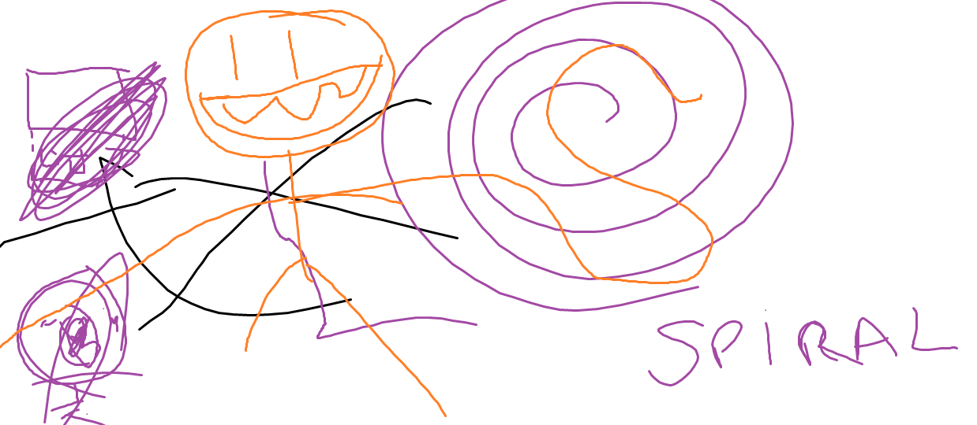

So, through my experience in India, I set out to observe and study closely how people associated and generated discourse. Obviously, I found a variety of discourse wherever I went. But what stood out was that when cross-cultural interactions occurred, they would naturally spur as means for learning, even though we are usually taught in teaching courses that language learning is only effective when we give learners a specific purpose/task (i.e., book a table at a restaurant, complaining, etc). So, one of my questions is, is that idea true? I then resorted to books, and one which caught my attention was “Pedagogy of Freedom – Ethics, Democracy and Civic Courage” by Paulo Freire where he had written about ‘historical unfinishedness’.


In a diverse country such as India, popular ideas such as those seem to fall through the cracks as both the layman as well as the doctor know multilingualism as being a part of their cultural and historical identities.

By putting ‘historical unfinishedness’ into an English teaching perspective, would we say that second language learners are likely less proficient than those who already speak English as a first language? How? To what extent are teachers taking accountability of learners’ literacy development whether they are first or second language learners?

To better illustrate this, the classroom where the primary coordinator and I would go had had no teachers inside it since the bell had rung and teachers were switching periods. In the meantime, one student thought he would use that time to go to the toilet. Suddenly, the coordinator spotted the student walking on the corridor and stopped to question him where he was going. So, he answered her by saying what he was doing: “going to the toilet”. That’s when she raised her voice and angrily hit him on the back. In this case, education is the bitter medicine against indiscipline and loss of tradition.

If we were to take a look at history, by the book, it might evoke memories like dusty treasures, old furniture, numbers, benchmarks and maybe some spiders. My point is, it has become easy for the English teacher and the learner to be deceived about what their beliefs are of history and culture, which affects how learners develop literacy in the first place since they assume they should get rid of how their history and culture in order to become educated.

However, seeing it as how people carry out their lives in coexistence, teaching and learning then involves “the emergence of language, culture, and communication at levels of complexity much greater than that which obtains at the level of survival, self-defence, and self-preservation.” (Paulo Freire, p.33)

So after that occurrence, I wanted to know what the teachers had been thinking about the incident I had witnessed. Despite the mixed feelings and lack of responses, the most recurring answer was that it had been part of the culture. They also mentioned that many parents still believed that the teacher was entitled to use physical force to “correct” the pupil. But apart from the will to conserve tradition and ethics, teachers were relying only on a partial or borrowed knowledge (by tradition) of what history and culture truly mean.

So how would you consider culture in English teaching?

The Oxford Languages Dictionary defines culture as “the ideas, customs, and social behaviour of a particular people or society”. By that definition, we could say that there are fixed values which have been embedded by tradition and lifestyles in which people tend to follow. Although the definition is not incorrect, I wouldn’t say it is sufficient.

As an alternative, instead of unconsciously perceiving at culture and history as determinants to good and bad English, the English teacher now sees consciously that culture and history are more like drops in the ocean, he/she can work with, and where culture and history meet, but are not strict conditioners of learning. Furthermore, the literal definition of culture does not obscure learners’ historical unfinishedness, as in the anecdote “it is unknown for lions to cowardly murder lions of the same family group, or of another group, and afterwards to visit the families to offer them their condolences.” (Freire, p. 33)

Learners go to school as independent individuals, with the right of action and speech, and in no way are serving as an end-product of their history and culture due to established norms and imposed values. In fact, new narratives are formed as learners engage and open new pathways of understanding about other cultures and humanity’s history, which their predecessors wouldn’t possibly fathom.

Thus “historical unfinishedness” as Freire once put it to this day and age would be the using knowledge as an axis for more learning, in other words, learning is not simply a means per se with a predetermined outcome. That is why I would argue that seeing teaching English as a matter of skills - vocabulary, reading, writing, etc is a reductionist approach.

By allowing historical unfinishedness, we can come to find that “(…) “… [our] presence in the world is not so much of someone who is merely adapting to something “external”, but of someone who is inserted as if belonging essentially to it.” (Paulo Freire, p. 33). That means we are helping learners get comfortable at being historically “exposed” (Alan Maley) and taking a step back from knowledge to let learners produce their own history and culture. For that reason, it is only natural that we feel anxious when it seems that we might be walking against the “cold winds” in a harsh season of systematic teaching.

The poem “Outside the Box” by Maley, was published in a book by the British Council about a decade ago plays a role in taking the theme further:

“Being inside the box
was comfortable – warm and cosy.
We curled up with cushions of routine,
wadded with words,
blanketed by books,
swaddled in certainties.
…
Out here we are exposed,
and cold winds blow. …
but here we can move and breathe,
see clear to the far horizon. …”
Source: Maley, A and Peachey, N (2015) Creativity in the English Language Classroom. British Council.

By taking an epistemological perspective in ELT, and not by reducing contextual experience to teaching languages as fragmented skills or simply as language items, in Freire’s terms “… bureaucratizing of the mind”, creativity would emerge. Having a round approach to teaching poses some doubts in the mind of the 21st century learner, a century of no delimited boundaries, where teachers are encroached with the syllables and perceive language learning as a monolingual activity.

However, it is undeniable that literacy and language learning go hand in hand, with each individual and the world of which they are part although implemented systems have been widely neglectful of such art due to treating English teaching as fragments (i.e., pieces of vocabulary, writing in the passive/active, etc), as if skills alone would suffice to integrate and navigate contextual constraints. I would argue that the teacher can be more enthusiastic.

But it is good reminder that “literacy isn’t a single skill that simple gets better with age … Being literate is very different for the skilled first grader, fourth grader, high school student, an adult, and the effects of school experiences can be quite at different points in a child’s [or anyone’s] development.” (Catherine Snow, et al, 1991, p.9 – from The Literacy Bug.). That is to say that by always trying to give a solution to the multilingual learner (i.e., specific skill tasks) or ‘purposes’ to speak have hindered the discovery and creative process which in turn has left a precipice in literacy development (not acquisition).

To better illustrate this, I would like to share some of my own ideas alongside Christopher Walker’s thoughts from his highly regarded book “English is a Simple Language”. The key words have been put in bold:

Coursebook Fragmented Thinking | Discovery
“Use formal register to write business letters, and informal to write to friends.” | How socially “close or distant” (Walker, C.) are you from your friends? When you are writing a letter, choose one person, and be as specific as you can.
“Write sentences in passive and active voices.” | How can we “shift between passive and active voices” (Walker, p. 205) within a particular context/register/genre?
“Write sentences in the present simple, the past simple, future simple, present perfect, etc.” | Are we using English tenses to express actions in English ‘timing’ (ibid.) or are you resorting to L1’s ‘timing’?  (i.e., “I see a dog” is not the same as “I was seeing a dog”.).

All in all, “in nature we never see anything isolated, but everything in connection with something else which is before it, beside it, under it and over it.” - Johann Wolfgang von Goethe.
References
Catherine Snow, et al, (1991) (https://www.theliteracybug.com/synoptic-overview)
Freire, P. (1970, 1993) Pedagogy of the Oppressed. Continuum, London/New York.
Freire, P. (1974) Education for Critical Consciousness. Continuum, London/New York.
Gerrard, S. (1996). A philosophy of mathematics between two camps. In H. Sluga, H. and D. Stern (Eds.), The Cambridge companion to Wittgenstein. (pp. 171 - 197) Cambridge: Cambridge University Press.
Goldberg, N. (1986) Writing Down the Bones. Shambala Boston & London.
Maley, A and Peachey, N. (2015) Creativity in the English Language Classroom. British Council.
Walker, C. (2022) English is a Simple Language. Closely Observed Literature.
https://www.brainyquote.com/authors/johann-wolfgang-von-goeth-quotes

Please check the Pilgrims f2f courses at Pilgrims website.

Please check the Pilgrims online courses at Pilgrims website.

