Tell our stories to the world – Fighting oblivion in Gaza
This article was first published in the spring 2025 edition of Melta News and is republished with kind permission.
People worldwide share children’s stories on the internet in David Heathfield and Haneen Khaled Jadallah’s project “Tell a Child in Gaza’s Tale”
David Heathfield is a world storyteller, teacher trainer and writer from Exeter, UK. He has authored Storytelling With Our Students and Spontaneous Speaking (both DELTA) and numerous articles and book chapters. He provides Creative and Engaging Storytelling for Teachers (CrEST) courses for worldwide participants on Zoom. Together he and his wife Tammy Heathfield are Heathfield Creative English Coaching.
www.davidheathfield.co.uk and www.heathfieldcoaching.co.uk
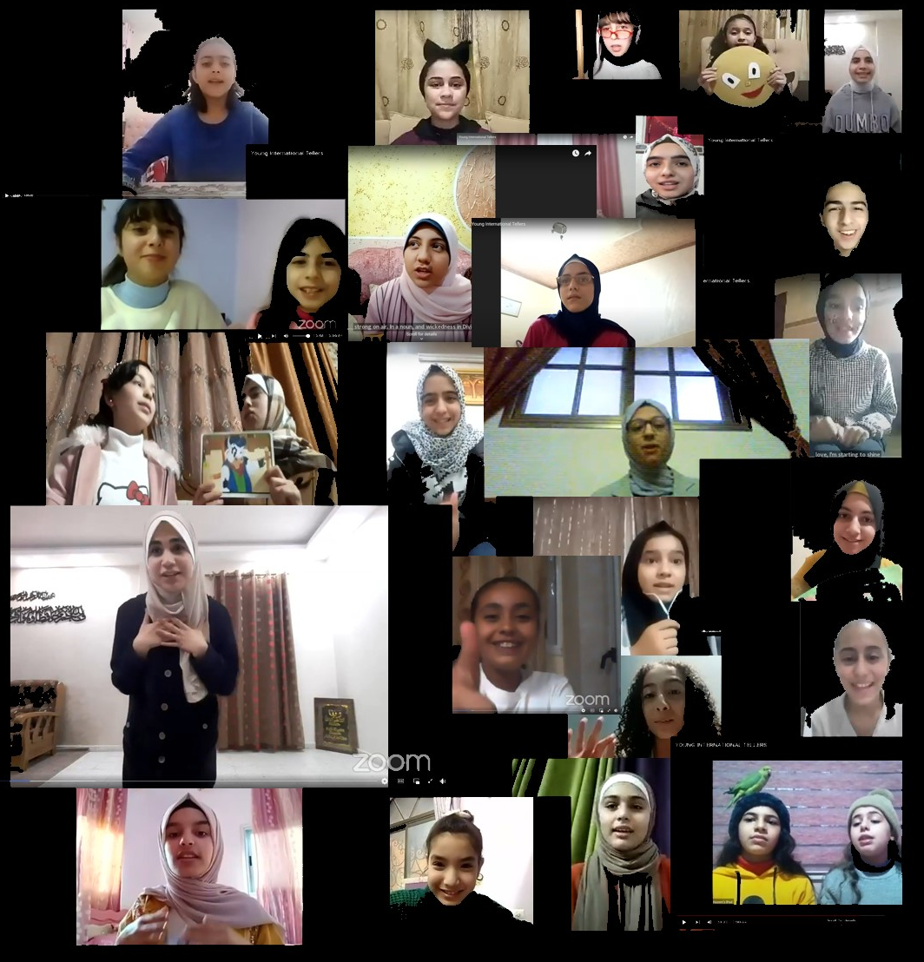
Young International Storytellers in Gaza telling stories at the World Storytelling Cafe
In 2020 during lockdown, I launched a weekly Tuesday event together with John Row at the World Storytelling Café. It was called “Young International Storytellers”. At the time, I had connections with teachers from Gaza, who invited their students to take part in the format. One of these students was Farah, then a 14-year-old girl.
Getting back in touch
In September 2024, Farah got back in touch with me for the first time in four years. After a wonderful short conversation between Farah, now 18, her younger sister Hala, my wife Tammy and me on Messenger, Farah decided to record herself telling the old Danish folktale The Boy Who Sold the Butter. She said "I'm so happy because I came back to telling stories. I want to thank all the supporters."
We could sense how healing this experience was for Farah in the midst of the most unimaginable loss and horror which she and her sister are living through. I’m not going to share those details here. Here’s the link to Farah's delightful video: https://youtu.be/sXK-BaIJS6s?si=DYlb_iyHDPVGzOW, beautifully edited by her younger sister, Hala, another wonderful Young International Storyteller. Here is a full transcription of Farah’s video and a suggestion for how your students might learn to retell the story.
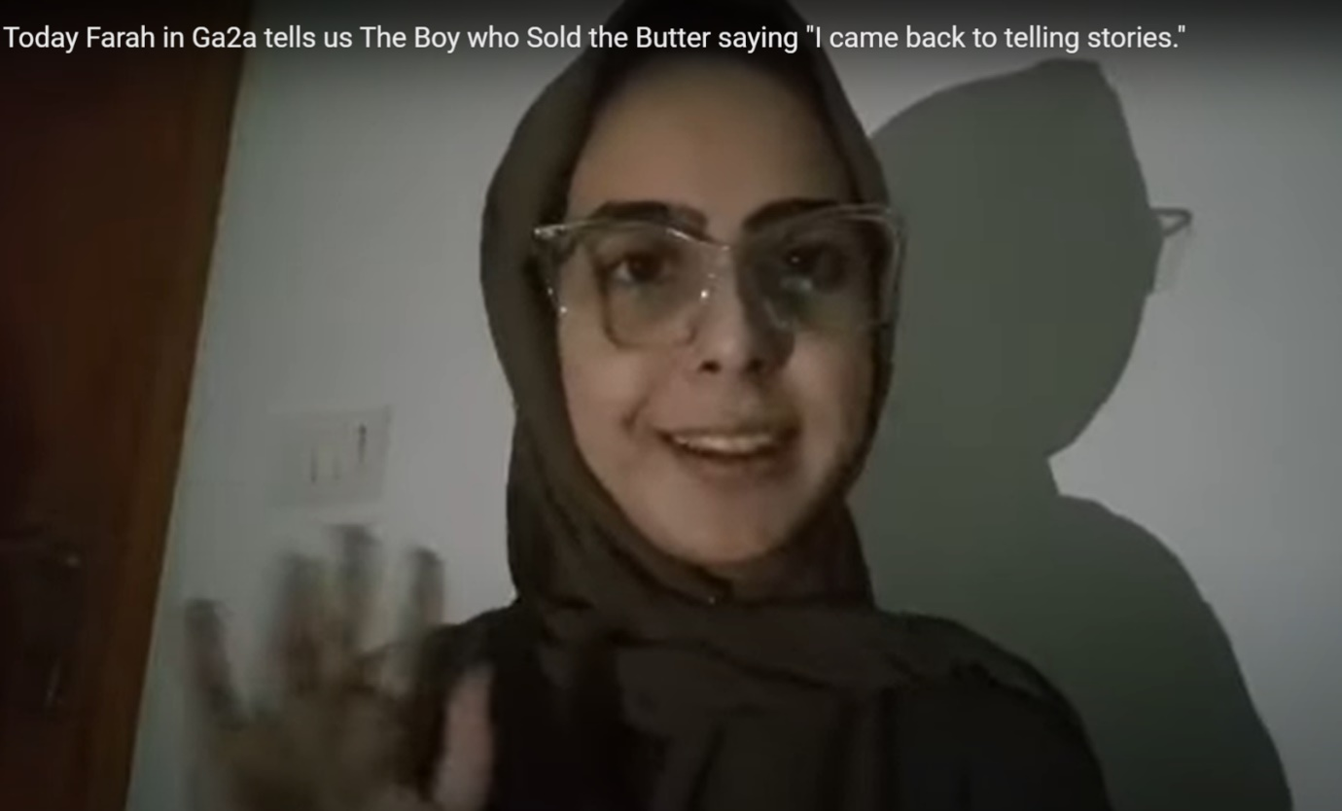
Farah in Gaza telling The Boy who sold the Butter in September 2024

The Boy Who Sold the Butter: Transcription
Hi everyone! I am Farah from Gaza and I’m 18 years old. Today I am going to tell you a new story. It is called “The Boy Who Sold the Butter”, and actually I am so happy because I came back to telling stories. The last time I was told [a story] was in 2020 – that is, four years ago. So let’s get started.
There was once a woman who had a foolish son. When he helped with the chores on the farm, he usually made a mess. So she found it easier to do all the work by herself. One morning she churned a big batch of sweet butter, and she planned to take it to town and sell it. And her son begged: “Mom, please, Mom – let me take the butter and sell it in town! Please, Mom! Please!”
“No!” said his mother. “You have never even been to town. It is so big that you will get lost. Stay home and keep the cow company, okay?”
“Please, Mom! Let me take it to sell it in town! Please!”
“I said no. I will not let you go. Stay home!”
But he pleaded with her for so long that she finally agreed: “Okay, you can go.” She gave him some advice on how to sell the butter, and off he went.
He followed the road just as his mother had told him. After what seemed a very long time he came to an enormous rock. And he thought: “Hmmm... My mom told me the town is so big. This stone is certainly big. It must be the town!”
So he said to the rock: “Town, would you like to buy some of my mom’s butter?” The rock, of course, did not answer. It was a rock. But this did not stop the boy. He went right on talking. He was a fool, after all.

Retell it your way!
Challenge your learners to make Farah’s story their own
Materials: A pencil or pen, a piece of A4 paper, the video of Farah telling the story available via this link: https://youtu.be/sXK-BaIJS6s?si=DYlb_iyHDPVGzOW
Procedure:
1. Use the procedure below to learn and retell Farah’s story “The Boy Who Sold the Butter” using the Story “S” technique. Second best option: you can read the above transcription aloud to the class.
2. Ask learners to draw a giant “S” on a piece of A4 paper.
3. Demonstrate briefly how to do very quick and simple sketches along the curves of the “S” from top to bottom.
4. Explain to learners that you’d like them to do similar sketches to help them remember the key events / expressions in the story while you tell it to them again.
5. Tell the story again without pausing. At the end allow students a minute to complete their story “S” either alone or with help from a partner.
6. Ask pairs of learners to retell the story together with the help of their Story “S”.
7. Play the video of Farah telling the story and invite students to give examples of what they enjoy about her vocal expression, humour and physicality when telling the story.
8. Ask pairs of learners to now take in turns to tell the story to each other and then comment on what they enjoy about each other’s storytelling.
9. Optional: Ask learners to add a new ending to the story.
10. Invite learners to retell the story in English or any other language at least twice to people they meet outside class and to report back in the next class about how their storytelling improves and evolves.
Don’t be surprised: The more times learners tell a story, the more the story becomes their own.

The next project
I'm sharing this as part of “Tell a Child in Gaza's Tale”, a project I am running together with Haneen Khaled Jadallah. Starting on 10 November 2023, shortly after the current critical situation in Gaza began, I shared a link on my Facebook page every day to a video recording of a child from Gaza telling a story to the camera.
Nearly all these recordings are from World Storytelling Café archive recordings on YouTube and Facebook from 2020 to 2022. People around the world, many of them teachers of English who love oral storytelling, followed and commented, expressing admiration for and solidarity with the children and their teachers whose circumstances we can only imagine. This continued until 13 January when I shared the 65th daily story. In autumn 2024, I retold The Fox’s Tail to a group of schoolchildren in Hamburg. It’s a Palestinian folk tale which Farah told four years ago. Here’s a link to the video from the Hamburg school: https://youtu.be/4nzNDHTfRGU?si=PHVQI-B2TrjpiGxX
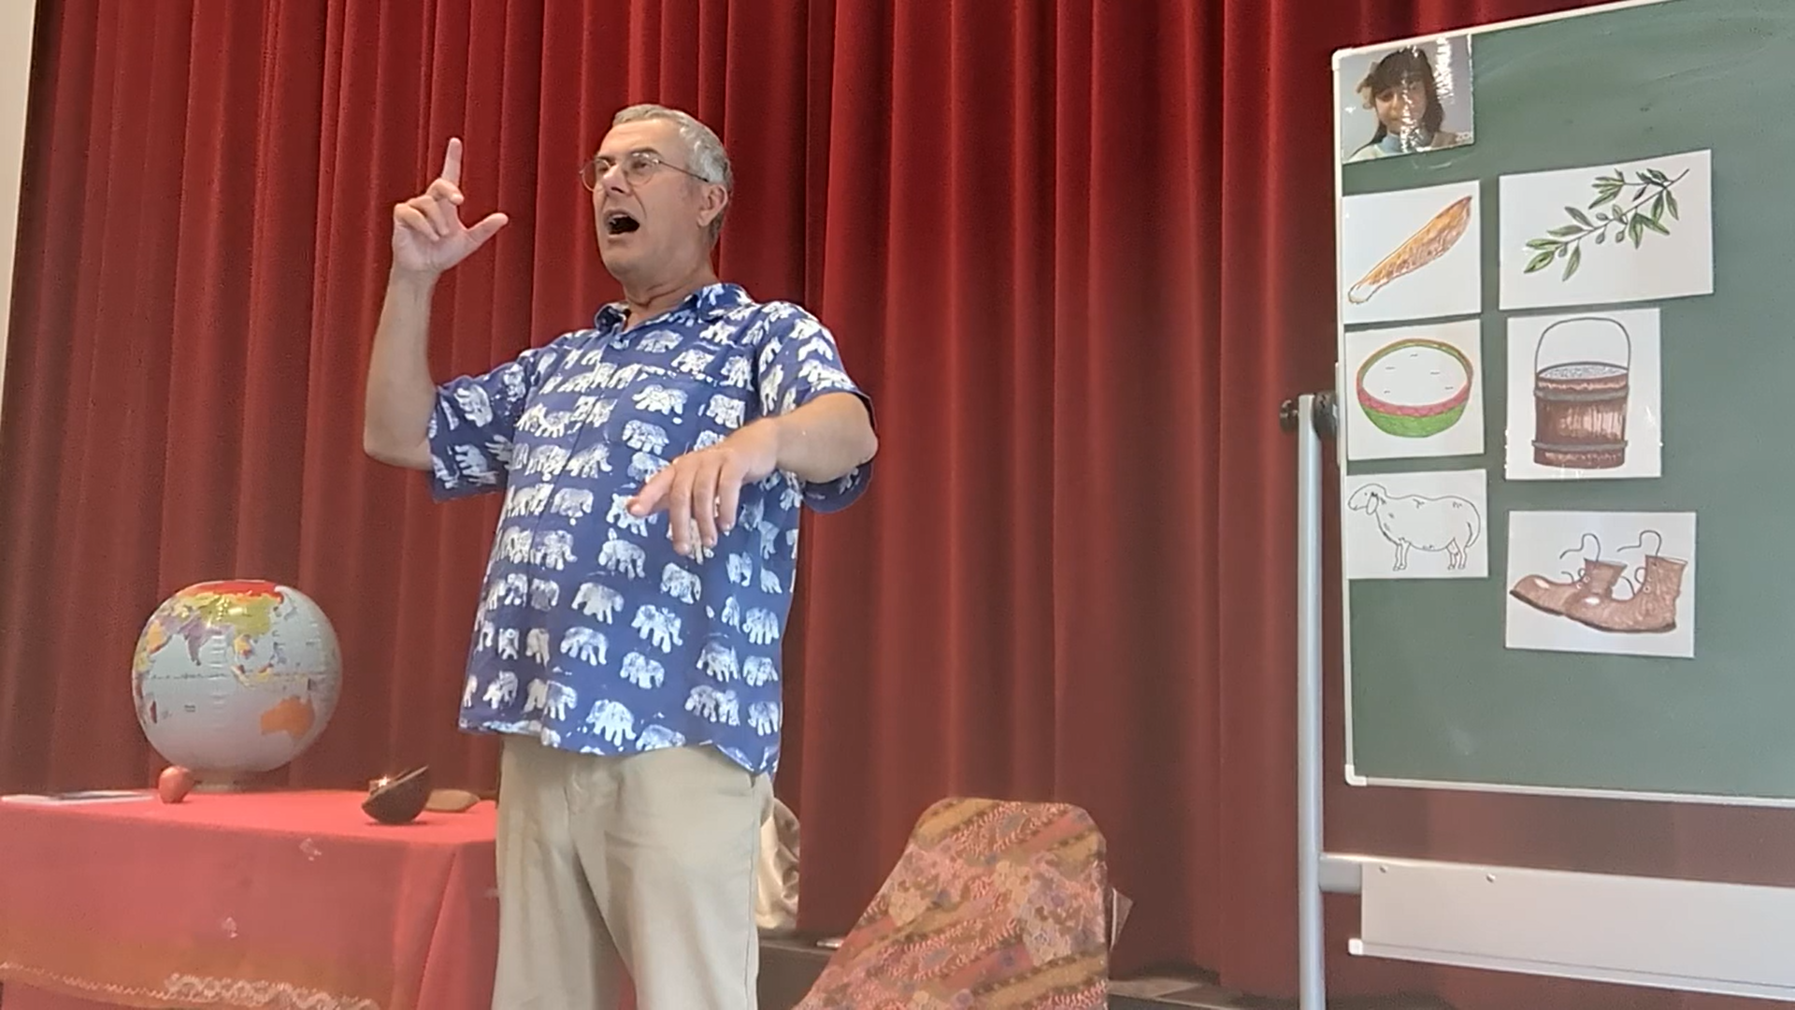
David retelling the Palestinian folk tale he learned from Farah “The Fox’s Tail” with children at a Grundschule in Hamburg, Germany
Now you tell a tale
And now, Haneen and I invite you, your students and everybody you know to choose a tale, retell it and share it around the world to return the hospitality shown from their homes in Gaza by wonderful young storytellers since 2020. It means the world to Farah and all the Palestinian children and teachers. For more information about the project and about adding your video to the global public playlist, you can contact me at davidheathfield@hotmail.co.uk.

Here are the stories: https://drive.google.com/file/d/1BKu7JPXmONEB6y5cbeGlUW6zWi3SmRAP/view
Here are storytellers like you and your students from around the world retelling the Gaza children’s stories: https://youtube.com/playlist?list=PLj-mcWeMmSZw63V5abQ4fw3JIITI_S_kS&si=du47VczUOOkf3dQo
Farah telling The Boy Who Sold the Butter:
https://youtu.be/sXK-BaIJS6s?si=DYlb_iyHDPVGzOW
Farah four years ago 23 December 2020 aged 14 tells The Fox's Tail: https://youtu.be/I8P5vktiHQY?si=_Yxfb_mIYPqriufb
David Heathfield retelling The Fox’s Tail last autumn in Hamburg: https://youtu.be/4nzNDHTfRGU?si=PHVQI-B2TrjpiGxX.

