Pilgrims and IATEFL Edinburgh
Hanna (Hania) Kryszewska with Phil Dexter, Pilgrims Trainers


The IATEFL (International Association of Teachers of English as a Foreign Language) International Conference in Edinburgh took place from Tuesday, April 8th to Friday, April 11th, 2025, with Pre-Conference Events (PCEs) on Monday, April 7th. The conference was held at the Edinburgh International Conference Centre
Arrive in Edinburgh
When you arrive in the city centre the majestic castle greets you. You get a feeling of Scotland straightaway…
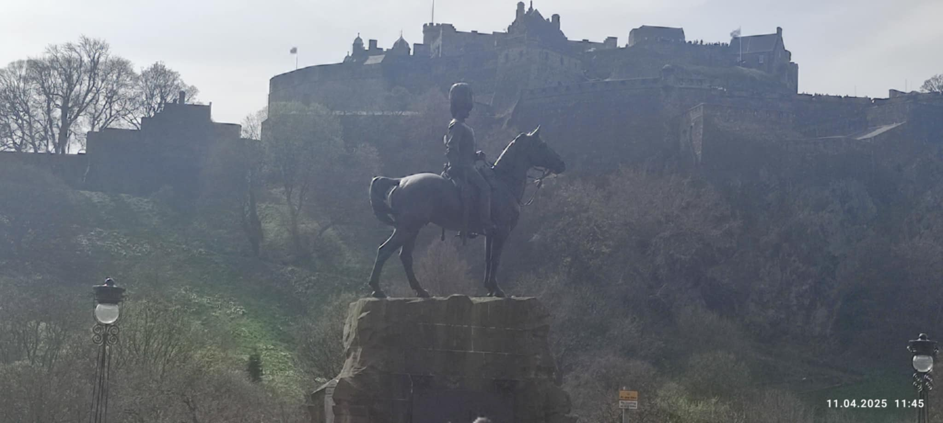
As you admire the castle you can listen to bagpipers performing in Princess Street. Amazingly the piper I met played the Polish national anthem for me.

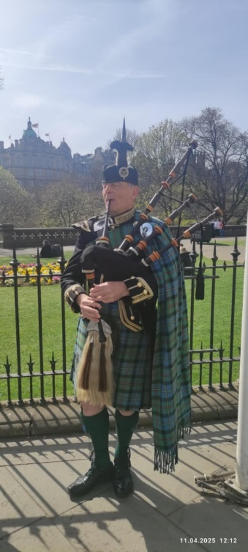
Arrive at the conference
We join the queue to register, get our badges and pick up our conference bags with the conference programmes (if you want a printed version) and some goodies. (Good news as there is less and less paper wasted).
Nobody minds the long wait as you can start chatting to colleagues from all over the world and chat to friends you had not seen for a while. So many conversations get interrupted as you spot yet another person you know. Sometimes it can be pretty annoying.

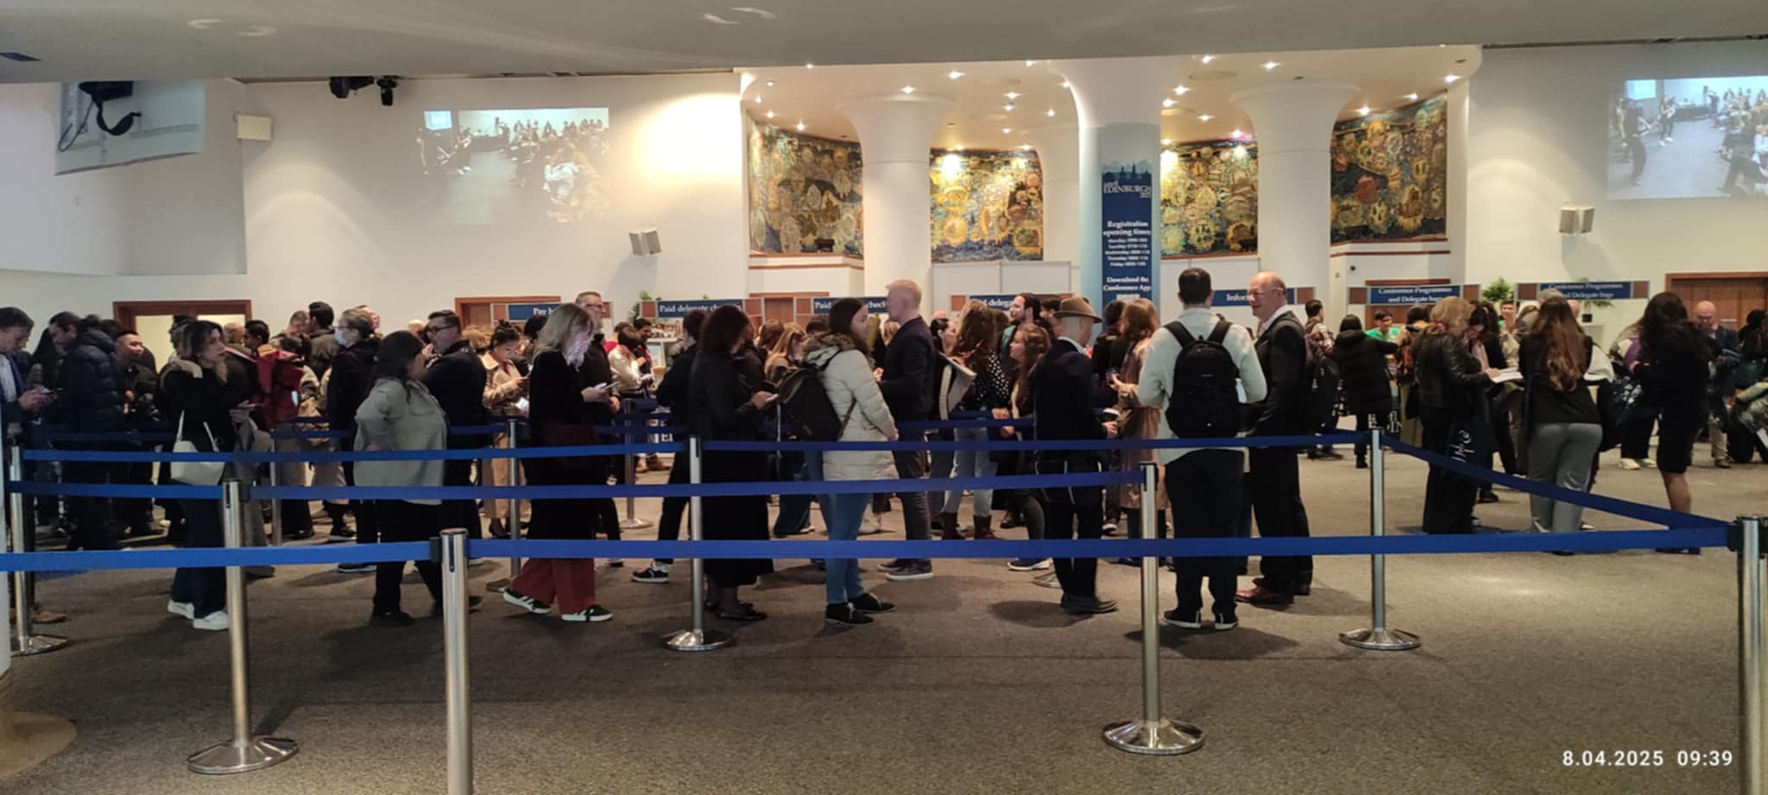
The exhibition area
The exhibition area is the best place to meet colleagues, make appointments, visit the stands, chat to publishers’ reps and, of course, visit the Pilgrims stand. For me it is also an opportunity to harvest articles and spot potential contributors to HLT.
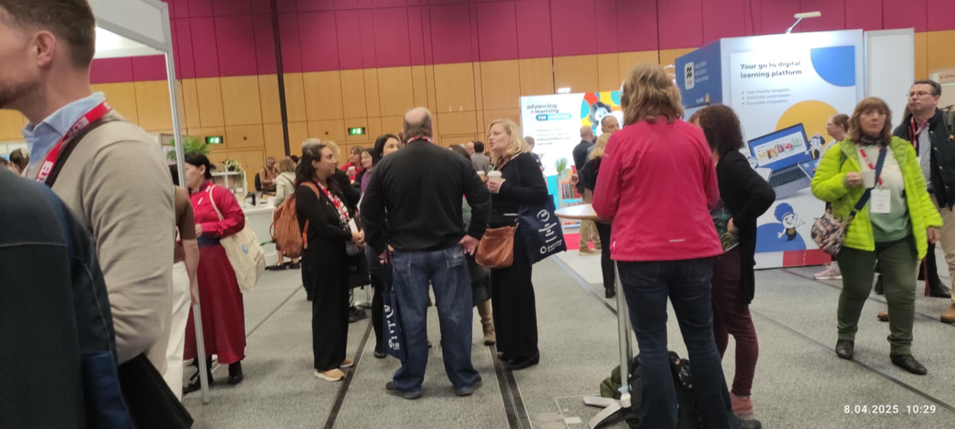
The Pilgrims stand was manned by Stefy, Suart McDonald and Claire Hunter, with some help from Phil and Hania. Thank you Edinburgh school of English for your invaluable support.
So many people came to our stand to chat, to remember the Pilgrims courses they had attended in Canterbury or are planning to come to Segovia.
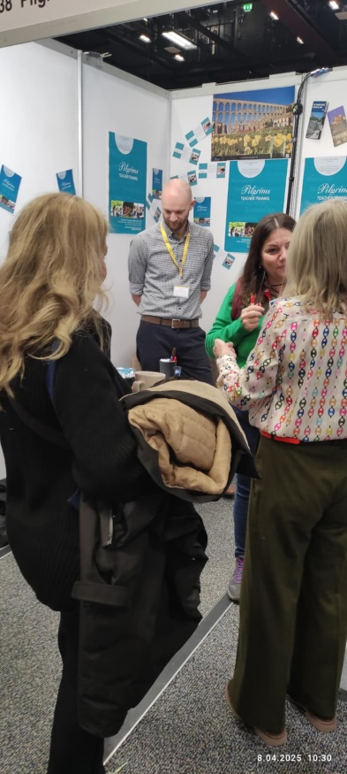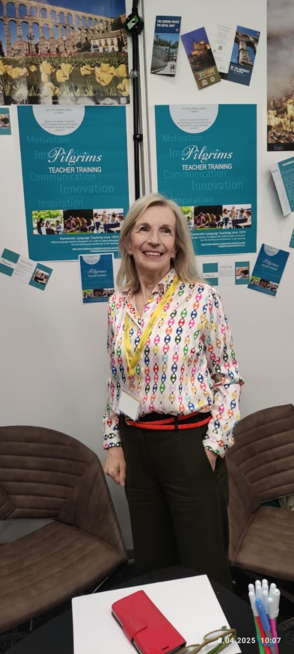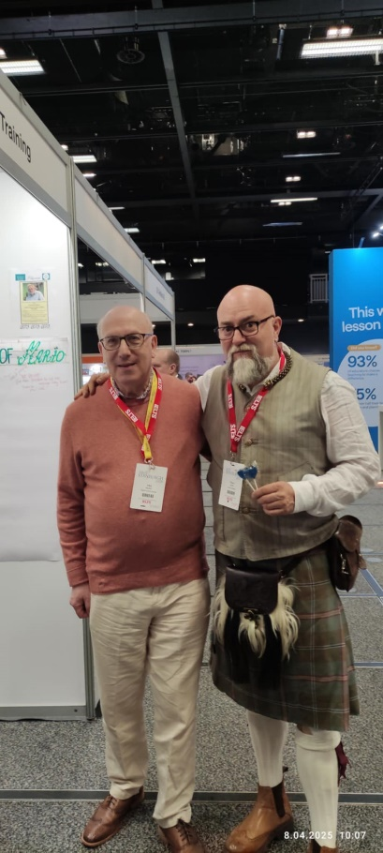

As you take photos in the exhibition area you could try to do the ‘Big Five’ with your camera, i.e. catch five well known teflers in one photo. I managed three - John Hughes, Shaun Wilden and Hugh Deller. But then I did not try hard enough.
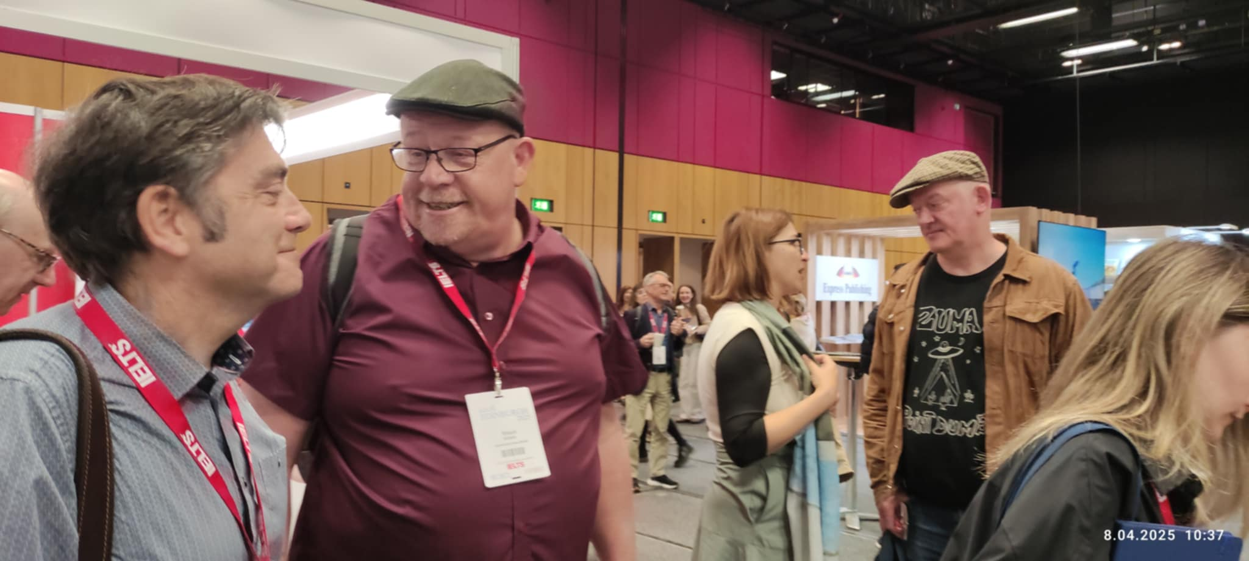
The content
The plenaries, workshops pop up presentations, poster presentations and other events were very inspiring. The Pilgrims contributions were:

Implementing inclusive learning practices in school contexts collaboratively

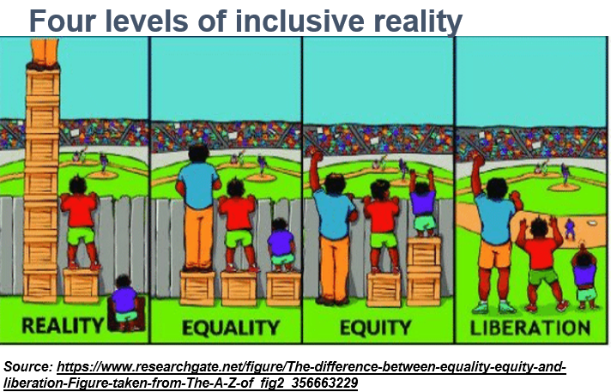

Phil Dexter’s talk was included in the IATEFL SIG -Inclusive practices and Special Educational Needs (IP& SEN) showcase day. Phil focused on how inclusive practices can meet the needs of most learners whatever their additional needs if we start from a strengths based approach working with what all learns can do well. While additional support needs can be important is medical diagnosis our work as teachers is looking at educational support approaches and Phil outlined a number of strategies and activities that can support this.
and
Hania Kryszewska spoke about: thought provoking language classes; how to choose and use texts

In language classes students must understand - step one is comprehension questions, step two: teaching for understanding e.g. reading between the lines, step three: critical thinking, step four: mediation - interaction with the text, step five, the pinnacle: reflection hopefully leading to a change of heart. This can only happen through thought provoking topics which the workshop looks at.

As usual there was so much going on, that it was difficult to choose which session to attend. My favourite takeaway is in this session title. Very Humanistic.
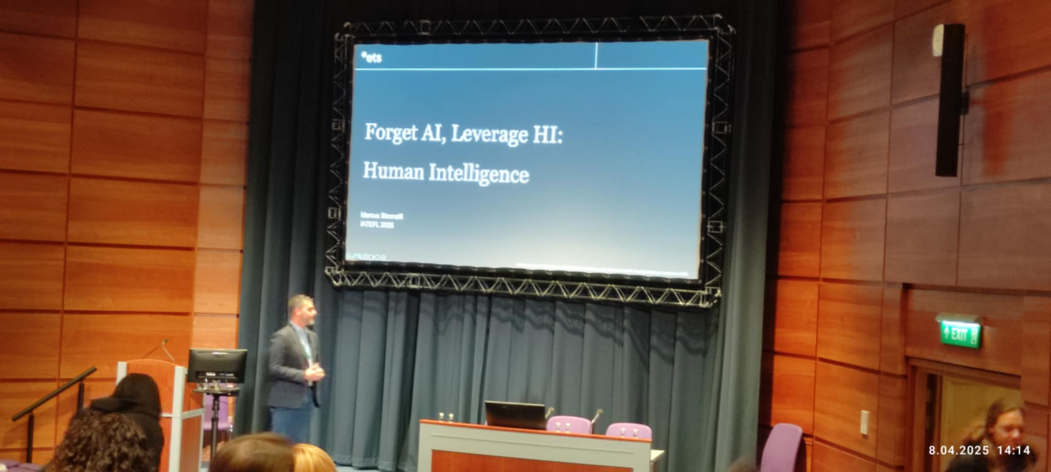
Walls
Walls seemed to be the theme of the conference. Here are two examples – one organised by OUP:
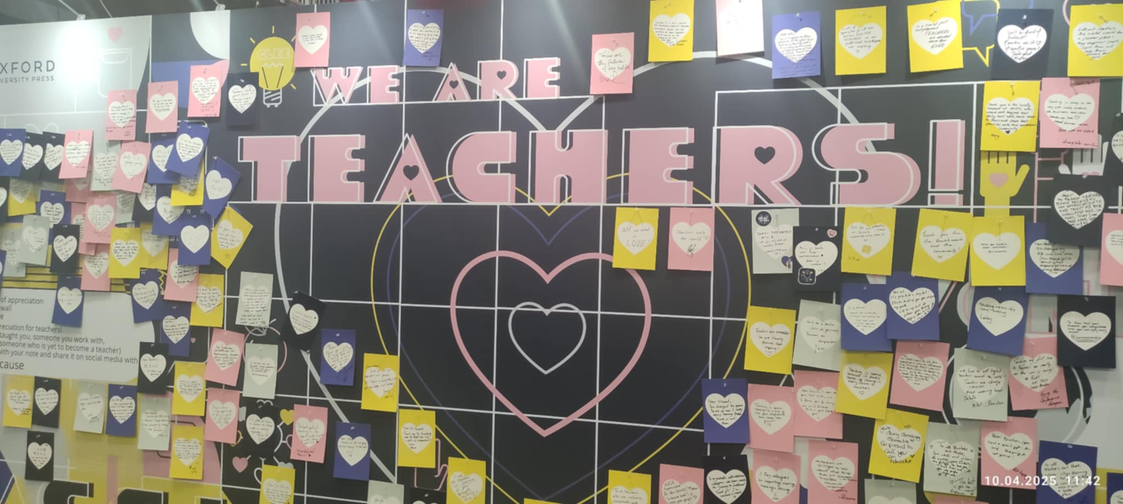

and one at our Pilgrims stand devoted to Mario Rinvolucri. Many people remembered Mario but sadly the young generation sometimes asked: Mario who?
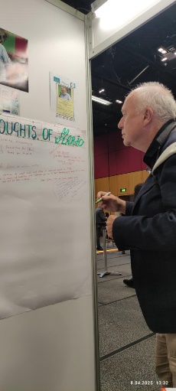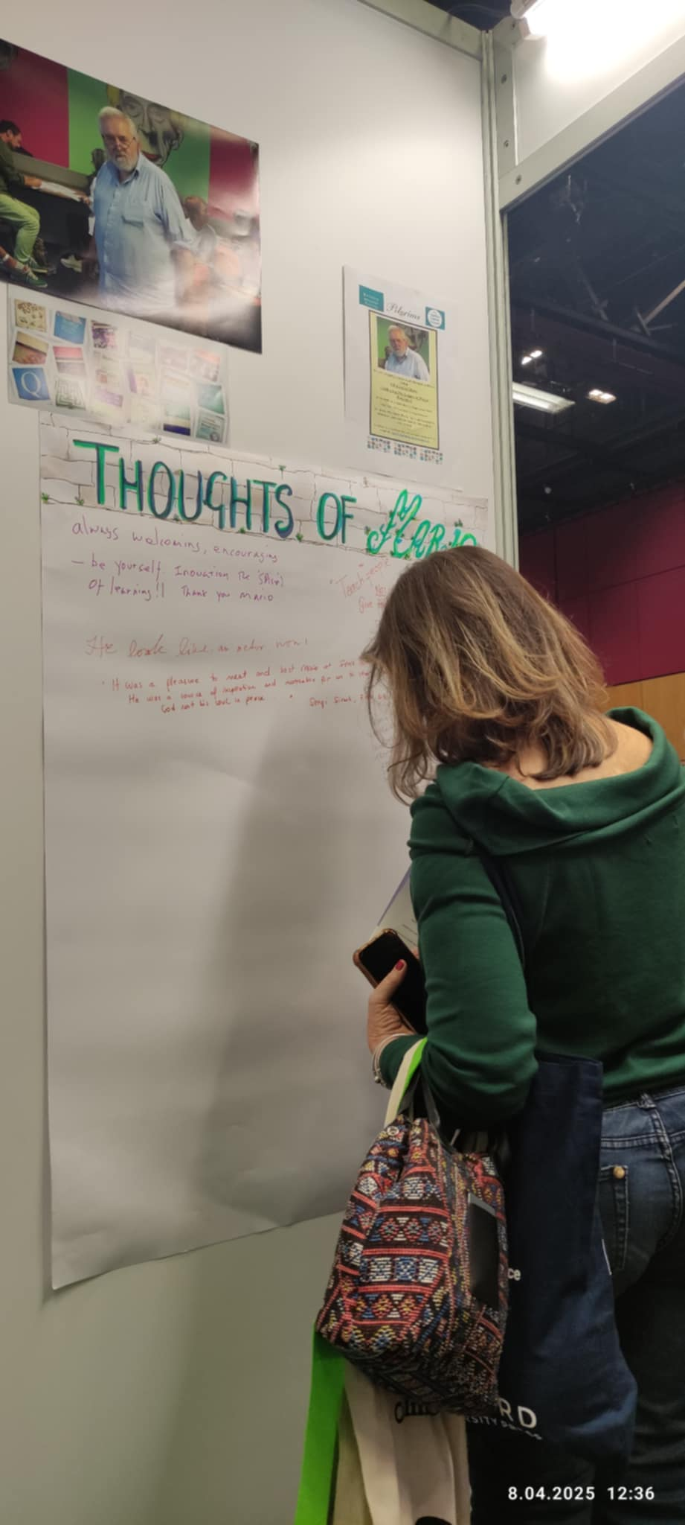
We also attended the tribute session which gave us the the opportunity to remember colleagues who've died during the year since the last conference. It was very moving and beautiful – very well conducted by Peter Grundy.

Celebrate
Of course, as usual publishers and other exhibitors celebrated various anniversaries which we were invited to attend. We enjoyed some bubbles, canapés, cakes and above all each other’s company.
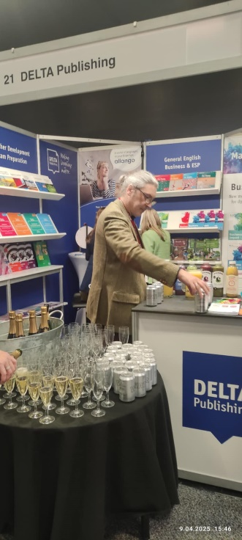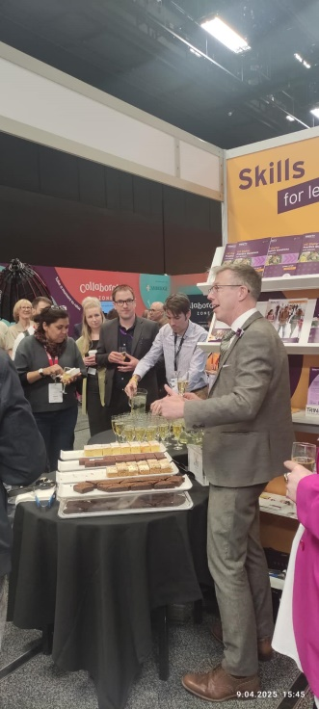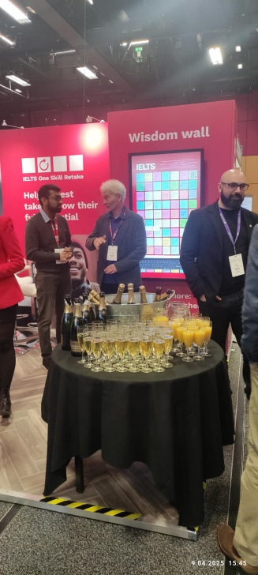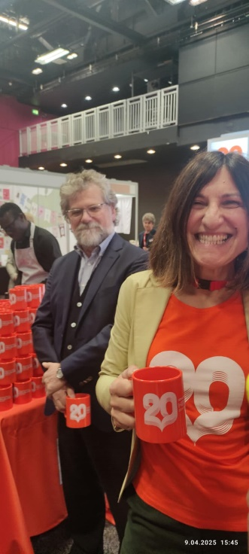
Good-bye
Unfortunately, all conferences come to an end. There was little time to do some shopping in Princess Street for outfits or small souvenirs like a tin of shortbread or fudge.
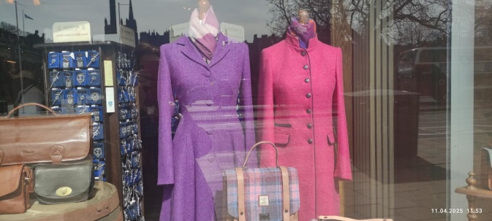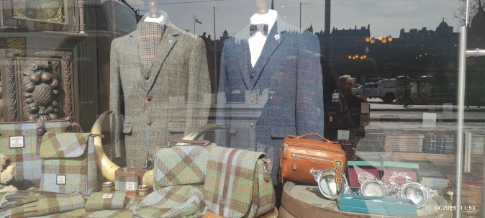

See you next year at IATEFL Brighton!



