Embracing AI to Transform ELA Learning

Erika García Saucedo, México

Erika García Saucedo teaches at ATS (American School of Tampico) in Tampico, México. She currently teaches 6th grade English and is the English Department Head for Middle School. She has a Masters in Education, having taught ELA for over 15 years, with ample experience teaching Middle School through adult learning. She presented the project referenced in the article at October 2024´s edition of the MexTESOL convention in Monterrey, México. Email: egarcia@ats.edu.mx

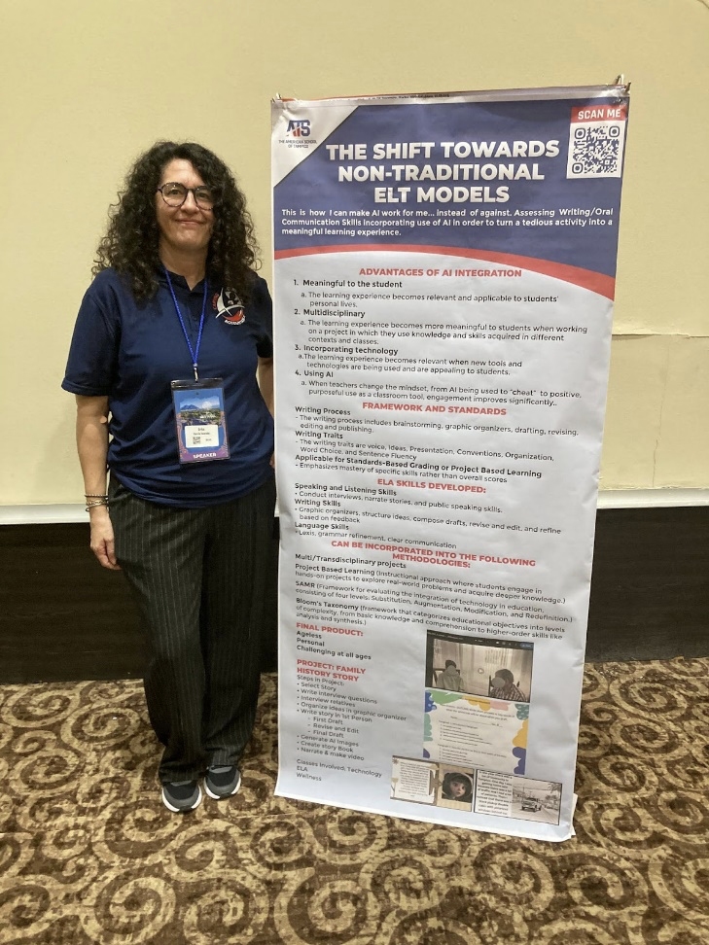

Introduction

As ELA educators, we face a persistent challenge: making writing assignments engaging while ensuring they meet educational standards. Writing, a critical component of language learning, often feels burdensome to students and teachers alike. However, with the integration of artificial intelligence (AI) into the classroom, educators have an opportunity to revitalize the teaching and learning process. AI not only adds creativity to writing tasks but also aligns with interdisciplinary approaches, ultimately creating an engaging and rewarding experience for both educators and learners.

AI: A partner, not a rival

One of the primary concerns about incorporating AI into education is the misconception that it might replace traditional teaching. In reality, AI serves as a tool to augment teaching practices, not replace them. It provides opportunities to innovate how writing is taught, assessed, and experienced. Teachers can use AI to streamline grading, provide personalized feedback, and encourage students to explore their creativity in ways that traditional methods often cannot. The key is to use AI intentionally and strategically, ensuring that it complements, rather than overshadows, the teacher's role.

A compelling example of how AI can enhance the ELA classroom is the "Family History Story" project. This multidisciplinary initiative integrates AI to enrich the learning experience, showcasing the potential of AI as a meaningful teaching partner.

The ‘Family History Project’: A deep dive

The Family History project is more than a simple writing assignment. It transforms traditional essay tasks into an immersive, technology-driven experience. Here’s a detailed look at how it unfolds:

1. Interviewing relatives

Students begin by interviewing family members about significant events or experiences in their lives. This step teaches research skills and encourages students to connect with their heritage. Acting as journalists, they prepare thoughtful, open-ended questions, such as, "What was the most challenging moment you faced as a young adult?" or "Can you describe a family tradition that has been passed down?" These interviews not only develop oral communication skills but also build empathy and active listening.
Students record their interviews, ensuring they focus on presentation skills like eye contact, clear articulation, and respectful body language. This process also addresses speaking and listening standards, such as posing and responding to specific questions with elaboration and detail.

2. Crafting the narrative

Using the information gathered, students write a narrative in the first-person perspective, imagining themselves in the shoes of their interview subject. This step emphasizes the writing process, from brainstorming and outlining to drafting and revising. Students learn to organize their stories into cohesive paragraphs, incorporating descriptive language and sensory details to bring their narratives to life.

The writing phase aligns with Common Core standards for narrative writing, which focus on developing real or imagined experiences using effective techniques and well-structured event sequences. Teachers can use rubrics to assess voice, organization, word choice, and sentence fluency, ensuring that each piece meets established criteria.

3. Generating visuals with AI

The project takes a creative turn when students use AI tools like NightCafe or Canva to generate images that illustrate key moments in their stories. For example, a narrative about a grandparent’s journey to a new country might include visuals of a bustling port or a family reunion. Students learn to craft detailed prompts for the AI, honing their descriptive skills as they guide the tool to create meaningful images.

This step introduces students to emerging technology, helping them understand how AI can be a powerful tool for storytelling. It also encourages them to think critically about how visuals can enhance a narrative, making their stories more engaging and impactful.

4. Producing a multimedia story

The final phase involves combining text, visuals, and narration into a multimedia presentation. Students create a digital storybook, dividing their narratives into sections and pairing each with an AI-generated image. They record themselves reading the story aloud, synchronizing their narration with the visuals. This activity integrates writing, speaking, and technological skills, providing a comprehensive learning experience.

The end result is a polished digital story that students can share with their families and peers. This tangible product serves as a source of pride and a meaningful keepsake, reinforcing the value of their efforts.

Why this matters

Projects like the Family History Story resonate deeply with students because they are:
- Relevant: By focusing on personal and family stories, students find meaning in their work, making the assignment more engaging and authentic.
- Multidisciplinary: The project integrates skills from multiple disciplines, including research, writing, oral communication, and technology. Wellness can also be involved, helping students identify with the main feelings in the story and helping them build empathy by connecting with their relatives´ experiences.
- Engaging: The use of AI and multimedia elements transforms a standard writing task into an exciting and interactive endeavor.
This approach not only fosters creativity but also equips students with skills that are vital in today’s digital world. It demonstrates that writing can be more than a solitary task; it can be a collaborative and dynamic process.

Additional AI-enhanced project ideas

Inspired by the Family History Project? Here are more ideas to explore:
- Community Chronicles: Students interview local community members and create a digital magazine featuring stories, interviews, and visuals generated with AI. This project fosters a sense of connection and civic responsibility.
- Future Aspirations Diary: Students imagine their lives 20 years from now, crafting diary entries about their future selves. AI-generated visuals depict their envisioned careers, homes, and achievements, making the exercise both aspirational and creative.
- Literary Worlds Reimagined: Students rewrite scenes from classic literature, using AI to create visuals that reflect their unique interpretations. This project deepens their understanding of literary elements while encouraging imaginative thinking.
Embracing the future

Integrating AI into ELA classrooms is not about replacing traditional methods but enhancing them. AI allows teachers to rethink how they approach writing instruction, making it more relevant, engaging, and impactful. By leveraging technology, educators can inspire creativity, foster interdisciplinary learning, and better prepare students for a world where AI plays an increasingly central role.

As educators, we have the opportunity to redefine what it means to teach writing in the 21st century. By embracing AI, we can transform writing from a dreaded task into an exciting journey of discovery and expression. Let’s take that step together, making the classroom a space where technology and creativity intersect to empower every learner.
https://www.ats.edu.mx/
https://mextesol.org.mx/convention-2024
Acknowledgement

This article has been written using AI to adapt the content of a slides presentation about the project referenced. Once again, proving AI is a valuable tool for teachers. Please find the PDF waiting do be downloaded at the bottom of this page.

Coming soon! Please check the Pilgrims in Segovia Teacher Training courses 2026 at Pilgrims website.

Please check the Pilgrims f2f courses at Pilgrims website.

