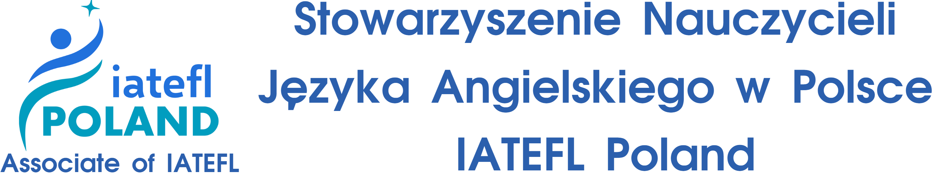

The 34th IATEFL Poland International Conference
Make sure to save the date for the 34th IATEFL Poland International Conference to be held from September 19-21, 2025, at Lodz University of Technology in Łódź, Poland. Building on the success of last year’s event in Gdansk, which attracted over 650 professionals from over 30 countries, this year’s conference promises to continue fostering global collaboration in English language teaching. This year’s conference will feature over 200 speakers, 30 plenaries, talks, workshops, live & advanced lessons, and computer labs presented by an amazing lineup of well-known international speakers from the ELT community. Attendees may also engage with exhibitors and enjoy our optional Conference Dinner with entertainment.
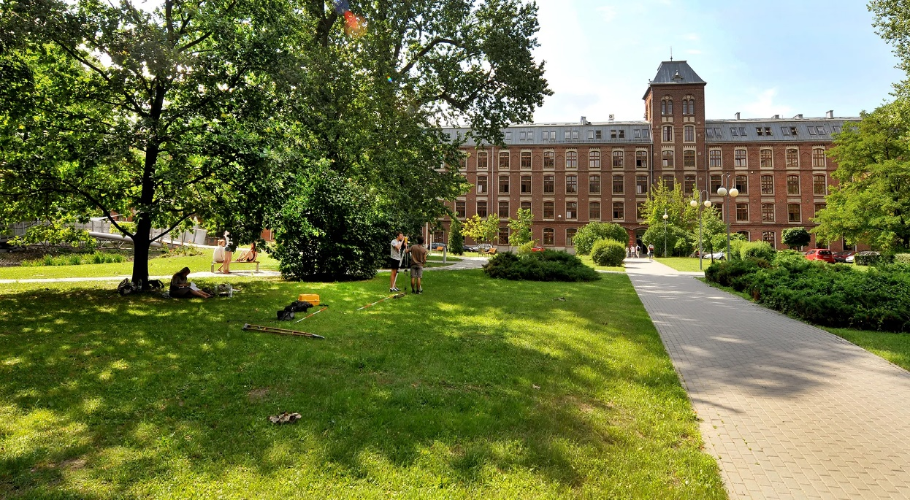
The 2025 edition is set to bring together even more ideas and innovations for the ELT community. Planning and preparations are well underway for the event. This year, we have had an unprecedented number of proposals and registration is well ahead of our conferences since COVID.

The conference theme Back from the Future encourages attendees to reflect critically on the responsible use of AI and technology, urging a thoughtful examination of its long-term impact on society, ethics, and education. One of the main focuses is on bringing pedagogy and methodology back into teaching, emphasizing the importance of intentional, research-informed practices in the classroom. In addition, the conference highlights the need to support learners with diverse needs, ensuring that educational innovations remain inclusive and equitable.
Registration is now open at iatefl.org.pl /see below/.
We hope you join us for the largest and most exciting ELT conference in Poland, and perhaps Europe, this year.

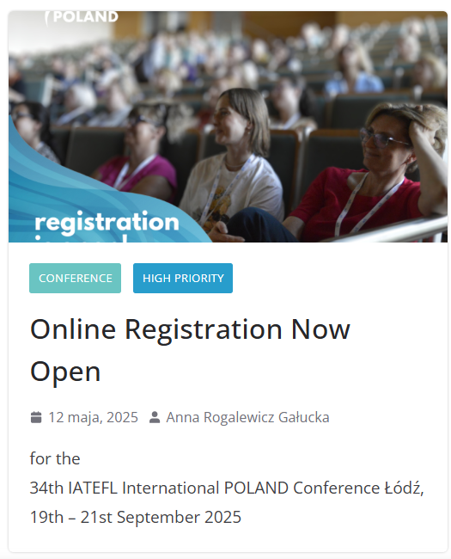

34th IATEFL International POLAND Conference Łódź
19th – 21st September 2025
REGISTER HERE

