Global Skills – Create Empowered 21st Century Learners

from OUP, with Hanna Kryszewska, Poland



Acknowledgement
This text contains fragments of the OUP Introduction to Global Skills written by Sarah Mercer and Nicky Hockly. You can also find there a link to download the position paper.

Sarah Mercer is Professor of Foreign Language Teaching at the University of Graz, Austria, where she is Head of ELT Methodology. Her research interests include all aspects of the psychology surrounding the foreign language learning experience, and she has written and edited prize-winning books in this area.
Nicky Hockly is the Director of Pedagogy of The Consultants-E, an online training and development consultancy. She is a teacher, trainer, and educational technology consultant who works with teachers all over the world. Nicky writes regular columns on technology for EFL teachers in professional journals and has written several prizewinning methodology books.

In the introduction the authors say:
The world is changing at a rapid pace and it is hard for educators to even imagine what kind of skills and competences their learners will need 10, 20, 30 or even 50 years from now. What is clear, however, is that traditional academic subjects alone will not be enough. Many curricula across the globe already include some form of life skills education. It has increasingly become the norm that many educators are expected to integrate the teaching of these skills into their subject teaching. Yet, the support and training educators receive varies widely. This is where we hope our Position Paper can help ELT teachers, in particular, to reflect on and find ways to teach global skills alongside their language aims in sustainable ways.
After having examined many diverse frameworks for global skills, we have distilled them into five clusters. These are:
- Communication and collaboration
- Creativity and critical thinking
- Intercultural competence and citizenship
- Emotional self-regulation and wellbeing
- Digital literacies

The categories reflect the 21st century skills - not just the 4Cs

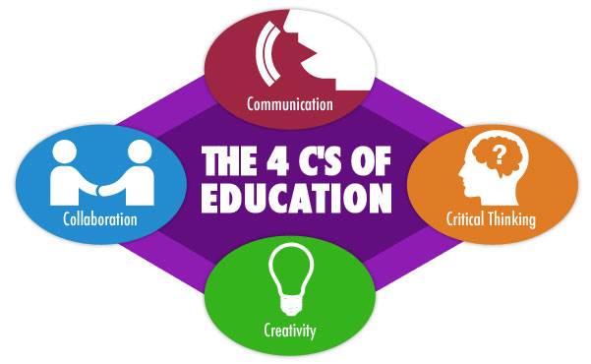
source

but the broader description represented by this diagram

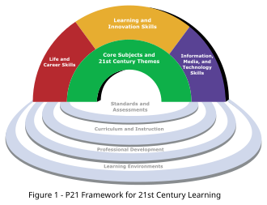

source

The areas we can cover in class are for example:
- comparing different media sources for critical thinking

- creating digital reports to be shared with classmates and based on online research

- asking open-ended questions which promote creativity, critical thinking and interaction with the text

- encouraging project work which goes beyond the class and reaches out to local communities and addresses burning local issues

- starting small which means run short activities and over time let them take more time and more insight

- using available published resources to start you off, for example

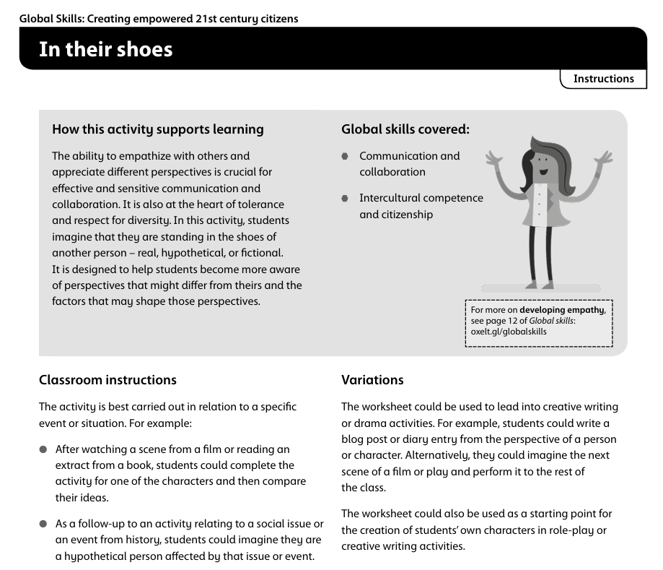

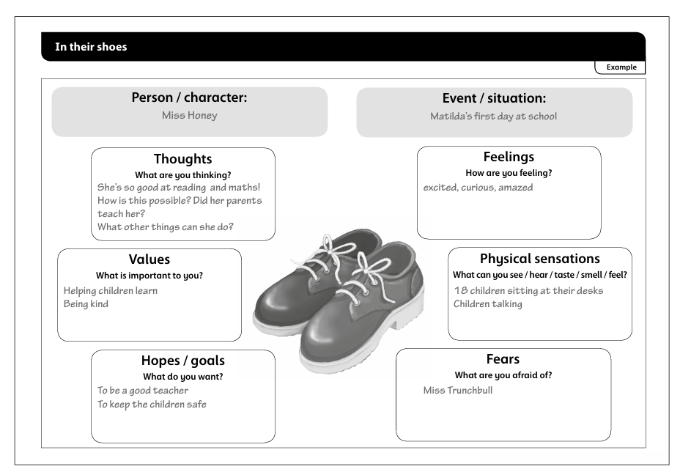

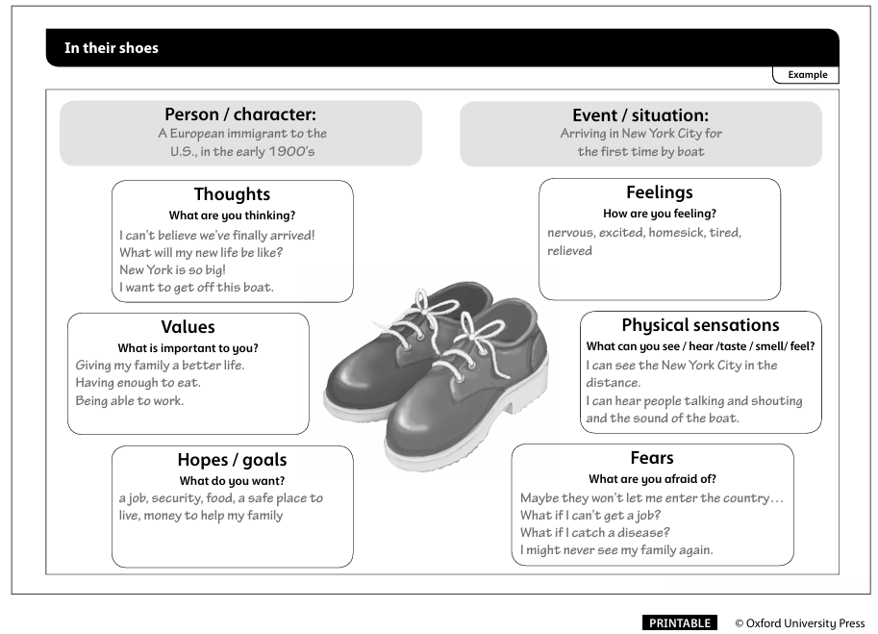

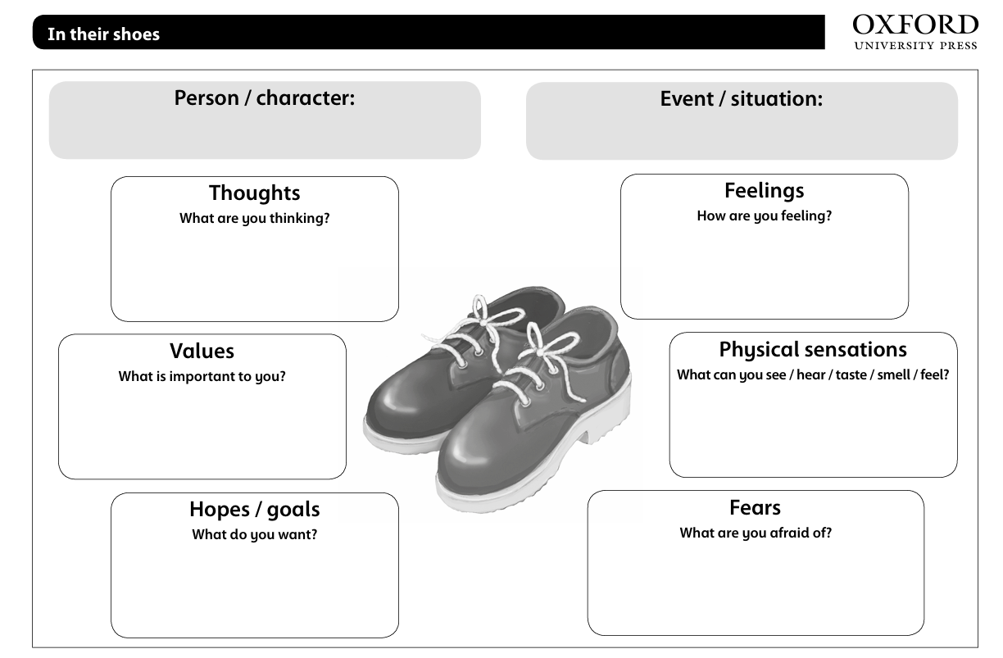

Please check the Pilgrims in Segovia Teacher Training courses 2026 at Pilgrims website.

Please check the Pilgrims f2f courses at Pilgrims website.

