

New: Spoken Grammar
All you need to know to teach spoken grammar in the language classroom
By Jon Hird



Spoken grammar is often neglected in the classroom. It refers to features that commonly occur in more conversational speaking as well as in informal spoken-like contexts, such as social media. Much of the grammar covered in published ELT materials and taught globally perpetuates the standard ELT syllabus, which is largely based on ‘tidy’ and very often more written-like grammar. In Spoken Grammar, Jon Hird explores how teachers can supplement or modify the more traditional ELT approaches by adding elements of spoken grammar to their teaching.

The aspects of spoken grammar featured in this book are clearly identifiable, straightforward and teachable. They are features that can be easily explained and practised. The book begins by exploring the nature of written versus spoken English. It then moves on to look at why and how to introduce and practise spoken grammar in the classroom. Alongside clear and practical explanations, it provides authentic examples of each point to help provide context. It also provides plenty of examples of exercises that can practice the language.
The book begins by exploring the nature of written versus spoken English. It then moves on to look at why and how to introduce and practise spoken grammar in the classroom. Alongside clear and practical explanations, it provides authentic examples of each point to help provide context. It also provides plenty of examples of exercises that can practice the language.
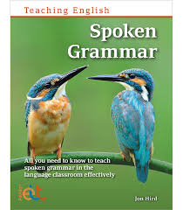
Through using this book, teachers will:
- Become more aware of the features of spoken grammar.
- Understand how it can be broken down into and presented in bite-size manageable and teachable elements.
- Be inspired and empowered to create their own activities to incorporate spoken grammar into their lessons. These can be adapted to suit their learners’ needs and interests.
- Become aware of how spoken grammar can be introduced into the classroom in a variety of ways, including:
  - Taught as a ‘spoken grammar’ lesson in itself,
  - Explored as part of a lesson, possibly to supplement the more conventional grammar that is being covered,
  - Picked up on in, say, a listening activity to promote noticing of the spoken grammar feature.





Out now: Women in ELT

The brain, language and power

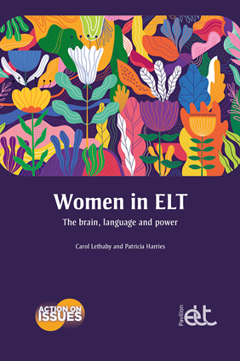
Launching the Action on Issues series, Women in ELT explores how and why sexism and gendering is so prevalent in English language teaching, and offers practical ways to combat it.

Gender inequality has far-reaching historical roots across much of society, and the story of women’s status and position in ELT is an intrinsic part of this complex history. There are no easy answers, but Women in ELT explores how and why sexism and gendering is so prevalent in English language teaching, through an accessible, evidence-based exploration of the history, theory, science and current circumstances. It then offers practical ways for teachers and teacher educators to face these issues in their own contexts – both within the classroom, and in the wider ELT industry.

