

“This book will be enormously helpful to those responsible for schools. Ian Timbrell offers a coherent approach with guidelines for decisions and advice on best ways forward, all with sensitivity and always in the best interests of young people.”
– Mick Waters, educationalist and author

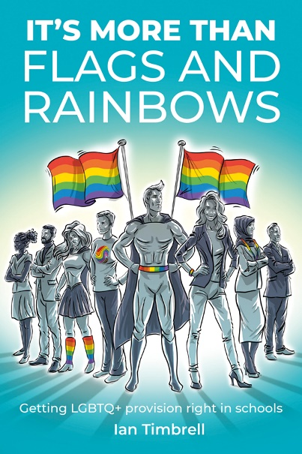
It’s More than Flags and Rainbows:
Getting LGBTQ+ provision right in schools
by Ian Timbrell
ISBN: 9781781354285
Price: £18.99
Published by: Crown House Publishing
Date of publication: June 2025
An inspirational handbook that provides educators with step-by-step guidance for creating truly inclusive schools where every child feels safe, seen and supported.

How can we build truly inclusive schools?

Significant progress has been made in relation to LGBTQ+ rights in the last few decades, with the legalisation of gay marriage marking a major turning point. Despite this, for many LGBTQ+ students, the reality of school life remains challenging at best. Between 30% and 50% of LGBTQ+ young people are likely to have experienced bullying in schools, and they are twice as likely to experience depression, anxiety, and panic attacks compared with their peers.¹ From a recent rise in anti-LGBTQ+ rhetoric in public discourse to debates over curriculum content, young people are still growing up in an environment where their identities are politicised and erased.
Even in schools that outwardly celebrate diversity, LGBTQ+ inclusive actions tend to be limited to token gestures or one-off assemblies which are insufficient and rarely tackle the root cause of homophobic bullying. In an age of political and ideological polarisation, it’s more important than ever to establish a comprehensively inclusive environment in schools where every child feels safe, seen and supported; not just during Pride Month, but every day of the year.


As the founder of the not-for-profit organisation, More Than Flags and Rainbows, Ian Timbrell is a passionate advocate for LGBTQ+ inclusion in schools. Drawing on his personal journey and 20 years of teaching experience, Ian works with schools across the UK, distilling his lived and professional insights into practical strategies for creating safe, inclusive environments where everyone can thrive.

Ian’s new book, It’s More Than Flags and Rainbows: Getting LGBTQ+ Provision Right in Schools, is an inspirational handbook that helps schools develop the confidence and the know-how to embed inclusivity as a consistent and sustained part of school life. It gives teachers and leaders step-by-step guidance, enabling schools to plan strategically to establish an environment where all children and young people can freely express their authentic selves. Although the focus of the book is on LGBTQ+ diversity and inclusion, many of the principles in this book are applicable to most areas of diversity.
At the beginning of each chapter, Ian includes a vignette from his life story, offering context about how he arrived at his ideas, and also demonstrating how the issues tackled in the book appear in real-world settings. Written with warmth, passion and empathy, It’s More Than Flags and Rainbows is both a rallying cry and a practical toolkit for change.
Essential reading for headteachers, teachers, pastoral leads or anyone passionate about LGBTQ+ inclusion and diversity in schools.

“Relates what happened in the 1980s and 1990s to the education issues and challenges of today and gives us a new and wiser perspective. As someone who knows Andy and has observed his thinking over 40 years, I loved it.”
– Professor Steve Munby CBE (former CEO of the National College for School Leadership, England).

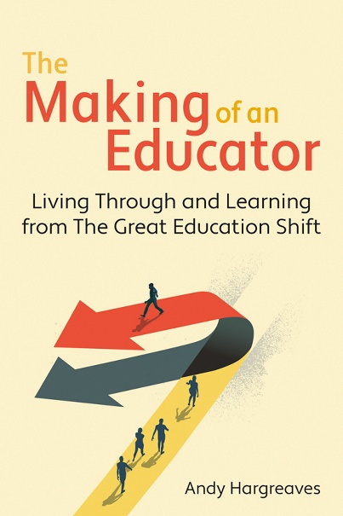
The Making of an Educator:
Living through and learning from The Great Education Shift
by Andy Hargreaves
ISBN: 9781785837524
Price: £16.99
Published by: Crown House Publishing
Date of publication: May 2025
What does it mean to become an educator during one of the most profound periods of educational and social change in modern history?

What the 1980s can teach us about today’s education crisis

The world is changing – quickly – and schools and educators across the world are navigating a period of enormous change. Political polarisation, economic instability and social upheaval are reshaping the way we teach and learn. But some argue that this change isn’t new at all. As journalist Larry Elliot puts it, Britain remains stuck in the past, still governed by the neoliberal ideas that took hold in the 1980s and continue to define our politics, and consequently, our education systems.¹


In his seminal new book, The Making of an Educator, prolific author and world-renowned educationalist Andy Hargreaves draws a parallel between what he calls two ‘Great Education Shifts’ in the 1980s and today.

This beautifully written, sometimes provocative and, on occasion, utterly hilarious book charts the first 15 years of his career in education as a teacher, researcher, academic and growing collaborator with schools. This was during a period of profound educational change in the 1980s, following a political and, ultimately, global move towards what is now known as neoliberalism with a shrinking state, market competition, the emergence of the standards and accountability movement and a decline in the status of teachers. It brought an end to an era defined by public investment, pursuit of equality, commitment to educating the whole child and support for a strong and highly qualified teaching profession.
Andy’s reflections on the present and the past cast a new light on some of the most pressing issues in education today, such as:
- the need to understand teachers before we try to change them
- the art of balancing self-regulated learning with teacher direction
- the importance and also the overreach of the evidence-based education movement
- the firestorms that surround intellectual bias and academic freedom
- the struggles that young teachers and researchers face early in their careers
- the common quest of educators to create the generations of the future and make history together
At a time when teachers are being asked to do more with less, and to remain positive in the face of constant upheaval, The Making of an Educator will serve as both an inspiration and a provocation. It will enable readers to gain fresh understanding about their own life and development as educators and equip them to engage with the profound changes that education and the world around them are undergoing now with wisdom, strength and renewed purpose.
A must-read for anyone working in or interested in education today.

"Because of You, This is Me is a gut-punch of a memoir—
raw, hilarious, and deeply moving. A must-read.”
– Zara Janjua, presenter, journalist and writer

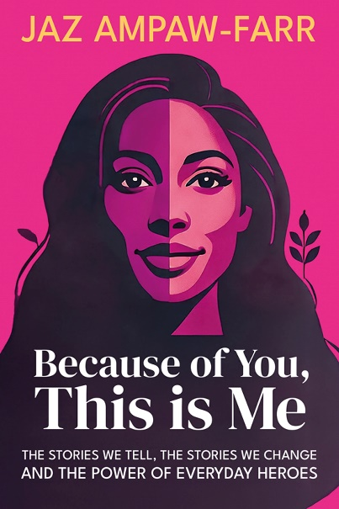
Because of You, This is Me:
The stories we tell, the stories we change and the power of everyday heroes
by Jaz Ampaw-Farr
ISBN: 9781781352984
Price: £16.99
Published by: Crown House Publishing
Date of publication: July 2025
A raw, honest memoir-meets-manifesto that celebrates the everyday heroes in our schools and the life-changing impact they have on the students in their care.

Multi-award-winning speaker, Jaz Ampaw-Farr celebrates the everyday heroes in schools and the profound impact they have on the students in their care

In schools across the country, teachers are being pushed to their limits. They are tasked with not only delivering lessons but also providing comfort, protection, and support. For children growing up in poverty, facing instability at home, or suffering the effects of trauma, schools frequently serve as the final safeguard. Teachers are often the first to recognise when something is amiss and can make a profound difference in the lives of vulnerable students through their compassion and intervention.
One of Alan Sugar’s former apprentices, Jaz Ampaw-Farr, is a multi-award-winning international speaker and self-described ‘resilience ninja’ whose enthusiasm is both infectious and hugely motivating. Growing up in poverty and neglected and abused by her parents, Jaz was destined to become a statistic. Her story was changed by five teachers who made a point of putting human connection first, despite the challenges of the education system.

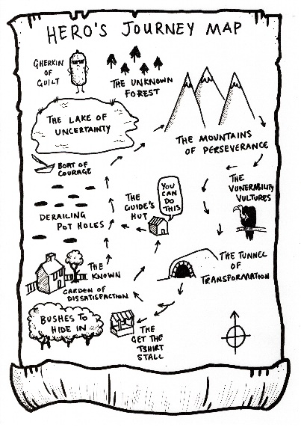
Because of these five teachers, Jaz went on to become a teacher, writer and award-winning international speaker who engages educators and galvanises them into embracing the difference that they can make when they, too, put being a human first. Through celebration and provocation, she uses the transformative power of her own story to inspire the everyday heroes of education and is responsible for empowering millions of teachers with her record-breaking TED talk.

In her upcoming book, Because of You, This is Me, Jaz brings her signature blend of insight, inspiration and laughter to the page to celebrate the vital and transformative impact teachers have on the children in their care. It’s easy to feel disillusioned in an exhausting education system, but Jaz’s celebration of teachers is a tangible reminder that their small actions have a profound impact on the students in their care.
In this book, Jaz shares her story – often harrowing but always uplifting – to show how the everyday heroes in our schools can transform the lives of the children who need their help the most.
Essential reading for all educators.

**Trigger Warning:** This book addresses themes of child abuse and neglect, which may be upsetting or triggering for some readers. If you or someone you know has been affected by similar issues, please take care when reading and consider seeking support.

"An incredibly powerful book, deeply moving yet inspirational, deeply personal yet incisive in its analysis of the education sector. More than anything, it provides a voice and an insight into the lives of children in classrooms that are often unseen and misunderstood by educators and policymakers.”
– Professor Damien Page, Vice Chancellor, Buckinghamshire New University

