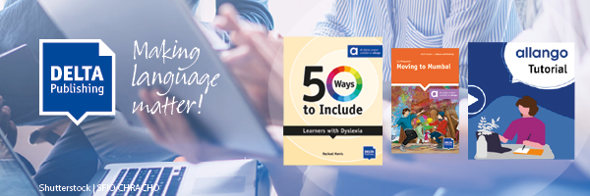
Welcome to the summer DELTA Publishing Newsletter
The summer break is always a perfect time to gather new ideas and familiarize yourself with new teaching possibilities. Digital media can help bring variety to your lessons and support students in their learning. With our digital materials on our learning portal allango, you can take advantage of these benefits.
You can trial many of the Digital Editions free of charge as follows:
1. Go to www.allango.co.uk
2. Enter the required NP number or title into the search box
3. Select the book cover
4. Click on "Register now and test for free (7 days)"
If you need more information about allango and the free test licenses, have a look at our video tutorial:

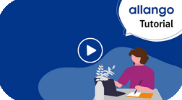

Don't forget to take care of yourself! We have new titles for teacher development - you will surely find something that will take your teaching to the next level!
Have lots of fun teaching and a nice summer,
The DELTA Publishing Team

  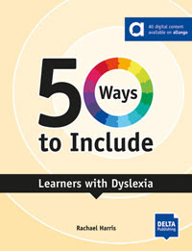
  50 Ways to Include Learners with Dyslexia
  This title will help you to find your way to including learners with dyslexia in your class by:
  • offering quick solutions to the challenge of including a learner with dyslexia
  • suggesting specific ways to include and support learners with dyslexia as you move through the stages of teaching from identifying students' needs to assessment.
  • providing opportunities for reflection and action planning

  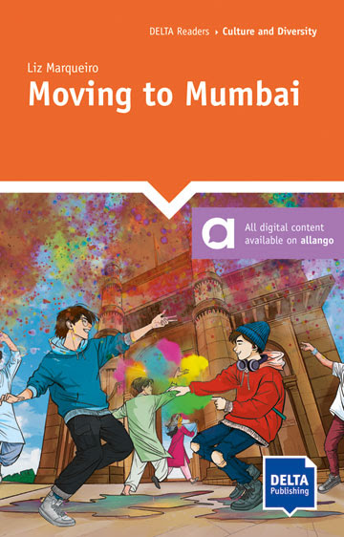
  Culture and Diversity | Level B2
  Moving to Mumbai
  James and Ash have to leave their London life in the middle of the school year to go to an international school in, wait for this: Mumbai. What were their parents even thinking?!
  The 16 year-old twins have very mixed feelings about this upheaval. Through their journal entries, they share the impact that this new life in India, with all the accompanying challenges of culture shock and reactions to their family's LGBTQIA+ identity, is having on their mental health - and it's quite a rollercoaster ride.
  Digital Edition allango for teachers and students

  
  This month, you'll find an extract of 50 Ways to Include Learners with Dyslexia as a free download in the teaching tip of the month area. You are not registered? Don't hesitate to sign up here!
  Teaching Tip of the Month

NEW RECORDINGS

  
  If you've missed any of our online seminars, or you’d like to rewatch them, just log in to your DELTA Publishing account here and go to:
  Recordings of past events

EVENTS CALENDAR

Check out global ELT events on the DELTA Publishing Events Calendar. If an event is happening near you and it's not on the calendar, drop us a line with the information and we'll add it to the calendar.

  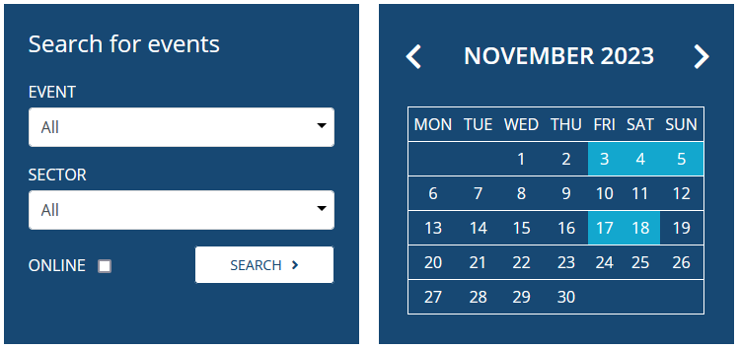
  Calendar
  Add an event

CONTACT

If you have any questions, we are happy to help you!
 info@deltapublishing.co.uk

