Letter 1
Dear Teacher,
Thank you to all of you who hosted the Roadshow this year. The full 96-minute 2024-2025 Tune Into English Roadshow, filmed in schools and theatres in Polla (SA), Barletta (BT), Naples, Sulmona (AQ), Montesilvano (AQ), Vicenza, Fiumicino (RM) and Darfo Boario Terme (BS), is now streaming free until 31st October. You can see seven more full shows as part of the Tune Into English subscription plans.
See videos from all Roadshow tours, from 2005, Comments, Primary Show
“The best ESL experience ever!” – Prof.ssa Antonella Porcu, Liceo Scientifico “G. Spano”, Sassari
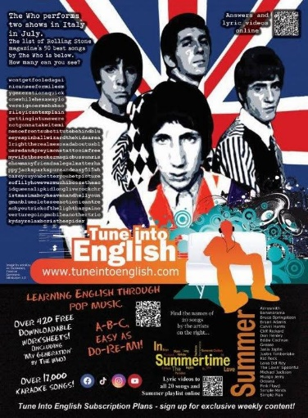

Rolling Stone’s 50 Greatest Songs by The Who
Summer Songs
July’s New Downloadable Worksheet
My Generation – The Who
One of the English band’s best-known songs, this worksheet looks at rhyming words and phonetics.
– Over 425 Downloadable worksheets now online
– Download complete list of online worksheets
Most of the worksheets have been written by your colleagues – perhaps you have prepared one and want to share it?
The Song on Speak Up
In the July issue of Speak Up, Tune’s monthly column looks at the story behind and the language used in The Who‘s The Kids Are Alright. You can read this and previous columns here.
Also online:
– Over 17,000 Karaoke songs
– Notes From An ELT Consultant – free to Supporters of the site!
– Once – 48-page Film Worksheet
– Ten Years of The Tune Into English Roadshow – the book
– Tune Into English on YouTube
– Tune Into English on facebook
– tuneintoenglish on Instagram
– tuneintoenglish on Tiktok
Thank you to all for supporting the website, and particularly to those who have signed up for the weekly exclusive content. Keep singing!
Best wishes, enjoy the holidays,
Fergal Kavanagh
www.tuneintoenglish.com
The web’s largest free resource for learning English through pop music!

Letter 2

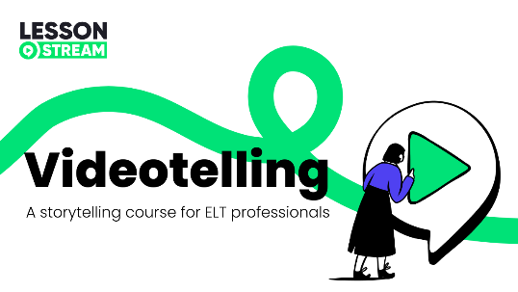

Hello Hanna,
Today, I have something exciting to share.
If you’ve followed my work for a while, you’ll know I believe that storytelling is at the heart of great teaching. It’s how we connect, how we explain and how we inspire learning.

Storytelling is a fundamental function of language. It’s what makes language meaningful.

Of course, stories don’t just entertain – they spark curiosity, boost creativity and fuel communication. In the classroom, they create opportunities for collaboration, critical thinking and purposeful language use.

That’s why – over the past few years – I’ve been helping teachers like you build confidence in bringing storytelling into your lessons. And after hundreds of hours working with educators around the world, I’ve created something new:



Videotelling masterclass
- Build your storytelling skills and confidence – and help your students do the same.
- Discover a more communicative way to use video in language teaching.
⭐️ ⭐️ ⭐️
The masterclass is delivered as two 90-minute online workshops, limited to just six participants per group creating a safe space for personalised feedback and support.
⭐️ ⭐️ ⭐️
A couple of weeks ago, I ran the masterclass face-to-face in Denmark. Here's what two participants had to say:

“This training has the potential to revolutionise my English teaching. It opened my mind to the possibilities of using video and storytelling to boost classroom conversation. I’m absolutely convinced it’s key to motivating my students and getting them talking.
The reality is that today’s learners live in a world of Instagram, YouTube, and TikTok – so it makes sense to give them the tools to describe and analyse that content. The video and storytelling techniques allow them to extract key words, phrases, and rich descriptive language from videos.
What fascinated me most was how well these techniques support differentiation for students across a wide range of English levels. It really was revolutionary – one of the best trainings I’ve attended."

Sheila Marie Jakobsen (teacher)

“I’ve never seen myself as a natural storyteller, but Jamie’s simple, clear framework gave me the confidence to try – and it worked. I left the workshop feeling more capable and motivated to keep developing my own storytelling skills.
I’m also looking forward to using the same ideas in my classroom, as I can already see the benefits for my pupils: more fluent language use, richer vocabulary, and stronger grammar. Thank you!"

Sarah Nakel (teacher and trainer)

Join us

Jamie Keddie

Lesson 3

Background info: Sherrise Roehr recently left her role as Senior Director of Publishing at National Geographic Learning. She had been with the company for over 28 years and was recognized for her work in developing award-winning educational materials. Her departure was announced on May 9th, and she has received many positive comments from colleagues on LinkedIn.

Dear All

On May 9th, my role at National Geographic Learning was impacted by a larger reorganization. It has been an honor and privilege to be a part of the team that has created and driven the success of the ELT group. I am deeply grateful for the opportunities this leadership role has provided me.
Working for a company that is truly mission driven, that is focused on making a difference in students’ lives and in the world has been incredibly motivating to me.

In 2011 Cengage Group formed a new entity, National Geographic Learning, in partnership with the National Geographic Society. As a key member of the management team, we defined how this would change our business, our mission, and our brand. We created our brand promise: Bring the world to the classroom, and the classroom to life. The materials my teams created delivered on that promise.

I helped build an organization that drove consistent growth, growing by a factor greater than ten during my tenure.

I led the Boston based teams on content strategy, development, and product launch. Together we produced the majority of National Geographic Learning’s best-selling English language learning titles, from pre-K through upper-Secondary, Academic, and Adult.

The project that I am perhaps most proud of is Our World. I was the driving force behind Our World, which put NGL on the map in the highly competitive global, primary market. This was our first primary series, and it catapulted our growth as a number one selling series for over a decade now, defining who we are as a high-quality, aspirational brand, while also helping us to grow from a small, but respected, publisher to one of the top four in our industry.

It has also been exciting to work with our Digital team to develop a best-in-class educational platform. It’s been fascinating to reimagine how content can be delivered, practiced, and assessed in more engaging and personalized ways that drive better student outcomes and engagement—not to mention more support for teachers and administrators. There is so much possibility with digital that has not yet been realized in the markets.

While I have loved working with the NGL team, I am looking forward to finding new ways that I can make a difference. I’m excited about the possibilities of working on new challenges, that allow me to leverage my expertise in content strategy, team development, and innovative product solutions. If you know of any leadership opportunities, or would just like to connect, I’d love to have a conversation. Each of us can make a difference, but together we can do so much more.

Thank you
SR

Letter 4

Dear Members

This association has agreed to assist in determining a sample of language teachers for qualitative research conducted by a doctorate student at Case Western Reserve University, Weatherhead School of Management. The supervisor of this student is Professor Richard Boyatzis. The study will investigate "teaching characteristics" employed by teachers today.
The study is conducted following the professional ethics of the Internal Review Board, whose approval has been granted. Nominations as well as interviews will be conducted under strict confidentiality and after each interview a number code will be assigned to help ensure that personal identifiers are not revealed during the analysis and write up of findings.
By visiting the website and nominating, your consent to participate will be deemed as given. The website for nominations is :
https://cwru.az1.qualtrics.com/jfe/form/SV_79vzkXLd5sHGMWa

You will firstly be required to determine your elegibility to act as a peer nominator for the purpose of this study. The study requires confirmation that you have been working as a language teacher for more than two years. YES/NO
If not, then you will not be eligible to nominate and your nomination will not be disregarded.

If yes, then you will be requested to write the names of language teachers that you consider, to the best of your knowledge, to be outstanding teachers. You may write as many or as few names as you feel appropriate. If you choose no teacher, please leave the boxes blank and skip to the end.

The study team will collect and compile the data for the doctorate student to then contact nominated teachers to be interviewed. These interviews are voluntary and confidential. Invitees reserve the right to decline to be interviewed.
Thank you for your attention and we hope to determine a sufficient number of sample for the research to have impact and meaning for teachers today.
Kind regards
CWR Study Team

Letter 5
Dear all,
Journal of Mixed-Methods Studies in English Language Teaching (MMSELT) is a peer-reviewed, interdisciplinary, refereed journal focusing on theories, methods, and applications of mixed-methods research in applied linguistics (AL) in general and English language teaching (ELT) in particular. The Journal welcomes manuscripts that meet the general criteria of significance and scientific excellence. To that end, we would like to ask you to contribute your mixed methods studies in AL or ELT to the journal.
You can submit your manuscript at: https://sanad.iau.ir/journal/mslt

It is appreciated if you forward this mail to your colleagues and other AL and ELT researchers.
With Regards,
Amir Sarkeshikian,
MMSELT Journal Director-in-Charge
https://sanad.iau.ir/journal/mslt
jmmselt@gmail.com

Letter 6
Dear ELTnet

I thought I would let you know that I received this message from Palgrave this morning regarding the Teacher Burnout book.

We are very pleased to inform you that your book has been published and is available on https://link.springer.com/book/10.1007/978-3-031-85024-0

If I have already contacted you about this, I am sorry to be cluttering your inbox, but the problem is that some of you are on more than one of my contact lists. If this is the case for you, might I suggest that the Delete button, usually in the top right hand corner of your keyboard is a quick and efficient answer to this problem.

But I wanted to make sure I got everybody, since many of you have contributed to writing the chapters, or you have participated in the studies. Many thanks for your contribution.

I think this is an important and under researched issue, so if you would like to help by spreading the news among your own contacts, that would be great.

Thanks again and best wishes,
Carol Griffiths

Letter 7

𝐄𝐪𝐮𝐢𝐩 𝐘𝐨𝐮𝐫 𝐋𝐞𝐚𝐫𝐧𝐞𝐫𝐬 𝐟𝐨𝐫 𝐭𝐡𝐞 𝐑𝐞𝐚𝐥 𝐖𝐨𝐫𝐥𝐝!
Ready to go beyond the textbook? Explore our course 𝟐𝟏𝐬𝐭 𝐂𝐞𝐧𝐭𝐮𝐫𝐲 𝐒𝐤𝐢𝐥𝐥𝐬 with Hanna (Hania) Kryszewska and bring the 4 C’s—communication, collaboration, critical thinking, and creativity—into your classroom.
☛ Learn practical tools and warm-up tasks
☛ Discover creative and critical thinking strategies
☛ Foster meaningful student collaboration
Earn certificates for each module, with a final certificate awarded upon course completion.
Start learning today and become the educator of tomorrow. https://shorturl.at/Q07bL
hashtag#OrientBlackSwan hashtag#21stCenturySkills hashtag#ProfessionalDevelopment hashtag#TeacherTraining hashtag#CriticalThinking hashtag#CreativityInLearning hashtag#Collaboration hashtag#CommunicationSkills hashtag#CPD hashtag#CPDforTeachers

More here

Orient BlackSwan Team

