Reclaiming the Inner Compass: A Humanising NLP Journey for Teacher Wellbeing

Effie Kyrikaki, Greece
Effie is the founder of NeuroLearningPower®, (or NLPower) the evidence-based mentoring framework and certified training methodology that supports educators and their students to thrive emotionally and academically. She holds a MSc in Psychology and Coaching and is a teacher trainer, international NLP trainer, author of articles and book chapters in academic publications on the key role of teacher wellbeing in a healthy educational ecosystem. Supporting teachers’ wellbeing is a mission she pursues as creator of the “Wellbeing Program for Teacher Students” running at the University of Athens TESOL faculty. She is also the co-creator of EmpowerED, the initiative to bring awareness and wellbeing skills to schools.
Email: metamathesis@gmail.com



A new column
Being invited to create a column as an expert on one’s mission in a leading field publication is exhilarating. Being invited to write for Humanising Language Teaching—a space founded by Mario Rinvolucri, a legend in ELT who didn’t just embrace but elevated one of my lifelong passions, Neuro-Linguistic Programming (NLP) application in education—feels like... bliss? Alignment? Coming home?
Mario was a magician in creating alternative, engaging, transformative learning experiences using multi-modal approaches. He knew well how versatile the NLP framework is at enhancing both teaching effectiveness and student learning by offering practical strategies to improve communication, motivation, and cognitive flexibility. He did this with a focus on students, their needs and present state. Actually, this is precisely what I consider an essential contribution of NLP to any teacher’s practice: unconditional positive regard for oneself and others, similar to the approach of humanistic psychology. The realization that “the map is not the territory” as Gregory Bateson so aptly put it, was my first awakening call all those years ago, when I started my journey down this intriguing road.
For me, humanising isn’t a concept. It’s a mission. It’s the lens through which I’ve seen not only the classroom and the learner but first and foremost, the teacher. I remember reading one of Mario’s articles years ago (here ) and thinking: This is exactly the problem. Teachers aren’t failing. The system is failing them.
The consequences are undeniable: Passionate young teachers, once inspired, gradually lose their spark. Seasoned educators, once deeply rooted in purpose, are now battling fatigue, disillusionment, and burnout. Quiet quitting is the new term—not always physical, but definitely emotional. Teachers are showing up... but drained, detached, demotivated.
This series is a call to pause, recalibrate.
Why this series, and why now?
First and foremost, because the heart of education is not policy or curriculum—it’s people. And at the heart of those people are teachers. When a teacher thrives, the classroom breathes. When a teacher reconnects with clarity, purpose, and vitality, everything from pedagogy to relationships transforms. It is no coincidence that international bodies like OECD, the European Union and UNESCO are calling or creating initiatives for teacher wellbeing.
To add to the challenge, our students are also transforming, not always to the best. As the percentages of mental health issues among children and teenagers are rising alarmingly around the globe, our students need us in a much more expanded and inclusive role — as coaches that can teach them life and flourishing skills. And of course, exponential changes in resources like AI, are pushing for a paradigm shift in our focus on several areas of the teaching process.
This series will explore how we can nurture the inner world of the educator, empower ourselves and our students to not just deal but thrive in change using tools from NeuroLearningPower®, the evidence-based framework that supports educators and students worldwide to thrive. NLPower draws its underpinnings from Neuro-Linguistic Programming (NLP), coaching psychology, and neuroscience. Not gimmicks, not quick fixes—but deeply human, neuroscience-informed and wellbeing-focused cognitive-behavioral tools that shift perception, reframe emotion, and unlock resourcefulness.
I know you are curious of how NLP is weaved into my journey and the great gift I was dealt with in the early years of my career. You may also be wondering how NeuroLearningPower® is connected to educator flourishing. This is a part of my personal journey that I will share in upcoming articles. The first articles will address different facets of the teacher’s inner ecosystem—like purpose, mindset, identity and emotions. We will also explore student engagement, emotional regulation and embracing students’ journey. Together, these explorations aim to support what I call Whole Educator Wellbeing—a blend of congruence, emotional resilience, and personal empowerment.
Because this isn’t just about teachers surviving. It’s about schools becoming places that nurture flourishing, starting with teachers—for their own wellbeing, for their students’, and for the future of education.

EMBRACE
This series, on second thought, is not just a call to pause or recalibrate. It’s a call to reclaim the inner compass, to reignite purpose, and to empower the educator from within. Through the lens of NLP and the neuroscience of wellbeing, the HLT column EMBR.ACE
E – Empowerment (a Wellbeing-led life)
M – Mentoring & Mindset (humanized experience with NLP tools)
B – Belonging (relational safety & peer connection)
R – Resilience & Reflection (empowerment, wholeheartedness)
. – for
A – Awareness (self, others, language, systems)
C – Change(options, insight, transformation)
E – Exploration (engagement, creativity, play)

My intention is for EMBR.ACE to be a practical and supportive path for both educators, students, and their natural ecosystems–schools, lighting the path toward a more empowered, relational, and whole-hearted vision of educational flourishing. Because thriving is a radical act of courage. And because thriving teachers don’t just survive the system—they transform it from the inside out.

Favourable winds to our exploration sails.

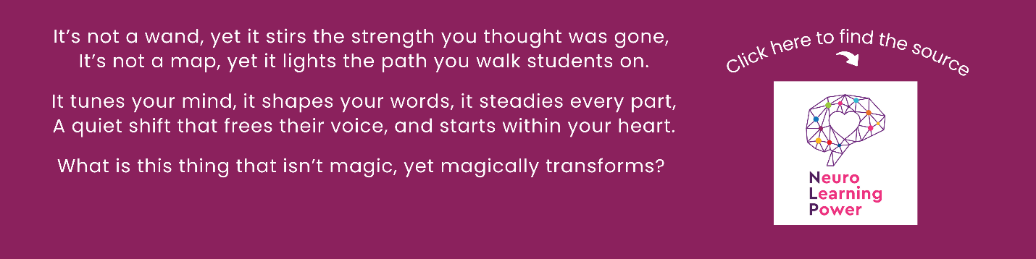

Please check the Pilgrims in Segovia Teacher Training courses 2026 at Pilgrims website.
Please check the Pilgrims f2f courses at Pilgrims website.
I

