Is or ‘s?

Mark Hancock, UK
Mark Hancock is a teacher, trainer, and author of many ELT titles including Pronunciation Games and English Pronunciation in Use Intermediate and Mark Hancock’s 50 Tips for Teaching Pronunciation (all CUP). His self-published collection PronPack 1-4 received the 2018 ELTons award for innovation in teacher resources. His latest book is PronPack: The Minimal Pair Collection (Hancock McDonald ELT). Email: mark@hancockmcdonald.com

“What is up?”: is that sentence right? Well, I suppose so, but maybe it’s so right that it’s wrong. That ‘is’ so badly wants to be contracted to ‘s: “What’s up?”. But it’s interesting, because is doesn’t always want to be contracted. Ok, “The train’s late” is good, but “The bus’s late” seems weird. Why? Well, because it’s hard to pronounce, and it looks like in this case, the pronunciation is leading the grammar. We don’t write “bus’s” because it’s too difficult to say! So try this maze. You have to go across the stones from black to black, but only step on a stone if you could contract “is” between the two words. The first move is done for you!

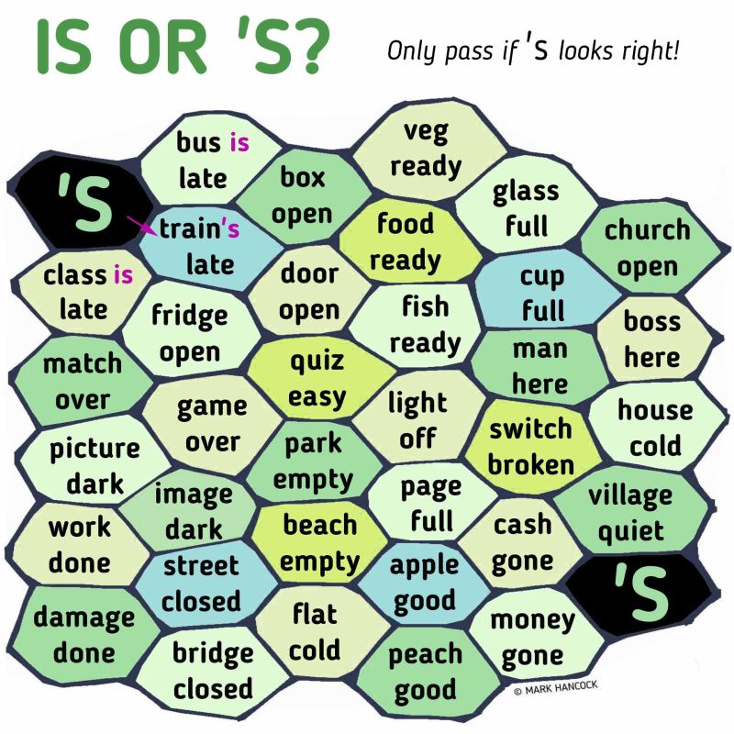

Acknowledgement
This activity is reprinted from LinkedIn

Please check the Pilgrims in Segovia Teacher Training courses 2026 at Pilgrims website.

Please check the Pilgrims f2f courses at Pilgrims website.

