Good-bye Jill – In Memory of Jill Hadfield

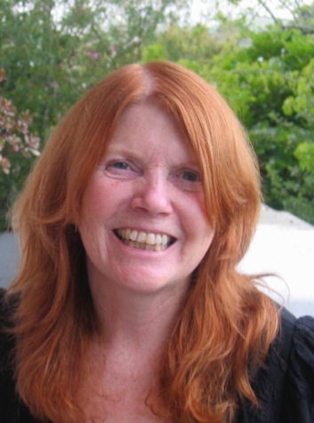
Jill Hadfield
Renowned ELT (English Language Teaching) author and educator Jill Hadfield passed away in May 2026. She was widely celebrated for her iconic Communication Games series and her extensive work training teachers globally.
Jill Hadfield was a transformative figure in English Language Teaching. Over a career spanning more than 40 years (Elementary Communication Games publ. 1984), she authored over 30 influential teacher resource books. Her philosophy shifted language classrooms away from rote memorization and toward dynamic, human-to-human connection.


It is with great sadness that or ELT community learned of the passing of a wonderful person, colleague and prolific author, our dear Jill Hadfield. It is very sad news for all of us who knew her and those who are members of the EFL community. In this issue of HLT we remember and honour Jill, a warm, generous and creative person who has changed the EFL scene for good. I wonder if there is an ELT teacher who has not come across her name and taught from her books.

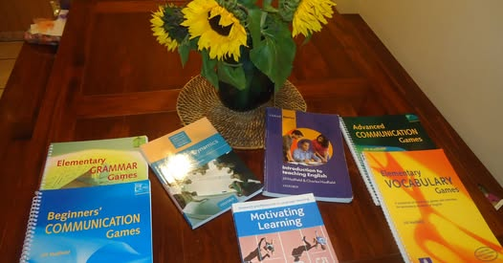
Many of you will recognize the books in this photo, but there are many more….
To the best of my knowledge her most significant contributions and published works include:
1. The Communication Games Series
- Classroom Staples: Published primarily with Longman, books like Elementary Communication Games (1985) and Advanced Communication Games became standard fixtures in staffrooms worldwide.
- Pedagogical Impact: She pioneered the use of highly practical, game-based learning to reduce student anxiety, promote contextual grammar practice, and boost speaking interaction.
2. Classroom Dynamics & Motivation
- Social Bonds: Her 1992 Oxford University Press book, Classroom Dynamics, broke new ground by teaching educators how to build trust, empathy, and a positive group identity among students.
- Learner Motivation: She co-authored Motivating Learning alongside renowned linguist Zoltán Dörnyei, bridging the gap between motivation research and actionable classroom tasks.
3. Accessible Teacher Training
- The Oxford Basics Series: She co-authored multiple introductory manuals (including Simple Speaking Activities and Simple Listening Activities) to support teachers working in low-resource environments globally.
- Global Reach: She personally trained teachers across diverse locations, including the UK, France, China, Madagascar, Tibet, and New Zealand, where she served as an Associate Professor at Unitec.
- Introduction to Teaching English
4. Digital Innovation
- Interaction Online: Co-authored with Lindsay Clandfield, this work re-imagined online teaching. Instead of static chat forums, it focused on creative, low-tech ways to foster human interaction through screens, earning a shortlist spot for the prestigious British Council ELTons Award.

5. Coursebooks
- She co authored Excellent course

Jill travelled the world extensively training teachers, presenting at conferences and writing for newsletters and magazines

https://www.youtube.com/watch?v=y21rj9Vqcac
https://www.youtube.com/watch?v=GAjTHStWE74&t=2s

https://www.iatefl.org/lockdown-downunder-some-snapshots-and-online-lesson-ideas-new-zealand/
https://www.hltmag.co.uk/dec22/what-is-zoomfatigue
https://www.hltmag.co.uk/dec22/microbreaks-in-online-language-teaching

Jill also wrote fiction and poetry
https://www.hltmag.co.uk/feb22/dr-rieux-checks-his-facebook-newsfeed
https://old.hltmag.co.uk/aug17/poem03.htm


What a remarkable person she was!

Some tribute voices
***

In memory of Jill Hadfield, a remarkable author, educator, and cherished member of the IATEFL family and the Materials Writing Special Interest Group. Through her inspiring work and dedication to language teaching, she touched countless teachers and learners around the world. Her legacy will live on in the people she inspired, the communities she helped shape, and the passion for teaching she shared so generously.
Jill, you will be deeply missed and fondly remembered! 💜

***

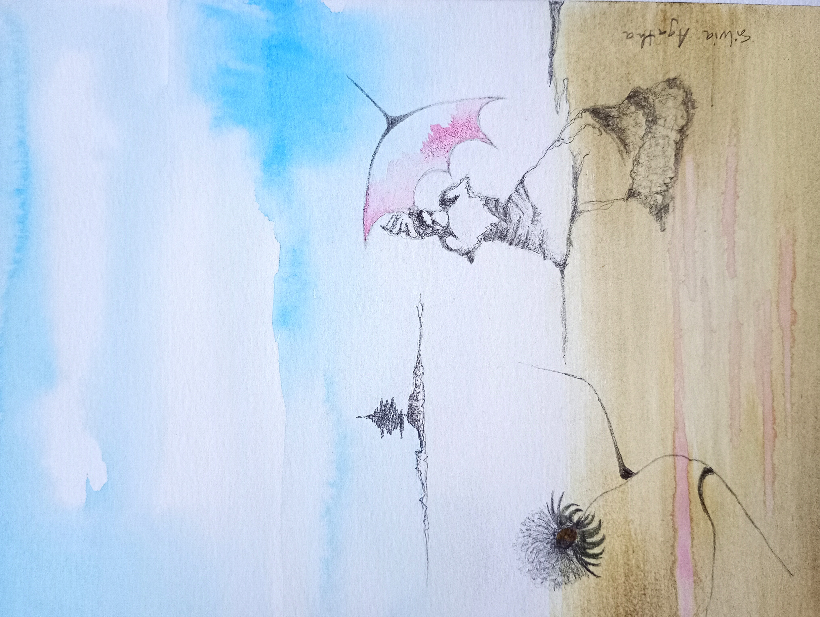
weaving
… and then she started weaving the light
the beams were invisibly going up and down and up and down
at the same time you could hear a piano playing in the background
and a gentle touch …

Sylwia Zabor-Żakowska
***

We have lost a dear friend, and a friend of words. I am myself having dizzy spells and difficulty in focussing, so this will be short. I apologise for this.
Jill was a stickler for the best words in the best order. She had a heart of gold wrapped in a fine intellect. Behind her concern for the best use of words lay a deeply caring person - someone who loved her friends unconditionally. I shall miss her keen intelligence and her caring personality greatly.
Alan Maley
***
What I admired about Jill’s work was its warmth, openness, and humanity. She brought creativity and care into language education in a way that felt natural and generous rather than performative.
I think many people were quietly touched by that spirit, even from a distance.'
Dat Bao
***
Thank you for the opportunity to honour the memory of Jill Hadfield. Although I never had the privilege of meeting her in person, her work has been a constant source of inspiration and guidance throughout my professional journey.
As an educator and trainer in the field of aeronautical English and language teaching methodology, I have frequently turned to Jill's publications for insight, creativity, and pedagogical wisdom. Her expertise in classroom dynamics, communicative activities, and humanistic approaches to language learning profoundly shaped the way I design and deliver training sessions. Books like Classroom Dynamics and Communication Games were not just references—they were practical companions that helped me create more engaging, learner-centred experiences, even in highly specialised contexts such as air traffic control training.
What I admire most about Jill's work is how she consistently bridged theory and practice with warmth, clarity, and respect for both teachers and learners. Her materials never felt like static resources; they felt like invitations to connect, to experiment, and to humanise the language classroom—values that resonate deeply with my own teaching philosophy and with the TRAINAIR PLUS methodology I apply in my work.
Though we never crossed paths personally, Jill's legacy lives on in the lessons I plan, the activities I adapt, and the educators I mentor. I am grateful for her contributions to our field, and I did not want to let this moment pass without acknowledging the quiet yet powerful impact she had on professionals like me, who learned from her words and carried them into classrooms far beyond the contexts she originally imagined.
Thank you, Hania, for creating this space to remember and celebrate Jill. Please accept this short tribute as my heartfelt contribution to the August issue of HLT.
Dora Troitiño

***
We launched the Simon Greenall Award in 2021 in memory of my husband,
Simon Greenall who died in 2018. The Award, sponsored by Macmillan
Education, International House London and International House World, is for
projects that build communities through learning English. The prize includes
six hours of mentoring.
We chose our winners – the Dau Dau project led by Sirhajwan Idek from
Kenigau College in Malaysia. Then we had to find the promised mentor. I called
Jill Hadfield, with some trepidation as I was about to ask a huge favour, and
she replied ‘I’d be honoured’.
I am forever grateful to Jill and to Charlie for making our first Simon Greenall
Award such a success.
Jill Florent
***
I met Jill and Charlie in mid eighties in Torquay. It was a BC placement to observe great teachers at work. For me, a teacher from communist Poland who was finding out about the international ELT scene for the first time, meeting them was such an honour. I will never forget their warmth, kindness and willingness to share their ideas.
I was under a great impression of Jills presence – an English country girl’s look, ginger hair, her skirts and blouses, and great kindness combined with great intellect, diligence and very systematic hard work.
Since then, we kept in touch in person but much more through the books and ideas Jill shared with us. These ideas shaped me as a teacher ( e.g. Games series), a trainer (e.g. Basics, ) and educator ( e.g. Motivating Learning). She found time to write for HLT and be part of the creative writers’ circle.
I found it reassuring just to think she was there or I would bump into her at the IATEFL conference... unless she could not travel from New Zealand or was caught up in something else. So, when I saw that note on Fb I got worried, but I did not know then that it was a kind of good-bye… this year and ever again. I will miss you Dear Jill. Good-bye.


