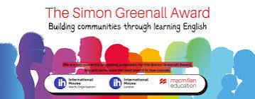

The Simon Greenall Award 2026

The Simon Greenall Award celebrates the life and work of Simon Greenall OBE, teacher, trainer, materials writer, President of IATEFL, trustee of International House.

The Award offers mentoring, promotional visibility and a grant for projects dedicated to building communities through learning English. It is sponsored by Macmillan Education, International House London and International House World Organisation.

***
WINNER - Simon Greenall Award 2026

English on the Mountains This project enables children in the remote Pomak villages across Xanthi and Rhodope in northern Greece to learn English where it is not taught in schools. Hundreds of children aged 4-18 attend year-round online lessons and meet in summer schools. They learn through play, art, storytelling, environmental projects and entrepreneurship. They develop confidence, make friends and find pathways to further education, new knowledge and skills

“I am grateful and excited our project has been selected for the award … it will open the door…”

Fay Marinides: Originator and coordinator, Anatolia College of Thessaloniki, Northern Greece Email: faymarin@hotmail.co.uk

George Pickering will offer mentoring to Fay at English on the Mountains to develop a plan for succession and for on-going teacher development. George is an educational coach, trainer and consultant with management experience in private and state ELT sectors. He has mentored senior managers in a range of educational contexts and is academic director of the English UK Diploma in English Language Teaching Management. He is a trustee of IATEFL

Fay Marinides

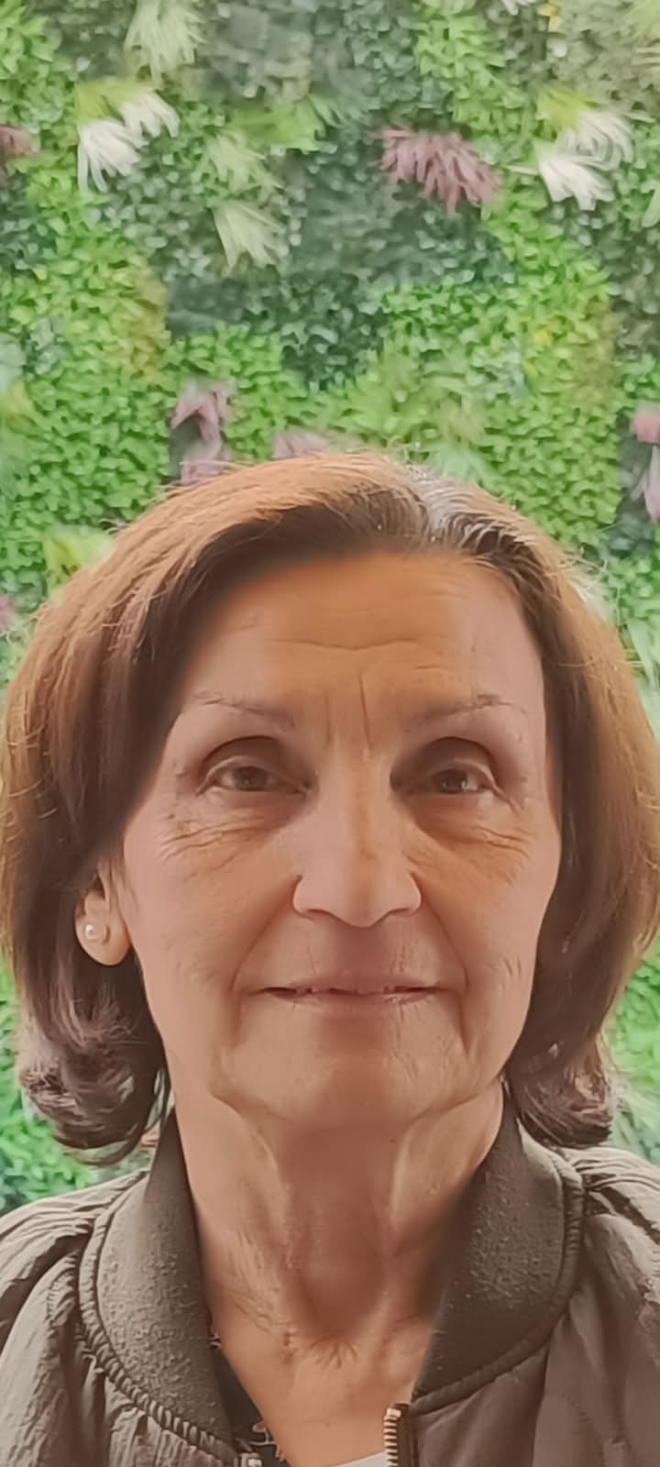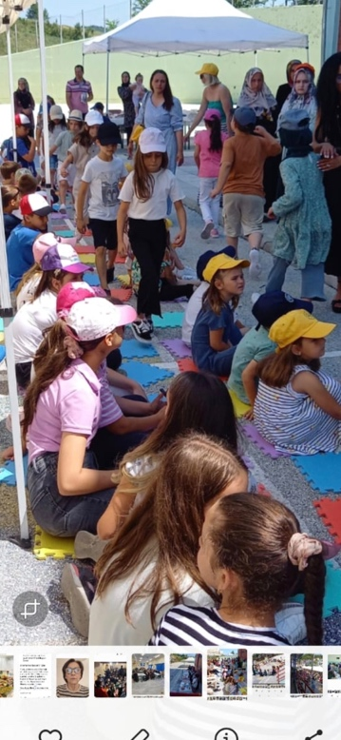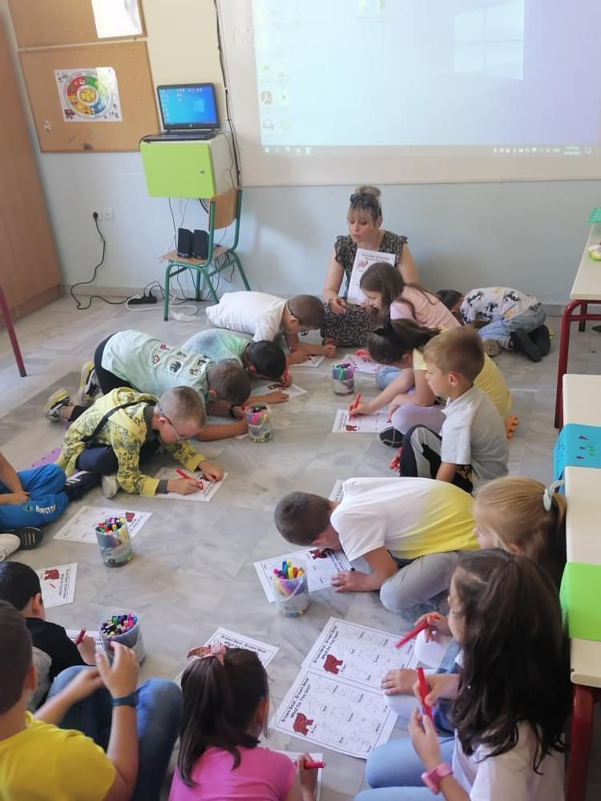

English on the Mountains links students from isolated villages and gives them access to life-changing opportunities

HIGHLY COMMENDED - Simon Greenall Award 2026

Ukraine Speaks English. This project provides free online English-speaking classes for Ukrainian children aged 4-18. The aim is to enhance their language skills in a safe community setting, offer new skills and knowledge through speaking clubs, art classes, yoga classes, book clubs and storytelling activities. These informal sessions are delivered daily, linking students to a community of volunteer teachers, librarians, scientists, and other professionals from around the world.

Olena Zhupanova - Project Manager. o.zhupanova@vchysia.org.ua https://vchysia.org.ua/en/

Katja Preston will offer mentoring to help with the evaluation of communication skills to enable the project to demonstrate how it achieves its aims. This will support their international fund-raising. Since 2003 Katja has worked in a broad range of ELT schools on six continents. For 5 years she been Assessment and Training Coordinator for International House World Organisation. She is passionate about supporting teaching professionals to develop their skills.

Olena Zhupanova, Don Gladiuk, volunteer teacher Canada, online astronomy lesson
Project Manager
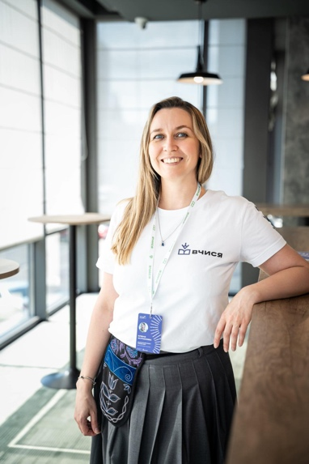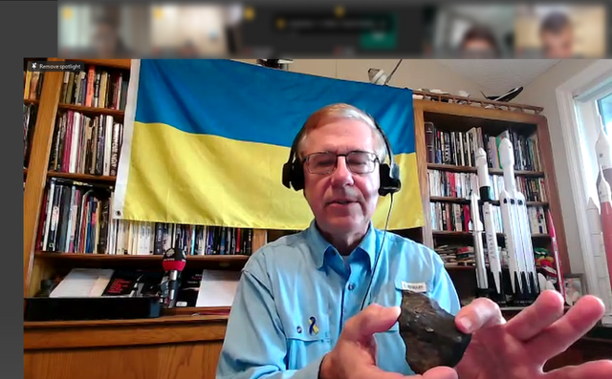

Ukraine Speaks English provides educational support for students from volunteers around the world

HIGHLY COMMENDED - Simon Greenall Award 2026

The Good Games Project. This is a community-driven English learning initiative. Participants learn English naturally through playing board games in structured sessions led by trained youth facilitators. The sessions involve storytelling, discussion, strategy and collaboration. The project creates inclusive environments where students can practise speaking without fear of making mistakes. The aim is to build a sustainable English-speaking community.

Khalifa Affnan: Originator and coordinator
khalifasuper@gmail.com https://sites.google.com/moe-dl.edu.my/thegoodgamesproject
https://www.facebook.com/kvceurekahub

Shaun Wilden will offer mentoring to help integrate language learning into the board game sessions in a structured and intentional way, so that game-playing can be recognised as a meaningful and serious learning approach. Shaun is an ELT teacher and trainer with a passion for board gaming. He is particularly interested in how modern boardgame mechanics can be utilised to support ELT, and encourage interaction, problem-solving, and meaningful language use. He is vice president of IATEFL

Khalifa Affnan: Good Games Project

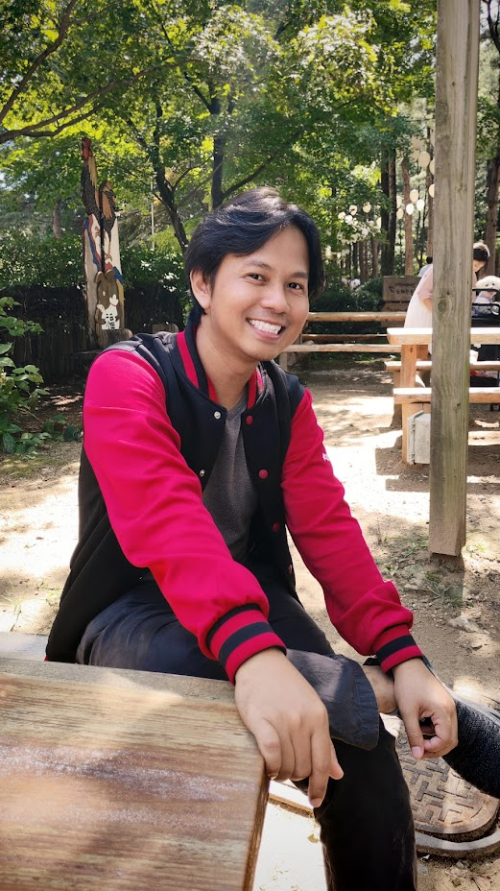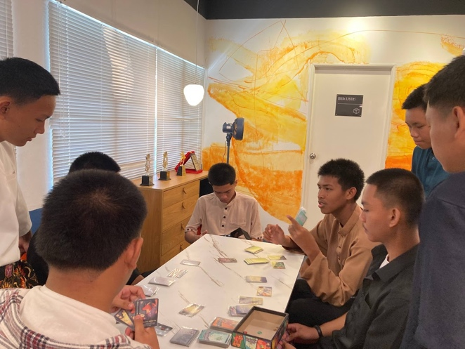

The Good Games project makes language a tool for belonging, leadership and creative expression rather than a subject to memorise

The 2027 Simon Greenall Award will open for application 1st November 2026 at
https://www.macmillanenglish.com/simon-greenall-award-2027

***

Previous Simon Greenall Award winners
2024: The Happy Teachers' Mentorship Programme Originated and coordinated by Venice Irving in Jamaica: hellohappyteachers@gmail.com https://teachenglishcaribbean.wordpress.com
Mentor: Annie Thomson

2022: The Dau Dau Project originated and run by Sirhajwan Idek & Nurazilah Othman of Keningau College in Sabah, Borneo, Malaysia. sirhaj87@gmail.com https://youtube.com/playlist?list=PLV8X8t3WqXOIlv6c0Muu8rspRWw4sZ_ro&si=sfOi6MwHEZ-19tf7
Mentors: Jill and Charlie Hadfield

