Letter 1
Dear Language Teacher.

Thanks for the positive comments about the last newsletter. I am glad that many found it useful and informative. But it is already time for the June issue! I already have about 5 pages-worth of "stuff"! There are 3 points I would like to make.

1. Please let me know asap if you would like something (e.g. a publication, a conference notice, etc.) put into the June newsletter. The best way for you to do this is to send me something already formatted to A4 size, no more than half a page in length, that I can easily cut & paste into an appropriate space. This saves me a lot of time (and I also have lots of other things to spend my time on!) and helps to ensure that it goes into the newsletter as you would want it.

2. Please try to ensure I have your latest email. I know now while I am still writing this that almost before I have clicked the "send" button my inbox will be full of error messages. Most of these relate to those who have given me an institutional email and then changed their job. For this reason, I personally prefer a personal email - I personally use my gmail which hasn't changed since I set it up many years and different lifetimes ago. Of course, those who have changed their email since I last messaged won't get this anyway, but if you are planning to change your job (and therefore your email address), or if there is any other reason for an email change, can you please let me know so that I can change it in time.

3. The issue of teacher wellbeing, and the question of what causes teacher burnout and attrition and what can be done about it, has been gathering strength recently. It is often suggested that the other stakeholders in the education environment (especially the students, parents and administrators) need to take more responsibility for maintaining the wellbeing of their teachers, but we already know that this often does not happen. The answer therefore seems to reside in the teachers themselves and in the steps they take to assume agency. I am currently beginning to work on a study of the challenges teachers face and what they do about these challenges. I attach a questionnaire with items gathered from the literature, research and personal experiences in the hope of trying to identify the kinds of actions that teachers take to deal with their challenges. It is, of course, entirely voluntary, but much appreciated, and your participation will help to ensure a representative range of suggestions can be included among the results. If you are interested in participating, please download the attachment, fill it out and send it back to me (carolgriffiths5@gmail.com). Many thanks.

Best wishes, Carol Griffiths

Letter 2
Hi Hania
Do you agree?
Tim
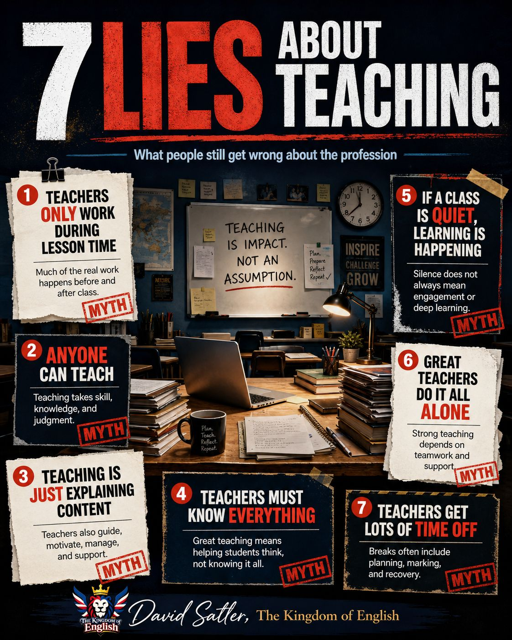

Letter 3

Dear all,

It's even worse than we thought.

Alan

How AI helps to supercharge oil and gas production



How AI helps to supercharge oil and gas production
AI is quietly boosting fossil fuel expansion, helping companies to drill more confidently and enabling even more...

Letter 4


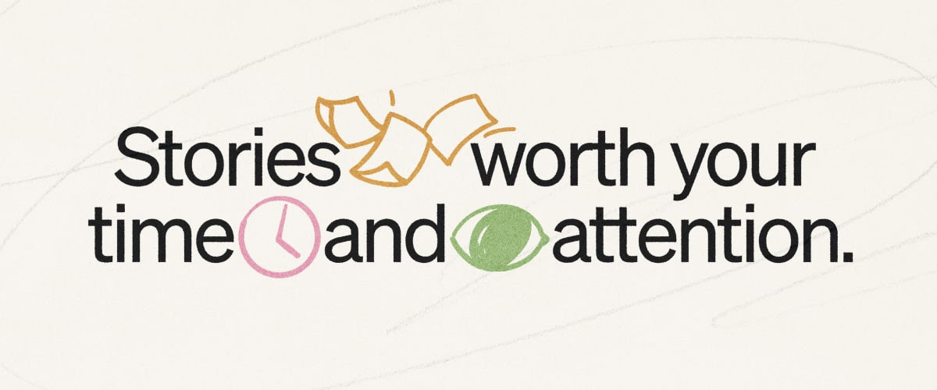

Hi Hania,

There’s a lot to discover on Medium: writers from all over the world, publications devoted to any conceivable subject, and stories of every type.
While your Feed and Daily Digest are shaped by your chosen topics, reading history, and engagement, there are a few other things you can do to get even more from your Medium experience.

01. Follow wisely (and widely). Choose some of your suggested writers, topics, and publications to follow. This will help populate your feed with some familiar voices and subjects you already care about.

02. Keep up with our staff’s favorites. Be sure to save our staff picks to Your Library. These stories are hand-selected by members of our curation team for quality and span subject matter.

03. Give your week a new highlight. Subscribe to our Newsletter. Published each Friday, it combines a thoughtful essay with a collection of links to notable stories from around the Medium universe.

That’s all for now. Enjoy your reading time.
The Medium team

Letter 5
I’ll never understand this teaching paradox…
Some teachers won’t let their students drink water…
while holding a 2L thermo of coffee like it’s their emotional support animal.
Now that I’m on the “teacher side” of the classroom, the contrast hits even harder.
It’s almost comical… until you realise students spend hours trying to “ask permission” for basic human needs.
Hydration? Needs approval.
Bathroom? Needs negotiation.
But the reality is simple…
Students aren’t trying to escape the lesson.
They’re just trying to function.
Like any of us.
And honestly, one of the easiest ways to build trust and improve behaviour is to stop treating normal body needs like rule-breaking events.
Good teaching isn’t only about grammar, completing tasks or making perfect lesson plans.
It’s about empathy.
If we want students who feel safe and respected…
we have to start by respecting their most basic needs.
Teachers! what’s one school rule you’ve always thought made zero sense?

Laura Román Crespo

Letter 6

Reading the comments of IATEFL attendees leaving the conference all inspired and energised and connected to a like-minded community, I've got to recommend this professional development community to teachers looking for more of the same (And, no, I'm not being paid to plug this!)
I joined Lessonstream a few years back basically just because I love good teaching ideas and good energy, and Jamie Keddie has both in spades. That and because I'm convinced of the power of storytelling and images to deliver more memorable learning.
For me, it's the perfect kind of professional development, stimulating and supportive in equal parts: techniques for using video, ready-to-run lessons, relaxed workshops to share teaching ideas, inspiring talks like the one given recently by Mike Budden on (the pedagogical benefits of) reading aloud and of course lots of great stories.
Do check it out: https://lnkd.in/eZkXHDqk

Paul Dummett

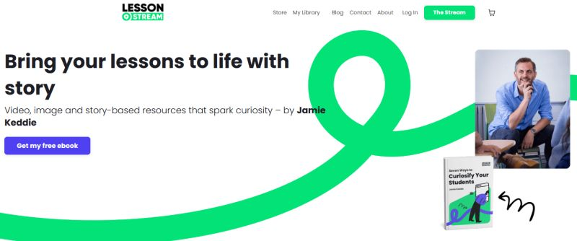

Letter 7
Thank you Hania.

I know you do not promote.. I only wish to advise you of my lastest book.

Roy



