Elevating Well-being in the Language Classroom: The ELEVATE+ Model for Flourishing in ELT

Adelina Sánchez Centeno, Argentina

Adelina Sánchez Centeno is an EFL teacher-researcher with more than 20 years of experience at university level in Argentina. She has written and co-written several academic papers on teacher well-being and has presented at many international conferences. She is the chair of the Positive Psychology SIG of the International Association for the Psychology of Language Learning. She enjoys working with language educators, teacher trainers, and institutional leaders from around the globe to build supportive educational communities. E-mail: elevateeducationtoempower@gmail.com

Introduction: Our mission for elevating English language teacher well-being

Elevate Education to Empower is an educational consulting initiative I founded in Argentina with expansion to the world. Our core mission is to promote the implementation of Positive Language Education by providing well-being literacy to language teachers. Through strategic courses and open-access resources, we train educators to transform their classrooms, leverage their strengths, and elevate their well-being through theoretically solid tools.

A central part of this initiative involves sharing free, practical resources, including our monthly newsletter, digital "Freebies", and the interactive Elevate Calendars. To date, we have designed more than ten positive psychology-based activities (freebies) and twenty specialised calendars, each carefully structured to provide teachers with daily actionable micro-steps toward mindful teaching and self-care. Using these resources daily allows educators and their students to expand their emotional granularity, improve their pedagogical knowledge, and integrate authentic materials into their classrooms. The ultimate purpose of these communications and tools is to foster a global network of educators who can freely share downloadable lesson plans, calendar prompts, and templates focused on human flourishing.

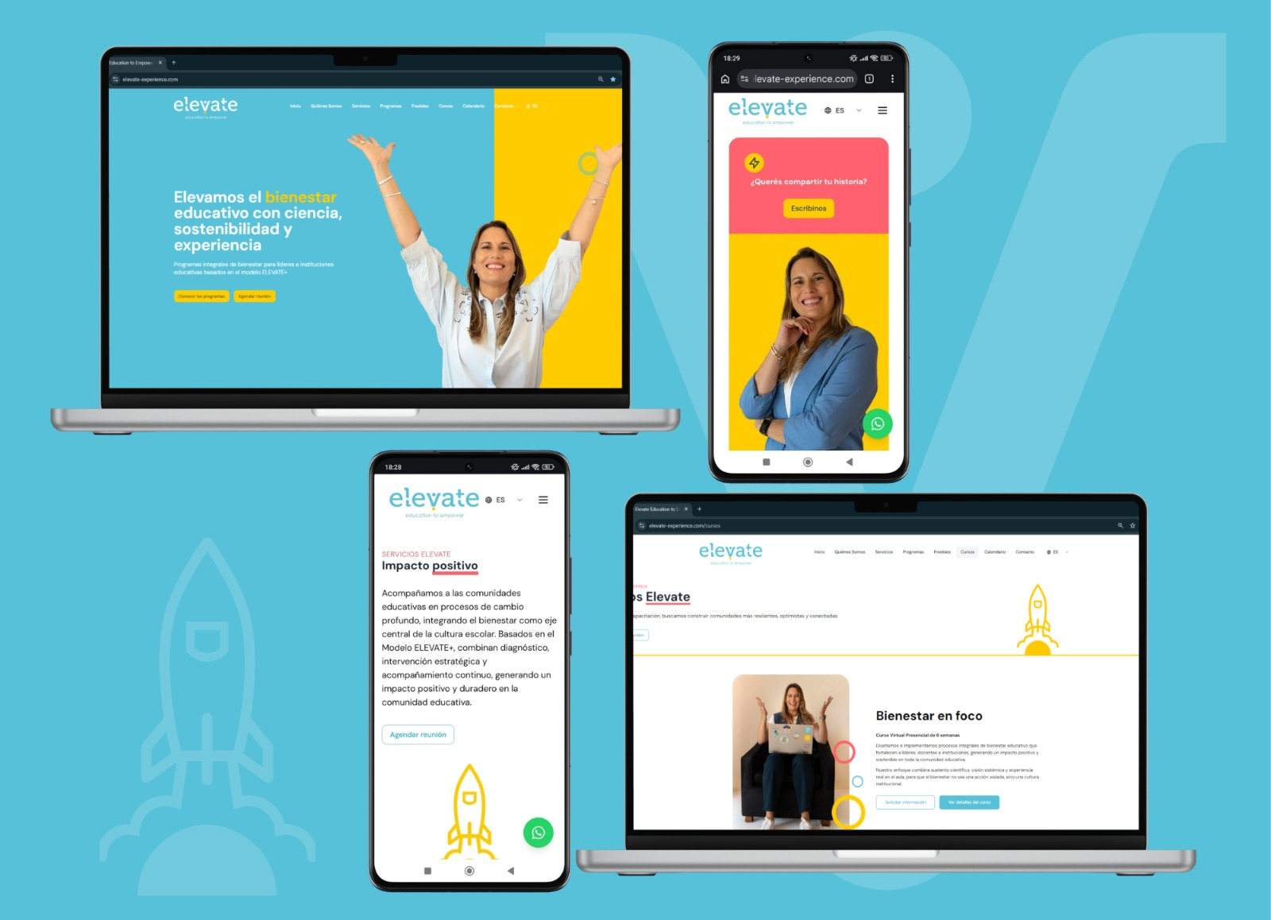

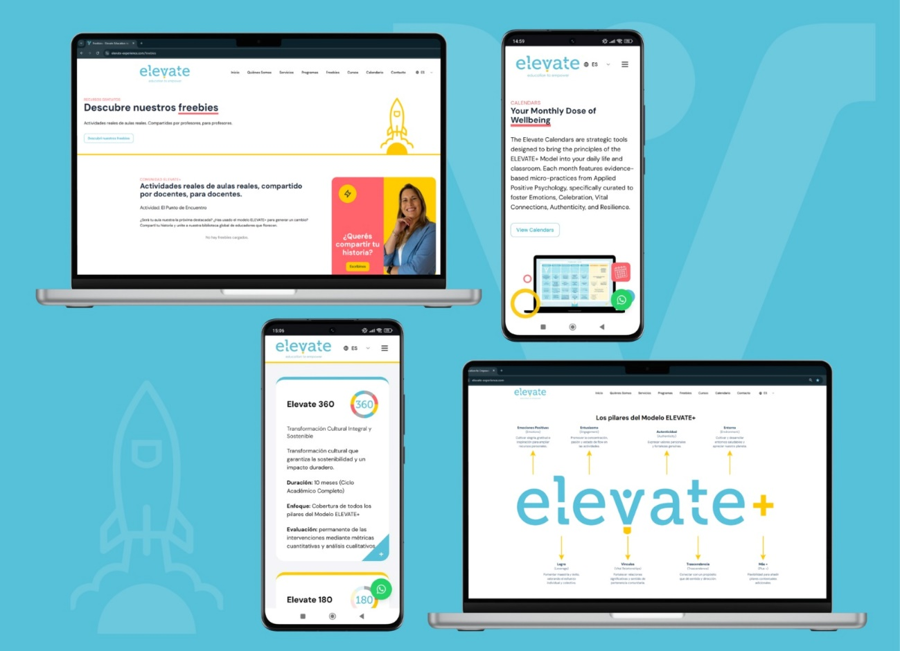

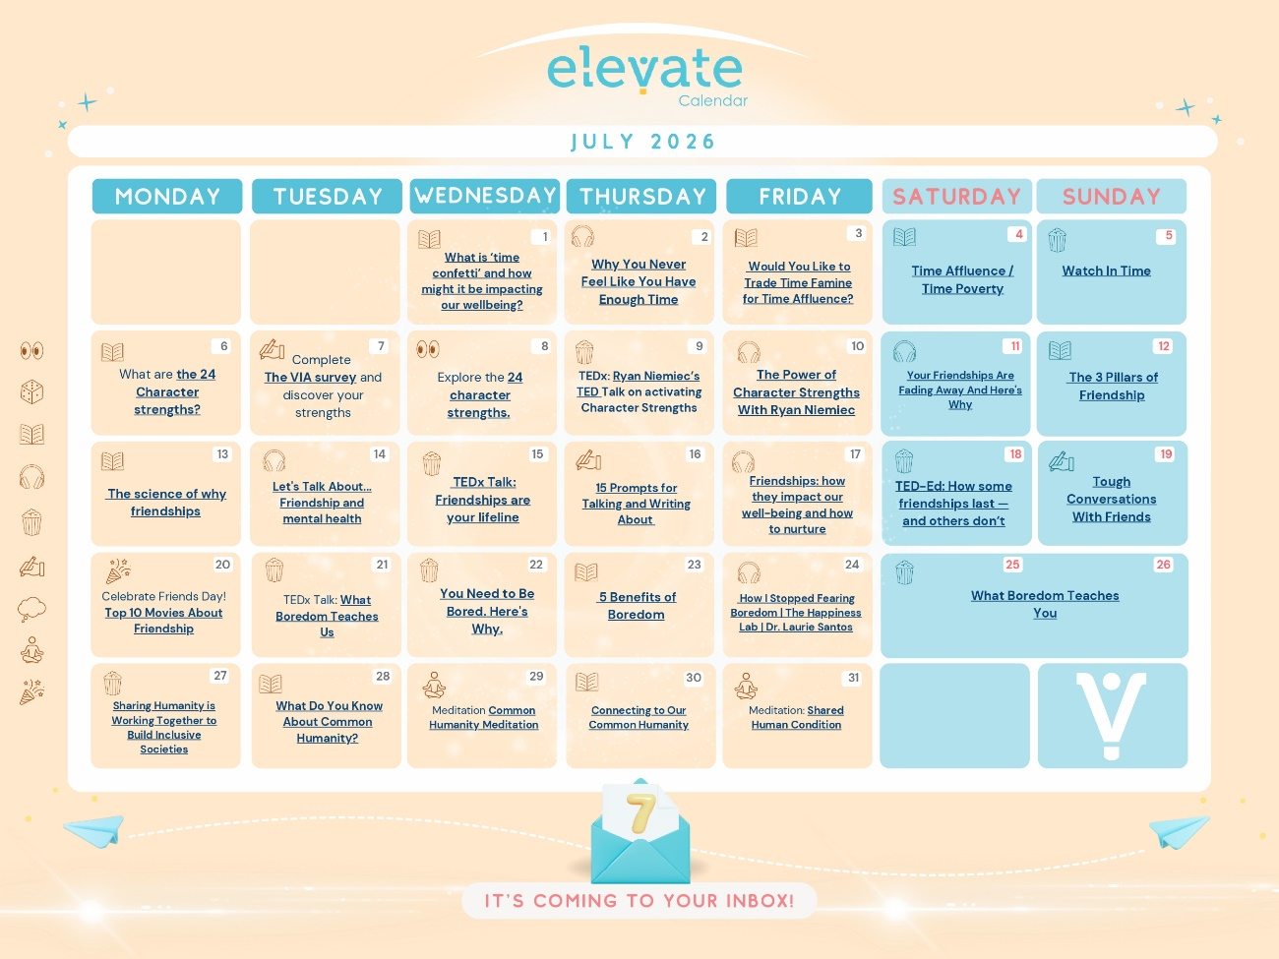

The foundational framework: The ELEVATE+ Model

Inspired by Martin Seligman’s PERMA model of positive psychology (2011), the ELEVATE+ model adapts these pillars into a context-sensitive, humanistic structure that can be tailored for any language classroom. This model provides the structural framework for all our resources, positive psychology interventions, and our series of Elevate Calendars. Ultimately, the ELEVATE+ model serves as an adaptable framework for any classroom intervention aiming to foster educational well-being.

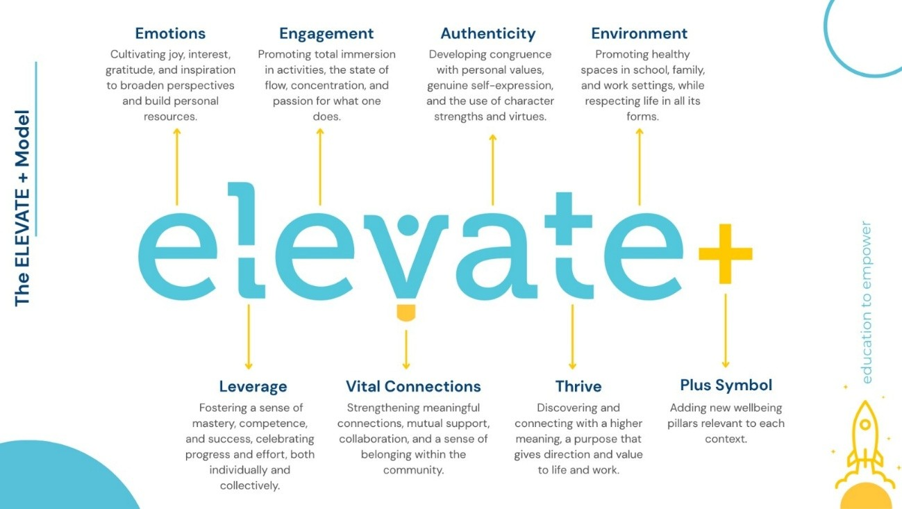

The pillars of the ELEVATE+ model are:

E - Emotions: Cultivating joy, the capacity to love, optimism, hope, gratitude, pride, interest, inspiration, and a love for learning to broaden perspectives and build personal resources applicable both in the classroom and in daily life. Simply put, by reducing negative emotions and increasing positive ones, our well-being and quality of life increase.

L - Leverage: It is fundamental to feel that we can accomplish our goals and believe in ourselves to promote our well-being within educational contexts. Fostering a sense of mastery, competence, and success—while celebrating both individual and collective progress and effort—is key to the teaching and learning processes, as well as to creating safe environments that catalyse learning.

E - Engagement: By promoting total immersion in activities, engagement, concentration, and a passion for what one does, the state of "flow" emerges. This allows teachers and students to enjoy every experience and acquire meaningful learning.

V – Vital Connections: When we build healthy bonds within our educational community, we strengthen meaningful connections, mutual support, collaboration, and a sense of belonging, thereby enhancing the overall level of educational well-being.

A - Authenticity: Developing alignment with personal values, genuine expression, and the use of character strengths improves our capacity to teach and learn while fostering our educational well-being.

T - Transcendence: This pillar refers to meaning or purpose in life. It involves discovering and connecting with a higher meaning—a purpose that gives direction and value to both life and work. Knowing who I am and who I want to be is essential for the holistic well-being of all members of educational communities.

E - Environment: This pillar refers to cultivating and developing healthy environments across school, family, and work domains (whether digital or in-person), as well as respecting and appreciating our planet and the living and non-living beings with whom we share it.

+ (Plus): This symbol provides the possibility to add foundational pillars of well-being such as Vitality (Zhivotovskaya, 2016), Physical Health (Kočí & Donaldson, 2024), Economic Security (Kočí & Donaldson, 2024), and the pillars included in the EMPATHICS model developed by Oxford (2016). The plus (+) symbol allows us to incorporate dimensions of well-being that may be highly contextual to the specific educational systems where the ELEVATE+ model is implemented.

The ELEVATE+ model ensures a comprehensive approach that enhances both the socio-emotional and cognitive development of the educational community, effectively responding to the demands of new educational paradigms. Understanding that education transforms human beings and that “through the transmission of knowledge and skills, education transports them from their present state to a different future state” (Adler, 2017, p. 50), the ELEVATE+ model aims to make that future state one of flourishing and holistic well-being.

In addition, being part of the Elevate Community means being able to share events, positive psychology interventions, and reflections with like-minded teachers from around the world, showcasing what you are doing to foster well-being in your school contexts. Educators can complete our subscription form to start receiving our monthly newsletters and join this growing network. The primary objective of Elevate Education to Empower is to build an educational community that aspires to lead by example for future generations, creating an environment where teaching and learning flourish in harmony.

Inside the toolkit: Newsletter highlights

To demonstrate how the ELEVATE+ model translates from theory into actionable reality, we can look at three comprehensive examples of the insights, global connections, and classroom tools shared in our recent monthly newsletters.

1. May highlight: From Argentina to China – Showcasing our context

Our May initiatives focused heavily on bridging local realities with global conversations. I participated in the prestigious PLL6 Conference in Shantou, China, learning from the world’s leading experts in the psychology of language learning.
What made this milestone truly special was the opportunity to bring local Argentinian classroom data to a global stage. Alongside my colleague Laura Ardissone, the research carried out at Instituto Cruz del Sur was presented under the title: New School, New Challenges, Old Resources? How the implementation of Positive Education affected EFL teachers’ well-being. This case study explored the dynamic equilibrium of two EFL teachers’ challenges and resources faced during the inaugural year of a secondary school in the province of Córdoba in Argentina. This presentation ignited a beautiful ripple effect that started in China and continues to flow back into our global community spaces.
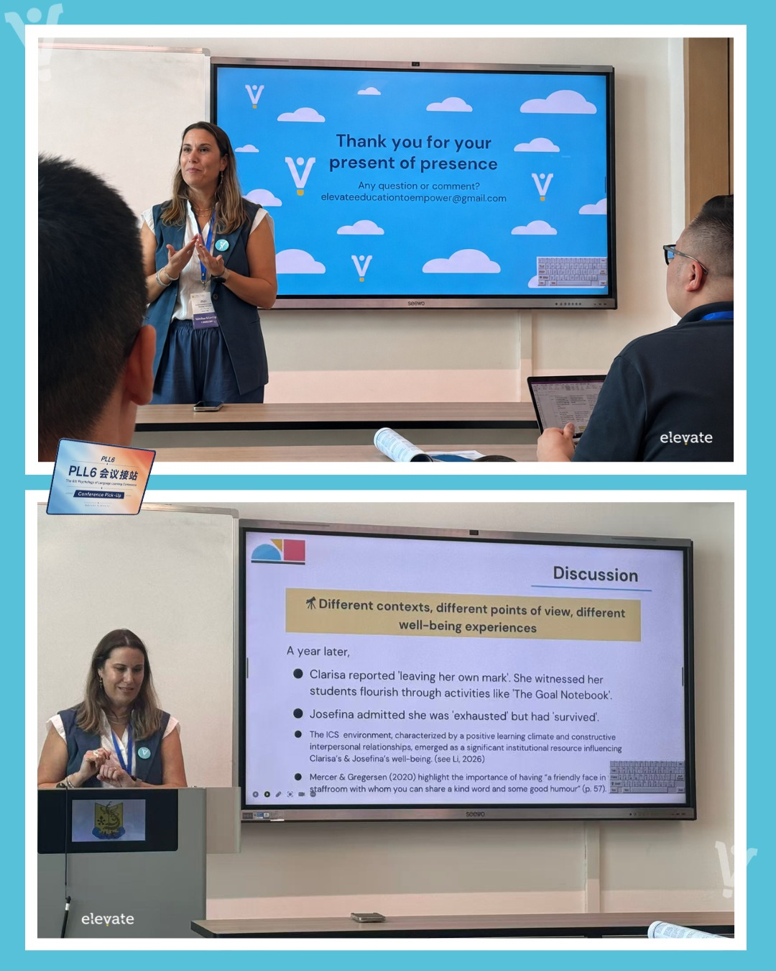

2. June highlight: Reminiscing about the Teacher Well-being Retreat

In June, we participated in the first Teacher Well-being retreat, "Reinventarse" (Reinventing Oneself), held in Villa General Belgrano, Córdoba, Argentina, which was organised by Rosana Freddi. This magical encounter merged nature, community, and learning. During this retreat, three scientifically grounded sessions were delivered to help teachers rebuild their personal resources:

Weaving Upward Spirals of Positivity: Reflecting on the importance of prioritising teacher well-being as the true engine of quality education. Taking care of ourselves is never a selfish act; it is a vital pedagogical necessity.

Savouring the Present to Design My Future: Experiencing the "science of savouring" to stretch and treasure positive sensations, accompanied by a mindful body scan to activate the nervous system for deep relaxation and presence.

Once upon a time… my reinvention: Harnessing the fact that human beings are storytelling machines. By consciously projecting the second half of the school year with meaning and transcendence, teachers can actively write the professional narrative they want to experience.

Beyond the theoretical frameworks, this retreat allowed busy educators to lower their guard, take a deep breath, and remember the fundamental purpose that led them to choose this beautiful profession in the first place.

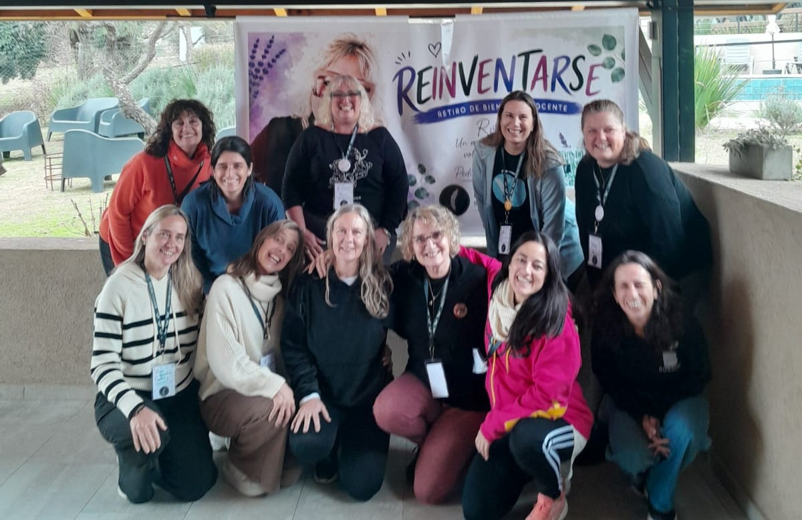

3. July highlight: The "Freebie" Hub & Classroom application

The heart of our digital hub is a living library where theory turns into practical action—featuring real activities for real classrooms, shared by teachers, for teachers. This July, we highlighted our latest open-access resource available for immediate download: "Upward Spirals of Positivity".

Focusing explicitly on the Emotions pillar of the ELEVATE+ model, this activity combines mindfulness, music, and the science of gratitude. It is structured for language students to explore, experience, and physically build an upward spiral of well-being through a hands-on crafting experience.
Teachers implementing this activity noted a profound shift. Language students opened their hearts, becoming deeply receptive while contrastingly mapping out upward spirals of positivity against downward spirals of negativity. The moment the entire class lifted and stretched their physical, cut-out spirals was pure magic. Furthermore, guiding this intervention actively fuels and restores the teacher's own emotional well-being.

We want to give your creativity a global platform. If you have tried an Elevate activity, applied any of our twenty calendars, or designed your own tool based on the ELEVATE+ model, you can share your story through our community form. By doing so, you gain professional recognition as a leader in Positive Language Education, fuel your own well-being by knowing your purpose is inspiring others, and generate a powerful ripple effect that transforms classrooms globally.



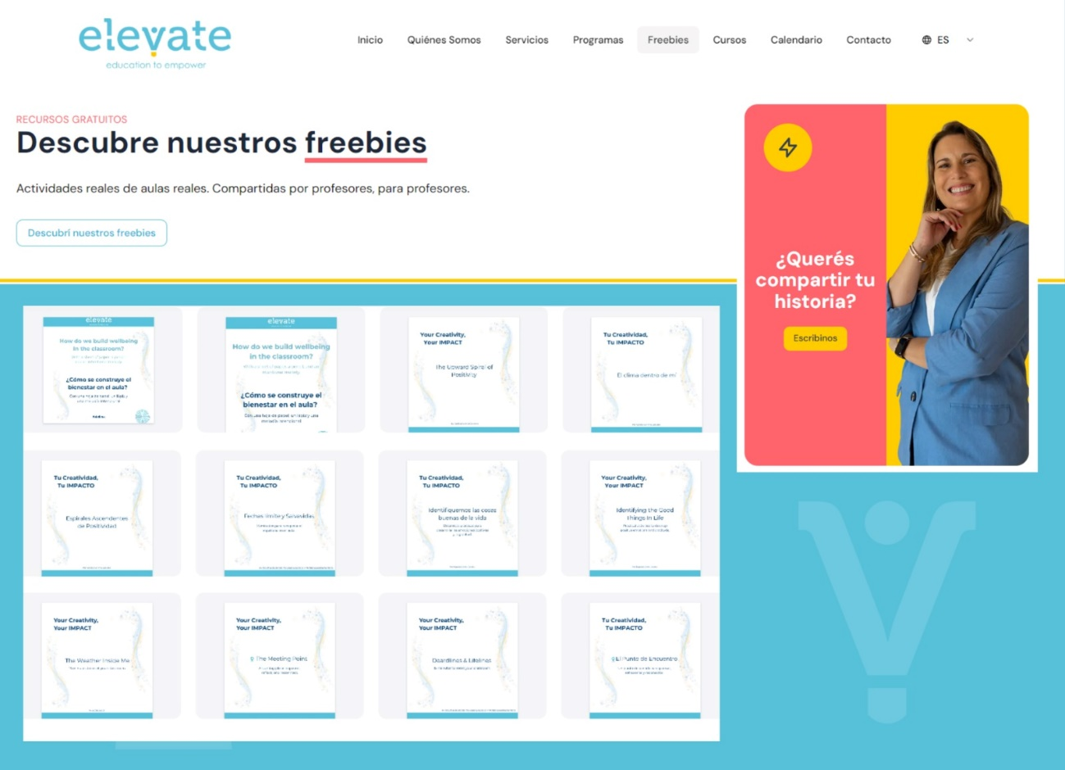

Conclusion: A Future of hope
All these open-access resources, our twenty tactical calendars, and the broader Elevate community represent my humble contribution to promoting student and teacher well-being within the vital field of language teaching and learning. My ultimate hope is that Positive Language Education can foster the full development of every individual, ensuring that teaching and learning languages become processes that are truly worth experiencing.

References

Adler, A. (2017). Education and well-being. In The Routledge International Handbook of Critical Positive Psychology (pp. 45–55). Routledge.
Kočí, C., & Donaldson, S. I. (2024). Well-Being and Success for University Students. Applying PERMA+4. Routledge
Oxford, R. L. (2016). The EMPATHICS model: A vision for language learner well-being. In The Psychology of Positive Language Learning (pp. 10–35). Multilingual Matters.
Seligman, M. (2011). Flourish: A Visionary New Understanding of Happiness and Well-being. New York: Free Press.
Zhivotovskaya, E (n.d.). The Flourishing Center. Retrieved March 18, 2023, from https://theflourishingcenter.com/

Useful links

Elevate Education to Empower Website: https://elevate-experience.com
Community Subscription: https://forms.gle/PknxKLtaB3cE2QZ6A
Classroom Activity Submission Form: https://forms.gle/G9rUUfs4enRM38wh8
IAPLL - PLL6 Conference in Shantou, China: https://www.iapll.com/PLL6
Institutional Research Context: https://institutocruzdelsur.com.ar/2024/
Villa General Belgrano, Córdoba, Argentina: https://villageneralbelgrano.gob.ar/

Coming soon! Please check the Pilgrims in Teacher Training courses in 2027 at Pilgrims website.

