It's Just Business - A Surreal Short Film Against Modern Slavery

Judy Boyle, Greece

Judy Boyle is the founder of The NO Project, an award-winning, arts-based, global educational campaign against modern slavery and human trafficking. She has been involved in anti-human trafficking and anti-slavery educational actions for 25 years.
Judy is a teacher, trainer, researcher and author. Her background also includes professional theatre and filmmaking. In 2022, Judy directed and produced It’s Just Business, an award-winning, surreal short film against modern slavery, based on a spoken-word poem by a 16-year-old high school student. Email: judy@thenoproject.org

The NO Project award-winning lesson plans

The NO Project has created free, downloadable teaching resources on human trafficking and modern slavery. Each lesson is based on a true narrative and is approached with dignity, sensitivity and respect. Designed for upper secondary, young adult and adult learners, The NO Project lessons are ideal for both on-line teaching and in the classroom. Each unit includes slides, artwork, authentic interviews, videos, lexical input, original listening material, and a gentle step-by-step teacher’s guide. Also provided are student autonomous learning resources with suggestions for project-based actions beyond the class. These teaching resources have been featured in the Master’s in Education Program at Havard Graduate School of Education and are being used by thousands of educators worldwide.
The teaching material was created in partnership with The Rights Lab, Nottingham University, UK.

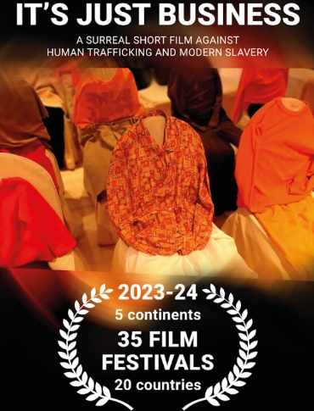

Dear reader – your actions could impact the safety of your learners.

Student-initiated slam poetry becomes an award-winning surreal film against human trafficking and modern slavery…and now we need your help for the next step!

It’s Just Business: a little background information
Several years ago, a 16-year-old high school student in a European capital attended The NO Project multi-media seminar designed for upper secondary school students. Their reaction to learning about the crime was to create the powerful slam-poem It’s Just Business.
In collaboration with the young poet, the poem became the basis of a 7-minute surreal short film It’s Just Business which has been featured in film festivals on all continents.
The NO Project is currently developing teaching resources to accompany the film which will soon be available to the public.
It's Just Business is a radical departure from many anti-trafficking/anti-slavery films that focus on the narrative of the victim. Both the poem and the film take a completely different point of view (POV), and in doing so we intentionally avoid the violent, exploitative, cliched imagery often present in anti-trafficking/anti-slavery messaging.

- Would you and/or your students like to part of developing or trying out brand new lesson plans based on the surreal short film IT’S JUST BUSINESS?

- Are you working with students whose English level is B1+ or higher?

- Do your students like learning about real world issues, or more precisely crimes, focusing on social justice while, at the same time, developing their English knowledge and skills?

- Are your students 16 years or older? (The educational resources are not suitable younger learners – students need to be upper high school age, young adult or adult learners.)

Please contact us! We would love to hear from you.

Remember we provide FREE online seminars suitable for teachers and/or for students. Please do not worry if you yourself don’t know too much about human trafficking or modern slavery. As you will see from The NO Project site - including the free downloadable lessons – we do neither assume nor expect you to know about the crime in detail. (That’s our task!)

A special day

December 2, 2026 - Global release date of the short film It's Just Business.

Although It's Just Business has been featured in 35 film festivals globally and screened at international teaching conferences and during on-line teacher training seminars – we have not released for public viewing…yet. That is going to change!

Why this specific date?

December 2nd is the United Nations International Day for the Abolition of Slavery.

Here are some statistics from the UN site:
- An estimated 50 million people are in modern slavery, including 28 million in forced labour and 22 million in forced marriage.
- Almost one in eight of all those in forced labour are children. More than half of these children are in commercial sexual exploitation.
- Most cases of forced labour (86 per cent) are found in the private sector.
- Almost four out of five of those in forced commercial sexual exploitation are women or girls.
Lesson plans in progress: a mini task for you to try out.

Introduction: We are currently piloting different ways to approach the film in diverse educational contexts. This is just one approach before the students even get to view the film. What are your thoughts on this task – please drop us a line.
A personal comment: Each time we try this approach the students get so involved in the process, it ends up taking longer than we anticipated – all due to the students’ spontaneous engagement. The students so far have said they like this task as it gets them thinking straight away – and the words themselves bring up many thoughts and emotions.
In many cases, I have not even mentioned that we will watch a film.

Procedure:
1 First, look at the two slides. Each slide contains ten words.

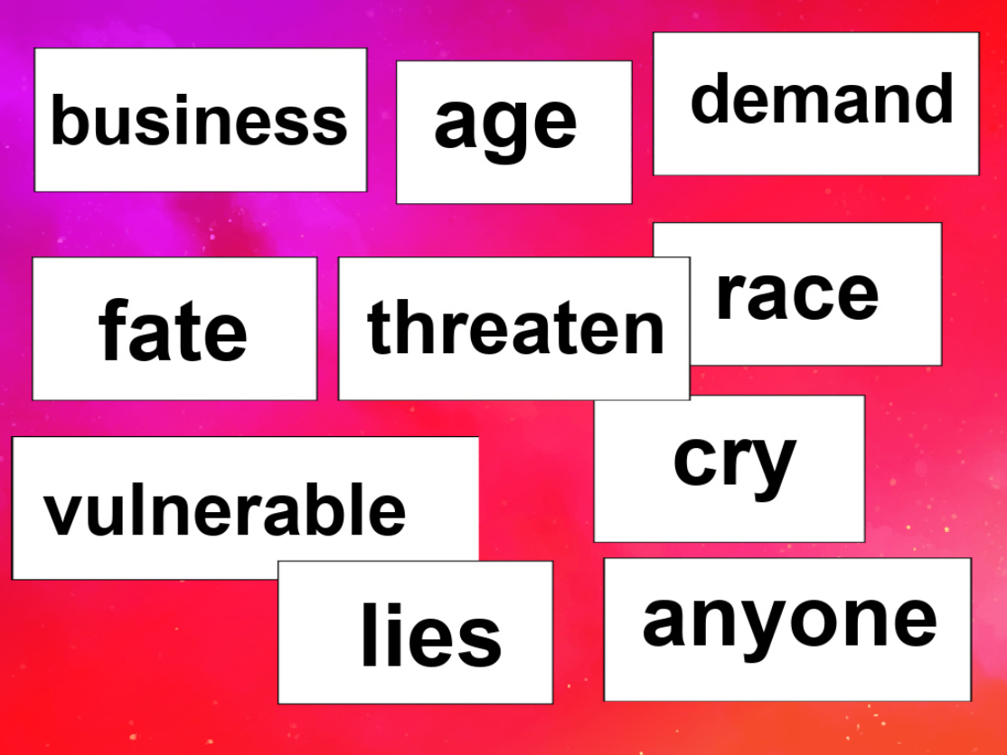

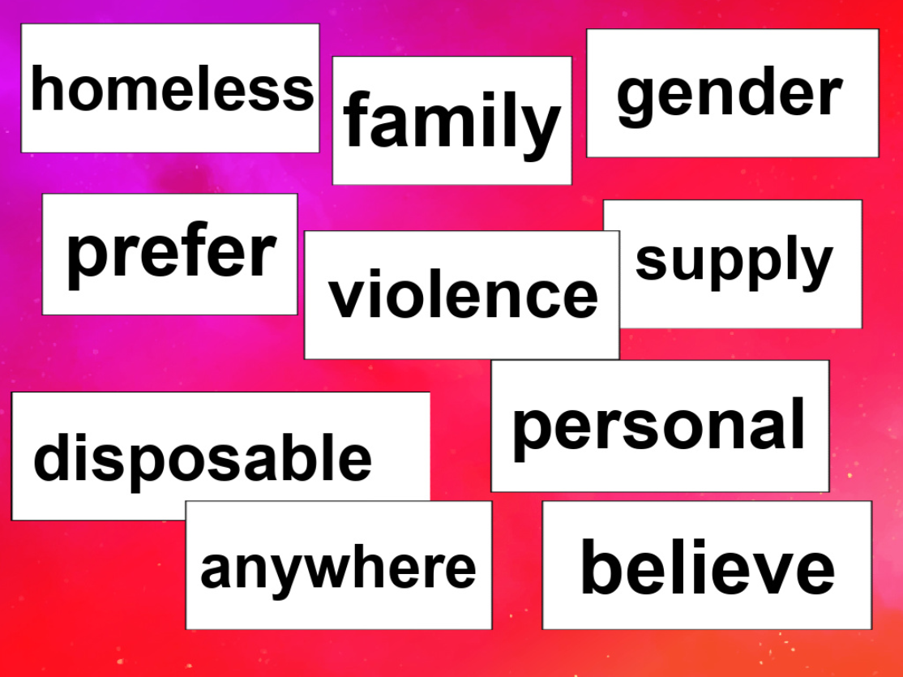

Teaching note: Each word in these two slides is from the original spoken-word poem, It’s Just Business. The vocal sound design of the film follows the exact progression of the original poem.

2 Next, guess which word from slide #1 might appear in the same line from the poem with a word from slide #2?

Teaching note: From a teaching point of view, these 20 lexical items reflect the level of language that your students need to be somewhat familiar with or ready to learn.

3 Next step. Now create a possible sentence that could include a word from slide #1 and a word from slide #2.

Teaching note: This task we carry out as interactive pair or group work - and 10 sentences will comprise the outcome.

4 Discussion
- What might each sentence be about?
- Whose ‘voice’ is speaking?
- And to whom are they speaking – and why?

5 And a final task for you…

The title of the film, IT’S JUST BUSINESS is a line from the poem. In fact, the full line is, ‘It’s nothing personal. It’s just business.’
- How does this translate into other languages that you speak?
- Do similar phrases exist?

6 Finally, given the intimate violation and exploitation of a body that slavery involves, be it of a baby, child or adult, the phrase ‘It’s nothing personal’ could not be further from the truth. Try saying the phrase out loud several times - in any language of your choice.
The irony is horrific and one of the greatest injustices of our time.

Please help us – we cannot do this alone.

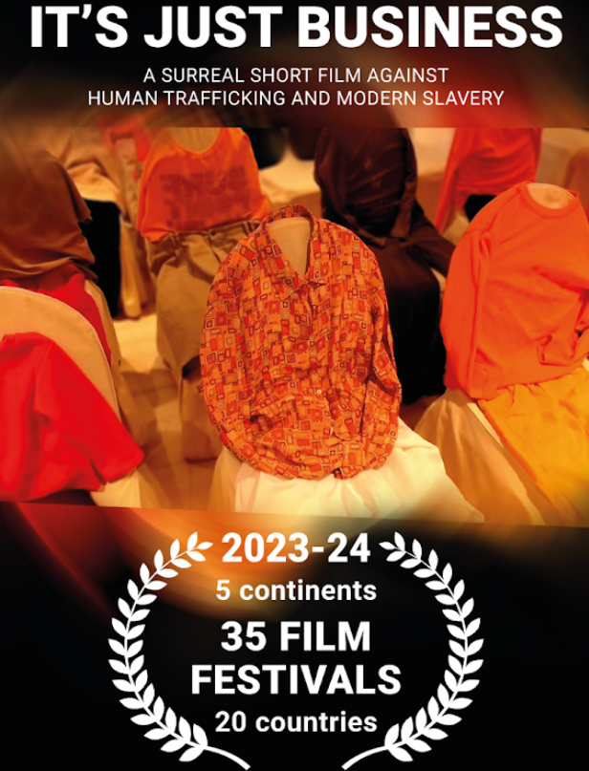

Coming soon! Please check the Pilgrims in Teacher Training courses in 2027 at Pilgrims website.

