
What Do You See?
Jamie Keddie, Spain
Jamie Keddie is a Barcelona-based teacher trainer and storyteller. He is the author of 'Images' (Oxford University Press, 2008), 'Bringing online video into the classroom' (Oxford University Press, 2014). 'Videotelling: YouTube Stories for the Classroom' (LessonStream Books, 2017).

From the Editor
Twice a month, Jamie Keddie sends out the LessonStream Post – a story or storytelling idea for the classroom. It's free to sign up and you can do so here: https://lessonstream.com
1. Tell students that they are going to see a painting of a costal Aegean landscape. Ask them to guess some of the things that they will see (e.g. the blue sky, the sea, cliff, fishing boats).

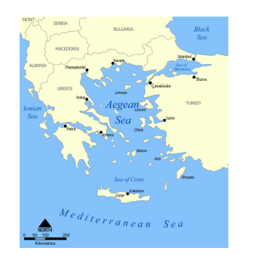
2. Show students the painting.
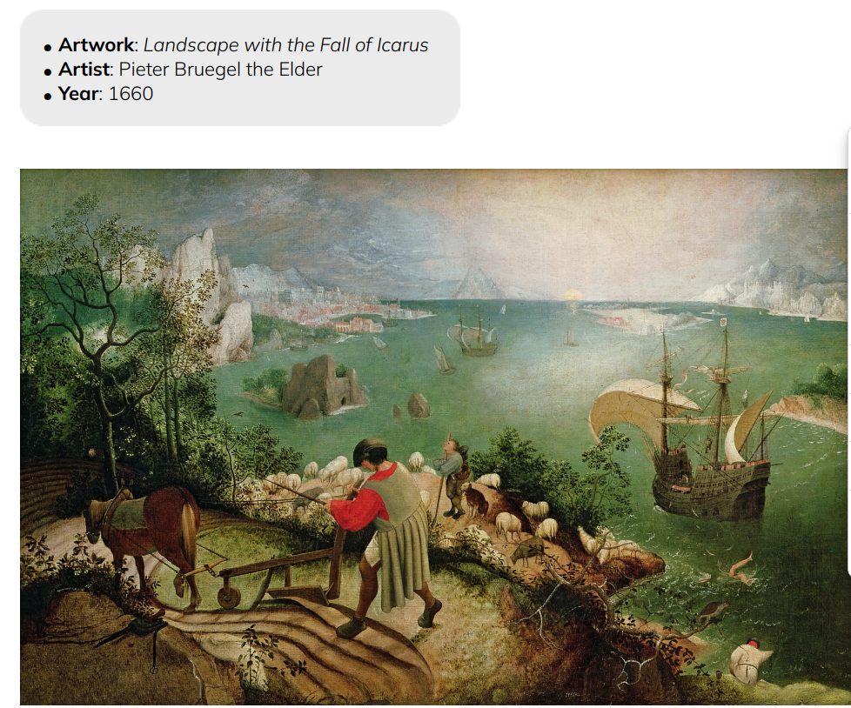
3. Tell students that you are going to give them an observation test. Give them exactly 60 seconds to look at image and remember as much about it as possible.

4. After 60 seconds, remove the image from view. Put students into pairs and ask them to write down everything that they can remember about the picture. Ask them to write down the following:
• Things that you saw in the picture
• Things that were happening in the picture (i.e. past continuous sentences)

5. Go over students’ answers and try to elaborate on them when possible. For example, if someone saw a shepherd, ask them if they can remember what he was doing. Write students’ answers on the board. (See the box at the bottom of the page.)

6. Did anyone notice the key detail in the painting? Near the bottom right of the picture, above the fisherman and the bird on the branch, there is a pair of legs and an arm in the sea.

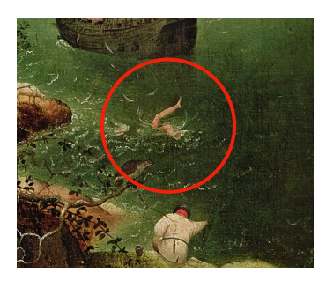

7. Go back to the image and let everyone see the detail for themselves. Can anyone explain what is happening? Does anyone know this story?

The painting is an unusual depiction of Icarus, a character in Greek mythology. Icarus and his father Daedalus had been imprisoned on the island of Crete. Daedalus created wings from beeswax and feathers which allowed them to fly away and escape. However, despite warnings from his father, Icarus flew too close to the sun. This melted the beeswax which held the wings together and Icarus fell into the sea and drowned.

8. Ask students top write a poem about the painting with the following format:
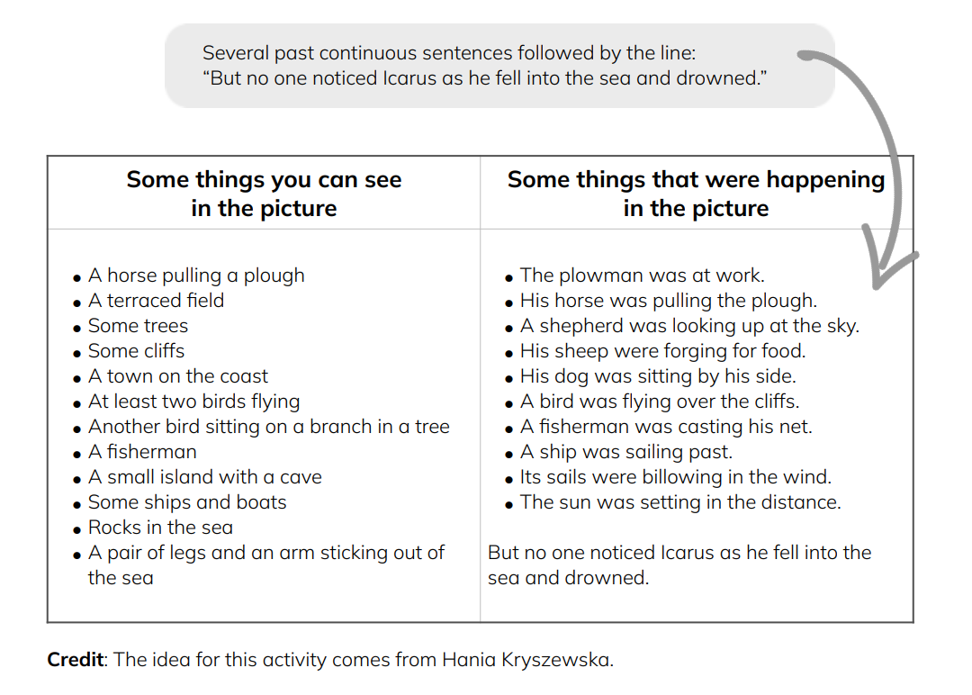

Coming soon! Please check the Pilgrims in Segovia Teacher Training courses 2027 at Pilgrims website.

