

We are proud to stage once again the largest foreign language teaching events in Thessaloniki and Athens.
On Friday, 3 July 2026, we sent the first e-mail to 24.480 foreign language teaching professionals in Greece regarding the participating exhibitors in the Autumn '26 IPEs.

Online registration for the leading foreign language teaching events in Greece, the
Autumn '26 Thessaloniki and Athens International Publishers Exhibitions, has opened!

Register now online!
Participating in the presentations during exhibition hours is free to all foreign language teaching professionals.



With the support of
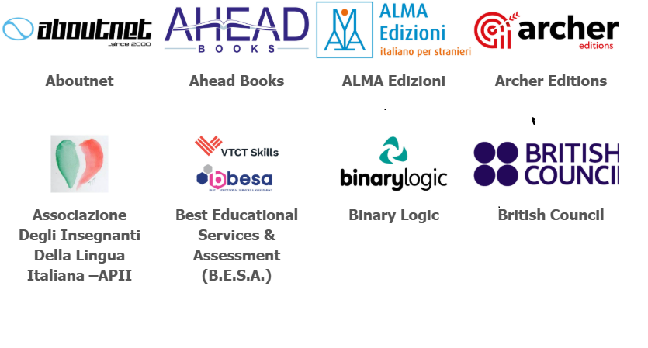
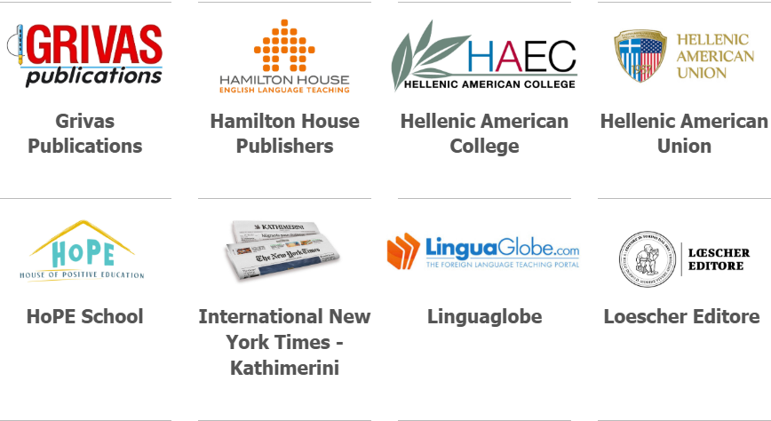

Looking forward to welcoming you in Greece:
in Thessaloniki, on Sunday, 30 August 2026, at the Grand Hotel Palace
in Athens, on Saturday/Sunday, 05/06 September 2026, at the Divani Caravel Hotel

Spread the word and invite your colleagues.
Philip Dietschi
INTERNATIONAL PUBLISHERS

