Shall I Check my Email? and Other Flow Charts

found on Pintrest by Hania Kryszewska, Poland

Fun
Flow charts are great fun. Great fun to follow, great fun if you design your own. Great fun if you practice or drill conditionals.

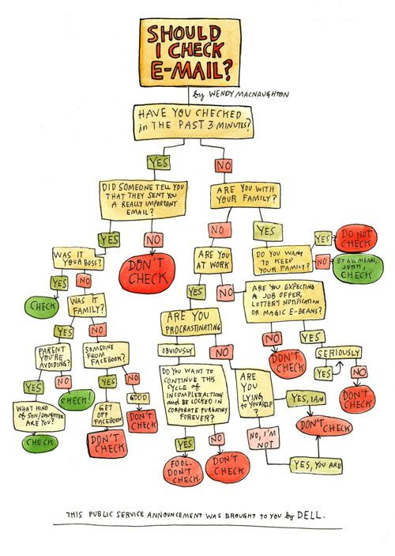

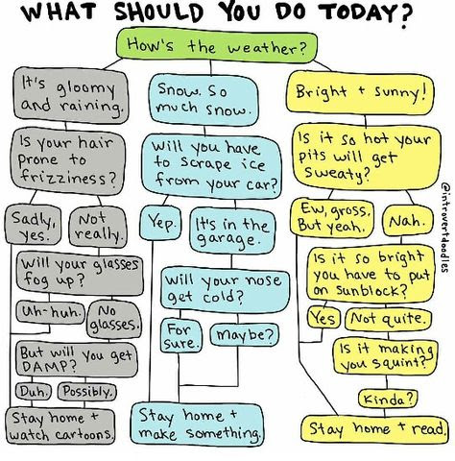

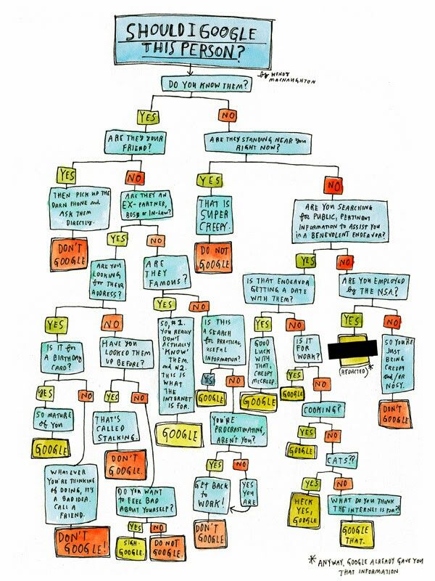

Mores serious stuff
But they can be more serious and springboards for discussion or to instroduce the subject of the lesson.

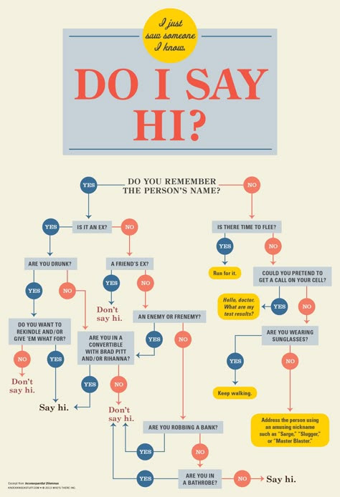

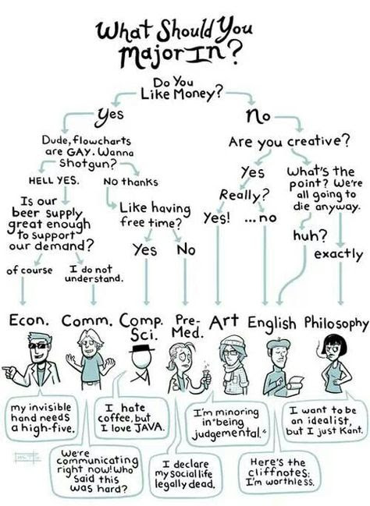

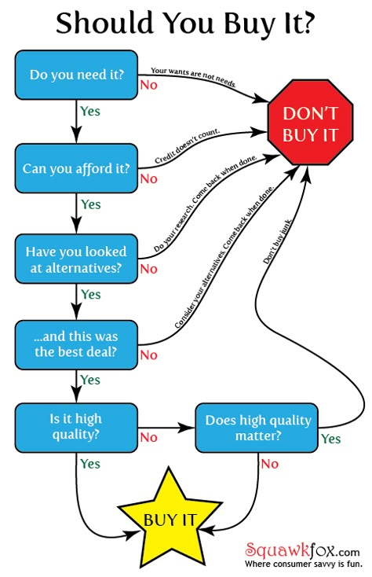

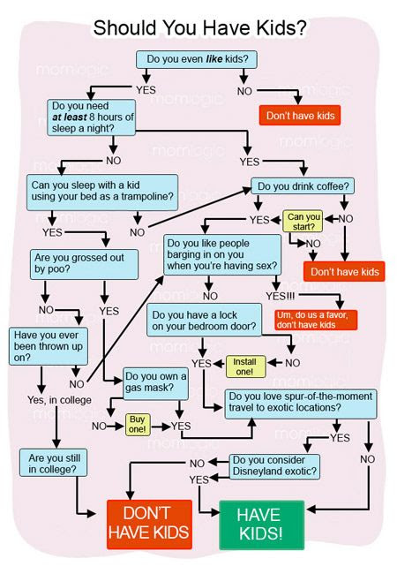

Coming soon! Please check the Pilgrims in Teacher Training courses in 2027 at Pilgrims website.



