Colloquium 2026
45th Annual International TESOL France Colloquium
Happy 45th Anniversary
More than a Teacher: The Expansion of Skill Sets of the 21st-century Language Educator
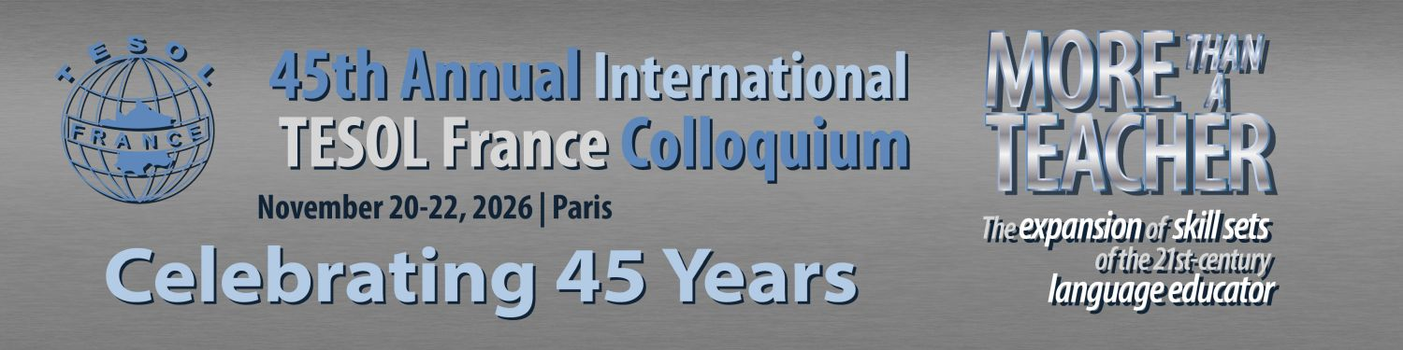
Dates:
20th November, 2026
21st November, 2026
22nd November, 2026
Venue: Paris



We welcome you to be part of the 45th Annual International TESOL France Colloquium for 2026.
Plenary speakers

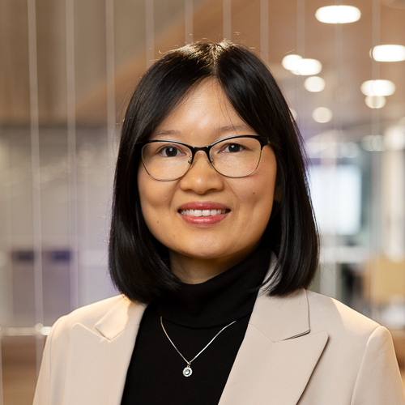
Dr. Minh Hue Nguyen.
Dr Minh Hue Nguyen is a TESOL teacher educator and researcher at Monash University,
Victoria, Australia. She has 22 years’ experience in English language teaching and teacher
education in Asia and Australia. She is currently teaching in the Master of TESOL, Master of
Teaching, and Bachelor of Education (EAL specialism) programs, as well as supervising PhD
students. She has been consulted by government bodies to develop practical resources for
teachers and actively contribute to reforming the Vietnam&#39;s English Teacher Competency
Framework, the Victorian EAL Curriculum and the Victorian Government’s EALHer publications include a monograph on language teachers’ professional learning, an edited book on language teacher agency, and more than 40 papers and book chapters on language teachers’ navigation of various aspects of their role. The theme that connects all her research projects, teacher education practices, and consultancy is the expanded skill set that English language teachers need in order to teach in the 21st century. Her work generates practical implications for teachers, teacher educators and language policy makers.

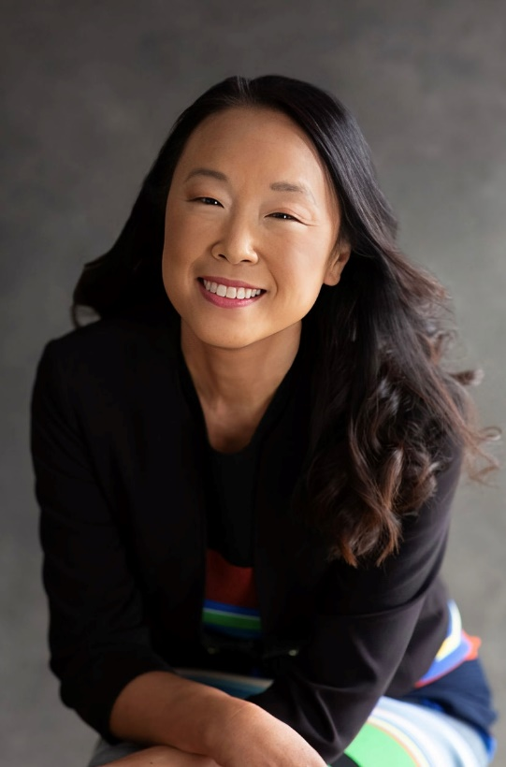
Joan Shin
Joan Kang Shin, Ph.D. is a Professor of Education in the College of Education and Human Development at George Mason University in the United States. At George Mason, she is the Associate Dean for Faculty Success and the Director of the Global Online Teacher Education Center (GOTEC). Dr. Shin specializes in teaching English as an additional language to young learners and teenagers as well as online TESOL education. She is an award-winning author and series editor for National Geographic Learning. Her titles include Breaking Through the Screen, Teaching Young Learners English, Our World, and Impact. In 2021, she was named one of the top 30 English Language Specialists by the U.S. Department of State in recognition of her lasting impact on the Specialist Program and the field of TESOL. She currently sits on the Board of Trustees for The International Research Foundation for English Language Education (TIRF).
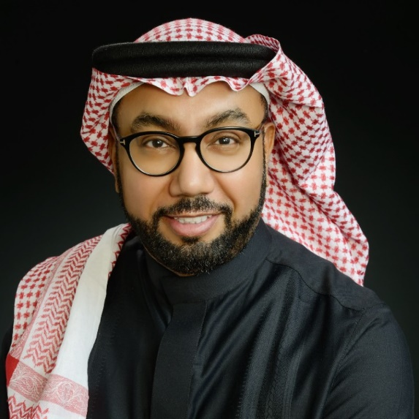
Prof. Dr. Tariq Elyas
Prof. Tariq Elyas is a full-tenured professor of Applied Linguistics at King Abdulaziz University, KAU (Saudi Arabia). He is also a Research Fellow at Prince Sultan University (Saudi Arabia) as well as AHSS Global Research Fellow at Queen’s University (UK). He holds an MA in English Literature (USA), a PhD in Applied Linguistics (Australia), an LLM in International Law and Human Rights (UK), and a Post-Doctorate in Applied Linguistics from Newcastle University. His research papers have appeared in top-tier research journals, such as the British Journal of Middle Eastern Studies, Digest of Middle East Studies, Contemporary Review of the Middle East, Journal of Arab and Muslim Media Research, Semiotica, International Journal for Semiotics of Law, World Englishes, Asian Englishes, Journal of Psycholinguistic Research, Journal of Neurolinguistics, Cambridge Journal of Education, and ELT Journal.Prof. Elyas has been awarded the Bundey Prize for English Verse (Australia), Travel Writing Fellowship (USA), Cambridge Gulf Research Award (UK), Year-Emerald Publisher (UK), Chevening Fellowship (UK), EU-GCC Relations Project Award (Belgium), Post-doctoral Summer Research (PDSR) Program-British Council Award (UK), and Best Supervisor Award in the Humanities & Social Sciences Track-KAU in 2018 and 2020 (Saudi Arabia).

How to register

Here is the link to register: https://www.tesol-france.org/index.php?page=tesol-france_colloquium

Registration is OPEN
- early bird conference fees available before September

Earlybird Colloquium rates
All current members: € 20
One Day Fee: € 35
All non members: € 45
Speakers & Posters: € 30

- Standard Colloquium rates
All current members: € 40
One Day Fee: € 35
All non members: € 70
Speakers & Posters: € 30

See you in Paris!

Post script

Call for volunteers!

Hey people in France, calling all those looking to either learn specific skills in running a national association or those wishing to put their leadership skills to work with TESOL France. We need you to bring new ideas to update, willingness to work in a team, willingness to network with people, communicate our activities, needs and mission, and many other things. Contact us.



