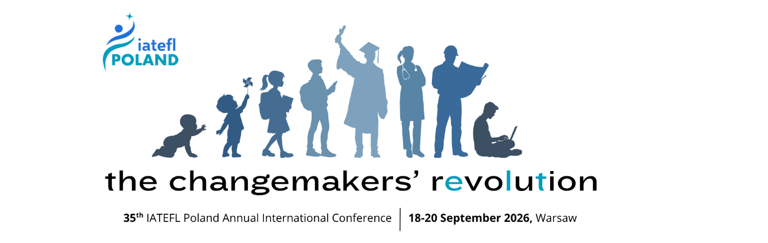
About IATEFL Poland

IATEFL Poland (International Association of Teachers of English as a Foreign Language) is one of the largest and most vibrant professional networks for English language teachers in Poland.
Mission Statement

Stowarzyszenie Nauczycieli Języka Angielskiego w Polsce IATEFL Poland aims to be the leading organisation representing English teaching professionals within the country, offering a range of services and publications which serve to support and maintain the development of its members within the EFL world.
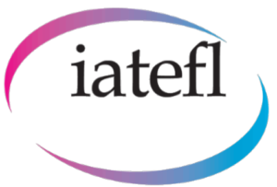

When and where?
The 35th IATEFL Poland Annual International Conference, to be held September 18th–20th, 2026, at Vistula University in Warsaw, invites proposals from passionate educators, trainers, researchers, and innovators who are ready to shape the future of English language teaching.
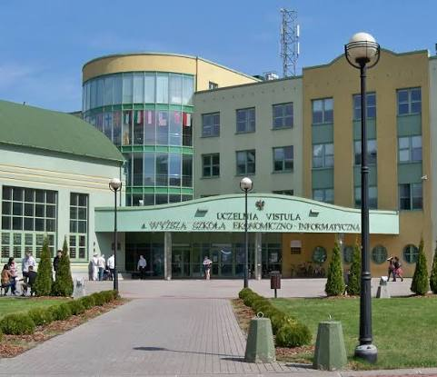
Under the theme The Changemakers Revolution, the conference will explore how learning is evolving across every stage of life—from early childhood education to higher education, teacher development, and adult workplace learning. We welcome presenters who are leading change, challenging tradition, and bringing fresh ideas to classrooms and learning communities worldwide.

As one of the most respected ELT events in the region, the IATEFL Poland Annual International Conference has welcomed participants from more than 30 countries and features a vibrant international community of teachers, academics, publishers, software developers, and educational leaders. The 2026 edition promises another outstanding three-day programme filled with world-class plenary speakers, practical sessions, networking opportunities, exhibitions, and professional development experiences.
What we have for you
- Plenaries
- 30-minute Talks – engaging presentations sharing practical ideas, research findings, classroom innovations, case studies, or inspiring perspectives.
- Workshops – highly interactive sessions designed to involve participants actively in learning and discussion.
Workshops may be scheduled for 45 minutes or 60 minutes, depending on programme needs and availability. Presenters should indicate their preferred length and flexibility when submitting.
- NEW THIS YEAR! Poster sessions
share your ideas, classroom practices, research findings, or innovative solutions with
fellow English language professionals. Poster sessions offer a great opportunity to
engage in meaningful discussions, exchange experiences, and inspire others in a
friendly, interactive format.

Meet the speakers

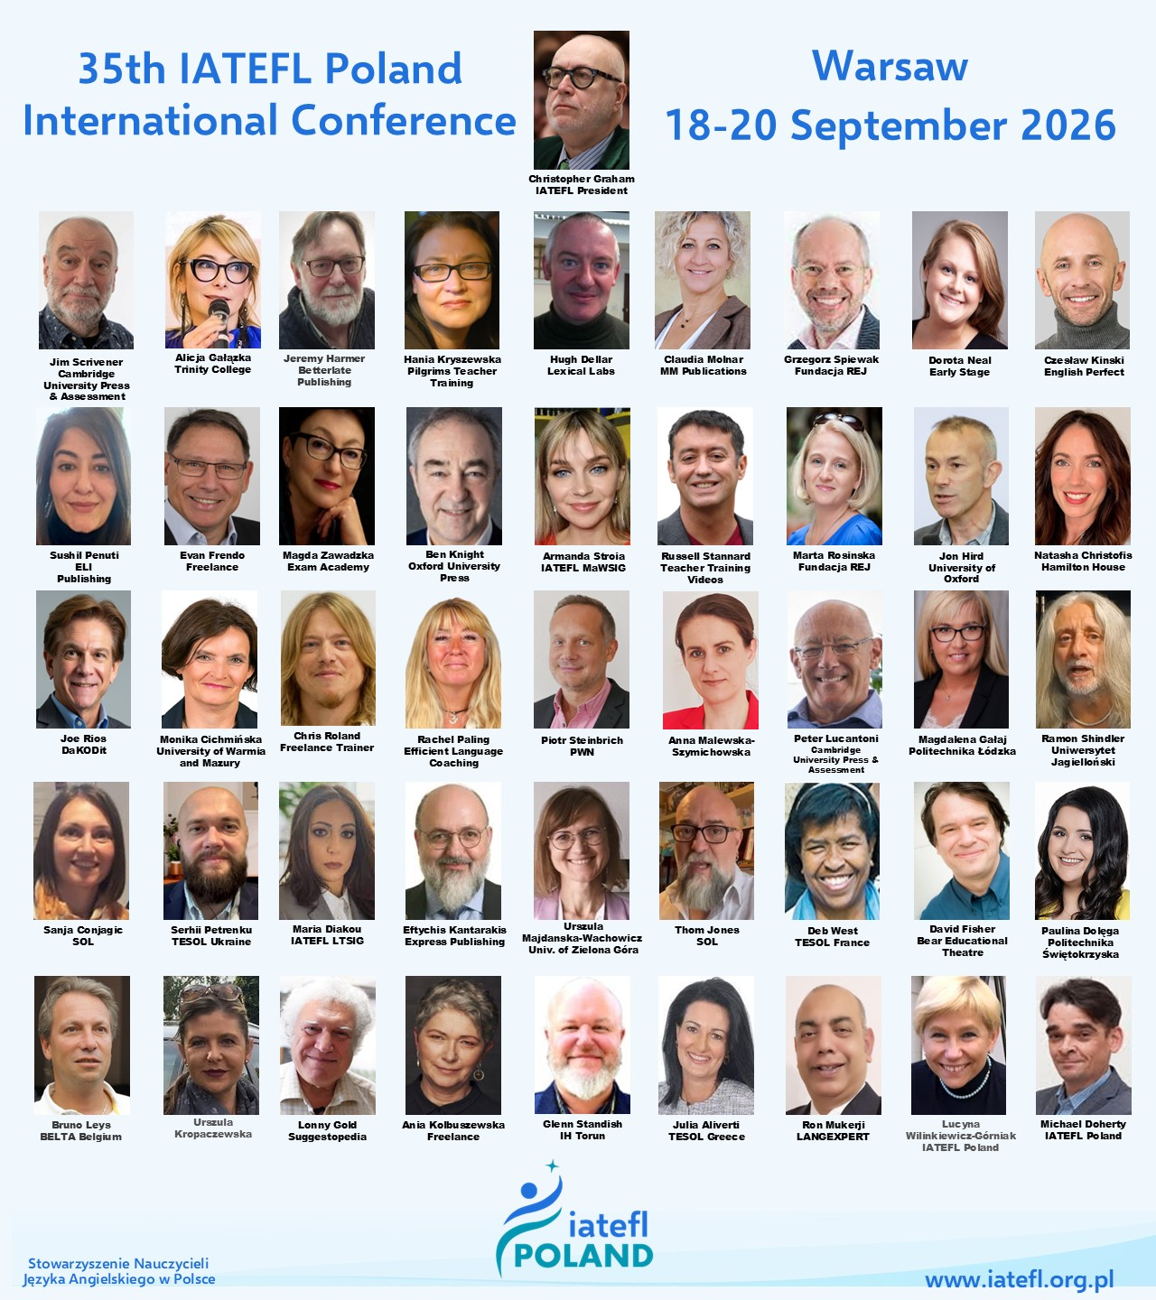

Links to mini interviews and promo by some of the speakers
IPL2026.0 - Rob Howard https://youtube.com/shorts/tsQqzhetuRo?feature=share
IPL2026.22 - Jim Scrivener https://youtube.com/shorts/1K4AtPYq5Ck?feature=share
IPL2026.1 - Jeremy Harmer https://youtube.com/shorts/XyHSiRl1a9g?feature=share
IPL2026.2 - Alicja Galazka https://youtube.com/shorts/Wms0fmY_omA?feature=share
IPL2026.3 - Christopher Graham https://youtube.com/shorts/V42ljdbkdp4?feature=share
IPL2026.5 - Hugh Dellar https://youtube.com/shorts/KbFcu3gK4DU?feature=share
IPL2026.6 - Marta Rosinska https://youtube.com/shorts/F7di4QUf2Jw?feature=share
IPL2026.7 - Grzegorz Śpiewak https://youtube.com/shorts/DhBOGGubOU4?feature=share
IPL2026.9 - Jon Hird https://youtube.com/shorts/Xtb_OCfxAjk?feature=share
IPL2026.8 - Hania Kryszewska https://youtube.com/shorts/BQp_kYpim9o?feature=share
IPL2026.13 - Chris Roland https://youtube.com/shorts/F-JOnZQBD0o?feature=share
IPL2026.14 - Peter Lucantoni https://youtube.com/shorts/0T7UvigQbTU?feature=share
IPL2026.11 - George Kokolas https://youtu.be/c1Y2-3NaE1g
IPL2026.10 - Claudia Molnar https://youtube.com/shorts/8DVbCQXkOzI?feature=share
IPL2026.18 - Paulina Dolega & Ron Mukerji https://youtube.com/shorts/g6qG5aYFDiM?feature=share
IPL2026.12 - Mirjana Mičetić https://youtube.com/shorts/OyIkvmlfqVo?feature=share
IPL2026.16 - Bruno Leys https://youtube.com/shorts/M0kdWoOzVpI?feature=share
IPL2026.15 - Deb West https://youtube.com/shorts/_k-XH9s_MlQ?feature=share
IPL2026.17 - Jana Pastorková https://youtube.com/shorts/Ft0g6j0tloo?feature=share
IPL2026.19 - Anna Plaksiienko https://youtube.com/shorts/2IR0wPdOz1k?feature=share
IPL2026.21 - Jon Burton https://youtube.com/shorts/nHueN7XWt9g?feature=share

Register here

Address
59-900 Zgorzelec, Poland ul. Armii Krajowej 51A
Phone
(+48) 503 017 030
E-mail address
office@iatefl.org.pl conference@iatefl.org.pl



