The Book That Inspired Me

Mario Rinvolucri, late Pilgrims trainer

Background
The article was originally published in IATEFL TG SID Newsletter in Spring 2001.

I know Mario swore by this book, so I was happy when I came across this text in my files. I have decided to share it with you even though the text was published 25 years ago. It is a real Golden Classic. It was written when Mario when Mario co wrote Ways of Doing with Paul Davis and Barbara Garside, and designed his Mindgame.


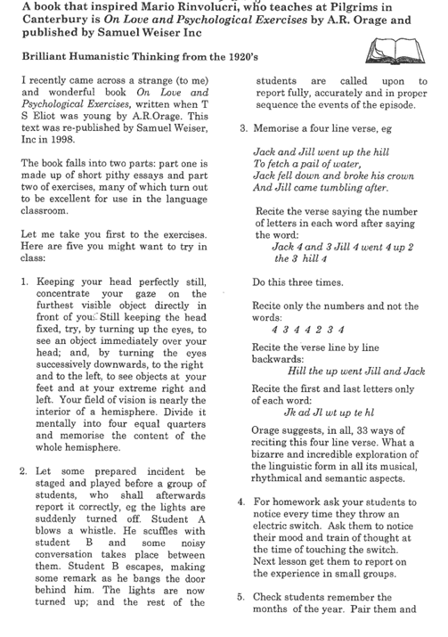
Page 1
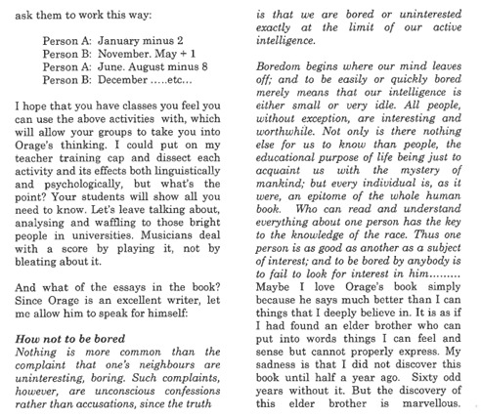
Page 2

You can read fragments of the book here.

