Active Citizenship in Secondary Education – Teaching Students to Engage, Think, and Act

Jelena Kovačević, Croatia

Jelena Kovačević is an English teacher, promoted into teacher excellent advisor at Ekonomska škola Požega, Croatia. She has coordinated multiple international projects promoting intercultural learning, digital literacy, and global citizenship. Jelena is a five-time consecutive recipient of the Most Successful Teachers Award by the Croatian Ministry of Education and an alumna of the SUSI for Secondary Educators program, sponsored by the U.S. Department of State. Her professional interests include sustainable education, global collaboration, and innovative language teaching methodologies.

Abstract
This article explores the concept of active citizenship in secondary education and offers practical classroom ideas for teaching it through experiential, project-based learning, collaboration and community involvement. Drawing on classroom practice and international collaboration within Erasmus+ projects, it demonstrates how civic values can be nurtured through discussions, hands-on projects and reflection. A practical classroom example — the Small Civic Challenge — illustrates how even simple student-led initiatives can spark meaningful local change and empower young people to become engaged and responsible global citizens.

Introduction

The world is changing fast. Education can no longer mean just cramming for tests or memorizing facts. It should push young people to be more than just observers—it should help them become thoughtful, responsible, and active members of society. That, in essence, is active citizenship — understanding your rights and responsibilities and choosing to participate in improving the world around you. Teachers matter a lot here. We, teachers, are the ones who can show students that they have the power to shape their communities—starting now, not someday far off.

What is active citizenship?

The Oxford Learner’s Dictionary defines active citizenship as “the practice of being a responsible member of a community by taking part in activities that improve life for everyone.” That’s the heart of it. Schools shouldn’t just get students ready for exams or jobs—they should help them get ready for life in a democracy.

John Dewey, an American philosopher, psychologist, and educational reformer put it best: “Democracy has to be born anew every generation, and education is its midwife.” Schools are places where students practice democracy for the first time — by speaking up, listening to others, working in teams, and solving problems together.

Teaching active citizenship in practice
You cannot confine active citizenship to a single class or subject. It should be intergrated into the entire curriculum, everything students do shaping the values of the whole school. In my own work with high schoolers, I use a mix of strategies to promote engagement, empathy, critical thinking, and—most importantly—acting.

Project-based learning (PBL)
Through Erasmus+ and other international projects, my students engage in real-world issues—cultural diversity, inclusion, sustainability and social responsibility. They learn by doing—planning initiatives, conducting research, presenting results, and reflecting on their impact.

Debates and simulations
Sometimes, we set up debates, run mock parliaments, or even try out model UN sessions. These activities sharpen their argument skills and push them to see things from different points of view. They also get a feel for how democracy works—not in theory, but in real conversations (sometimes heated ones!) with classmates. Democracy is never silent or simple, and students learn that through experience.

Community involvement
I regularly show my students inspiring examples of youth volunteering initiatives in Croatia — such as young people supporting local charities, participating in environmental actions, or organizing cultural and educational events. By seeing their peers’ positive impact, students realize that citizenship is not an abstract concept but a lived experience within their own community.
To strengthen the spirit of volunteering, I also highlight global observances such as International Volunteer Day, proclaimed by the United Nations and celebrated annually on December 5th, which serves as a reminder of how important volunteering is for building stronger and more welcoming communities.
Example from Practice: Small Civic Challenge
To help students experience civic responsibility, we run the Small Civic Challenge. After discussing and comparing active and passive citizenship, students design a simple but meaningful action to benefit the school or local community. They work in groups, create posters, present goals, debate feasibility, and then carry out their chosen project.
Previous ideas have included cleaning and greening school surroundings, organizing a donation action, or creating a campaign for mental health awareness. This challenge helps students see that change does not always come from big speeches or large budgets — it often starts with everyday kindness, teamwork, and initiative.
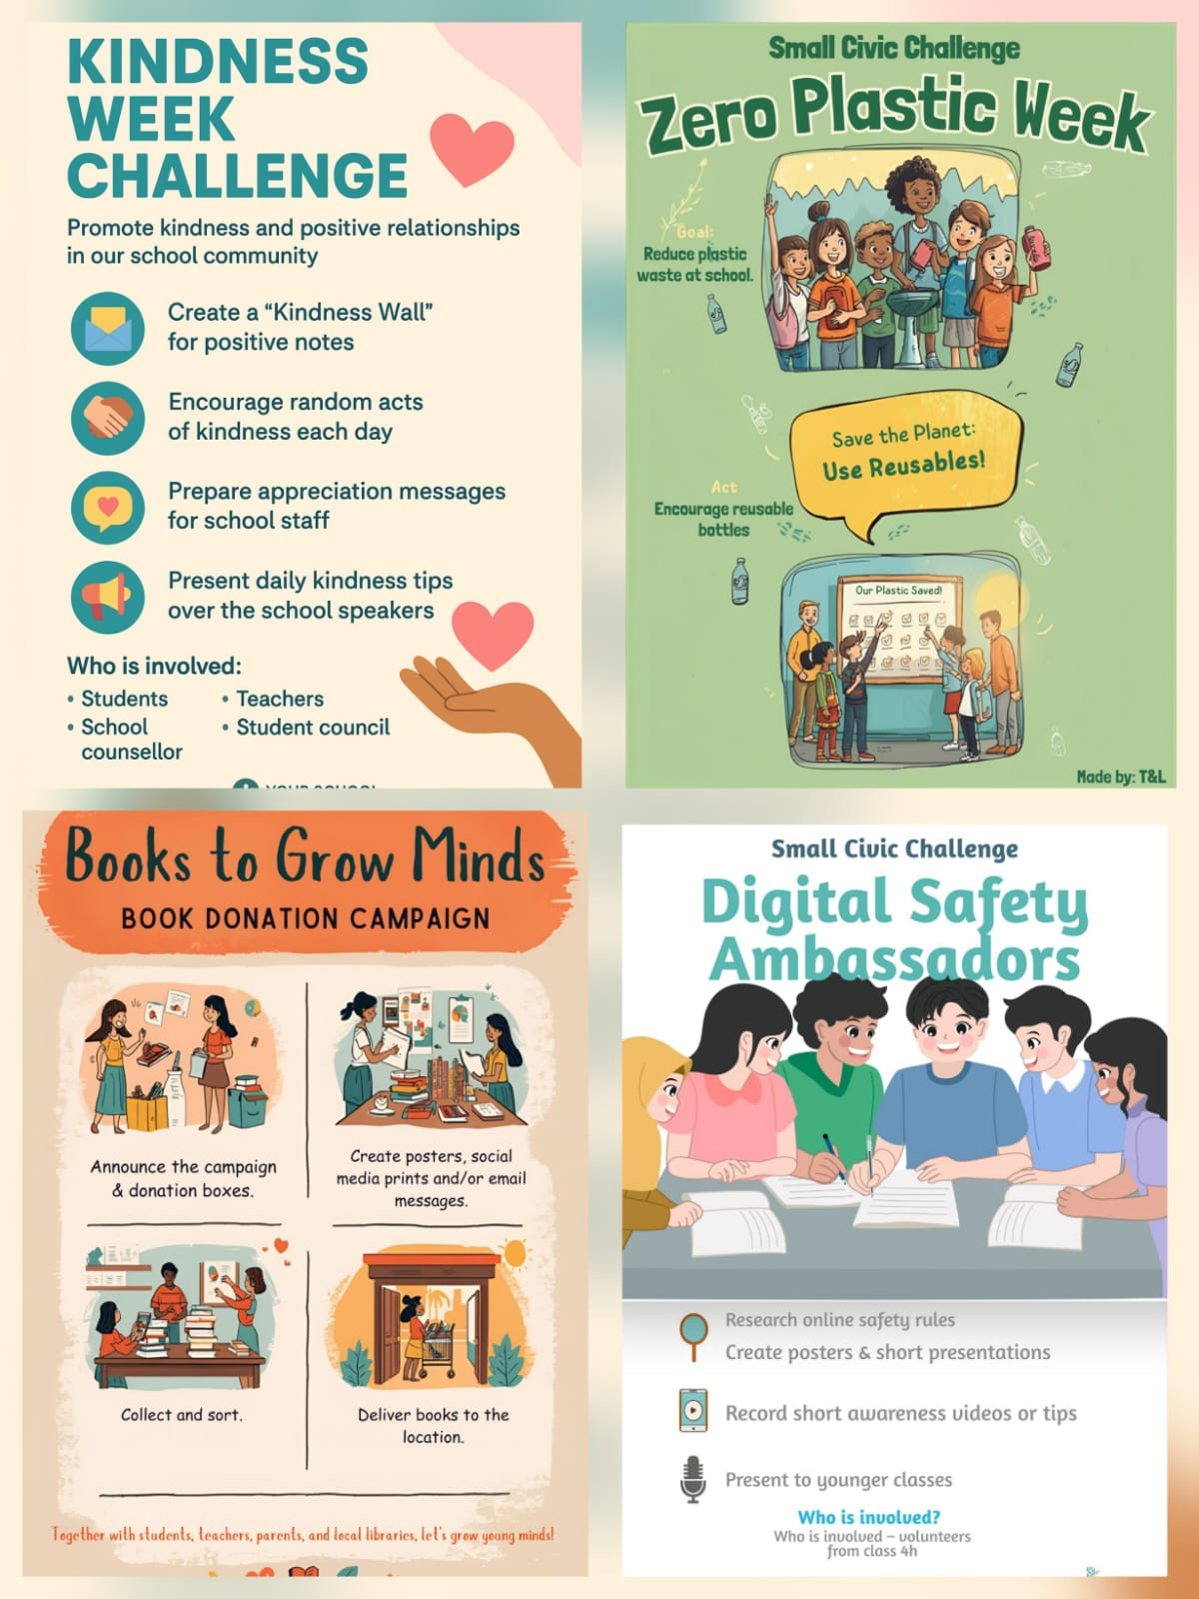

Digital citizenship

It is common knowledge that nowadays tech is everywhere and all aspects of life are dominated by technology. In a digital world, civic responsibility includes online behaviour. So, teaching students how to use digital platforms responsibly is not an option any longer—it is a must.
Activities such as creating online campaigns or digital posters about tolerance, kindness, or sustainability allow them to connect civic values with digital literacy and they start to see how civic values and digital skills go hand in hand.

Reflection and discussion

After every project or civic action, we reflect together. Students discuss what they learned, how they contributed, and how their actions affected others. Reflection isn’t just about looking back; it helps turn single-event activities into real, lasting values, like justice, fairness, and participation.

The role of the teacher

Teachers are more than just facilitators—we are role models. When we encourage and nurture respect, fairness, and open dialogue in class, we set the tone. We build a space where everyone feels safe to speak up and take part actively. That sense of belonging is the foundation of engaged citizenship.
Nelson Mandela wisely observed: “Education is the most powerful weapon which you can use to change the world.”
Teaching citizenship is not just teaching about society — it is shaping the kind of society our students will build.

Conclusion
Educating active citizens is one of the most important missions of modern education. It requires creativity, empathy, and the ability to connect classroom learning to real-world challenges. When students realize that their actions matter, they grow—not just as students, but as people.
Through experiential learning—such as hands-on projects, intercultural projects like Erasmus+ YES the Earth and DIGI-CUL, active involvement in the community, and real-world tasks like the Small Civic Challenge—teachers can help shape a generation that thinks critically, acts compassionately, and leads responsibly, preparing young people to build a more just and inclusive world.

Coming soon! Please check the Pilgrims in Teacher Training courses in 2027 at Pilgrims website.

