Pilgrims News August 2026

Phil Dexter, Coordinator Pilgrims Teacher Training and Editor Pilgrims Teacher Trainer Journal



Segovia by night

As always, the summer is a busy time for Pilgrims teacher training. We have just completed a great week in Segovia on our course “Teaching in a Humanistic and Creative way today” hosted by Raquel Lucia the centre manager at Werbum-Lab. It was a pleasure for me to be Course Director and work with our wonderful Pilgrims Trainers - Stefy Ballotto and Csilla Jaray-Benn.

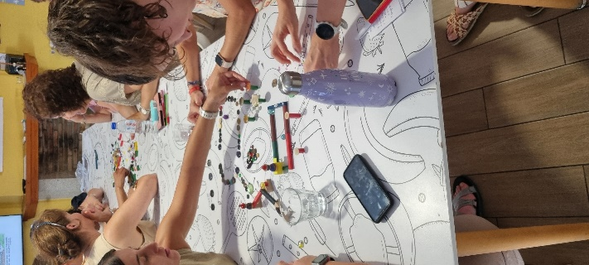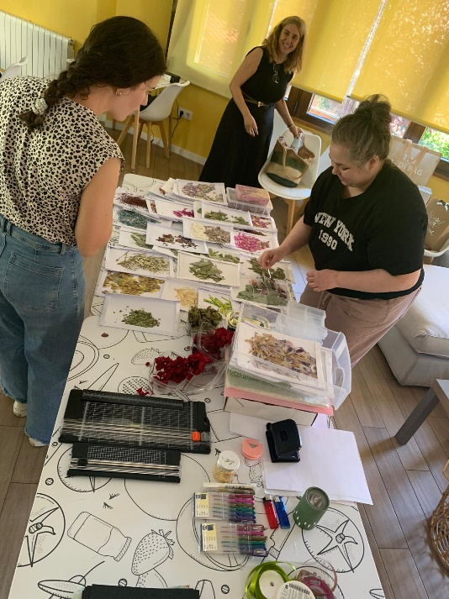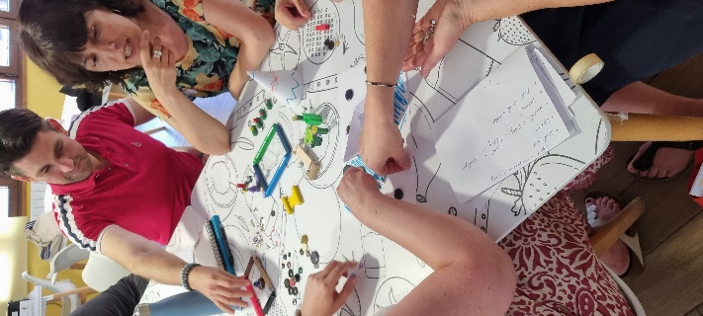

Participants on the course were a group of enthusiastic teachers from Castilla y León region in Spain, Erasmus + supported teachers from France, Germany and Italy and teachers representing TESOL Spain and APPI Teachers Association, Portugal. A full report on the week will be published in the next issue of the Teacher Trainer Journal in October. Below is some of a flavour of the enthusiasm in the week in pictures.

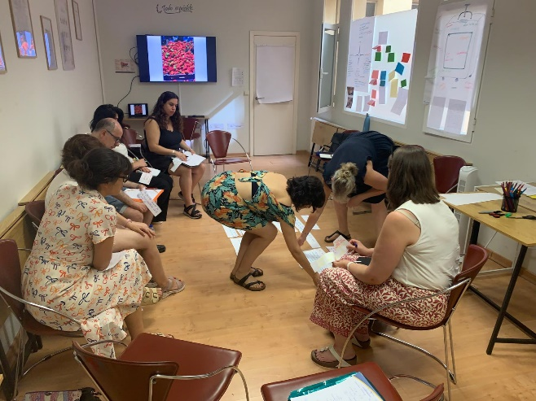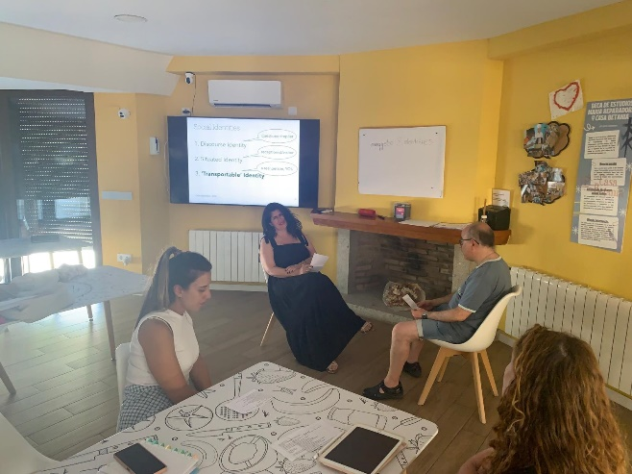

A significant development is the re-established relationship between Pilgrims Teacher Training and the Castilla y León professional development training department CFPI which we are planning for a continued support relationship into 2027 and beyond supporting training in both Segovia, Spain and in the UK. This goes together with the exciting development that the UK is returning to the Erasmus + programme in 2027. Do watch this space for more developments or find more information on our Pilgrims website
https://www.pilgrims.co.uk/teacher-training-courses

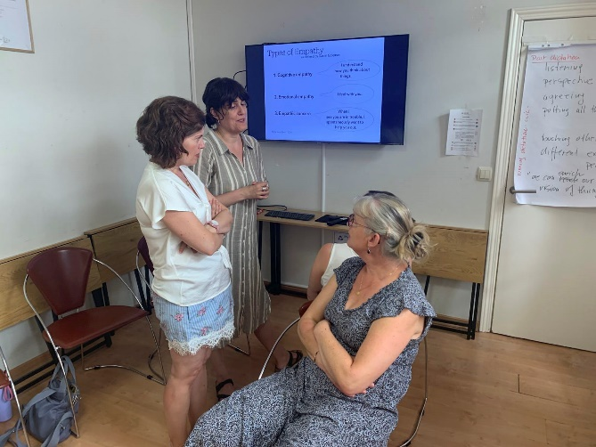

Pilgrims Teacher Training is also continuing our cooperation with the Learn & Lead Innovation network hosting training in Segovia this August on the course “Creative Teachers, Motivated Learners” facilitated by Phil Dexter and Stefy Ballotto, and Anna Pires is facilitating the “Intercultural Competence” course in Varna, Bulgaria.

The other major initiative is that Pilgrims Teacher Training is organising our first online conference over the weekend of 10th and 11th October - “Humanising Language Teaching Today - Teaching the Whole Person”. More details on the conference and how to attend can be found in other sections of this issue of HLT though for more information please contact us at info@pilgrims.co.uk We have an early bird price of 36 Euro in total for both days. More information can also be found on our website https://www.pilgrims.co.uk/teacher-training-courses/online-conference



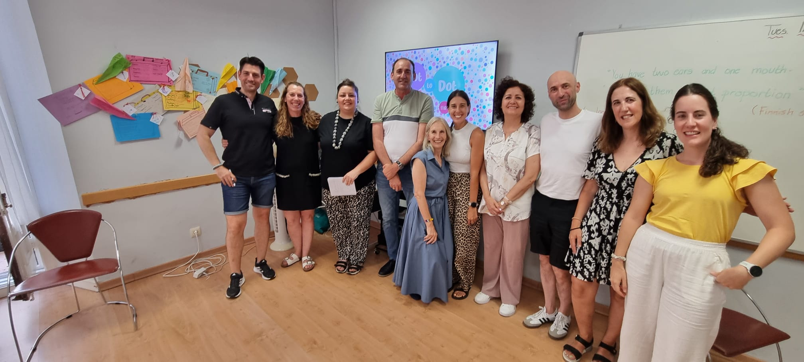

Coming soon! Please check the Pilgrims in Teacher Training courses in 2027 at Pilgrims website.

