Merry Christmas

found on the net by Hanna Kryszewska, Poland

… to those who celebrate it or teach about Christmas as part of culture. Simle

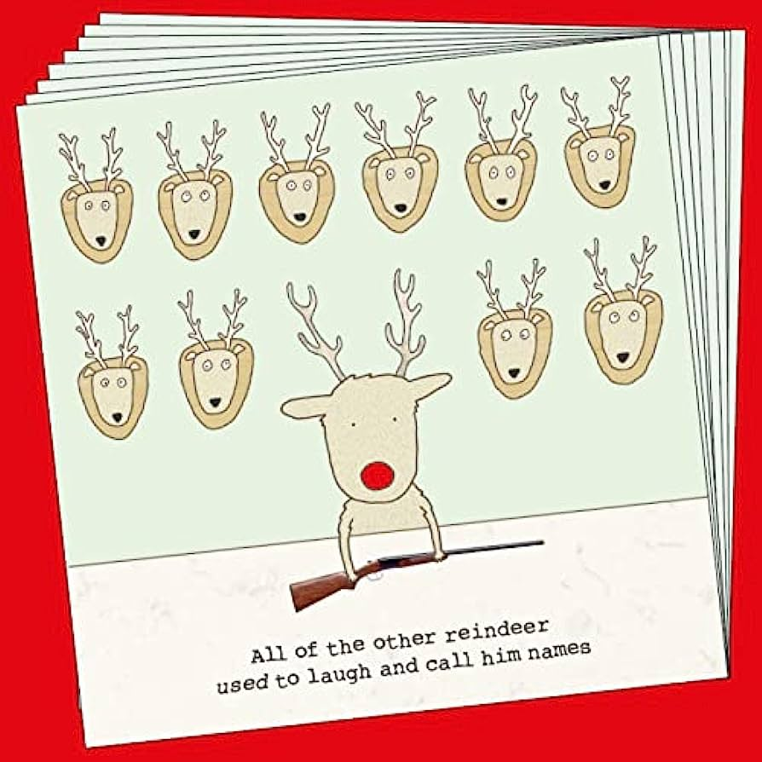




More at
https://gypsywolf.weebly.com/christmas-comics.html

Please check the Pilgrims f2f courses at Pilgrims website.

Please check the Pilgrims online courses at Pilgrims website.

