Volunteering with Ukrainian Refugees

Sinem Darıdere, Turkiye

Sinem Darıdere is an educational consultant, teacher and a CELTA tutor based in Izmir,
Turkey. She has taught a wide range of teaching contexts; nowadays, she is training on CELTA courses and running her teaching projects. She also works as the joint secretary of IATEFL IP&SEN SIG. Her main area of interest is using art and music in ELT, learner-and-teacher wellbeing.


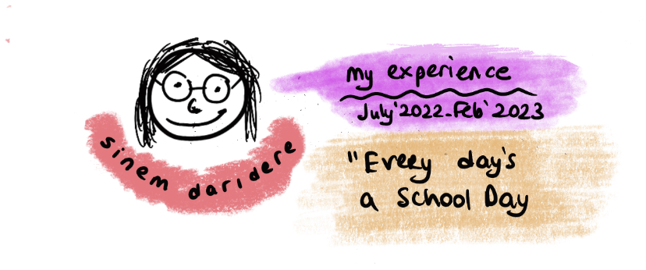


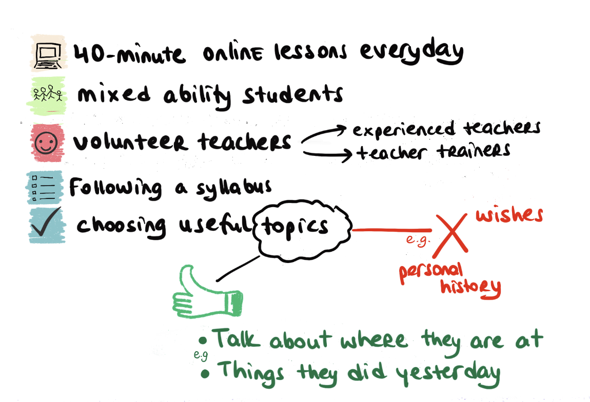

Please check the Pilgrims f2f courses at Pilgrims website.

Please check the Pilgrims online courses at Pilgrims website.



