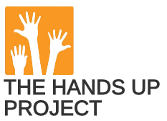

Stories from the Hands Up Project

Jamie Keddie, Spain

Introduction

I've always been fascinated by the way that story can foster community. And in that respect, no one has taught me more than Nick Bilbrough and the volunteers at the Hands Up Project.

(The following was originally posted on the LessonStream blog https://lessonstream.com/blog/)

Palestine, 2012

In case you don’t know Nick Bilbrough, let me introduce him. Here we are together on the very first evening of a mini tour of the West Bank in Palestine that was organised by the British Council in 2012. I still remember that great little restaurant in Ramallah.

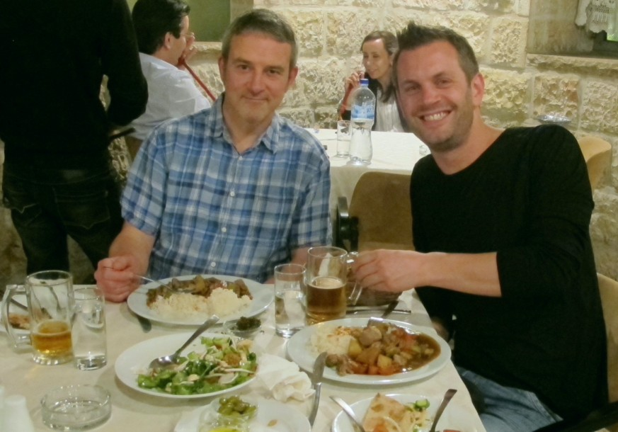

The British Council had brought four trainers over from the UK. And as well as Ramallah, we worked with local teachers in Hebron, Nablus, Jenin, Jericho and Bethlehem.

None of us had been to Palestine before and we were all deeply impacted by the vibrancy of the place and the friendliness and sincerity of the Palestinians.

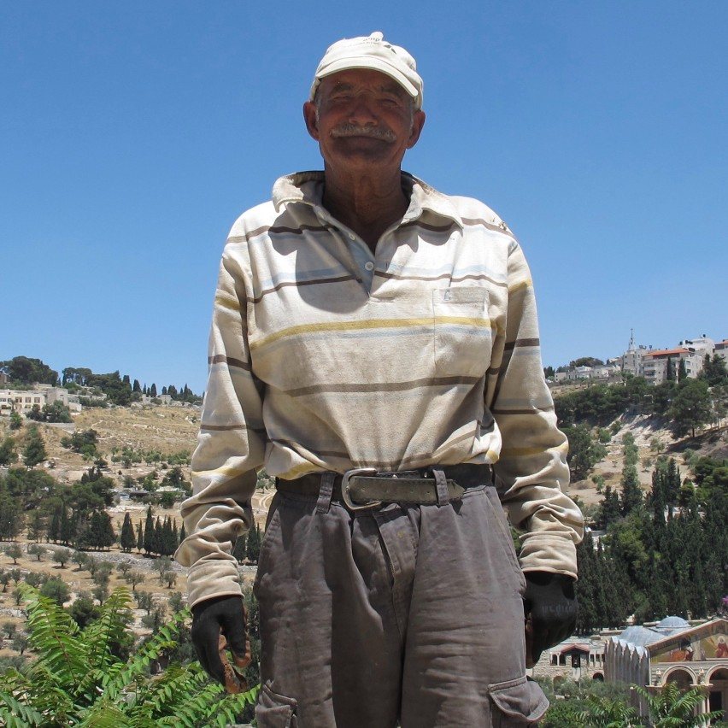

Looking back, it’s easy to question the point of trips like these. The official objective was, of course, teacher training.

But how much difference can four foreign trainers really make to any local teacher’s pathway of professional development? Very little, I would guess.

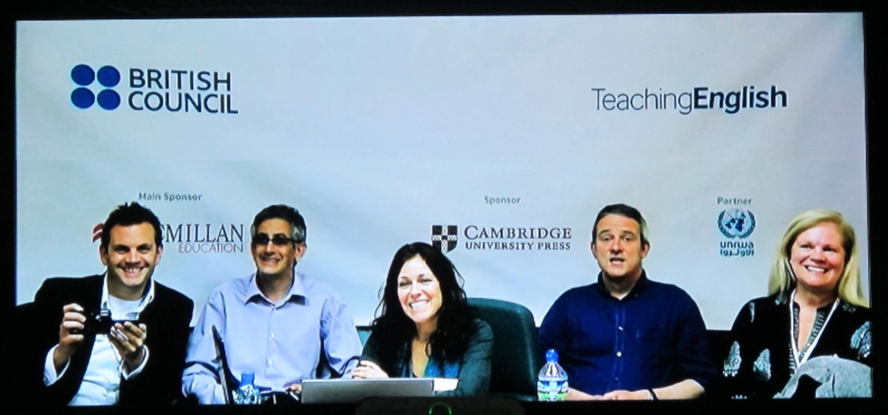

In the photograph from left to right: myself, Andrew Foster (British Council),
Julietta Schoenmann (HUP volunteer), Nick Bilbrough (HUP founder) &
Wendy Arnold (HUP volunteer)

So what did we really achieve?

Well, there is one detail that sticks in my mind. At the end of one of the training sessions, a young teacher ran over to us to thank us for the workshops we had given. But before she let us go, she said:

“You have no idea how much it means to us that you have come here. Please don’t ever forget us.”

For most of us, we can only ever imagine what it would be like to live in fear of the world turning its back on the injustices that we are forced to live under. And this must have stirred something in Nick. Within a year, he was back in the region giving storytelling sessions to local kids.

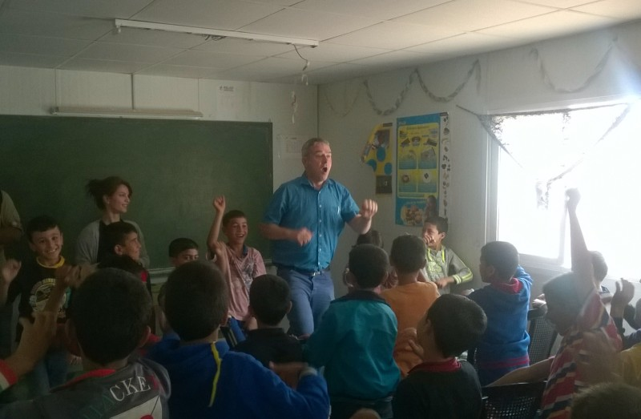

This was the beginning of the Hands Up Project, a registered charity that Nick founded in 2014.

For almost ten years, the HUP has been providing opportunities for children in difficult places, especially Gaza, by using English to communicate with one another across borders.

Storytelling is at the heart of everything and HUP teachers and volunteers have been making use of Zoom (long before its rise to pandemic fame) to connect classrooms by organising drama and storytelling sessions for school children.

Although that trip to Palestine seems like only yesterday, it’s incredible to think that already, there are children who have grown up with the Hands Up Project as an important part of their lives.

There are currently over 500 videos on the HUP YouTube channel including many performances by children in Gaza and beyond. Here are three of my favourites.

Video one: Welcome to Earth

If there’s one video that encapsulates the work of the HUP and illustrates how storytelling can foster community, it’s this one. It’s a truly collaborative piece of work that transcends borders.

Plays are usually performed on a stage, in a theatre or in a school. But this one was performed live on Zoom by three school girls in Gaza and two in Czechia. This original approach to drama, which emerged and evolved during the 2020 pandemic, has come to be known as remote theatre.

Welcome to Earth was originally written and performed by five Palestinian boys in 2019. It tells the story of five aliens from a distant planet who come to Earth, only to find that the planet is in crisis.

The play won a competition and was included in a book which was published the next year. It became a bit of a favourite with other students in the HUP community, including the aforementioned girls that you are about to see which was performed and filmed on Zoom in a single take and has not been edited in any way.

Video can be viewed here: https://www.youtube.com/watch?v=exAksvIsWD0

Credits: Written and originally performed by Mahmoud, Rida, Ahmed, Abdul-Rahman and Ahmed with the support of their teacher Ghada Hamdan at Askar Boys UNRWA school, Nablus, Palestine. In the video, the play was performed live and remotely by Yara, Rahaf and Malak from Beit Hanoun Prep A Girls School in Gaza city and Magdalena and Julie from Elementary school Dr. Edvarda Beneše in Czechia. It was directed by their teachers Rinan Jamal Al Muzanin (Gaza) and Jasmina Falge (Czechia).

Video two: I can

Here is a powerful story about breaking through barriers.

The play was created and performed by Basem, Mahmoud and Abd Alrahman from Mae’n prep boys school, Gaza with support from their teacher, Imad Wahba.

Video can be viewed here: https://www.youtube.com/watch?v=d8o2DgQUH8w

Video three: I can smell her

This play tells the moving story of a girl who copes with the loss of her mother, a reporter who was killed while covering a conflict in their country. She finds solace and a connection to her mother through the smell of the perfume that she used to wear.

It was created and performed by Raghad, Hala, Eman and Nour from Gaza Elementary B school, with support from their teacher Sahar Siam.

Video can be viewed here: https://www.youtube.com/watch?v=dvisREPoKWg

7th October 2023

On this day, Hamas militants crossed into Israel and committed the most horrific attacks, killing more than 1200 Israelis and taking over 200 hostages. The Israeli military retaliated with strikes against Gaza and by mid October, more than 11,000 Palestinians had been killed, including thousands of children.

From the very start of the war, HUP volunteers have been working hard to stay in touch with the English teachers and students, whose faces they would normally see on Zoom every day of the week.

Internet connection in Gaza is rare. But despite that, many of those teachers and students are contacting HUP volunteers whenever they can and are asking for one thing: to tell the world their stories before it’s too late.

In some cases, it’s already too late. HUP volunteers have become aware of several tragedies involving children and teachers in their community. But rather than go into details, I would prefer to end this post with a quick story that Nick Bilbrough once told me.

This was, in Nick’s own words, one of the most memorable and impactful moments from his teaching. It was back in the early days of the HUP and a group of Palestinian children had just performed a play on Zoom. But just before switching off the connection, a young girl walked up to the camera, bent down in front of it and said:

“Please Mr Nick. Can you tell the world that we are not terrorists?”

PS

I went live with Nick again last week and we took things in a different direction – he shared a number of poems by Gazan kids. It was incredibly moving and you can view the recording: https://www.youtube.com/watch?v=0GL0rmEzSFE

The poems came from a book that Nick edited titled "Moon tell me truth" and you can see and buy it here: https://www.handsupproject.org/shop

Links

HUP website: https://www.handsupproject.org
HUP YouTube channel: https://www.youtube.com/channel/UC3pWIDb1E63K6QeJhe0p5Uw
HUP on Facebook
All three of the plays mentioned in this post are included in the book Welcome to Earth which you can download for free: https://www.handsupproject.org/free-digital-download?fbclid=IwAR07BftOa82mYkwMA1KFkF7YLnY0xB3eg4SKjN-_AGhXX8laD-o3r6Jg4mI

Please check the Pilgrims f2f courses at Pilgrims website.

Please check the Pilgrims online courses at Pilgrims website.

